Skywarn Spotter Reference Sheet
Register Here or QR Code below: https://www.weather.gov/dvn/spotters#schedule
What to Report |  | How to Report
- Injuries/Fatalities  - Damage:  - Trees down (snapped or uprooted? diameter?)  - Branches broken (diameter?)  - Power poles down  - Structural damage  - Tornado (rotation like a spinning top? debris?)  - Funnel Cloud (rotation like a spinning top?)  - Wall Cloud (rotation like a spinning top?)  - Hail (all sizes)  - Wind Gusts (40 mph or greater)  - Heavy rain (1” or more)  - Unusual Water Issues:  - Floating/stalled cars  - Water on roads (flowing? depth? trend?)  - Unusual road closures  - Flooded buildings  - Mud or rock slides  - Rapidly rising water  - Dense fog (visibility ½ mile or less)  - Freezing Drizzle or fog freezing on roads  - Strong non-thunderstorm winds (40+ mph)  - Winter Hazards:  - Blizzard (Visibility <1/4 mile for 3+ hours)  - Snow Squall (sharp drop in visibility w/ heavy snow, strong winds, icy roads)  - Freezing rain (estimate on branches and elevated surfaces)  - Precipitation types not in the forecast  - Road conditions |  | Include: - Who you are (spotter number?) - Where you are - Where the weather occurred - When it occurred - What was observed  Contact NWS direct via:  Phone: (800) 803-9357 unlisted  Always call directly for tornado  and funnel cloud reports.  Web: www.weather.gov/dvn  (“Submit a Storm Report” under Current Hazards tab)  Share pictures via:  Facebook: NWSQuadCities  Twitter: @NWSQuadCities  Report through your local or county spotter network.
Helpful Internet Links
NWS Quad Cities  NWS for Mobile Devices  Becoming a Storm Spotter  Downloadable Spotter Guide  Online Spotter Training Course  Online Radar Basics Course  CoCoRaHS Network  Iowa Environmental Mesonet | http://www.weather.gov/quadcities  mobile.weather.gov  http://www.weather.gov/quadcities/spotters  www.nws.noaa.gov/om/brochures/SGJune6-11.pdf  www.meted.ucar.edu/training_course.php?id=23  www.meted.ucar.edu/training_module.php?id=960  www.cocorahs.org  mesonet.agron.iastate.edu

Supercells: Step By Step

Step 1: Identify the updraft (and downdraft)
Step 2: Determine storm motion
Step 3: Make sure your location is safe
Step 4: Assess strength/potential
Step 5: Look for visible rotation in updraft
Watch downdraft for strong winds / hail
or watch updraft for rotating wall cloud / tornado
Step 7: Report critical information
Step 6:
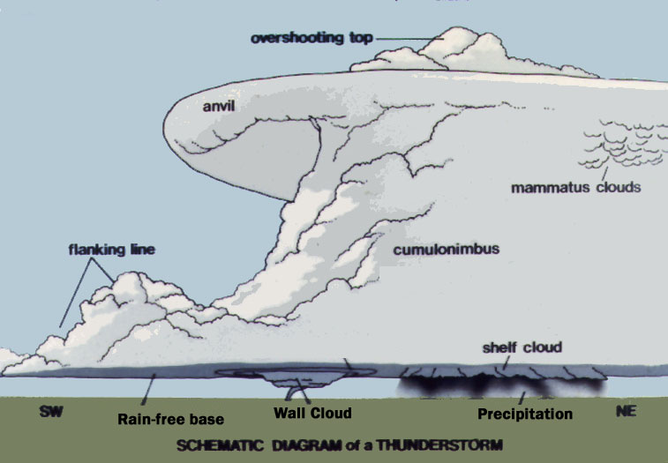

Estimating Wind Speed (Beaufort Scale)
25-31 mph Large branches in motion, whistling in power lines
32-38 mph Whole trees in motion
39-54 mph Twigs break off trees, wind impedes walking
55-72 mph Damage to chimneys and antennas, shallow-rooted trees blown over
73-112 mph Peels surface off roof, windows broken, trailer houses overturned
113+ mph Roofs off houses, weak buildings and trailer houses destroyed, big trees uprooted

