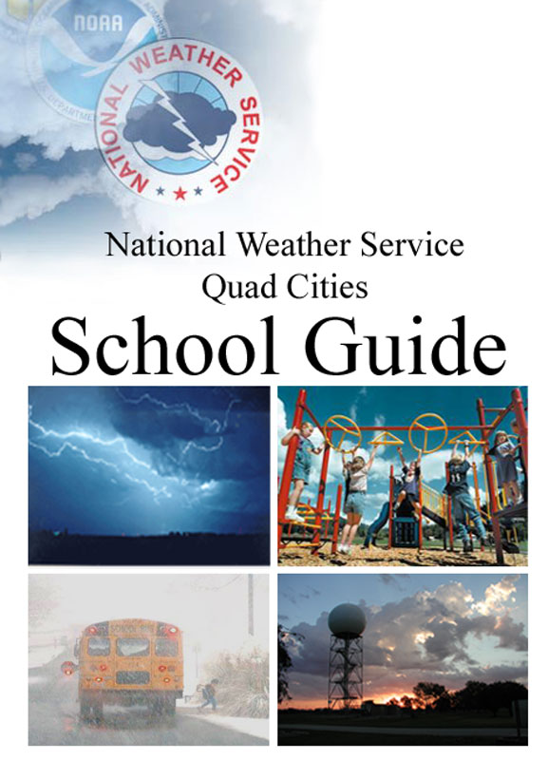

Contact:

Rich Kinney
Warning Coordination Meteorologist

National Weather Service Quad Cities
9040 N. Harrison St.
Davenport, IA 52806

Rich.Kinney@noaa.gov
563-386-3976 x726

Last updated February 14, 2024

Table of Contents

How to Develop an Effective Severe Weather Plan 2
- Designate the Weather Watcher(s) 3
- Develop a Communication Strategy 4
- Develop a Sheltering Strategy 6
- Identify Decision Thresholds and Actions 8
Dense Fog 9
Flash Flood 10
Heat 12
High Wind 13
Lightning, Thunderstorms, and Tornadoes 14
Snow/Ice 16
Wind Chill & Extreme Cold 18
- Document your plan 20
- Train all staff on the plan 20
- Hold seasonal sheltering drills 20
After the Storm 21
Putting It All Together: StormReady Schools 22
Appendices:
Appendix A: School Weather Strategy Worksheet 24
Appendix B: Special Considerations for Transportation 29
Appendix C: Special Considerations for Extracurricular Activities 30
Appendix D: NOAA Weather Radio 31
Appendix E: Glossary of NWS Messages 34
Appendix F: NWS Educational Resources 36

How to Develop an Effective Severe Weather Plan

It is said that the only thing harder than planning for an emergency is explaining why you did not.

Every school safety plan should encompass the range of weather hazards that occurs in the region and should include extracurricular activities, transportation, and special needs populations in addition to normal operations. Developing a practical and effective plan typically involves working with the local school board, administrators and faculty to implement the plan.

Pre-planning for all scenarios (normal operations, extracurricular activities, transportation, etc.) should include the following elements:
- Designate the weather watcher(s) and ensure they have the tools to monitor weather.
- Develop a communication strategy with redundancy and/or backups.
- Develop a sheltering strategy.
- Identify decision thresholds and actions for each weather hazard.
- Document your plan.
- Train all staff on the plan.
- Hold seasonal sheltering drills.

This guide provides specific guidance and more detail on each of these elements.
1. Designate the Weather Watcher(s)
Key points:
- Monitors weather
- Alerts decision maker
- Authority to implement emergency plan?
The designated weather watcher is key to the success of any severe weather plan. The designated weather watcher monitors weather information, allowing everyone else to focus on the activities at hand. Ideally, the designated weather watcher has the authority to enact the severe weather plan. When this is not feasible, it is critical that the decision-maker and designated weather watcher communicate extremely well so that dangerous delays in response do not occur.

It is also important that the role of the designated weather watcher is always filled, even during extracurricular activities. In other words, the responsibility is best tasked to a position rather than an individual who might or might not be there that day, and it may change depending on the activity and time of day. For example, the designated weather watcher during the day may be an administrative assistant in the front office, then perhaps an athletic director or assistant coach during a sports event. It doesn’t matter as much who it is, as long as everyone knows they carry the responsibility for monitoring conditions and alerting those who will “make the call”.

- Routine: The designated weather watcher would typically begin their day by reviewing the Hazardous Weather Outlook and local forecast for an overview of any anticipated hazards. Depending on the scheduled activities, they would then forward information about any potential impacts to the relevant decision makers.

- Hazardous weather monitoring: Before and during hazardous weather events, the designated weather watcher monitors weather information as it is updated and continues to alert decision makers of potential impacts. In rapidly changing or emergency situations, the designated weather watcher may be given the authority to enact the safety plan.

Monitor this Information:  Forecast  Forecast Discussion  Hazardous Weather Outlook  Severe Weather Webinars  DSS Packets  Watch  Advisory  Warning  Radar | Via these Tools:  www.weather.gov or other weather web site  - Point-n-Click Forecast  - Hourly Weather Graph  - Decision Support Web Page  Cell phone alerts (WEA, text or via an app)  email alerts  NOAA Weather Radio (see Appendix D)  Local TV weather  Local Cable Channel or secondary digital channel  Social Media  Private weather services  Phone call to NWS
Links
National Weather Service Quad Cities www.weather.gov/quadcities
Decision Support Web Page www.weather.gov/quadcities/briefing
2. Develop a Communication Strategy

Key points:
- Pre-notify whenever possible
- Is it effective?
- Redundancy and/or backups

Pre-Notify
Pre-notification allows people the opportunity to prepare themselves mentally for something unusual that may occur. When athletic officials know beforehand that there is a threat of storms, they are quicker to react when the lightning approaches; when teachers know there is a severe weather risk later that afternoon, they are more tuned to the PA announcements; perhaps the class has a substitute teacher who takes a moment to look at the classroom’s shelter location; maybe the parents at the football playoff game coordinate with their students where they will meet if lightning approaches. Regardless of the situation, response is enhanced when people are already aware that there may be a need to change their plans.

Pre-notification of a potential hazard can be accomplished through any number of simple means and can also remind people of what they would be expected to do if the hazard occurs. For example, a district-wide email in the morning can alert of a severe weather risk later that day and remind staff of their responsibility to stay alert. A sign at the ticket booth at an extracurricular event (be it sports, drama, or music), alerts attendees that they should pay particular attention to all announcements in case they would be required to shelter.

Choose an Effective Means
The most effective communication method often depends on both the nature of the hazard and the activities that are ongoing. For slower-to-evolve hazards such as snow storms, for example, email or posting to a known web page may be sufficient to notify people of a cancellation. On the other hand, evacuating a stadium for encroaching lightning is more urgent and requires a more attention-getting method. Regardless of the method used, simpler is usually better and the more consistency that exists year-round, the less confusion there will be.

Redundancy and/or Backups
Communication is key in any emergency situation. Unfortunately, things happen: power fails; technology doesn’t always work; situations change. Poor communication will slow or even prevent response. To complicate matters further, human nature pushes people to confirm a threat before they act. Thus it is always recommended to establish redundant communication streams. Providing redundant communication streams facilitates people gaining the same official information through different channels and thus spurs their action. When redundancy isn’t practical, then a backup plan should be in place for when the primary method fails.

The following table outlines some of the most common communication methods and their advantages and pitfalls.

Common Communication Methods
 | Advantages | Limitations  (address with backup or work-around)
PA System | - Can speak to most of building at once  - Can convey instructions and urgency | - Can be disrupted by power outages  - Hard to hear in large rooms (gym, cafeteria, auditorium)  - May not exist in detached buildings
Megaphone or air horn | - Works in lieu of PA systems | - Limited range
Two-way radio | - Can convey instructions and urgency  - May reach multiple buildings at once  - Inexpensive way to reach detached buildings  - Target key recipients | - Limited audience
Official web pages | - Default for many people to check  - Considered “official” by people | - Passive (does not “alert” people)
Official Social Media Channels | - Easily forwarded by recipients  - Widely used by students and families | - Not monitored 24/7
Scoreboards | - Can convey information to entire crowd  - Best for local communication | - May fail during power outages
TV monitors | - Communicates visually in noisy areas | - May fail during power outages
Text messaging | - Can reach many people quickly  - Easily forwarded by recipients  - Widely used by students and families | - Does not convey tone or graphics
Automated phone calling systems | - May work for something expected the next day | - Slow relay times  - Phone systems unreliable in storms  - May fail during power outages
Phone call tree (manual) | - Not recommended | - Slow relay times  - Often incorrect or incomplete info.  - Phone systems unreliable in storms  - May be limited in power outages
3. Develop a Sheltering Strategy
Key points:
- Prioritize shelter areas.
- Avoid large span rooms.
- Aim for 3 minutes.
- Consider all logistics.

Sheltering Considerations
- We recommend that everyone be able to reach shelter in less than 3 minutes.
- The logistics of and time required to move people to the shelter areas must also be considered. For example, congestion at stairwells and doorways may slow the sheltering process. Mobility-impaired students may require special assistance and more time.
- Close all doors and windows, including interior fire doors.
- In the shelter, people should have a way to monitor conditions to know when it is safe to emerge.
- Consider posting signs on designated shelter areas.

Choosing Shelter Areas
The greatest threats from strong winds (caused by tornado or severe thunderstorm) are roof failure, breaking glass, and flying debris. Without a specially designed shelter area, it is a matter of identifying those areas that are relatively safer than others. Schools are particularly diverse in design, and we recommend that shelter areas be identified with the help of an engineer or architect familiar with each building's design. You may wish to rank areas of your school according to safety and the logistics of reaching each space. Begin filling the safest areas and continue down your list until you have found space for the entire school body.

Evacuate High-Vulnerability Areas
- If your school has more than one level, move people from the upper floor(s) to the lowest level.
- Large-span rooms offer little protection. Move to safer areas.
- Mobile or temporary buildings are no safer than a mobile home and should be evacuated to the nearest sturdy structure.
- Move people out of rooms with exterior windows.

DO Shelter on the lowest floor in small, interior rooms.
The best protection is offered by small, windowless, interior rooms that are away from exterior doors (often bathrooms, hallways, and locker rooms). All doors and windows should be closed. Interior load-bearing walls with short roof spans provide better protection than temporary or non-load-bearing walls.

Do NOT shelter in large-span rooms or rooms with large windows.
The most dangerous locations during strong wind events are generally large rooms with expansive roofs such as cafeterias, gymnasiums, and auditoriums. Avoid the temptation to shelter in these areas. The collapse of the room's outer load-bearing wall can lead to the failure of the entire roof. Rooms with large windows that can shatter from airborne missiles or pressure stresses are also extremely dangerous. Once wind enters a building, additional damage is highly likely.

Additional Resources
Design Guide for Improving School Safety in Earthquakes, Floods, and High Winds
www.fema.gov/pdf/plan/prevent/rms/424/fema424_cvr-toc.pdf
Selecting Refuge Area https://www.fema.gov/sites/default/files/documents/fema_bara-new-checklist_10-4-2017.pdf
Engineered Safe Rooms www.fema.gov/safe-rooms

Wind Speed | Damage to  Typical School | Elementary School | High School
65 to  85 mph | Loss of some roof covering. Broken windows. | 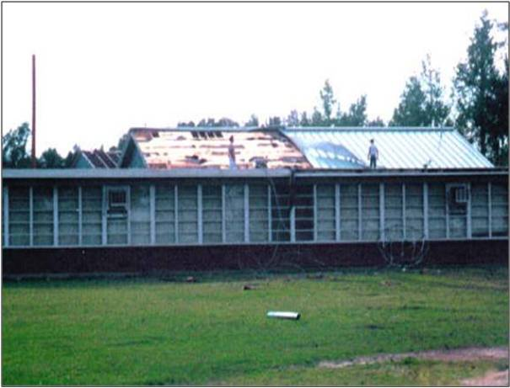 | 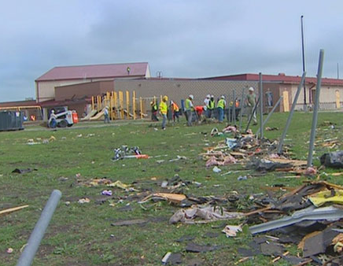
86 to  110 mph | Exterior door failures. Uplift of some roof decking; significant loss of roofing material. Loss of rooftop HVAC. Loss of wall cladding. | 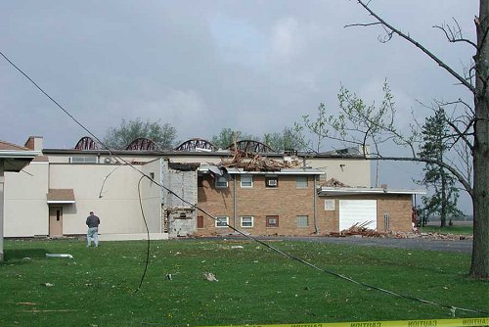 | 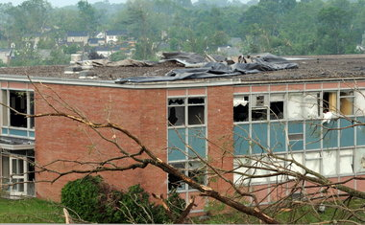
111 to 135 mph | Uplift or collapse of roof structure. Collapse of tall gym, cafeteria, and auditorium walls. | 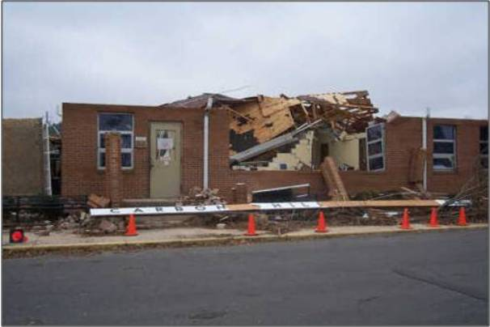 | 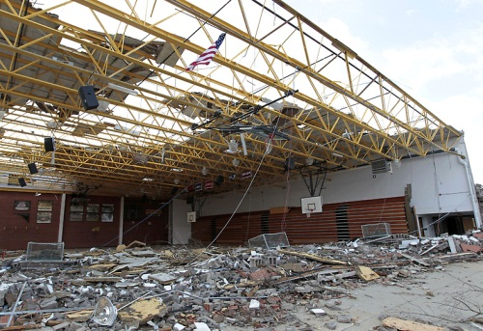
136 to 165 mph | Collapse of inner walls. Collapse of exterior walls on upper floors. Most interior walls on upper floor collapsed. | 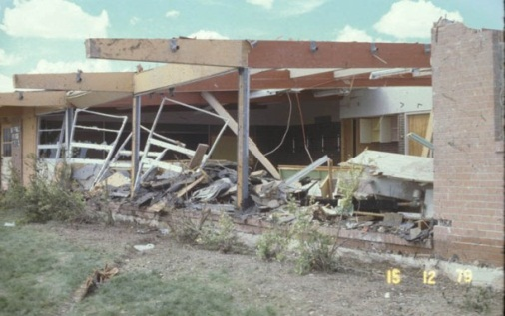 | 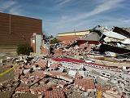
166 mph and higher | Total destruction of most or all of building. | 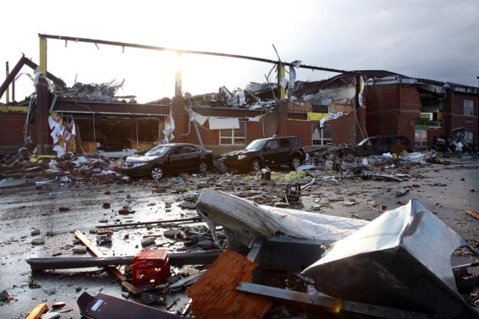 | 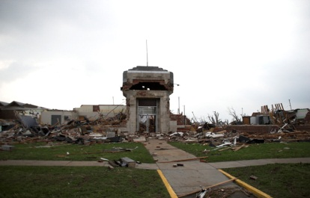

4. Identify Decision Thresholds and Actions
Key points:
- Identify threats.
- Determine action thresholds for each.

An effective weather plan addresses the range of impacts caused by the entire spectrum of weather hazards. In your plan, each hazard and its potential impacts should be identified, followed by the specific actions that are taken before, during and after the hazard occurs.

To facilitate developing a comprehensive and effective plan, the following pages provide an outline for the information flow related to specific weather hazards. Each section includes key background information related to that hazard, a table of decision thresholds and recommended actions for each, and links to supporting resources. The table below provides a key.

Threshold | Timing and Sources | Recommended Actions
Bold text: identifies the threshold itself (a decision point usually associated with increased confidence of the hazard’s occurrence)  Italicized text: Weather messages that should be monitored for or would identify this threshold | Plain text: Typical timing of this particular threshold  Italicized text: Where you can find these relevant weather messages | Actions that are recommended or typically associated with this threshold for this weather hazard

Weather Hazard: Dense Fog

Fog Facts

- Statistically, most local dense fog events occur in January, August, and February (in that order).
- In certain conditions, fog will deposit on roads as ice and cause exceptionally hazardous travel.
- On average, dense fog lasts for about 5 hours.
- Each year an average of 2 dense fog events occur during the morning school commute time.
- 82% of the time, dense fog lifts (visibility improves above ¼ mile) by 9 am.

Threshold | Timing and Sources | Recommended Actions
Potential for widespread dense fog exists  Forecast or  Hazardous Weather Outlook: first mention of potential for dense fog | Typically 12-24 hours ahead  via web page, email, TV, Weather Radio | None
Dense Fog Imminent or Occurring  Dense Fog Advisory: Visibility reduced to less than ¼ mile for a prolonged period of time over a widespread area due to fog.  May freeze on roads in certain conditions. | Typically 0-3 hours before onset  via web page, email, text alert, Weather Radio, TV | - Evaluate risk of ice on roads  - Assess extent and timing  - Consider late start as needed

Special Considerations for Transportation
When temperatures are near or below freezing, fog may freeze on roads, creating an extremely slick and near invisible glaze.

Weather Hazard: Flash Flood

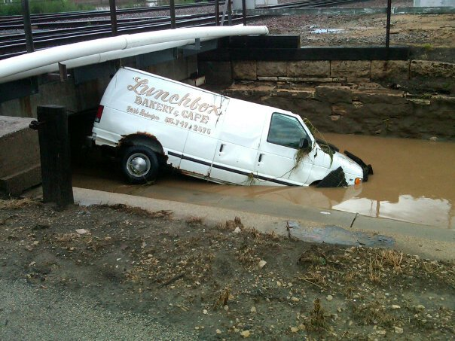 | - Flash floods can occur within a few minutes or hours of excessive rainfall, a dam or levee failure, or a sudden release of water held by an ice jam.  - Flash floods often have a dangerous current of water and can carry much debris.  - Flash flooding can continue long after rain ends.  - Know the flood prone areas in advance, such as low-lying spots and locations of rivers or creeks.  - Establish alternate routes to avoid driving through water.  - For flood-prone facilities, consider where and how to evacuate to higher ground.

Threshold | Timing and Sources | Recommended Actions
Potential for flooding exists  Forecast or  Hazardous Weather Outlook: first mention of potential for heavy rain or flooding | 2-3 days ahead  via web page, email, Weather Radio | Communicate potential threat to decision makers (pre-notify)
Flooding likely in the area  Flood or Flash Flood Watch: Heavy rain is likely with a 50% or greater chance for flooding | Typically a few hours to one day before expected flooding  via web page, email, text alert, Weather Radio, TV | - Communicate increased threat to all staff  - Establish strong communication between weather watcher(s) and decision makers at all events  - Ensure alternate transportation routes are accessible to avoid flood-prone spots  - Ensure evacuation routes are available at flood-prone facilities
Life-threatening flash flooding is ongoing or imminent  Flash Flood Warning: Confident of life-threatening flash flooding  Flash Flood Warning Update Statements: Updates on impacts of flooding, timing, location, creeks at risk, additional rainfall, status of warnings, etc. | Typically 30 to 60 minutes before flooding begins; updates issued throughout warning  via web page, email, text alert, Weather Radio, TV | - Read warnings and updates carefully for locations or creeks that may be under particular threat.  - Monitor flood-prone facilities near creeks and other low-lying areas for potential rapid flooding and prepare to move to higher ground  - Use alternate transportation routes to avoid flooded roads  - Respond to specific impacts as necessary

Special Considerations for Transportation
- Establish an alternate plan for bus routes that avoids flood-prone roads.
- NEVER ATTEMPT TO DRIVE THROUGH FLOOD WATERS!
  - If the water is too deep to see the road, DO NOT CROSS. The road may have been undermined or the water may be deep enough to stall the bus and place all of its occupants in danger.
  - Do not enter underpasses that are filling with water.
  - If the water appears to be flowing, do not enter. The bus will act as a barrier and the water will attempt to lift and move the bus.
  - If water is flooding over or around a bridge, do not cross it, it might collapse from the weight of the bus. The foundation of the bridge may have been compromised.
  - If caught in flood waters, abandon the bus and seek higher ground immediately.

Additional Resources
Flash Flood and Flood Preparedness and Safety (NWS) https://www.weather.gov/safety/flood
Floods (FEMA) www.ready.gov/floods
Flood Preparedness (Red Cross) https://www.redcross.org/get-help/how-to-prepare-for-emergencies/types-of-emergencies/flood.html

Weather Hazard: Heat

Heat Index Impacts
- As heat continues for multiple days, people become even more susceptible to its effects.
- Heat Index is the effective temperature the body feels when heat and humidity are combined.
- Heat index assumes shady, light wind conditions. Exposure to direct sun adds about 15°F.
Heat Index | General Effect on People
80 to 89º - Caution | Fatigue possible with prolonged exposure and/or physical activity.
90 to 104º - Extreme Caution | Sunstroke, heat cramps and heat exhaustion possible with prolonged exposure and/or physical activity.
105 to 129º - Danger | Sunstroke, heat cramps or heat exhaustion likely; fatal heatstroke possible with prolonged exposure and/or physical activity.
130º or higher - Extreme Danger | Fatal heatstroke highly likely with prolonged exposure.

Threshold | Timing and Sources | Recommended Actions
Potential for Extreme Heat  Forecast: First mention of extreme heat | 4-5 days ahead  via web page, email, Weather Radio | Communicate potential threat to decision makers (pre-notify)
Dangerous Heat Likely  Excessive Heat Watch: 50% confidence of extreme heat lasting for more than 2 days | Typically 48 hours before onset  via web page, email, text alert, Weather Radio, TV | - Communicate threat to all staff  - Refresh staff on identification of heat-related illness  - Develop alternate plan for outdoor activities (indoors or cooler time of day)
Unusual Heat Imminent or Ongoing  Heat Advisory: High confidence of unusual heat (heat index >100°F) | Typically 24 hours before onset  via web page, email, text alert, Weather Radio, TV | - Communicate threat to all staff  - Postpone outdoor activities or move them to cooler times of the day  - Provide extra water and cooling breaks at all outdoor activities that continue  - Monitor closely for heat illness symptoms
Extended Period of Extreme Heat Imminent or Ongoing  Excessive Heat Warning: High confidence of dangerously high heat for more than 48 hours (heat index > 105°F) | Typically 24 hours before onset  via web page, email, text alert, Weather Radio, TV | - Communicate threat to all staff  - Postpone outdoor activities or move to cooler time of day  - Request emergency response standby at any continuing outdoor activities  - Provide extra water and cooling breaks at all outdoor activities that continue  - Monitor closely for heat illness symptoms  - Monitor unairconditioned facilities for high temperatures. Consider early dismissal.

Additional Resources
Heat Preparedness and Safety (NWS) https://www.weather.gov/safety/heat
Recognizing Heat Illnesses (CDC) https://www.cdc.gov/disasters/extremeheat/warning.html
Extreme Heat (FEMA) https://community.fema.gov/ProtectiveActions/s/article/Extreme-Heat
Heat Preparedness (Red Cross) https://www.redcross.org/get-help/how-to-prepare-for-emergencies/types-of-emergencies/heat-wave-safety.html

Weather Hazard: High Wind

High Wind Facts

- One third of high wind fatalities are caused by falling trees.
- About the same number of people die from non-thunderstorm wind as severe thunderstorm wind.
- Most high wind fatalities occur in March, November, and December in that order.
- One half of high wind events in the Midwest occur in March and April.

Threshold | Timing and Sources | Recommended Actions
Potential for high wind  Forecast or  Hazardous Weather Outlook: first mention of potential for high winds | 3-4 days ahead  via web page, email, Weather Radio | - Inspect grounds for dead or dangling branches that could be more easily broken
Dangerous Wind Likely  High Wind Watch: More than 50% confidence of dangerously high wind (40+ mph sustained and/or 60+ mph gusts) | Typically 24-48 hours before onset  via web page, email, Weather Radio | - Communicate threat to decision makers (pre-notify)  - Remove dead or dangling branches that could be easily broken.
High wind is imminent or occurring  Wind Advisory: High confidence of sustained winds of 30 mph+ and/or wind gusts of 45-55 mph | Typically 6-12 hours before onset  via web page, email, text alert, Weather Radio, TV | - Alert drivers of buses and other high-profile vehicles to increased headwind and cross-wind  - Consider rescheduling roof maintenance or other elevated work/activities
Dangerously high wind is imminent or occurring  High Wind Warning: High confidence of damaging winds (40+ mph sustained and/or 60+ mph gusts) | Typically 6-12 hours before onset  via web page, email, Weather Radio | - Alert drivers of buses and other high-profile vehicles to increased headwind and cross-wind  - Reschedule roof maintenance or other elevated work/activities.

Special Considerations for Transportation
Strong headwind may slow bus routes, and strong cross-wind can become a driving hazard.

Special Considerations for Extracurricular Activities
Some extra-curricular activities may involve use of towers, ladders, or scaffolding which become dangerous in high wind conditions.

Weather Hazard: Lightning, Thunderstorms, and Tornadoes

All Thunderstorms  10%  1%  Lightning  Large Hail and/or  Damaging Wind  Tornado  Thunderstorm Threats | - Lightning occurs every month of the year and can happen anywhere.  - Lightning can strike as much as 10 miles from the parent thunderstorm.  - In the local area, we average 4 to 8 lightning strikes annually per km².  - All thunderstorms produce lightning and thus are potentially fatal.  - About 10% of storms will also produce large hail and/or damaging wind gusts. Only about 1% will produce a tornado  - Remain indoors for 30 minutes after the last lightning is seen or thunder is heard.

Threshold | Timing and Sources | Recommended Actions
Potential for thunderstorms  Forecast or Hazardous Weather Outlook: first mention of potential for storms | 2-3 days ahead  via web page, email, TV, Weather Radio | Communicate potential threat to decision makers and all staff (pre-notify)
Thunderstorms likely in the area in the next few hours  Severe thunderstorm or tornado watch: 50% or greater chance for severe storms; Storms may have the potential to produce tornadoes | Typically a few hours before storms  via Weather Radio , web page, email, text alert, TV | - Establish communication between weather watcher(s) and decision makers at all facilities and events  - Ensure all staff understand sheltering plan  - Pre-notify spectators, etc. of threat and plan.  - Monitor radar trends; focus on timing  - Consider postponing outdoor events  - Depending on timing, consider moving people out of vulnerable locations
Storms upstream and  approaching  as seen on radar, warnings issued for upstream locations | One hour or less  Via web page, email, text alert, Weather Radio, TV | - Monitor radar trends; focus on timing  - Move people out of vulnerable locations  - Close any open windows and doors  - Consider holding buses
Storms moving in  Storms within 30 minutes of arrival, or lightning or thunder occur | 30 minutes or less | - Immediately suspend outdoor activities  - Move all people indoors  - Hold buses  - Stay indoors for 30 minutes after thunder ends
Severe Thunderstorm Warning  Thunderstorm with hail quarter size or larger and/or wind over 58 mph is imminent | 0 to 40 minutes before storm  via web page, email, text alert, Weather Radio, TV | - Immediately move all people indoors  - Hold buses  - If wind 70+ mph, hail 1.75+ inches: move immediately to shelter areas, closing doors.  For duration of storm:  - Remain indoors or in shelter  - Monitor information sources for updates
Tornado Warning or  tornado spotted nearby  Tornado is likely or imminent | 0 to 30 minutes before tornado  via web page, email, text alert, Weather Radio, TV | - Hold buses  - Immediately move to shelters, closing all doors behind you.  While in shelter:  - Crouch with head toward a wall.  - Monitor information sources for updates

General Considerations
- When sheltering, bring class roster, flashlight, and emergency kit and close any doors behind you.
- We do not advise the dismissal of children during severe thunderstorm or tornado warnings. We strongly recommend everyone seek a safe location during imminent severe weather.
- You may also wish to consider if your students live in mobile homes, which are highly susceptible to damage. A school would be safer compared to a mobile home during a severe wind or tornado.
- There is no official “all-clear” from the National Weather Service. Monitor radio, TV, and internet sources for updates on the storm to determine when it is safe to come out of shelter.

Special Considerations for Transportation
- Consider holding the departure of buses whenever thunderstorms are expected to be in the area before students would arrive at their destination (including the time it takes for them to walk home).
- Pre-identify safe structures along routes where drivers may seek shelter if storms suddenly hit.
- Train bus drivers on how to react during severe weather:
  - If a tornado warning is issued or a tornado is sighted, go immediately to the nearest shelter.
  - As a last resort, evacuate students into the nearest ditch on the downwind side of the road away from power lines and trees. Students should lie flat and cover their heads.
  - If time allows, move the bus away from the students and remove the first aid kit.

Special Considerations for Extracurricular Activities
- After hours, it is critical that someone be designated as the weather watcher.
- All coaches, trainers, and officials should be aware of the risk of lightning and severe weather.
- If thunder or lighting occur, immediately suspend outdoor activities and move students and spectators to safety. Do not wait for rain! Extreme wind and lightning can arrive long before rain.
- Delay activities until thunder has not been heard and lightning not seen for 30 minutes.
- During extracurricular activities, there may be a large number of people who are not familiar with your severe weather plans. Communication that occurs before severe weather strikes will smooth the execution of your plan (such as posting signs and making announcements before the activity begins).

Special Considerations for Temporary Buildings
Temporary buildings offer no protection from extreme wind or tornadoes. Evacuate before severe weather moves into the area.

After the Storm
Once the storm has passed, stay alert for the possibility of additional storms. If your school sustains damage, shut off the gas and electricity. Do not attempt to evacuate students through damaged areas, as downed power lines and debris pose grave danger.

Additional Resources
Thunderstorm Preparedness Guide (NWS) https://www.weather.gov/ind/preparedness
Thunderstorms & Lightning (FEMA) https://community.fema.gov/ProtectiveActions/s/article/Thunderstorm-Lightning-and-Hail
Red Cross Thunderstorm Preparedness https://www.redcross.org/get-help/how-to-prepare-for-emergencies/types-of-emergencies/thunderstorm.html

Weather Hazard: Snow and Ice

Threshold | Timing and Sources | Recommended Actions
Winter storm possible  Forecast or  Hazardous Weather Outlook: first mention of strength of expected storm | 3-4 days ahead  via web page, email, Weather Radio, TV | - Communicate potential threat to decision makers (pre-notify)
Life-threatening winter conditions are likely  Winter Storm Watch or Blizzard Watch: 50% or greater confidence of 6 inches or more of snow, ¼ inch or more of ice, or blizzard conditions | 2 days before onset  via web page, email, Weather Radio, TV, text alert | - Communicate threat to all staff  - Monitor trends and timing
Life-threatening winter conditions are imminent  Winter Storm Warning: Confident of life-threatening winter conditions: 6+ inches of snow, slightly less snow with dangerous blowing and drifting, significant impacts to transportation | Typically 12 to 18 hours before onset  via web page, email, Weather Radio, TV, text alert | - Monitor trends and timing  - Assess timing of storm relative to activities  - Evaluate safety of transportation relative to timing and expected impact of storm  - Adjust activities as needed
Life-threatening blizzard conditions are imminent or ongoing  Blizzard Warning: Confident of life-threatening blizzard conditions: dangerously low visibility below ¼ mile in blowing snow, wind gusts over 35 mph. May or may not be accompanied by bitter cold temperatures and significant new snow accumulation. | Typically 0 to 6 hours before onset  via web page, email, Weather Radio, TV, text alert | - Monitor trends and timing  - Assess timing of storm relative to activities  - Evaluate safety of transportation relative to timing and expected impact of storm  - Adjust activities as needed
Life-threatening ice storm is imminent or ongoing  Ice Storm Warning: Confident of life-threatening ice conditions: power outages, significant impacts to transportation, ¼ inch or more ice accumulation on roads and power lines | Typically 0 to 12 hours before onset  via web page, email, Weather Radio, TV, text alert | - Monitor trends and timing  - Prepare for power outages  - Assess timing of storm relative to activities  - Evaluate safety of transportation relative to timing and expected impact of storm  - Adjust activities as needed
Hazardous winter conditions are imminent  Winter Weather Advisory or  Freezing Rain Advisory: Confident of winter conditions that will be hazardous but should not pose a threat to life if reasonable caution is used (3-5 inches of snow, less than ¼ inch of ice, etc.) | Typically 12 to 18 hours before onset  via web page, email, text alert, Weather Radio, TV | - Monitor trends and timing  - Be alert to worsening conditions  - Be prepared to cancel activities if necessary
Freezing Drizzle or Fog occurs  Minor ice accumulations on roads that cause temporary but significant travel impacts. Might not be well advertised. | Typically near 0 lead time  May be unanticipated. | - Evaluate safety of transportation and adjust activities as needed

Special Considerations for Transportation
- Strong winds that often accompany winter storms can add significantly to the risk for school buses because of their high profile.
- Children awaiting the school bus in the morning, standing exposed to a cold wind without proper clothing for protection, may develop frostbite or hypothermia. Bus drivers should be able to recognize symptoms of both hypothermia and frost bite.

Additional Resources
Winter Storms Preparedness Guide https://www.weather.gov/safety/winter-before
FEMA Winter Storms & Extreme Cold www.ready.gov/winter-weather
Red Cross Winter Storm Preparedness www.redcross.org/prepare/disaster/winter-storm

Weather Hazard: Wind Chill and Extreme Cold

Wind Chill Chart
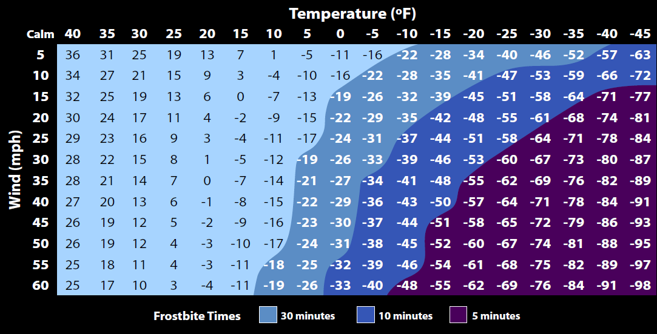
Key points:
- Note darker shading in chart above for shorter time to frostbite (exposed flesh will freeze).
- In general, extreme cold and wind chill are well forecast, high-confidence events.
- Extreme cold may occur as an isolated threat or as a compounding factor of a winter storm. As the snow/ice threat from the storm diminishes, it is not unusual for the extreme cold threat to continue or increase.
- In the local area, we average 5 events annually in the “advisory” (20-30 minutes to frostbite) range and less than one event annually in the “warning” (10 minutes to frostbite) range.

Threshold | Timing and Sources | Recommended Actions
Extreme cold potential exists  Forecast or  Hazardous Weather Outlook: first mention of severity of expected cold | Typically 3 days ahead  via web page, email, TV, Weather Radio | - Communicate potential threat to decision makers (pre-notify)
Extreme cold/wind chill is likely  Wind Chill Watch: More than 50% confidence of wind chills falling to -30°F or colder | Typically 1-2 days before onset  via web page, email, TV, Weather Radio, text alert | - Communicate threat to all staff  - Refresh staff on identification of frostbite and hypothermia
Extreme cold/wind chill is imminent  Wind Chill Advisory: Confident of wind chills -20 to -29°F that can lead to frostbite in 20-30 minutes | Typically 12-24 hours before onset  via web page, email, TV, Weather Radio, text alert | - Prepare for issues with buses starting  - Consider late start  - While ongoing, keep children indoors as much as possible
Life-threatening cold/wind chill is imminent  Wind Chill Warning: Confident of wind chills -30°F or colder that can cause frostbite in about 10 minutes | Typically 12-24 hours before onset  via web page, email, TV, Weather Radio, text alert | - Prepare for issues with buses starting  - Consider late start or cancellations if needed  - While ongoing, check children for signs of frostbite or hypothermia when they arrive  - While ongoing, keep children indoors

Special Considerations for Transportation
Children awaiting the school bus in the morning, standing exposed to a cold wind without proper clothing for protection, may develop frostbite or hypothermia. Bus drivers should be able to recognize symptoms of both hypothermia and frost bite.

Additional Resources
Winter Storms Preparedness Guide https://www.weather.gov/safety/winter-before
Recognizing Winter Illnesses from the CDC emergency.cdc.gov/disasters/winter/staysafe
FEMA Winter Storms & Extreme Cold www.ready.gov/winter-weather
Red Cross Winter Storm Preparedness www.redcross.org/prepare/disaster/winter-storm

5. Document Your Plan

Key points:
- Keep it simple.
- Train and practice.

Once you have developed a strategy for each of the weather hazards that may affect your facilities, document the plan. A worksheet can be found in this guide to get you started.

You may find it useful to incorporate the weather strategy into a more comprehensive multi-hazard plan. A word of caution, however plans that are long and cumbersome quickly become useless! Keep it simple! The most critical elements of your plan and any facility specifics should be summarized briefly for ready access at each location.

6. Train all Staff on the Plan

One of the greatest challenges to severe weather planning for schools is that the people involved are constantly changing. Students come and go; teachers, coaches, and staff change; teachers change buildings and classrooms; buildings themselves are renovated.

By ensuring that all staff are up-to-date on the severe weather plan for their current role and location well before severe weather strikes, confusion is minimized and precious minutes are saved in those moments when seconds could make a difference. Even when the situation is less urgent, training on a plan (and sticking to it), minimizes confusion and builds trust.

In-service sessions and staff meetings provide an excellent opportunity for training on the severe weather strategy for a district and/or facility. Newsletters, email, and other one-way communication methods may be suitable for a short refresher of a seasonal threat.

7. Hold Seasonal Sheltering Drills

Practice makes perfect! Practicing your severe weather emergency plan through periodic severe weather drills and severe weather safety training is critical to success. Drills not only teach students and instructors the actions they need to take, but will allow you to evaluate your plan's effectiveness.

When conducting a drill, evaluate the following:
- Did everyone hear the alert message?
- Did everyone understand what to do?
- Were they able to get to designated safe areas in a reasonable amount of time? (We recommend that everyone be able to reach their designated shelter area in less than 3 minutes.)
- Did the designated safe areas accommodate the students and staff?

A minimum of two drills per year are recommended: one in the fall as an introduction for new students and staff, and the second in the early spring.

You may wish to conduct the spring drill in conjunction with your state’s Severe Weather Awareness Week. (Illinois and Missouri usually designate the first week of March and Iowa typically designates the last week of March.) During Severe Weather Awareness Week, a time is set for a statewide tornado drill when a test tornado warning will be issued. This provides you an opportunity to test your communications and sheltering strategy from beginning to end.

Additional Resources
Annual drill dates and times https://www.weather.gov/safety/events_calendar
After the Storm

Damaged Facilities
- Once a storm has passed, stay alert for the possibility of additional storms.
- If your school sustains damage, shut off the gas and electricity.
- Do not attempt to evacuate students through damaged areas, as downed power lines and debris pose grave danger.

Parent Communication Plan
Part of your plan should include communication with parents.
- Do parents understand that children may be held at the school during severe weather?
- When children are being held at the end of the school day, how will you notify parents?
- If the school sustains damage, where should parents pick up their children?

StormReady Schools

What is StormReady?
Tornado Damage to Greensburg High School
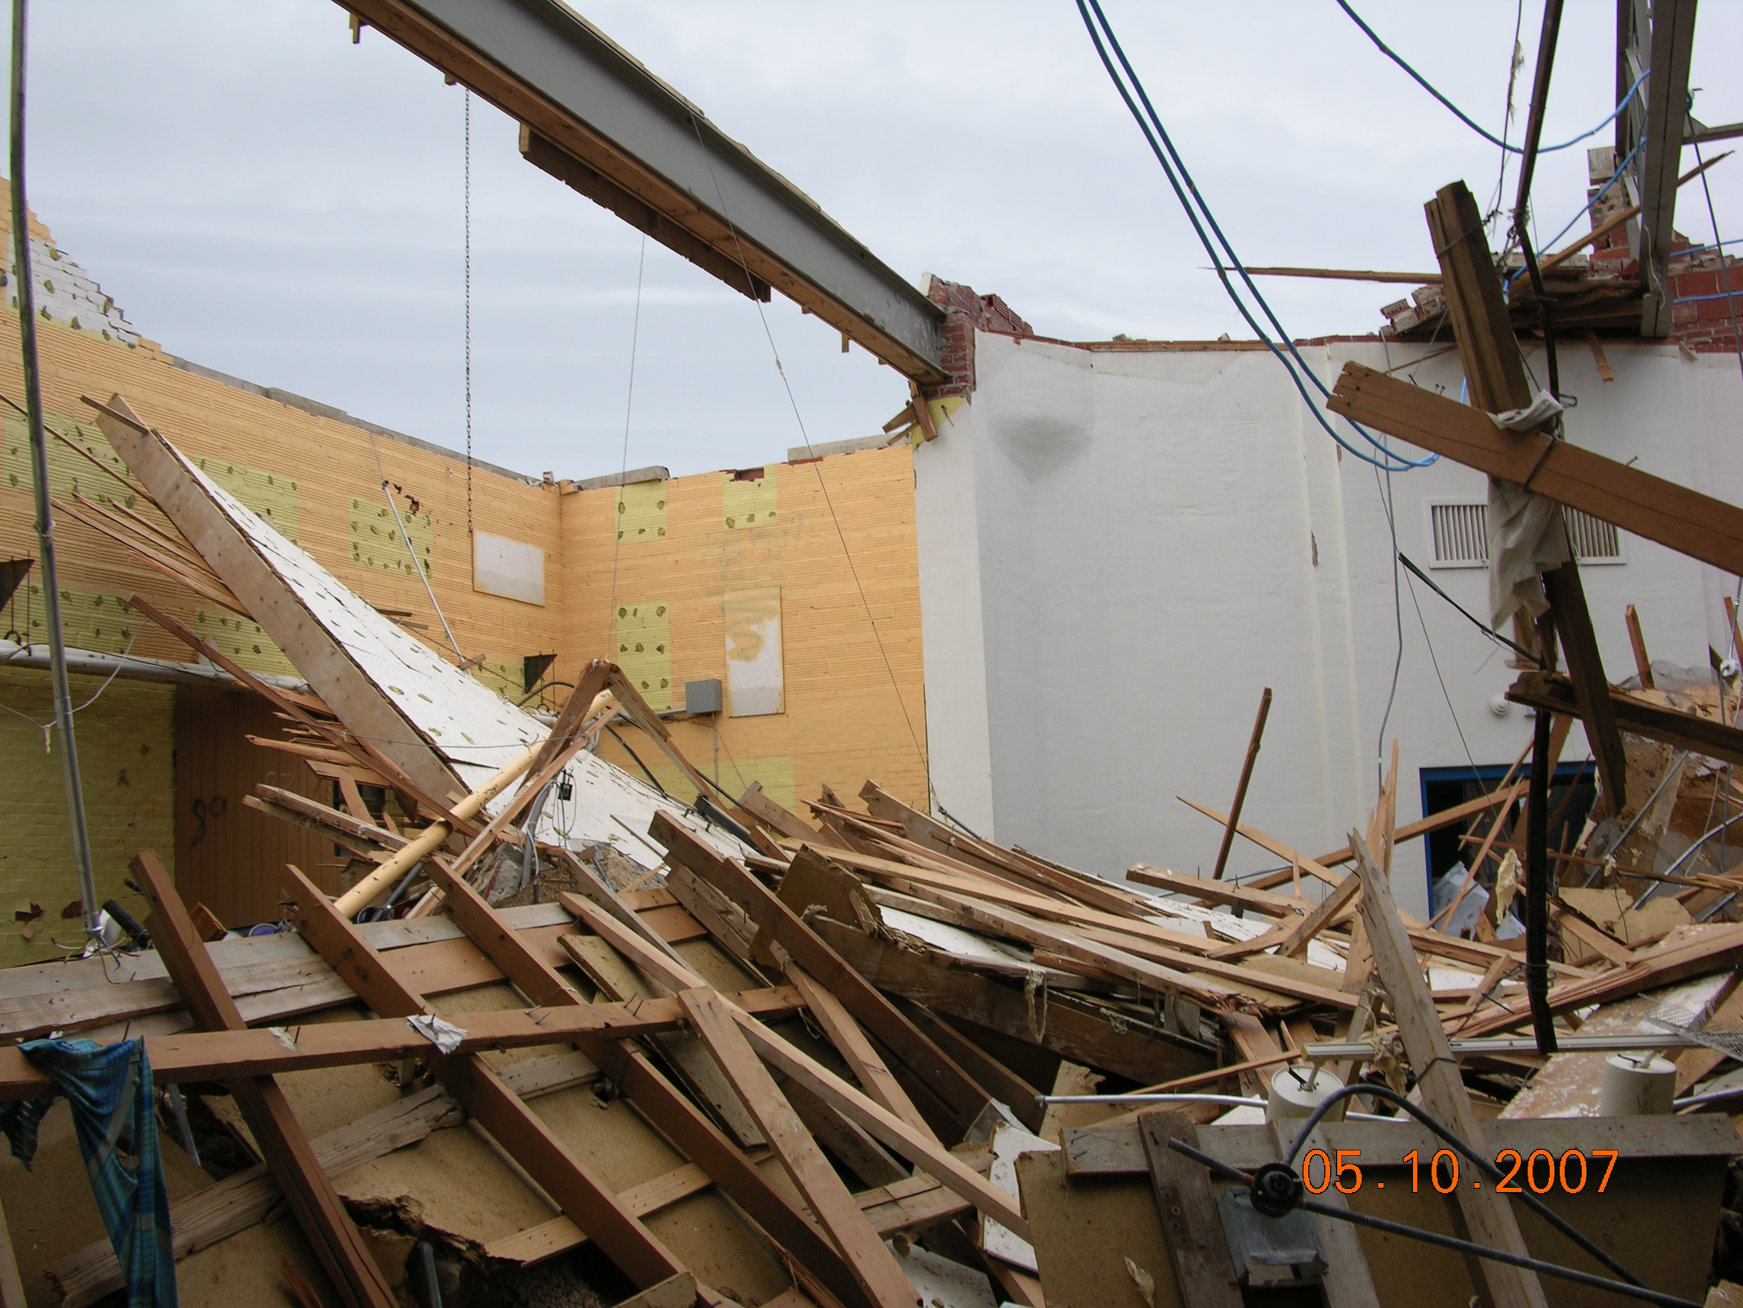
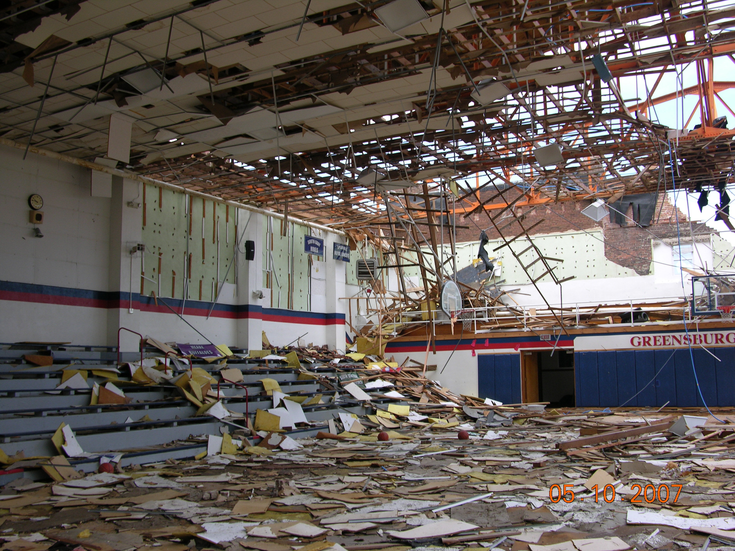
Photo Courtesy FEMA
Photo Courtesy FEMA
To help Americans guard against the ravages of severe weather, NOAA's National Weather Service introduced StormReady, a program designed to help communities and organizations arm themselves with the communication and safety tools necessary to save lives and protect property. In a nutshell, StormReady establishes an industry standard for severe weather preparedness and communication.

How does this apply to my school?
There is perhaps no greater potential weather disaster than one that impacts a school full of children. In much the same way that StormReady principles saved the lives of 50 movie goers in a single Ohio movie theater, the StormReady for Schools program could save the lives of dozens or even hundreds of students and staff.

What are the benefits of StormReady?
StormReady provides an opportunity to review and improve your severe weather plans based on current science and technology. StormReady schools receive a certificate and outdoor sign, typically presented at a school board meeting. Most importantly you will gain confidence and public recognition that you are doing all that you can to protect the lives of your staff and students.

Is there a cost for the program?
No. Application and participation is free – just the cost of your time to review your procedures and submit the application.

What are the StormReady Supporter eligibility guidelines?
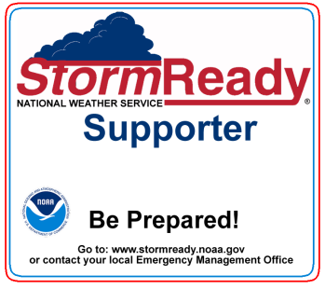
StormReady Supporter guidelines vary from area to area. In the Quad Cities region, guidelines include:
- Endorsement by local emergency management officials
- A written severe weather plan encompassing all components of the operation
- Practices, exercises, and/or training as appropriate
- Redundant ways to monitor weather, including NOAA Weather Radio where
available
- Appropriate dissemination method(s) and other means of taking effective action

How do we apply for StormReady?
The appropriate safety or leadership official submits a StormReady application, completing any parts applicable to the school. A printable form is available online at www.stormready.noaa.gov. The application is submitted to the local National Weather Service office, where it will be reviewed by the local StormReady board, comprised of representatives from the National Weather Service and local and state emergency management.

Find out more!
Contact your local National Weather Service Warning Coordination Meteorologist (WCM) or local Emergency Manager for further information about the StormReady Supporter for schools program.

Appendices
Appendix A: School Severe Weather Plan Worksheet

- Designated Weather Watcher(s): Who will monitor conditions?
Normal operations:____________________________________________________
____________________________________________________
Extracurricular activities: ______________________________________________
______________________________________________
Transportation: _______________________________________________________
_______________________________________________________
Resources needed: How will they monitor weather and communicate?

- Communication How will you communicate threat? At least 2-3 methods for each.

Communicate with: | Pre-threat notification via: | Imminent threat via:
e.g. school staff  stadium spectators | Email, intranet  signs at gate, PA system | PA, radio, text alert  PA, scoreboard
- Sheltering Strategy Identify shelter areas in all facilities.

Move from these areas: | To this shelter area:
e.g.: gym | Locker rooms

Time needed to shelter: _____________minutes (3 minutes is recommended)
- Identify Decision Thresholds and Actions

Threat | Threshold(s) | Action(s)
Dense Fog
Flash Flood
Heat
High Wind
Lightning, Thunderstorms, and Tornadoes
Snow/Ice
Wind Chill &
Extreme Cold
Other
- Document your plan
Plan reviewed by:
- Superintendent
- Principal(s)
- Operations Director
- Transportation Director
- Other________________________________________

Electronic version posted here__________________________________________

- Train all staff on the plan and their role(s). Indicate training strategy here.
Administration:_____________________________________
Faculty:___________________________________________
Custodial and Other Building Staff:_________________________________
Bus Drivers:_______________________________________

- Hold seasonal sheltering drills
Date:_______________________ Time needed to shelter:___________________

Date:_______________________ Time needed to shelter:___________________

Date:_______________________ Time needed to shelter:___________________

- After the Storm

Person(s) responsible for main electricity and gas shut off:_________________________

Parent communication: Who will do it and how?_________________________________

________________________________________________________________________

Appendix B: Special Considerations for Transportation

- All school bus drivers should be trained to handle severe weather situations.
- Every bus should carry an up-to-date roster of passengers.
- Consider holding school bus evacuation drills at least twice per school year.
- The primary concerns are flooding and tornadoes, but high wind, heavy snow or ice, extreme heat or cold, and wind chill also pose a threat to the student’s well-being.

Flash Flood
NEVER ATTEMPT TO DRIVE THROUGH FLOOD WATERS! If a bus route crosses small creeks or nears a river, determine an alternate route to travel or have a contingency plan to return to the school once flood waters are encountered. Major river flooding generally is well forecast with warnings issued early enough for schools and drivers to plan a strategy before placing the students on the bus. In general, shallow ponding of water on the roadway is usually not a problem. Sudden (flash) flooding poses the greatest threat.
- If the water appears to be flowing or is too deep to see the road, DO NOT CROSS. The road may have been undermined or the water may be deep enough to stall the bus and place all of its occupants in danger.
- Do not enter underpasses that are filling with water.
- If water is flooding over or around a bridge, the foundation of the bridge is likely compromised. Do not cross as it could collapse from the weight of the bus.
- If caught in flood waters, abandon the bus and seek higher ground immediately.

High Wind
Strong headwind may slow bus routes, and strong cross-wind can become a driving hazard.

Lightning, Tornadoes, and Thunderstorms
- Bus dispatchers should have access to emergency weather alerts and convey them to the drivers.
- Consider holding the departure of buses whenever thunderstorms are expected to be in the area before students would arrive at their destination (including the time it takes for them to walk home).
- Pre-identify safe structures along bus routes where drivers may seek emergency shelter if a tornado suddenly hits.
- Train bus drivers on how to react during a tornado:
  - If a tornado warning is issued or a tornado is sighted, go immediately to the nearest shelter.
  - If shelter is not available, as a last resort, evacuate students into the nearest ditch on the downwind side of the road away from power lines and trees. Students should lie flat and cover their heads.
  - If time allows, move the bus away from the students and remove the first aid kit.

Wind Chill and Extreme Cold
- Children awaiting the school bus in the morning, standing exposed to a cold wind without proper clothing for protection, may develop frostbite or hypothermia. Bus drivers should be able to recognize symptoms of both hypothermia and frost bite.

Appendix C: Special Considerations for Extracurricular Activities

- After hours, it is critical that someone be designated as the weather watcher.
- All coaches, trainers, and officials should be trained on weather safety and the school severe weather plan.
- All coaches, trainers, and officials should be aware of the day’s potential weather hazards.

High Wind
Some extra-curricular activities may involve use of towers, ladders, or scaffolding which become dangerous in high wind conditions.

Lightning, Thunderstorms, and Tornadoes
- If thunder is heard or lightning is seen, outdoor activities should immediately be suspended and students and spectators moved to safety. (Do not wait for the rain! Lightning can strike 10 miles away from a storm!)
- The delay in activities should last until thunder has not been heard and lightning not seen for 30 minutes.
- During extracurricular activities, there may be a large number of people who are not familiar with your severe weather plans. Any communication that can be done before severe weather strikes will smooth the execution of your plan. Examples include posting signs and making announcements before the activity begins.

Appendix D: NOAA Weather Radio All Hazards
NOAA Weather Radio All Hazards (NOAA Weather Radio) is the smoke detector of severe weather. Our warnings are delivered directly to you immediately when they are issued, so you can take the actions you deem necessary.

NOAA Weather Radio provides a continuous broadcast of weather information direct from the local National Weather Service office. All schools received these radios through a Homeland Security grant in 2006-2007. If you do not already have a weather radio at your school, please contact your county Emergency Management Agency to find out how to acquire one.

About the Broadcast
Recorded weather messages are repeated every three to five minutes. Routine programming includes current conditions, the 7-day forecast, and recent river stages. During severe weather, the National Weather Service preempts the routine weather broadcast and substitutes the warning messages.

All-Hazards
NOAA Weather Radio broadcasts alerts for all types of hazards - not just weather! As conditions warrant, the broadcast includes emergencies such as earthquakes, chemical releases, oil spills, nuclear emergencies, AMBER alerts, and national emergencies. Working with State and Federal agencies, NOAA Weather Radio truly is an all-hazards radio network, making it the single source for the most comprehensive weather and emergency information available to the public.

Local Coverage
17 NOAA Weather Radio stations serve the area covered by NWS Quad Cities. Each station covers an area approximately 40 miles from the antenna site. The effective range depends on many factors, particularly the transmitter height, terrain, receiver quality, and present weather. An outside antenna can significantly improve reception.

For schools, we recommend:
- A radio with SAME capability. This type of radio will sound an alarm when a warning is issued for your specific county. (You control the programming of this radio.)
- A battery backup in case of a power failure.
- Some more expensive models can be tied into your PA system, can set off a pager, or have flashing lights.
- Consider portable radios for your security staff, principal, coaches, and/or athletic director.

Remember to:
- Place the radio in a central location where the alarm can be heard by the decision makers.
- Make sure the radio is in stand-by mode, ready to alarm when a warning is issued.
- Replace the back-up battery yearly to make sure it will work in the case of a power failure.
- Monitor the weekly tone-alert test to make sure your radio is working properly and receiving the tone alert signal. (Tests are conducted each Wednesday around 11 am.)

Additional Resources
NWS NOAA Weather Radio www.weather.gov/nwr
Local Coverage

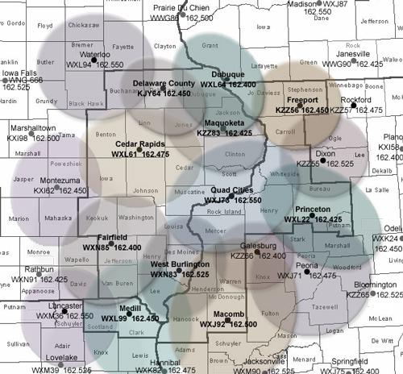
NOAA Weather Radio stations operate on one of 7 frequencies:
- 162.400 MHz
- 162.425 MHz
- 162.450 MHz
- 162.475 MHz
- 162.500 MHz
- 162.525 MHz
- 162.550 MHz

See below for local area stations and exact county coverage.
See next page for local FIPS codes.
Cedar Rapids - WXL61 162.475  IA: Benton, Cedar, Delaware, Iowa, Johnson, Jones, Keokuk, Linn, Tama, Washington.  Delaware County – KJY64 162.450  IA: Buchanan, Clayton, Delaware, Dubuque, Fayette, Jones, Linn.  Dixon – KZZ56 162.525  IL: Carroll, Lee, Ogle, Whiteside.  Dubuque - WXL64 162.400  IA: Clayton, Delaware, Dubuque, Jackson, Jones. IL: Carroll, Jo Daviess. WI: Grant, Lafayette.  Fairfield - WXN85 162.400  IA: Davis, Henry, Jefferson, Keokuk, Lee, Van Buren, Wapello, Washington.  Freeport - KZZ56 162.450  IL: Carroll, JoDaviess, Ogle, Stephenson, Winnebago. WI: Green, Lafayette.  Galesburg – KZZ66 162.400  IL: Henry, Knox, Mercer, Warren. | Lancaster – WXM36 162.550  IA: Davis, Appanoose. MO: Adair, Knox, Putnam, Schuyler, Scotland, Sullivan.  Macomb - WXJ92 162.500  IL: Adams, Brown, Cass, Fulton, Hancock, Henderson, Knox, Mason, McDonough, Schuyler, Warren.  Maquoketa - KZZ83 162.425  IA: Jackson, Dubuque, Jones, Clinton, Cedar, Delaware. IL: Carroll, Jo Daviess.  Medill - WXL99 162.450  MO: Clark, Knox, Lewis, Scotland. IA: Lee, Van Buren. IL: Adams, Hancock.  Montezuma – KXI62 162.450  IA: Iowa, Jasper, Keokuk, Mahaska, Marion, Poweshiek, Tama. | Peoria – WXJ71 162.475  IL: Fulton, Knox, Marshall, Mason, Peoria, Putnam, Stark, Tazewell, Woodford.  Princeton - WXL22 162.425  IL: Bureau, Henry, LaSalle, Lee, Marshall, Putnam, Stark, Whiteside.  Quad Cities - WXJ73 162.550  IA: Clinton, Cedar, Louisa, Muscatine, Scott. IL: Henry, Mercer, Rock Island, Whiteside.  Waterloo – WXL94 162.550  IA: Black Hawk, Bremer, Buchanan, Butler, Chickasaw, Fayette, Floyd, Grundy.  W Burlington - WXN83 162.525  IA: Des Moines, Henry, Lee, Louisa. IL: Hancock, Henderson, Mercer, Warren.

Programming Your Radio
The county codes for your local area of concern, called FIPS numbers, should be programmed into your radio according to its specific instructions. While each situation is unique, it is usually a good idea to include warnings for an adjacent county especially when located near a county line.

A Caution about Programming Your Radio
Remember that your radio will only alert you for counties within its local listening area, so tune to the station that gives you the best reception and check its listening area (previous page) before you begin.

If you frequently travel with your radio between two different stations, you can usually program multiple counties. For example, if you coach in Vinton (Benton County) and officiate games in Waterloo, you could program both Black Hawk and Benton Counties into your radio. Then you only need to change the stations when you travel between areas. Most SAME radios also have a way to revert to receiving all warnings within the listening area.

FIPS Codes for the Quad Cities Region
ILLINOIS | IOWA | IOWA (cont.)
Adams 017001  Boone 017007  Brown 017009  Bureau 017011  Carroll 017015  Cass 017017  DeKalb 017037  Fulton 017057  Hancock 017067  Henderson 017071  Henry 017073  Jo Daviess 017085  Knox 017095  LaSalle 017099  Lee 017103  McDonough 017109  Marshall 017123  Mason 017125  Mercer 017131  Ogle 017141  Peoria 017143  Putnam 017155  Rock Island 017161  Schuyler 017169  Stark 017175  Stephenson 017177  Warren 017187  Whiteside 017195  Winnebago 017201 | Benton 019011  Black Hawk 019013  Bremer 019017  Buchanan 019019  Butler 019023  Cedar 019031  Chickasaw 019037  Clayton 019043  Clinton 019045  Davis 019051  Delaware 019055  Des Moines 019057  Dubuque 019061  Fayette 019065  Floyd 019067  Grundy 019075  Henry 019087  Iowa 019095  Jackson 019097  Jefferson 019101  Johnson 019103  Jones 019105  Keokuk 019107  Lee 019111  Linn 019113  Louisa 019115  Muscatine 019139  Poweshiek 019157 | Scott 019163  Tama 019171  Van Buren 019177  Wapello 019179  Washington 019183
 |  | MISSOURI
Adair 029001
Clark 029045
Knox 029103
Lewis 029111
Putnam 029171
Schuyler 029197
Scotland 029199

 |  | WISCONSIN
Grant 055043
Green 055045
Lafayette 055065
Rock 055105

For FIPS codes for other areas, visit www.weather.gov/nwr or call 1-888-NWR-SAME.
Appendix E: Glossary of NWS Messages

The National Weather Service provides a number of messages which can assist you in decision-making for weather-sensitive activities. All of these messages are available 24-7 on our web page and via NOAA All Hazards Radio. A brief description of the most common messages follows.

Watches - Issued when a greater than 50% chance of life-threatening weather exists.

- Excessive Heat Watch – prolonged, extreme heat is possible.
- Fire Weather Watch – Extreme fire danger conditions are possible in the next few days.
- Flash Flood Watch - flash flooding is possible from a dam or levee failure. Flash Flood Watches are generally issued for areas less than the size of a state and can be valid for up to about 12 hours.
- Flood Watch – flooding and/or flash flooding are possible. Flood Watches are generally issued for areas less than the size of a state and can be valid for up to about 12 hours.
- Freeze Watch - Conditions are favorable for the occurrence of freezing temperatures.
- High Wind Watch – dangerously high (non-thunderstorm) winds are possible.
- Severe Thunderstorm Watch - severe weather (hail quarter size or larger and/or damaging straight-line winds 58 mph or greater) is possible. These watches are generally issued for areas the size of a state, and are valid for a four- to six-hour period.
- Tornado Watch – severe thunderstorms with tornadoes are possible. These watches are generally issued for areas and durations similar to severe thunderstorm watches.
- Winter Storm Watch - issued 18 to 36 hours in advance of severe winter weather conditions (snow, blowing snow, sleet, freezing rain, or a combinations) that may become life threatening.
- Wind Chill Watch - issued 18 to 36 hours in advance of expected extreme wind chills (-30°F or colder; time to frostbite ~10 minutes).

Warnings - Issued when life-threatening conditions exist or are imminent.

- Blizzard Warning - Sustained wind or frequent gusts >35 mph, considerable blowing and drifting snow, and a visibility of ¼ mile or less.
- Dust Storm Warning - Heat Index (HI) 105°F and a minimum overnight HI of 75°F.
- Excessive Heat Warning - Heat Index (HI) 105°F and a minimum overnight HI of 75°F.
- Flash Flood Warning - Heavy rains are or will shortly result in life-threatening circumstances due to overflowing streams or creeks, mud slides, dam breaks, water over roadways, etc. Usually issued for portions of a few counties for up to six-hour duration.
- Freeze Warning – Freezing temperatures are expected to affect vegetation.
- High Wind Warning - Sustained winds 40 mph for 1 hour or more or gusts 58 mph or higher.
- Ice Storm Warning – Ice accumulations ¼ inch or more.
- Red Flag Warning – Extreme fire conditions exist (fires will spread rapidly out of control).
- Severe Thunderstorm Warning - A severe thunderstorm (hail quarter size or larger - and/or straight-line wind >58 mph) is indicated by radar or has been reported by a reliable source. Usually issued for parts of a few counties up to one hour in duration.
- Severe Weather Statement – Primary message for providing updates on a severe thunderstorm or tornado warning. Usually issued for parts of a few counties up to one hour in duration.
- Tornado Warning - A tornado is indicated by radar or a reliable source. Usually issued for parts of a few counties up to one hour in duration.
- Wind Chill Warning - Wind chill values -30°F or colder (time to frostbite ~10 minutes).
- Winter Storm Warning - >6 inches of new snow in 12 hours or >8 inches in 24 hours, or for sleet accumulations >½, or a combination.

Advisories - Issued when conditions are hazardous but should not be life threatening if reasonable caution is used.

- Air Quality Advisory – During periods of poor air quality as determined by the state DNR.
- Dense Fog Advisory – Widespread visibility ¼ mile or less, creating a significant hazard.
- Frost Advisory – Frost formation is possible over a widespread area and may affect vegetation.
- Heat Advisory – Heat Index at or above 100 F+.
- Wind Advisory - Sustained winds >30 mph or gusts >45 mph.
- Wind Chill Advisory - Wind chill values -20 to -29° F (time to frostbite ~20-30 minutes).
- Winter Weather Advisory - Hazardous (but not generally life-threatening) conditions of
  - snow - generally 3-5 inches.
  - blowing snow – visibility less than ½ mile due to blowing.
  - Freezing rain <1/4 inch
  - sleet – less than ½ inch accumulation.
  - combination of winter precipitation.

Other Messages

- 7-Day Forecast - routine forecasts updated at least every 3 hours which contain the basic forecast elements (high and low temperatures, precipitation type and probability, wind, clouds, etc.) for the next 7 days.
- Decision Support Services (DSS) Packet- pdf briefing slides with additional detail on high impact weather.
- Forecast Discussion – a technical discussion of the reasoning behind the forecast.
- Hazardous Weather Outlook - A plain-language outlook of the potential for significant weather for the next twenty-four hours in detail, with a broader overview through the next 7 days. The timing, location, and intensity of the expected hazardous weather element(s) are discussed. This message is designed for decision makers such as emergency managers, school districts, and public works departments. The Hazardous Weather Outlook is issued each morning by 5 am, and updated as needed.
- Hourly Observations - a collection of weather observations taken shortly after the top of the hour which include temperature, current weather, wind, dew point, air pressure and seasonally, the wind chill or heat index.
- Public Information Statement – Usually issued to provide information on a NOAA Weather Radio outage. May also provide program updates or other administrative-type information.
- Special Weather Statement - our primary method for communicating forecasts of short-term (one to six hours in advance) weather that could have an impact.
- Webinar Weather Briefing – a video briefing on an event of significant impact. Video briefings are posted on our web page, office YouTube channel, Facebook page, and Twitter feed.
- Weather Story Graphic – a graphic image of the most important weather for the next several days. The Weather Story is viewable on our office web page.

Appendix F: NWS Education Related Services

Classroom Resources
These or similar materials may be borrowed from local National Weather Service offices for use
in the classroom. Contact your local office to discover the specific resources available to you.

- “Weather in a Box” classroom instrument kit
- Masters of Disaster classroom kits
- Sunwise toolkit
- Weathercycler teaching unit
- Printed weather handouts, cloud charts, etc

On the Web
NOAA/NASA Scijinks http://scijinks.gov
NOAA Weather and Ocean Education www.education.noaa.gov
NOAA Teacher at Sea Program teacheratsea.noaa.gov
NWS Teacher Resources https://www.weather.gov/mhx/outreachTeacherResources
NWS Weather Education and Outreach Links www.weather.gov/education.php
Masters of Disaster www.redcross.org/disaster/masters
American Meteorological Society Education Programs www.ametsoc.org/amsedu

