marker 1marker 3 colormarker 2 color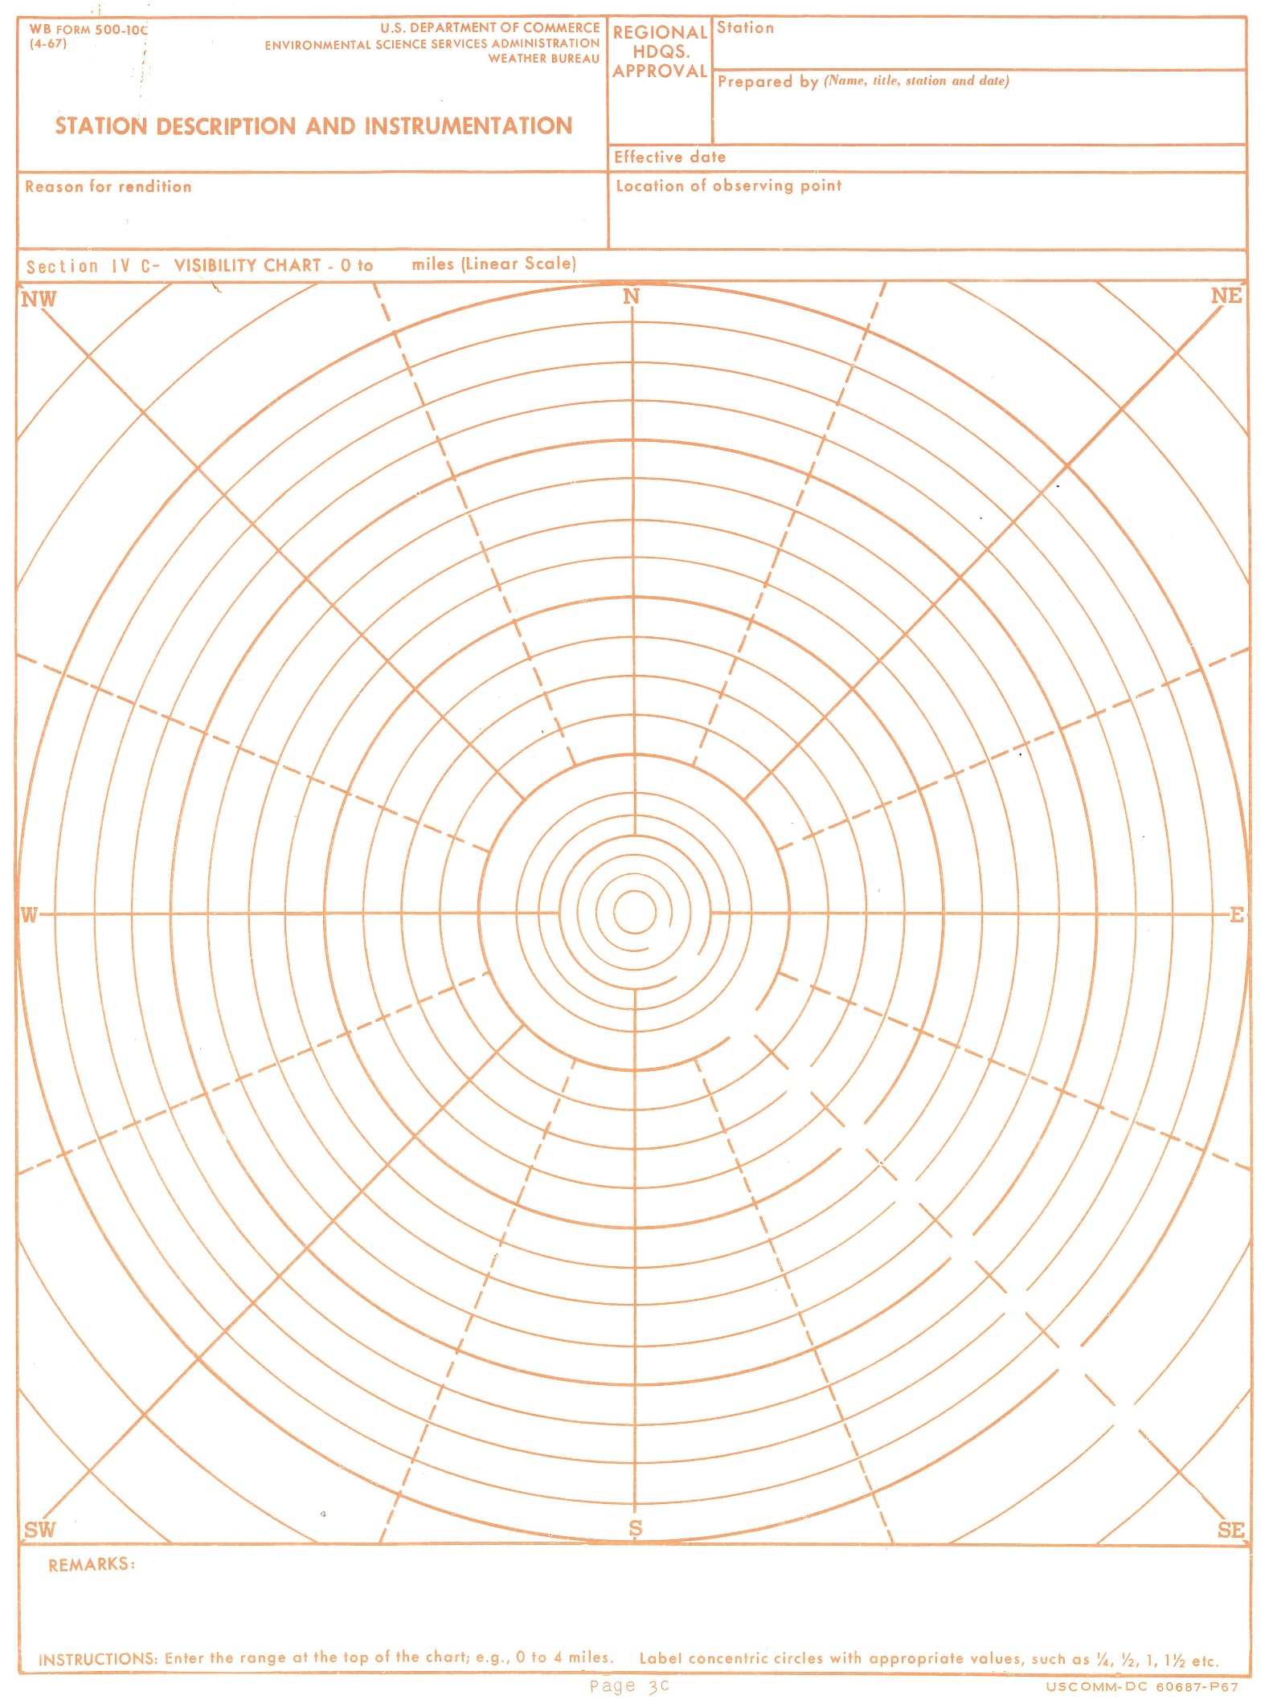

**RHQ**

**Review**

***(Date/Init)***

**Prepared by** *(Name, title, station, date)***-**

**Station–**

**Page 1 of 1**

**Section IV C- Visibility Chart – to miles**

**Reason for rendition–**

**PR FORM 500-10C US DEPARTMENT OF COMMERCE**

**(07-2015) NATIONAL OCEANIC AND ATMOSPHERIC ADMINISTRATION**

**NATIONAL WEATHER SERVICE**

**STATION DESCRIPTION AND INSTRUMENTATION**

**Location of observing point-**

**Effective date–**

**Day Marker**

**Night Marker**

**Day/Night Marker**

**22 Jul 2015**