2017 SWAP events across N ZDC on “SWAP Possible” or “SWAP Not Expected” Forecast Days

During the 2017 SWAP season, several SWAP events occurred when less than a 50% chance of SWAP was forecast (SWAP Possible or SWAP Not Expected). TS activity across the northern portion of ZDC was the culprit in many instances, but what helped generate/sustain the TS? Below are three such SWAP events illustrating important moisture/instability/shear signatures and forcing mechanisms…with radar/satellite imagery (displays are from Iowa Environmental Mesonet) during each TS outbreak. Information about SWAP timing and routes/gates/areas impacted was gathered from daily FAA Northeast Recap logs. Diagnosing the potential for SWAP across the northern portion of ZDC will become increasingly important on days when POTUS travels to and from Bedminster this spring/summer, as air traffic patterns will become even more complex.

30 April 2017

SWAP Timing: 4:10 pm – 6:25 pm

Routes/Gates/Areas Impacted: J518, J211, IAD (NW ZDC)

- Location, location, location! Just a few TS developed along a sfc boundary across N ZDC, but they were close enough to IAD and J518 to cause SWAP for a few hrs
  - Strongest TS remained tied to the terrain across NW ZDC
- Surface θₑ pooling occurred along the surface boundary
- TS development was enhanced by short-waves in SW flow, as observed in 700-400 hPa differential vorticity advection (positive vorticity advection is in blue below)
- 300 hPa wind not strong (25-30 kts where TS developed), but 300 hPa divergence was present

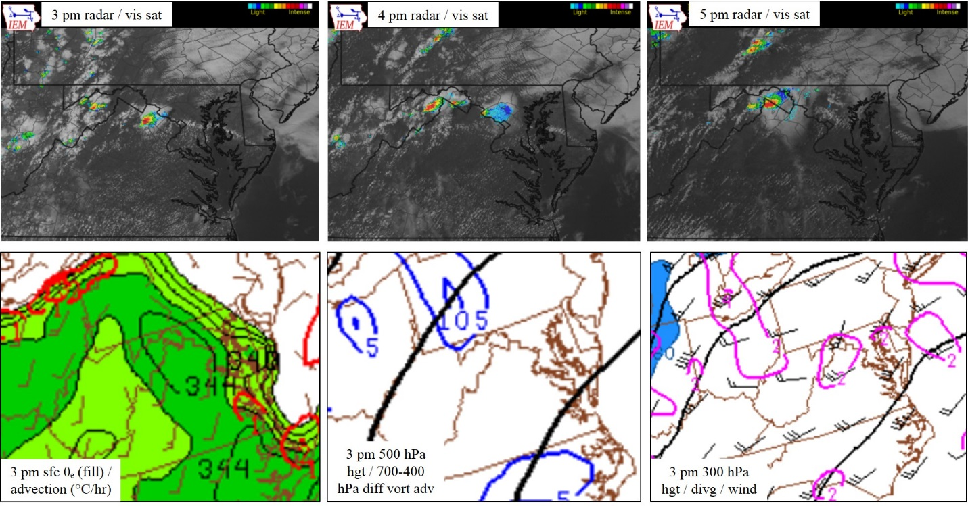

21 June 2017

SWAP Timing: 3:15 pm – 10:01 pm

Routes/Gates/Areas Impacted: N-NE ZDC – J220, J75, J121, Swann/Paleo, White/Wavey, NY Metros

- TS initiated along/ahead of an ESE-moving surface cold front and its pre-frontal trough (as seen in radar/satellite images)
  - Strongest development over PA mountains initially, with more development over the DELMARVA/S NJ (very sensitive air traffic region)
- SBCAPE not too high – up to ~ 1000 J kgˉ², but…effective bulk shear was very high: WNW at 35-50 kts+; linear organization/bowing occurred, so…
  - A lower CAPE/high shear event
- Very strong 300 hPa jet streak (110-125 kt) enhanced divergence/lift where TS erupted/moved
  - NE ZDC underneath left exit region of jet streak

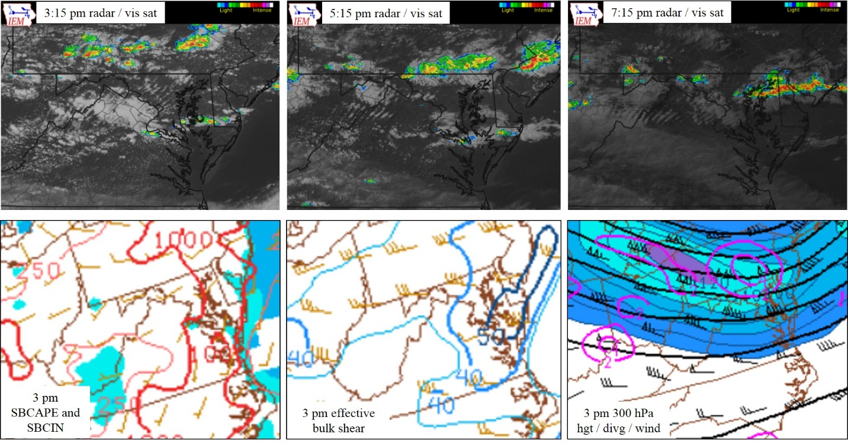

30 June 2017

SWAP Timing: 4:40 pm – 10:00 pm

Routes/Gates/Areas Impacted: J518, J48, J220, NY Metros

- As observed via radar/satellite, a line of TS developed along a weak surface boundary mid-aftn over higher terrain of W ZDC/SE ZOB/SW ZNY, then moved slowly east
- Despite the “weakness” of the surface boundary, surface (and, not shown, 850 hPa) frontogenesis appeared to contribute to TS generation
- TS fired where higher surface mixing ratios and weak surface moisture convergence existed
- Low-level instability was not tremendously high, but just enough existed, with 0-3 km lapse rates of 7-8°C/km across the TS area

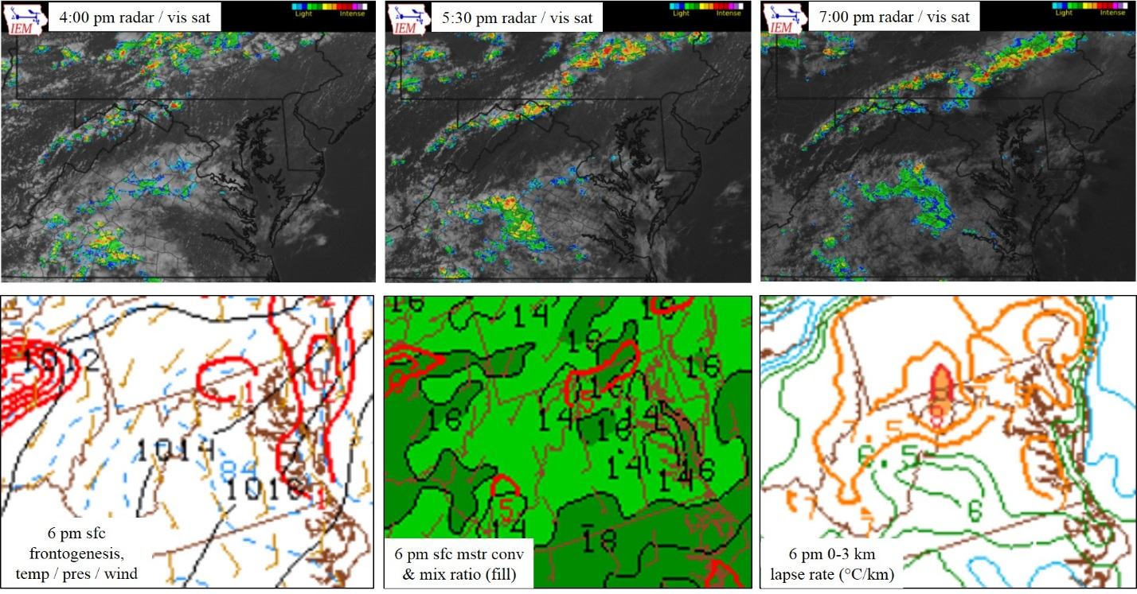

2017 Northern ZDC SWAP Examples: Part 2

(Figures created using Iowa Environmental Mesonet, SPC Hourly Mesoscale Analysis Archive products)

4 July 2017

SWAP Timing: 3:55 pm – 7:15 pm

Routes/Gates/Areas Impacted: J211/518, J48, J75, Swann/Paleo (E-NE DC Metros gates)

- Several areas of scattered TS resulted in SWAP across the northern half of ZDC
  - Far N ZDC:
    - Weak surface frontogenesis along a surface boundary worked with…
    - Weak shortwaves/mid-level PVA and…
    - Weak 300 hPa divergence, as the area was underneath the right entrance region of a departing jet max
  - Areas of weak low-level convergence, mid-level PVA, mid-level shortwaves and 300 hPa divergence combined with the higher terrain to generate TS across SW VA/SE WV
  - TS also developed under an area of 300 hPa divergence in SE VA
    - Likely in concert with local bay/sea breezes and flow around a weak wave moving slowly eastward along a weak stationary surface front across NC

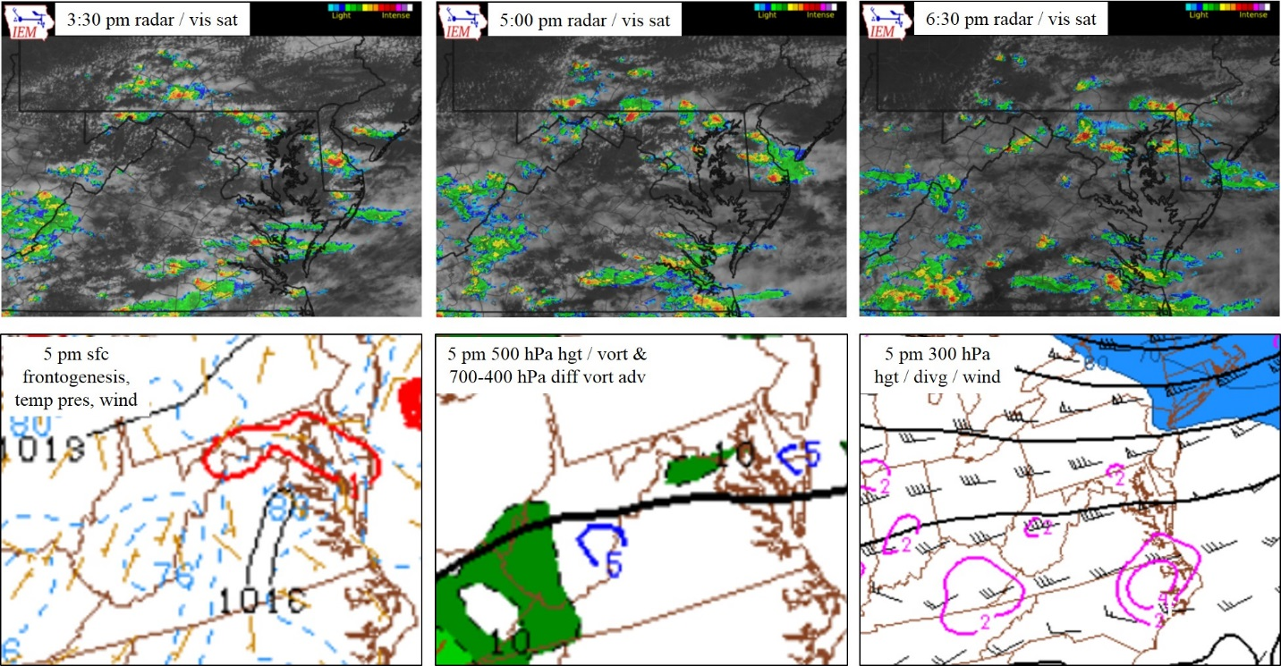

22 August 2017

SWAP Timing: 12:26 pm – 8:30 pm

Routes/Gates/Areas Impacted: OOD (N Gate of DC Metros), J518, J211, J220, J6

- A broken line of TS moved across N ZDC through the afternoon/evening hours, enhanced by:
  - Low-level (both 850 hPa – shown – and surface – not shown) frontogenesis
  - Very strong west-to-east oriented effective bulk shear (40-55 kts)
  - 300 hPa divergence under the right entrance region of a jet max

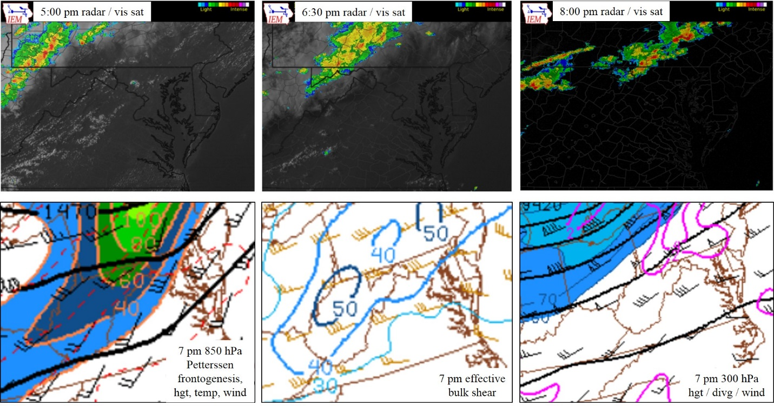

31 August 2017

SWAP Timing: 5:00 pm – 10:00 pm

Routes/Gates/Areas Impacted: OOD, J121, J174 (NE ZDC)

Much of the TS activity that caused SWAP on this day was across southern ZDC, but across far N ZDC, a few small clusters of TS developed ahead of a surface cold front. Not enough to worry about, right? Not quite, as the TS moved across a highly complex/high-impact region (PHL/N DELMARVA/S NJ). In certain situations (such as when the military restricts the usage of its airspace), the corridor through which all northbound and southbound air traffic moves can constrict to just 18 miles wide across S NJ. When that occurs, just one thunderstorm in that region with tops FL250-300 can stop the flow of air traffic, resulting in substantial impacts to the NAS.

During this particular SWAP event, shower/TS generation was aided by:
- The southward-advancing surface cold front
- A surface θₑ gradient
- Effective bulk shear of 30-35 kts; TS moved, generally, in the direction of the shear vectors
- An area of “marginal” SBCAPE; values were around 1000 J kgˉ² as TS strengthened across S NJ
- Also (not shown), the small clusters of TS developed under the right entrance region of a 100 kt+ west-east oriented jet max, which was centered over southern New England

