Nov. 27, 2009

IFR Case Nov. 12, 2009

John Kwiatkowski

This review was prompted by the following sequence of METARs at Muncie:

10Z 06004KT 5SM BR CLR 31/29

11Z 08006KT 3/4SM BR OVC002 32/31

12Z 09004KT 1/2SM FG VV001 32/31

13Z 09006KT 1/4SM FG VV001 31/30

In other words, conditions abruptly went from MVFR to VLIFR. Although VLIFR conditions did not affect any of our TAF sites, the case was so interesting I thought it worth documenting. Thanks are due to Joe Skowronek and Mike Ryan who actually figured out was happening—I am mainly acting as the recorder.

One of the remarkable things about this case was that it occurred in very dry air as shown by the 12Z sounding for Nov. 12 at Wilmington (Figure One).

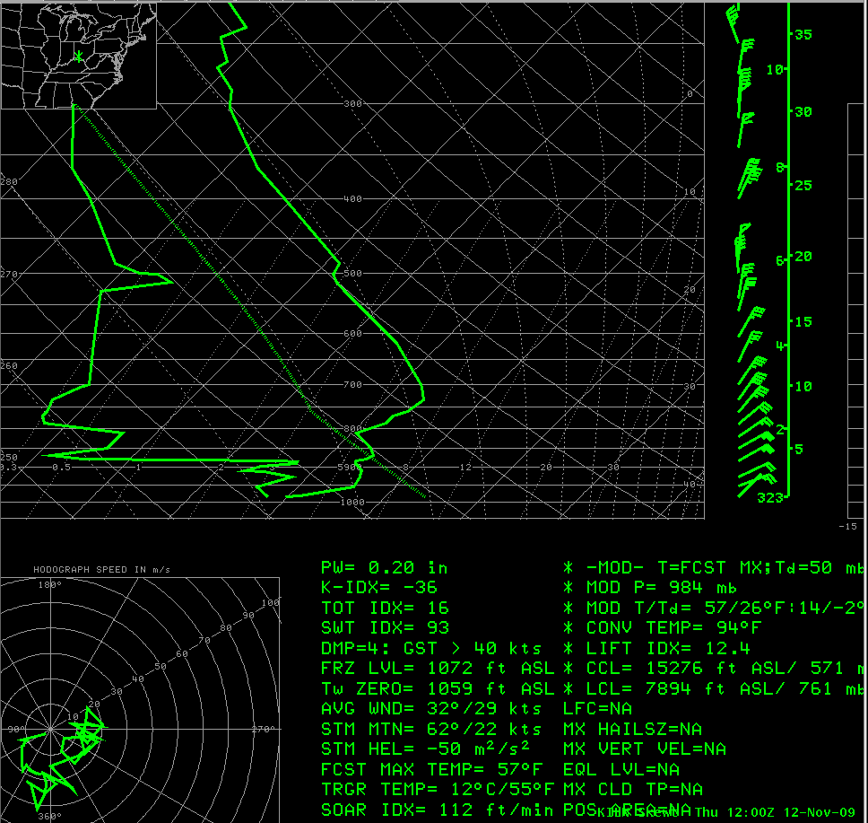
Figure One. ILN sounding at 12Z Nov. 12, 2009.

While a nocturnal inversion had clearly developed below 950 mb, the air was not that close to saturation even in the lowest layers. Also the Precipitable water of .20 inches was low for mid November (about 43 percent of normal), indicating the air aloft was quite dry and should have been resistant to fog development. At other locations in our CWA, BMG and LAF were VFR all night long, while HUF and IND never got lower than 5SM BR for brief periods.
Why did Muncie get so much lower than nearby locations? The answer in part is in Figures Two and Three. These show a band of stratus and fog advancing from near Toledo into east central Indiana.
The movement of the low clouds and the persistent east to northeast winds at Muncie suggest the following: overnight moisture from Lake Erie was carried southwest. Condensation occurred when the moisture crossed ground that had been cooling due to nocturnal radiation. As the nocturnal inversion formed, this condensation was trapped in a shallow layer. Eventually it migrated to Muncie, causing a sharp drop in flight conditions.

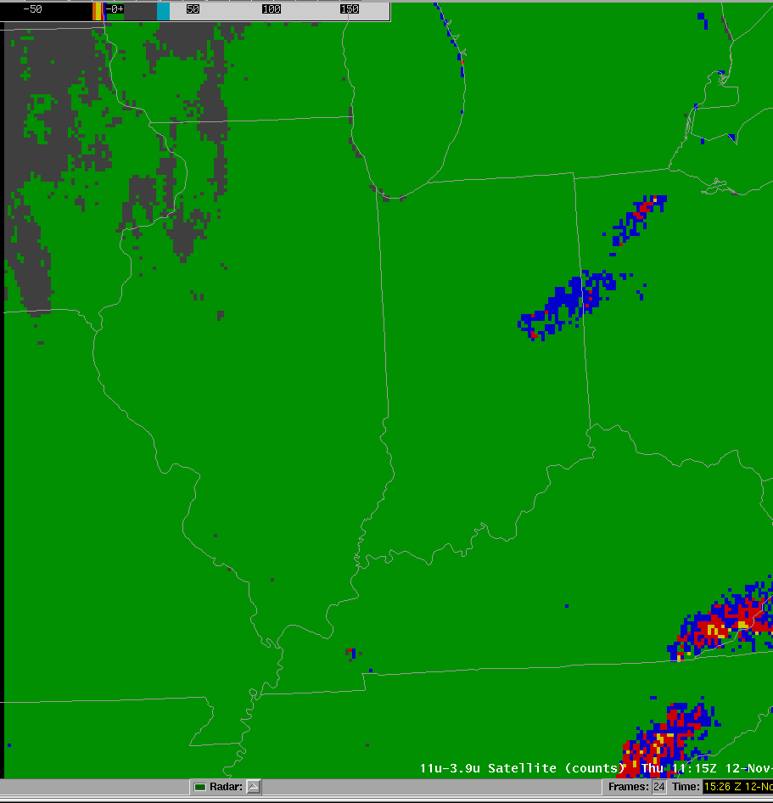
Figure Two. Satellite fog curve at 1115Z Nov. 12. Note stratus from east central Indiana to western end of Lake Erie.

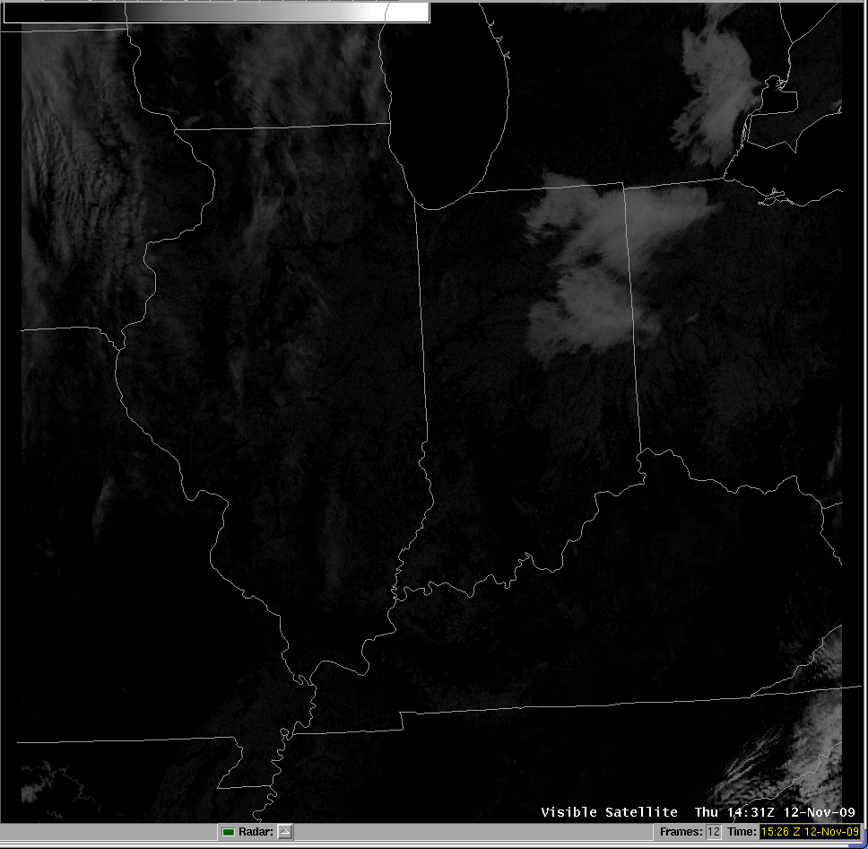
Figure Three. Visible satellite picture at 1431Z Nov. 12, 2009. By this time, fog/stratus had been over Muncie for more than 3 hours.
This an example of how the mesoscale had a big impact on flight conditions that the synoptic pattern didn’t indicate. As Mr. Skowronek observed, VLIFR would have affected Indianapolis if they had advanced a little farther. This type of moisture inflow from Lake Erie is unlikely to happen often. However knowing about it could help you avoid some surprises..

