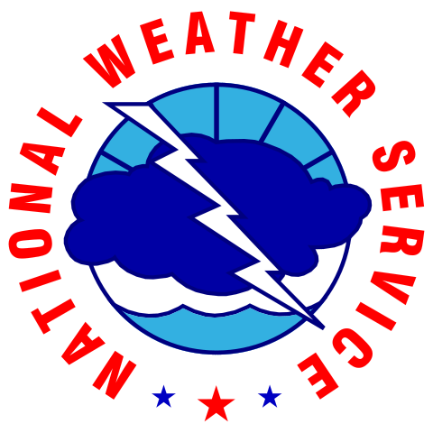

Student Volunteer Program Application

Thank you for your interest in volunteering with the National Weather Service Forecast Office in Charleston, SC.

Personal Details

**Name:** 

**Address: **

**Telephone: **

**E-mail: **

**Are you a U.S. citizen? **

Educational Experience

**Current College/University: **

**Major / Minor: **

**Current Year: **

**Expected Graduation Date: **

**Current Overall GPA: **

**Major GPA (if applicable): **

**Did you attend any other colleges/universities? **

**If so, please provide additional details (degree or number of credits earned, GPA, etc):**



Work/Volunteer Experience

**Most Recent Employer or Volunteer Activity: **

**City / State: **

**Start / End Date: **

**Description of Duties:**



**Other Employer or Volunteer Activity: **

**City / State: **

**Start / End Date: **

**Description of Duties:**



Additional Questions

**What are your career plans?**



**Why do you want to volunteer at NWS Charleston?**



**What is your availability?**

Begin Date: 

End Date: 

**What is your daily availability? (Please note, we are requiring a minimum of 8 hours)**

|  |  |  |  |  |  |  |  |
| --- | --- | --- | --- | --- | --- | --- | --- |
|  | Monday | Tuesday | Wednesday | Thursday | Friday | Saturday | Sunday |
| Morning |  |  |  |  |  |  |  |
| Afternoon |  |  |  |  |  |  |  |
| Evening |  |  |  |  |  |  |  |

**If you have any questions regarding this application or volunteer opportunity, please contact Emily McGraw at** [**emily.mcgraw@noaa.gov**](mailto:emily.mcgraw@noaa.gov)**. For more information on the National Weather Service in Charleston, visit our webpage at** [**www.weather.gov/chs**](http://www.weather.gov/chs)**.**