Outcome of the RARS Progress Meeting
UCAR, Boulder, 4 May 2011

The scope of the meeting was to address the RARS related issues emerging from APSDEU-11/NAEDEX-23 discussions and to review the actions needed with respect to the planned extension of RARS to new sounders including METOP/IASI, FY-3 MWTS/MWHS and NPP/CrIS.

- RARS Monitoring

A recent interruption of the RARS data stream from Argentina revealed the importance of monitoring not only the correctness of the data (which is done by the Met Office/NWP SAF) but also its availability and timeliness for GTS users. This is not within the scope of the central monitoring performed by the NWP SAF, who receives most RARS data by bilateral FTP. (Note: The RARS Operators Standards foresee that the RARS Operator “utilize an appropriate system for the tracking and resolution of operational anomalies”.)

Action 0: To define guidelines for monitoring availability and timeliness of RARS data on the GTS, for each RARS network, to be ultimately included in the RARS Operators Standards.

Action 1: To ensure that roles are assigned in each RARS network to perform regular monitoring of availability and timeliness of RARS data on the GTS, as foreseen in the RARS Operators Standards, and to ensure that anomalies are reported to the relevant RTH or RARS station without delay to enable corrective actions.

Action 2: Met Office to investigate whether the central monitoring can be extended to the availability and timeliness of RARS data obtained through the GTS, in addition to the regional monitoring performed by the RARS nodes.

- Information of the RARS User Community

In spite of several presentations and posters at ITSC sessions, there is no evidence that the NWP community is fully aware of RARS data availability. A survey performed during ITSC-17 provided disappointing low response rate.

Action 3: The RARS project (precise actionee TBD) to present RARS at ITSC-18 (Toulouse, 21-27 March 2012), introducing in particular the plans for new sounders. Contact the potential RARS users in advance of the conference to raise attention.

- Extension of RARS to IASI and CrIS

As identified in the Implementation Plan, the extension of RARS to hyperspectral sounders (X-RARS) raises issues of different kinds :
- To define the proper processing strategy (what processing to be decentralized vs performed at the RARS node)
- To identify the proper data set (channel selection and/or principal component)
- To define the receiving sites
- To ensure suitable connectivity of these sites to the regional nodes.

There were 2 actions on EUMETSAT from the 4th RARS Implementation Group Meeting related to the processing of IASI as a model for future RARS processing of CrIS :

Action RARS-IG 4.11: EUMETSAT, in cooperation with NWP SAF, to demonstrate the possibility to deliver an AAPP package to “virtual machines”. (Due date: June 2010)

Action RARS- IG 4.12: EUMETSAT, in cooperation with EARS-IASI partners, to demonstrate the removing of overlap among EARS-IASI data from adjacent EARS stations, as a possible model for the extension of RARS to advanced sounders. (Due date: February 2011)

Action 4: EUMETSAT (Simon Elliott) to report on the outcome of actions RARS-IG 4.11 and 4.12.

Regarding the data selection, the agreed approach is that, for hyperspectral sounders, RARS should work on a subset of channels (around 300 channels for IASI). ECMWF has highlighted scientific advantages in working on Principal Components, this would however require a prior filtering which is not yet universally agreed. The PC approach is thus premature. For CrIS, the channels still need to be selected.

Action 5: NOAA and relevant partners to define the selection of CrIS channels from the NPP Direct Broadcast to be processed and redistributed by the X-RARS project.

A preliminary list of stations was identified at the last RARS IG meeting. Environment Canada confirms Edmonton (See Annex 1). The connectivity should be evaluated through a survey and a trial.

Action 6: To perform a survey on the connectivity of the preliminary list of stations.

Action 7: To set up a communication trial among the relevant stations.

- Inclusion of FY-3 MW sounding data

The following partners indicated plans to receive FY-3 Direct Broadcast and contribute to RARS/FY-3:
- KMA (Jincheon)
- Met Office (Exeter)
- EC (Edmonton)
- BOM (5 stations)
- CMA (3 stations).

Action 8: The above organizations, with WMO, to coordinate with CMA to get the necessary technical documentation for FY-3 reception and pre-processing.

Action 9: NWP SAF, CMA, and all partners to develop a plan for development of the appropriate software to be applied by the RARS for the generation of FY-3 BUFR data

- Conclusion

Action 10: WMO (Jerome Lafeuille and Fred Branski) to organize a progress meeting (teleconference) to follow-up these issues early July 2011.
Action 11: WMO (Jerome) to convene a RARS IG meeting by fall 2011 (e.g. October).

_______________________

Annex 1: Preliminary list of X-Band RARS stations
Annex 2: List of meeting participants

Annex 1: PRELIMINARY LIST OF X-BAND RECEIVING SITES FOR X-RARS (4/05/2011)

EARS | South American RARS | AsiaPacific RARS
Lannion | Cachoeira Paulista | Melbourne, Darwin, Perth, Townsville
Moscow | Cuiabá | Casey (Communication limitation)
Khabarovsk | Córdoba | Kiyose
Novosibirsk | Santiago | Jincheon
Oman |  | Bejing, Guangzhou, Urumqi
Gander (TBC) |  | Maupuia
Edmonton |  | Singapore

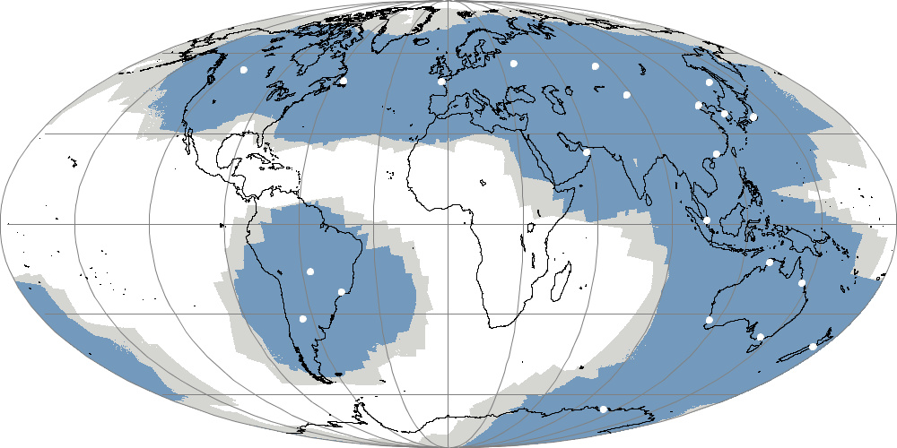

Annex 2:List of Meeting Participants

Organization | Representative | Email
Bureau of Meteorology | Anthony Rea | A.Rea@bom.gov.au
Environment Canada | Mike Manore | Mike.Manore@ec.gc.ca
Environment Canada | Gilles Verner | Gilles.Verner@ec.gc.ca
JMA | Yoshiaki Sato | y-sato@met.kishou.go.jp
KMA | Jae-Dong Jang | JaeDongJang@korea.kr
Meteo-France | Jean-Francois Mahfouf | jean-francois.mahfouf@meteo.fr
Met Office | Roger Saunders | roger.saunders@metoffice.gov.uk
NOAA/NWS/CIO | Fred Branski | Fred.Branski@noaa.gov
NOAA/NESDIS | Thomas Renkevens | Thomas.Renkevens@noaa.gov
NOAA/NESDIS IA | Michelle Hertzfeld | Michelle.Hertzfeld@noaa.gov
WMO | Jerome Lafeuille | jlafeuille@wmo.int

