6th Asia-Pacific Satellite Data Exchange and Utilization (APSDEU) Meeting
KMA, Seoul, Korea
June, 2005

U.S. National Oceanic and Atmospheric Administration (NOAA)
National Weather Service (NWS)
Office of the Chief Information Officer
Telecommunication Operation Center

Status Report

1. Operational Infrastructure

The major systems comprising the NWS Telecommunication Gateway (NWSTG) are:

- Central Data Switching System controls the exchange of data with remote locations. The primary remote locations are with the NWS specialized modeling centers, the commercial meteorological community, and major international communication switching centers. The international switching centers are on the Main Trunk Network (MTN) of the WMO's Global Telecommunication System.

The Gateway is the primary data communications switching system of the NWS. It is a global acquirer and distributor of weather messages in support of the NWS commitment to the WMO World-Wide data exchange structure, therefore, the Gateway maintains a recognition system for all weather data and products for purposes of exchange to global customers. This Center is a Regional Telecommunication Hub (RTH) of the WMO Global Telecommunication System (GTS) communications network.

This system also operates an ICAO Operational Meteorological (OPMET) data bank. It contains aviation METAR, TAF, and SIGMET data. The OPMET data bank supports the International Civil Aviation Organization (ICAO) World Area Forecast Center (WAFC).Center, and is an on-line, real-time message switching system.

The Gateway is also the U.S. World Area Forecast Center (WAFC) distribution system for the World Area Forecast System (WAFS). The WAFS distribution is through a satellite broadcast to geographical areas located over two-thirds of the globe.

Two existing switching engines:

- Government developed software operating on 2 IBM 9672 and 1 IBM 9673 main frames
- Sybase relational database operating on several IBM 6000/F50 and H50 servers

B. ASOS Operation and Monitoring Center (AOMC) monitors the quality and availability of the sensors in approximately one thousand five hundred Automated Surface Observing Systems (ASOS) at observing sites across the United States. The AOMC includes a 24x7 help desk which assists technicians in the repair of ASOS sites.

C. Advanced Weather Interactive Processing System (AWIPS) Network Control Facility (NCF) - The NCF is the central hub for the AWIPS communication network (ACN) comprised of a frame-relay wide area network (WAN) and a satellite broadcast network (SBN) using the SpaceNet 4 communications satellite. The Primary NCF is located in the NWSTG at the NWS Headquarters in Silver Spring, MD, it has a 24x7 help desk staff to assist field personnel in resolving problems with AWIPS hardware, software or the ACN. The Backup NCF (BNCF) is located at the NASA Independent Verification and Validation Center (IV&V) at Fairmont, WV.

The primary C-band satellite uplink facility for the AWIPS SBN is located at Ft. Meade, MD. The back-up AWIPS MGS is located at the NASA Independent Verification and Validation Center (IV&V) at Fairmont, WV.

D. Centralized Automated Data Acquisition System (CADAS) - CADAS automatically gathers data from depth and flow gages in rivers and streams throughout the United States.

E. EMWIN Systems Control Center – provides centralized monitoring and control for the Emergency Managers Weather Information Network (EMWIN). EMWIN is a suite of data access methods which make available a live stream of weather and other critical emergency information.

F. Telecommunications Links - The major telecommunication circuits that are linked to the NWSTG backup are:

Tier 1 - Those circuits linking the TG and BTG with other nodes of the Core network, all of which are under NOAA's control. These circuits are typically high capacity;

Tier 2 - Any other circuits, under NOAA control emanating from the TG and BTG. These circuits are typically medium capacity;

Tier 3 - Circuits not under NOAA control but which link the TG and BTG with other critical government and international sites. These circuits are typically low and medium capacity; and

Tier 4 - All other circuits, typically medium capacity circuits linking commercial users to the NWSTG.

G. Gateway Server Center (GSC) consists of approximately 77 servers and is not part of the switching infrastructure but provides FTP and HTTP services as well as other specialized processing.

Legacy Replacement and Backup Telecommunication Gateway Projects

Backup Telecommunication Gateway Capabilities

The NWSTG backup system will be located at a site approximately 65 miles distant from the primary NWSTG site. All major systems comprising the NWSTG with the exception of the Advanced Weather Interactive Processing System (AWIPS) Network Control Function (NCF) will be replicated at the backup site. All telecommunications circuits linking the primary NWSTG to the user community will be configured for redirection to the NWSTG backup when necessary.

The NWSTG backup system will normally be powered up but off-line and unstaffed with no significant data ingest until external circuits are redirected from the primary to the backup. Within one hour of implementation, normal message switching and processing will resume and the database will be fully replenished within 12 hours of implementation.

Background
In 2001 the NWS received approval and funding for Implementing a Backup Telecommunications Gateway at Mt. Weather Virginia to provide catastrophic backup capability for the Primary Telecommunications Gateway located at Silver Spring, MD. In 2002 the NWS appropriated funding to replace the Legacy Telecommunications Gateway. The assumption was that the Backup Telecommunications Gateway would be implemented prior to the Legacy Replacement. Since the original plan the NWS TOC staff has realized that the technical, performance and budget risks makes implementing the program less risky from all 3 perspectives by implementing the Legacy Replacement first.

Summary
The Integrated Project Office and the Telecommunications Operations Center (TOC) technical staff have determined that implementing the Legacy Telecommunications Gateway first as the least risky implementation method to support the successful rollout of the Backup Telecommunications Gateway.

Schedule

- The schedule shows that implementing the Legacy Telecommunications Gateway first will actually be shorter than a Backup installation first.

- Installation of the Backup telecommunications gateway first was estimated to take 3 months longer than the current schedule.

- Final installation of the Legacy replacement is estimated to have taken 17 months longer than the current schedule if the Backup were implemented first.

Legacy Replacement Project

Status Summary

Work has gone well on the Message Switching Software System (MS³) software integration. Development of the core MS³ system has been completed two and one half months earlier than scheduled. The test and development system is being reconfigured into an operational configuration for system performance and unit testing. Initial message flow and through put measurement tests are underway. The internal and external network implementations are also well along. Following expansion of the Power Distribution System and installation of equipment racks and cabling, the network team is implementing the network architecture and moving all the major subnets on to a GigE LAN. The internal network is being rebuilt to support simultaneous connectivity of a new IP network cloud (MPLS) and the existing Point-to-Point network. Additionally, the 2 gateways (legacy replacement and backup) have to talk to each other causing additional technical complexity. The new central storage system will consist of IBM ESS 800 Storage System and NetApps devices. The IBM ESS System is installed and the NetApps installation is underway.

Backup Telecommunication Gateway Project

A new building was completed and accepted in December 2004. Most major hardware systems have been installed at the NWSTG Backup. Cabling installation and additional systems work is underway.

External Network

Implementation of the MPLS network cloud is also well underway. Connectivity is in place to NWS Regions and several major centers. This week an initial OC3 connection to the primary NWSTG facility should be installed to allow for system testing with initial operational testing with transition of operational connectivity to begin 4Q05. The connection to the Primary NWSTG is expected to be OC12 when initial operational capability is reached with infrastructure in place for build out to OC48 as needed. Besides providing the operational communications network for NWS, it will also be built out as NOAANet to support all NOAA organizations.

Budget Profile as of April 27, 2005

Project | FY05 Funding | Funds Committed | Funds Obligated | Planned  Spending | Balance Available
Legacy Replacement | $2.47M | $2.43M | $2.43M | $.03M | $0M
NWSTG Backup | $3.04M | $2.38M | $1.52M | $1.18M | -$.52M
Combined | $5.51M | $4.81M | $3.95M | $1.21M | $-.52M

a. Budget: the FY05 Legacy Replacement budget was reduced by $1.2M. The IPO has managed to offset a substantial portion of the budget cut with aggressive and innovative acquisition strategies. However, some of the cost reductions have recently been offset by unplanned requirements (e.g., two additional NetCache servers) and testing costs. Currently, project spending projections indicate a $516K shortfall in FY05. The NWSTG IPO and TOC senior management are currently assessing the impact of the shortfall on the project schedule.

b. Budget: starting in FY07, the NWSTG Backup funding has been increased by $2.5M annually to support the increased network costs incurred by the new network architecture required to meet requirements imposed by the DOC CIO. A shortfall is possible for FY06. IPO is currently assessing the bandwidth requirements for FY06 to determine the extent of the shortfall.

Key Operational Dates:

RTG operational – 1Q CY06
BTG operational – 4Q CY06
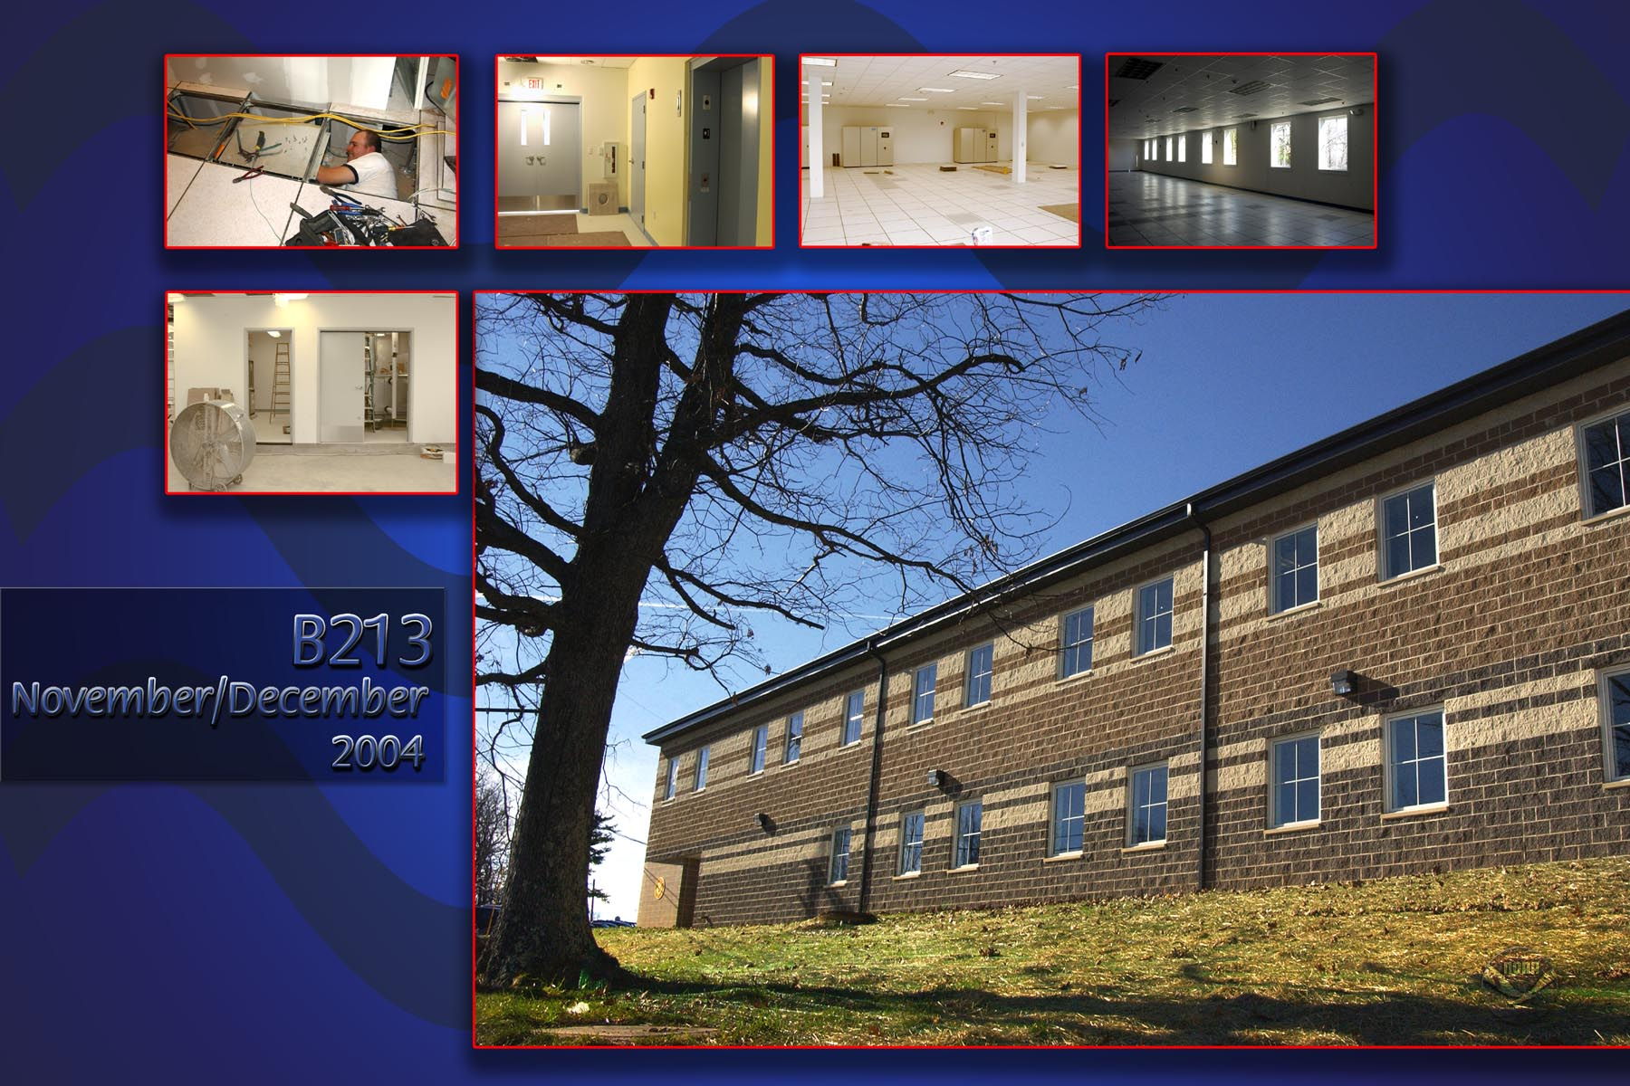
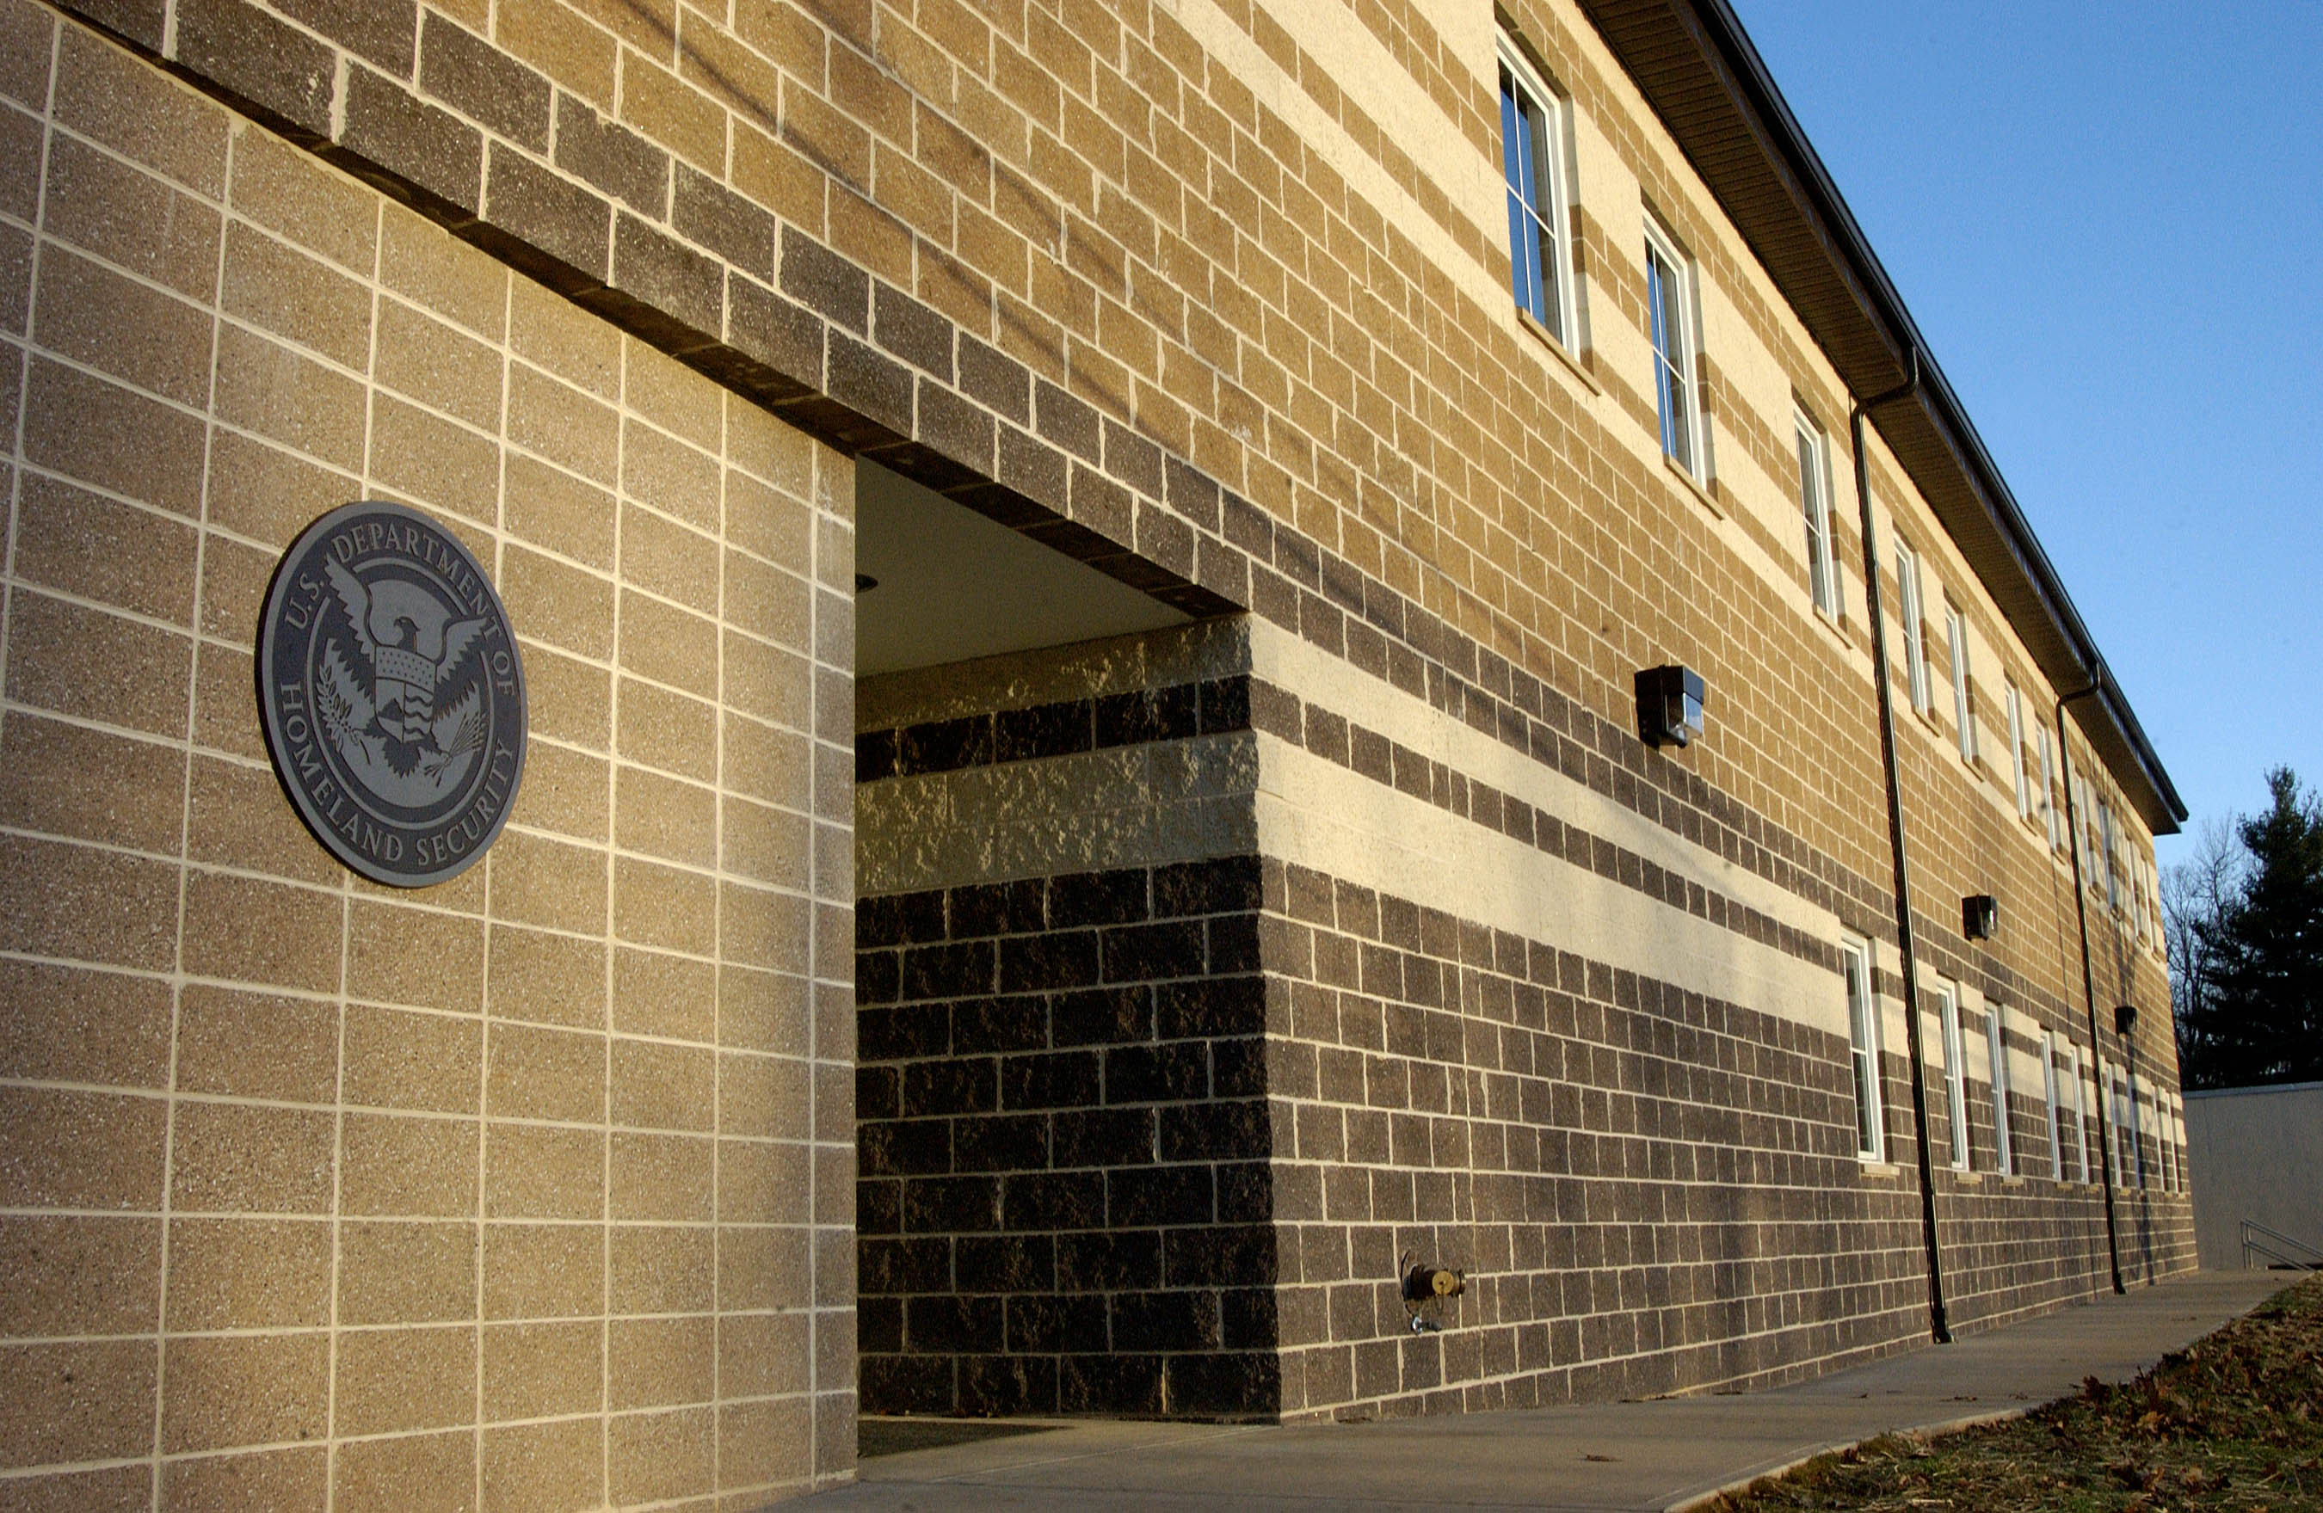
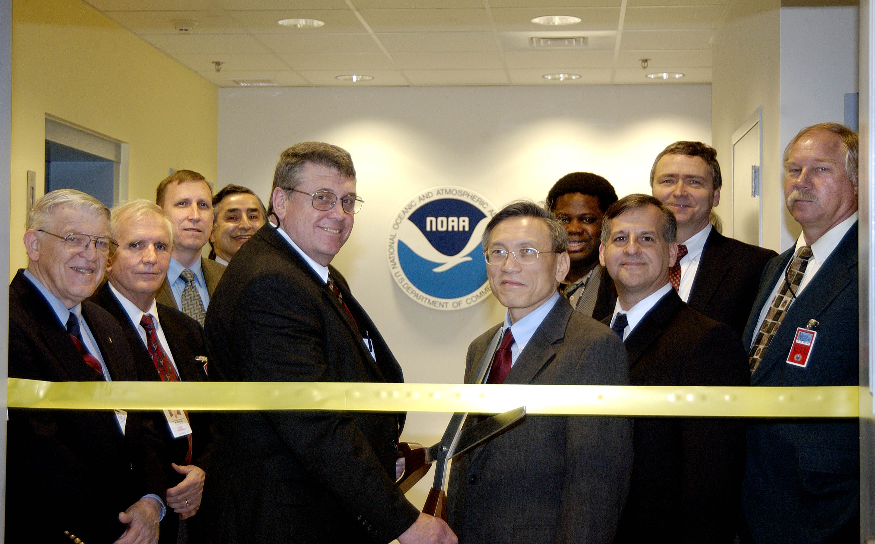
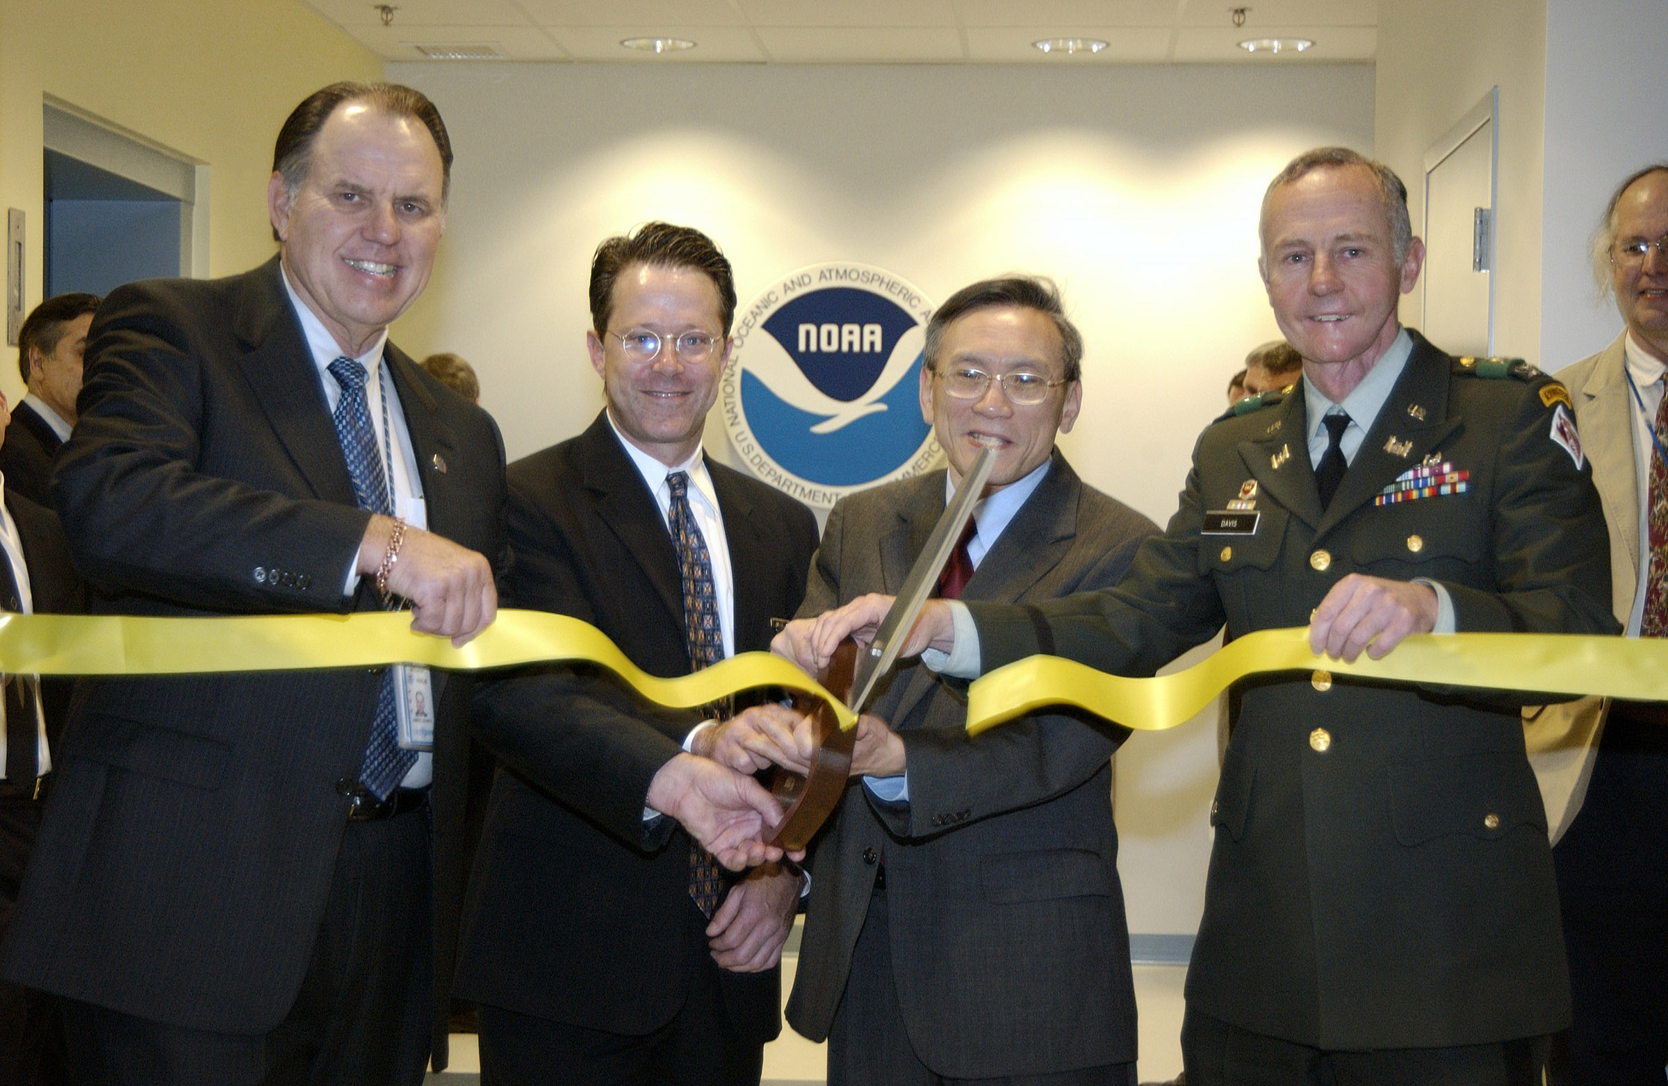
Contacts for NWS Data Management and for 24x7 help desk support for operational communication of data.

Fred Branski - Team Leader, Data Management

fred.branski@noaa.gov +301 713 0864 ext 146
Julie Hayes – Customer Relationship Manager

julie.hayes@noaa.gov +301 713 0864 ext 120
Walter Smith – Data Traffic Manager

walter.smith@noaa.gov +301 713 0864 ext 139

Richard Robinson - Data Manager

richard.robinson@noaa.gov +301 713 0864 ext 179

Cynthia Cromwell – Data Manager
cynthia.cromwell@noaa.gov +301 713 0864 ext 120

KWBC Communication Control Center (CCC) - Tech Control (
point of contact 24 hours every day)
Phone: +301 713 0902 Fax: +301 587 1773 Email: nwstg.toc@noaa.gov

