https://www.facebook.com/share/p/1FNXfQpx5c/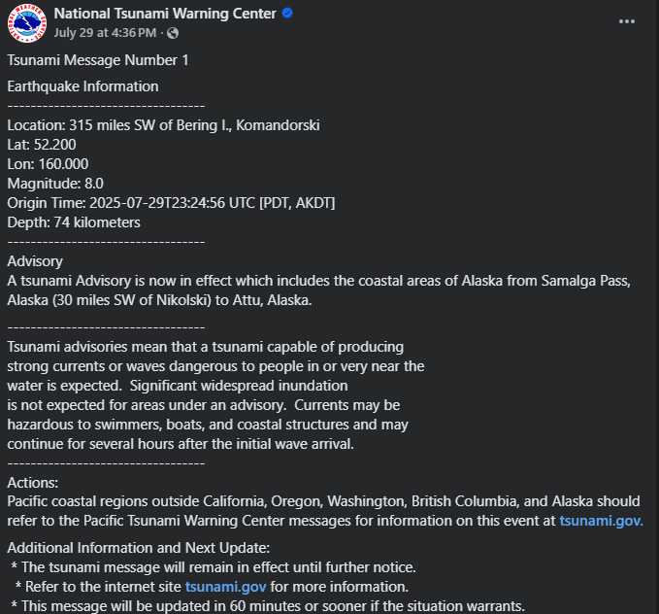

https://www.facebook.com/share/p/1ApaWsNErj/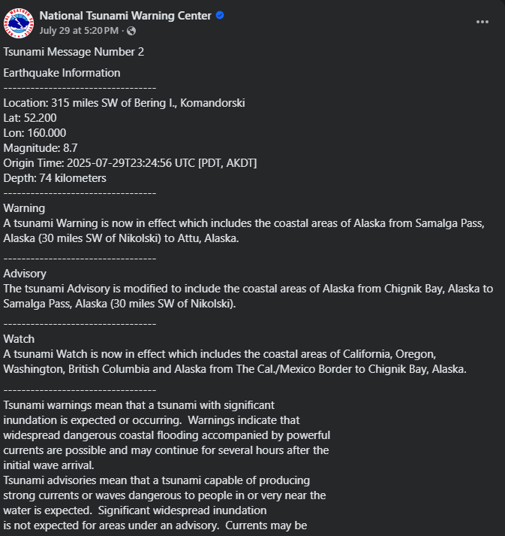

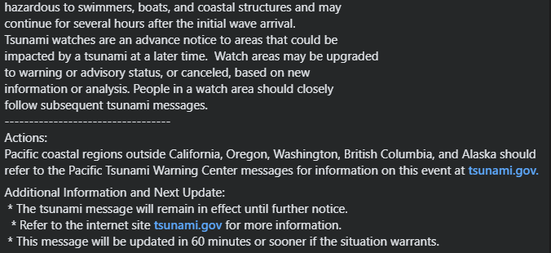

https://www.facebook.com/share/p/173kUKwT6d/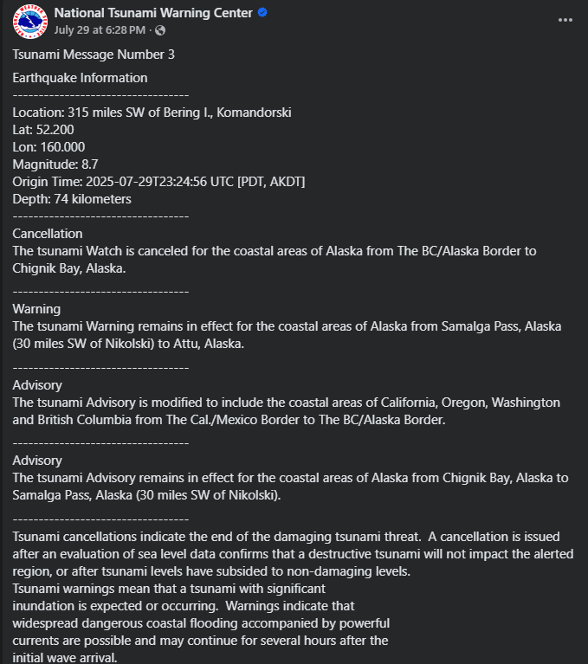

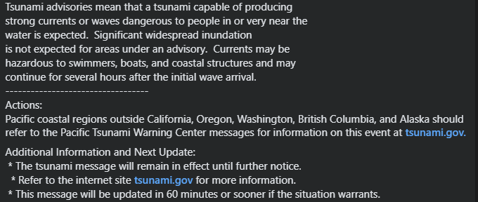

https://www.facebook.com/share/p/17LnbvjFPt/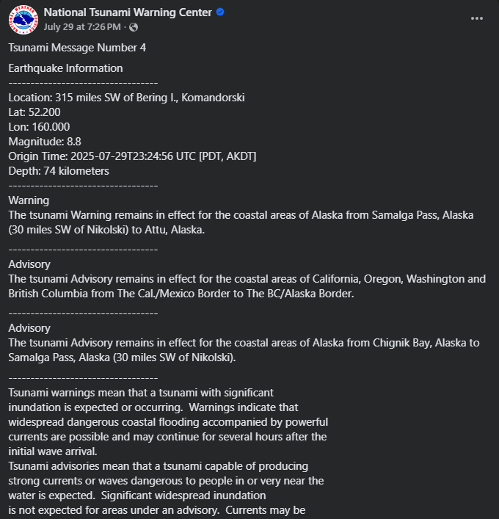

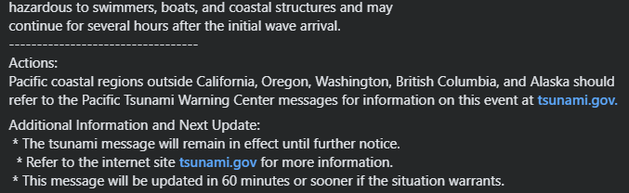

https://www.facebook.com/share/p/1BLcfttRFY/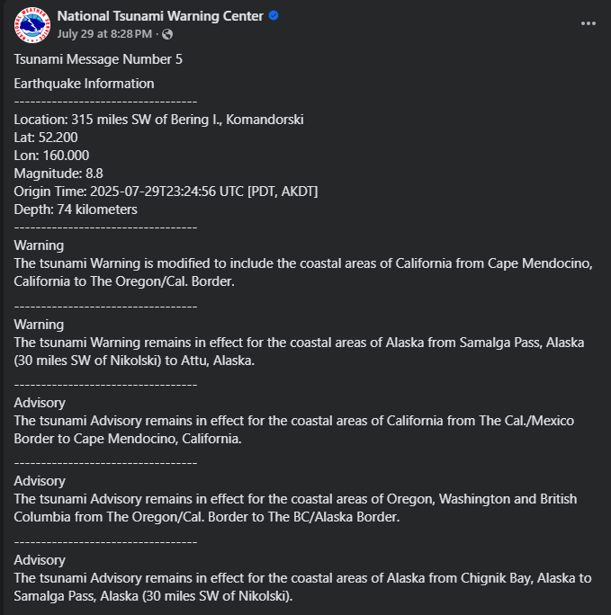

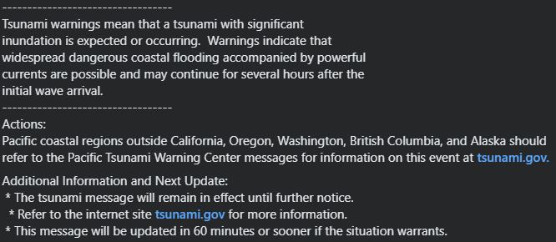

https://www.facebook.com/share/p/178ZsZZ5Jy/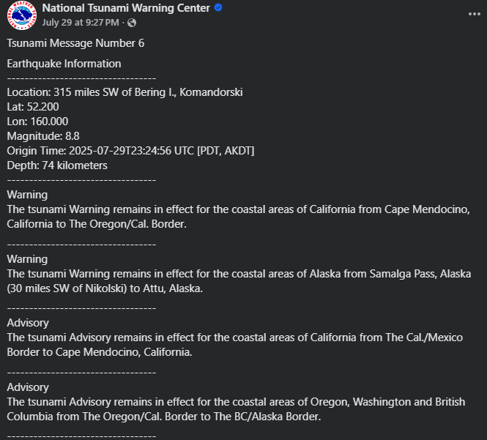

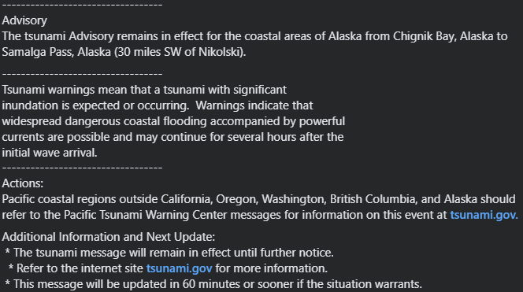

https://www.facebook.com/share/p/15TyEeEcaA/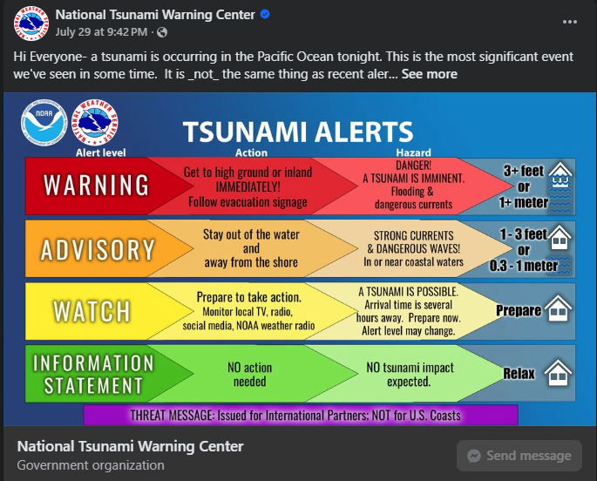

https://www.facebook.com/share/p/16mmL7WZWp/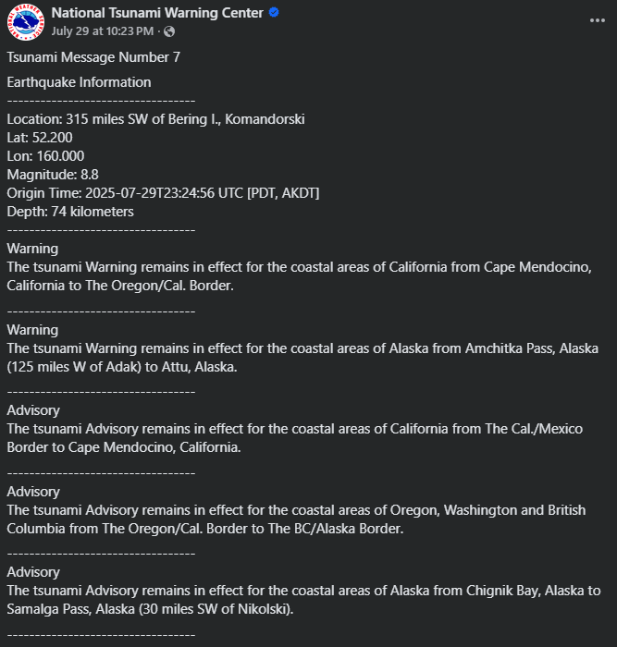

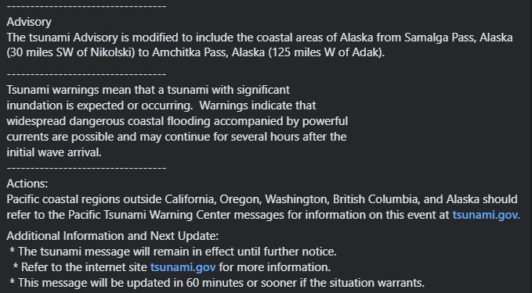

https://www.facebook.com/share/p/1XxbNx97dH/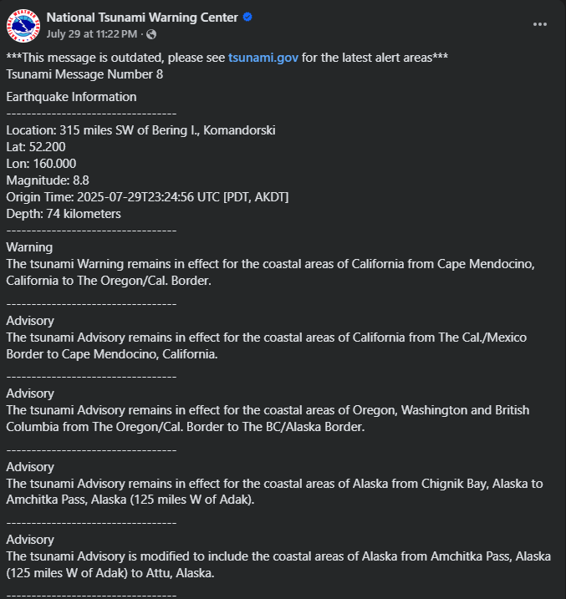

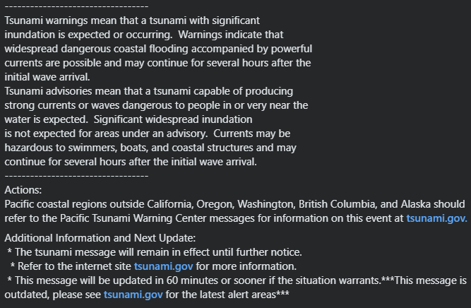

https://www.facebook.com/NWSNTWC/posts/pfbid02fa8EVFuMc7e5T9zT1C3bhyVKpfsVvwbkcfGFjorYSWr92Qzi5AWujZoEqJ5VV1k5l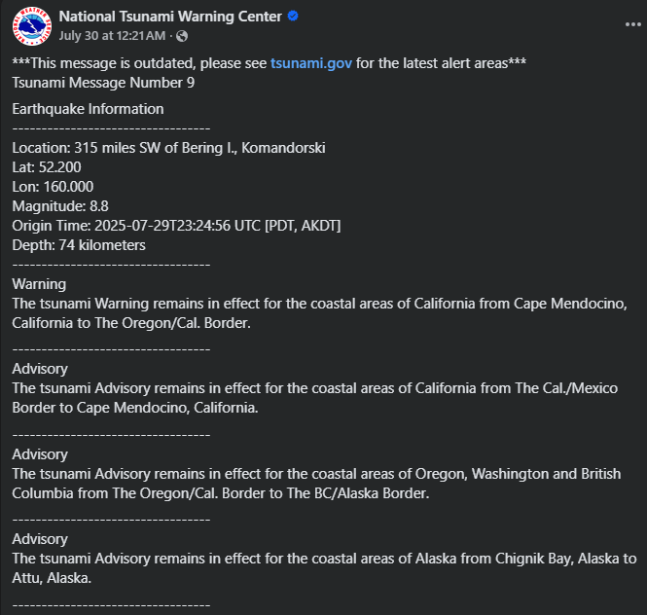

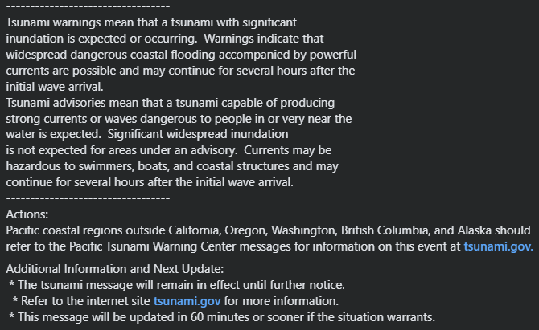

https://www.facebook.com/share/p/17Qqiingcw/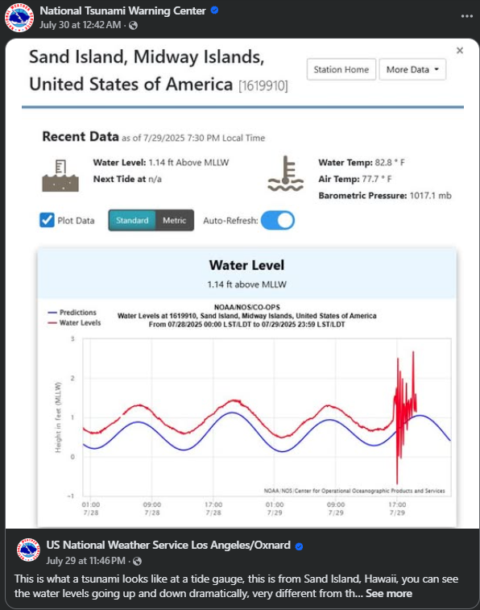

https://www.facebook.com/share/p/162rcytxyF/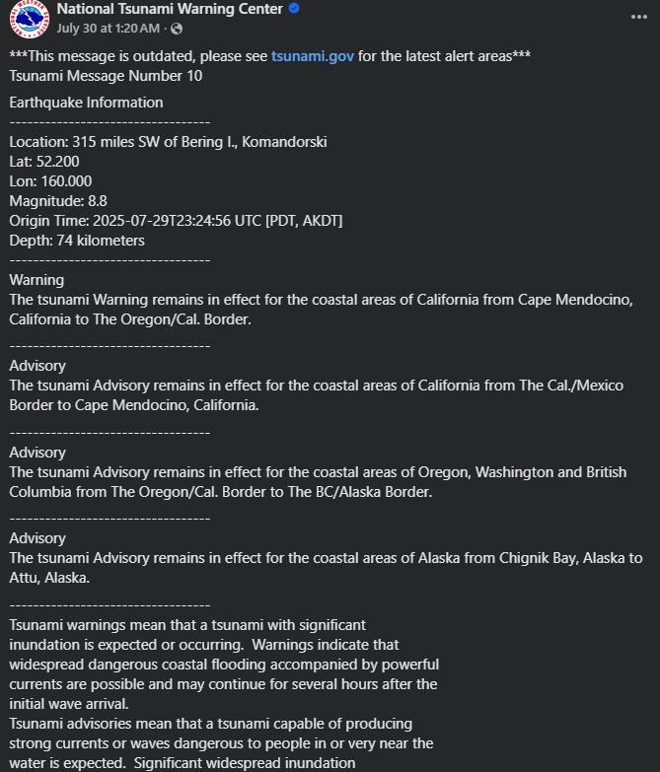

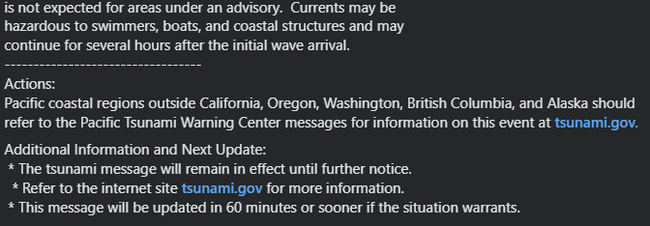

https://www.facebook.com/share/p/19SDTmSeNm/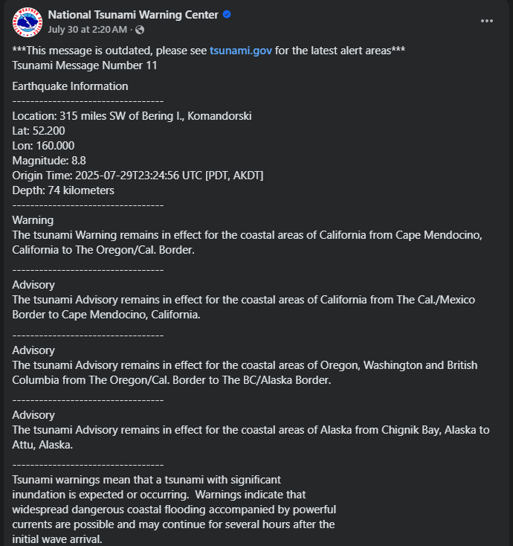

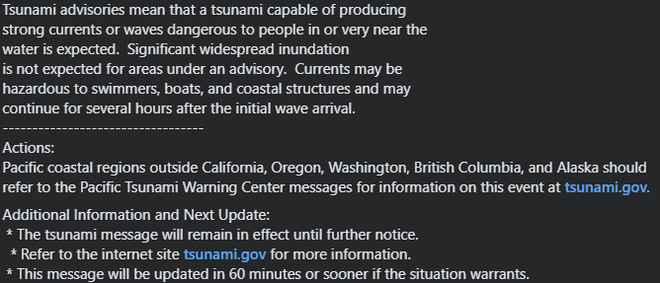

https://www.facebook.com/share/p/1BJW4iHibS/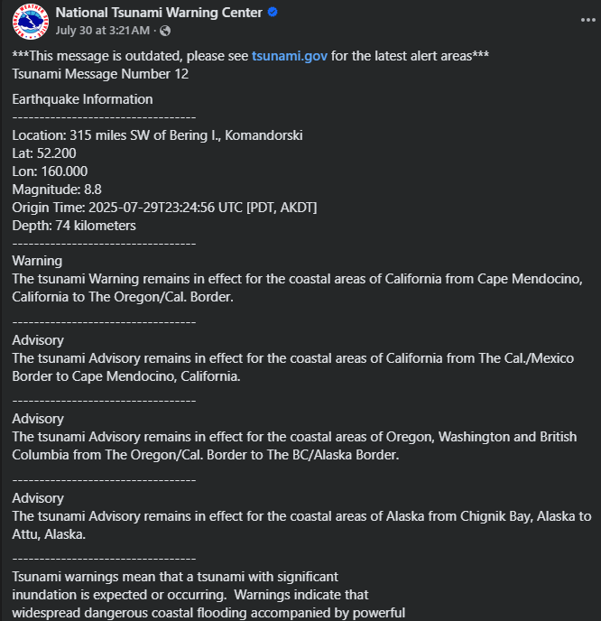

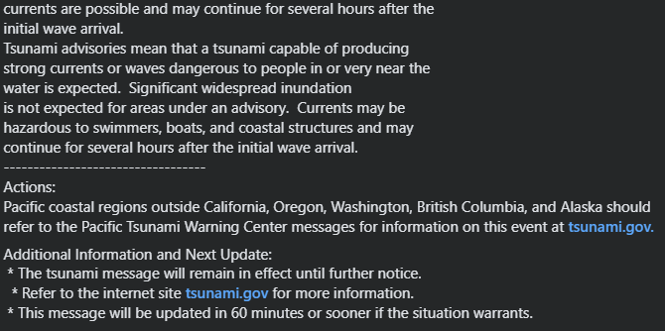

https://www.facebook.com/share/p/19SGYLv4Mi/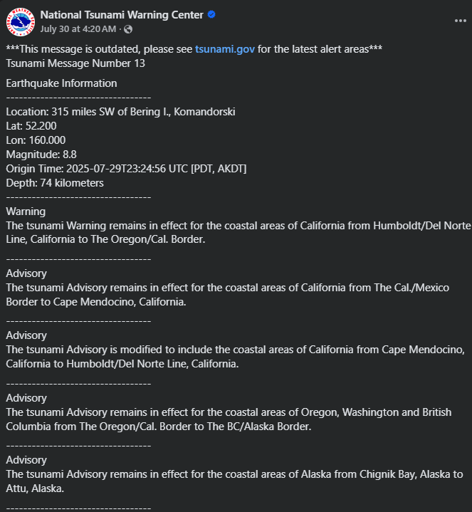

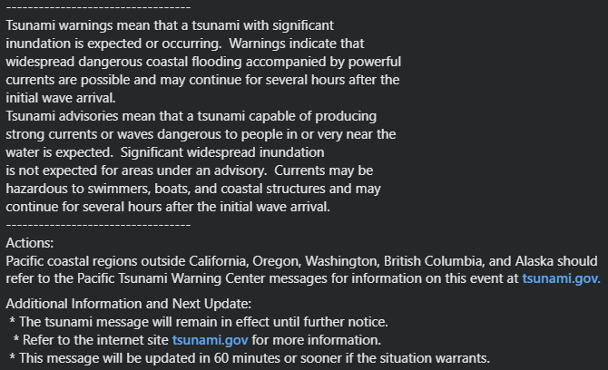

https://www.facebook.com/share/p/1CKPKfsuAb/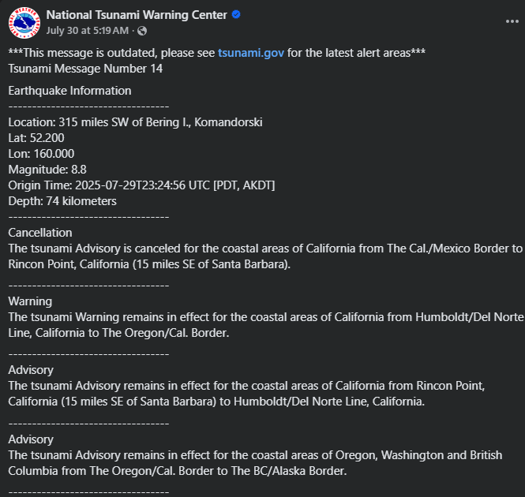

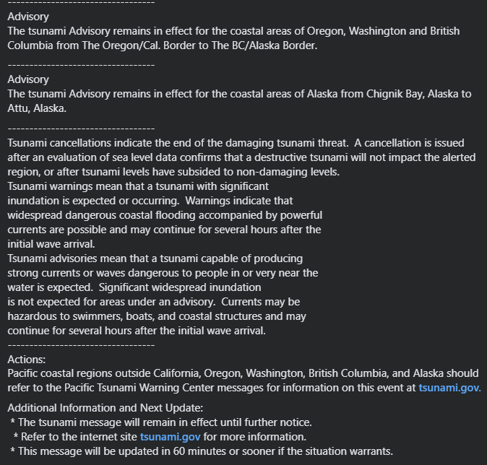

https://www.facebook.com/NWSNTWC/posts/pfbid02VAJWxhySeg3JEsMCdfw2kFw2XGgFLrmhZkH6bvyg35jRVTaUGfJPbaanz6c4PttRl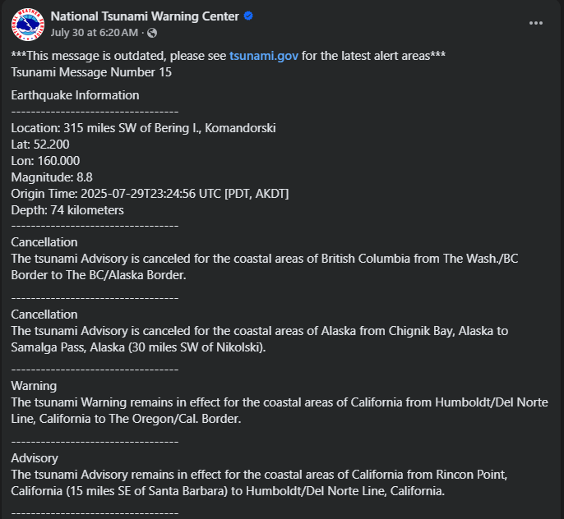

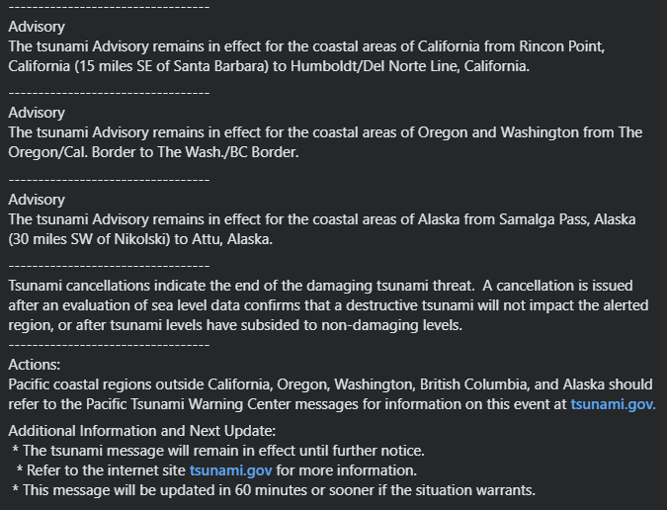

https://www.facebook.com/NWSNTWC/posts/pfbid02WTz7FA1G1Ux1NHzJEf6NSybvFnBuToDq1RHazu9SUtfj2vm5jDhcMLLxjRti8T6El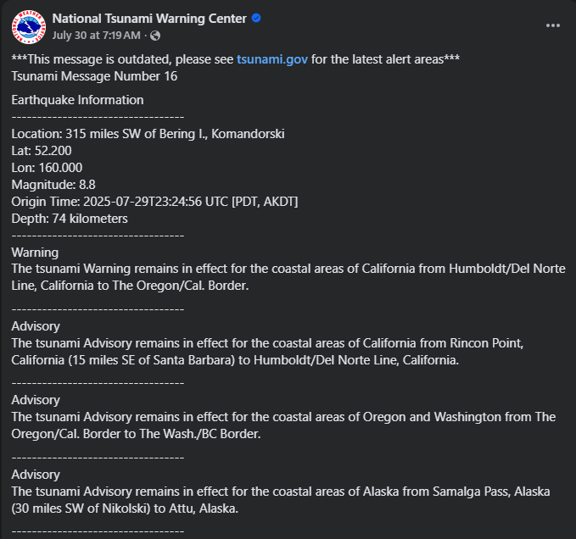

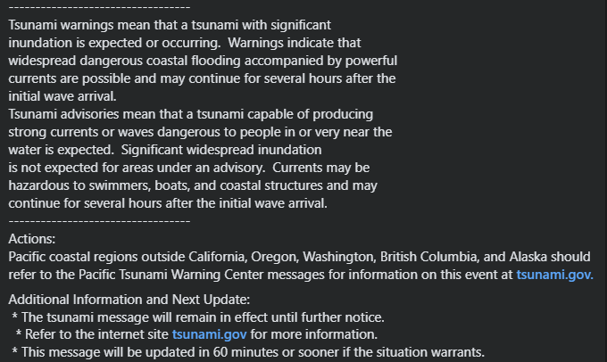

https://www.facebook.com/share/p/1FQEs6Bwiq/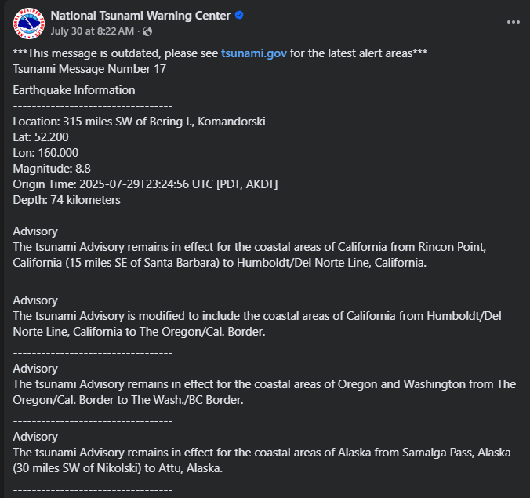

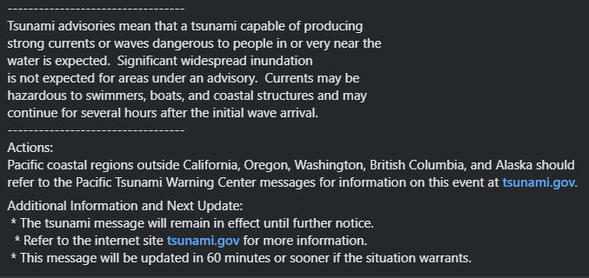

https://www.facebook.com/share/p/15ymr2JLzF/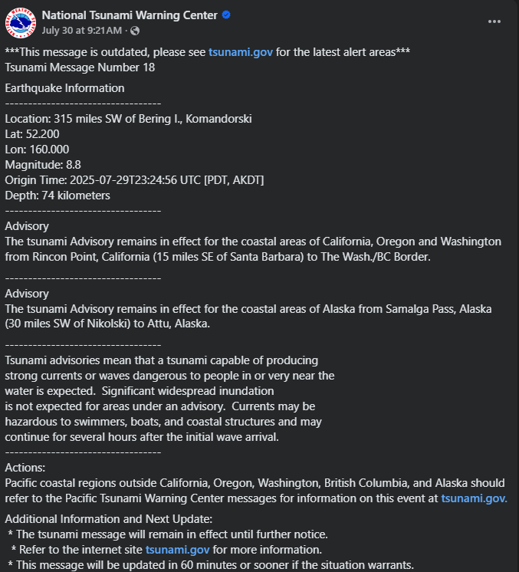

https://www.facebook.com/share/p/1ACx95keoz/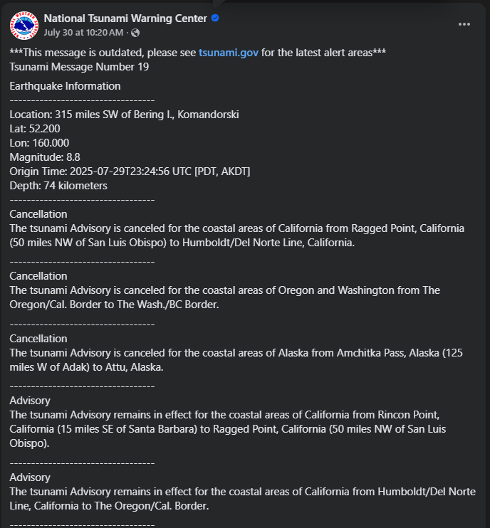

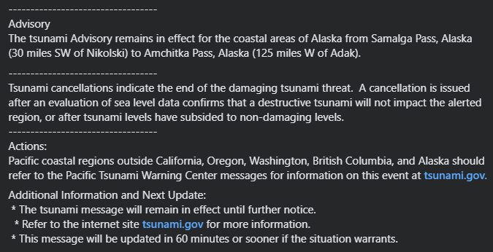

https://www.facebook.com/share/p/19qnt2Sgjb/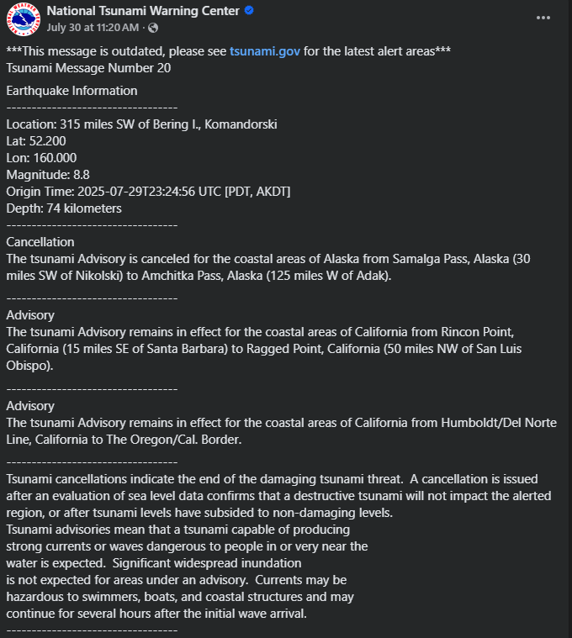

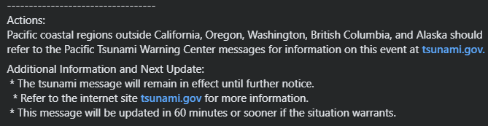

https://www.facebook.com/share/p/1BHKRmDMsH/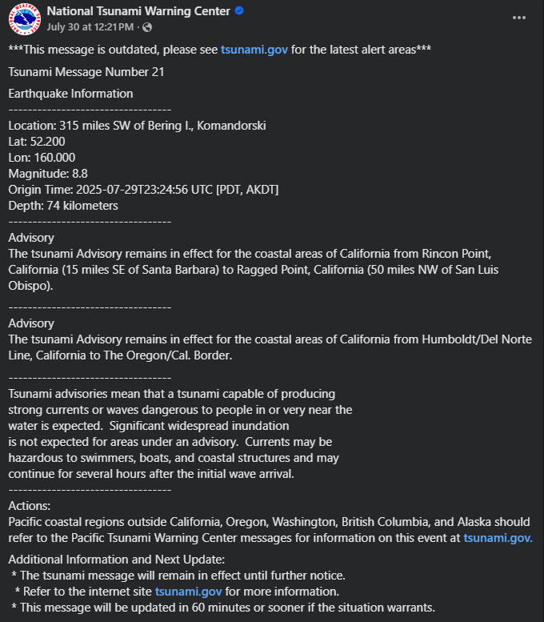

https://www.facebook.com/share/p/1Gb1NTXUqG/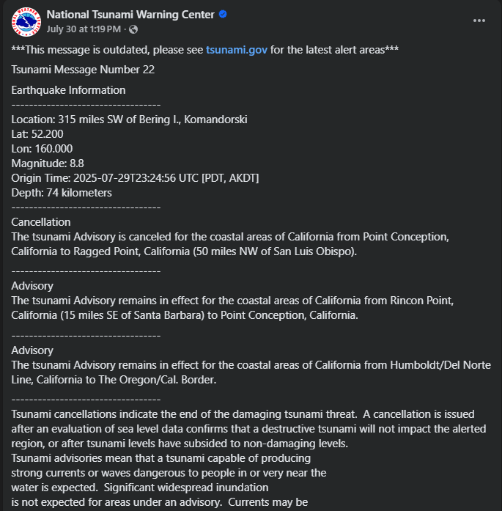

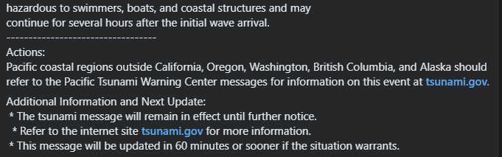

https://www.facebook.com/share/p/19tDyQS6pm/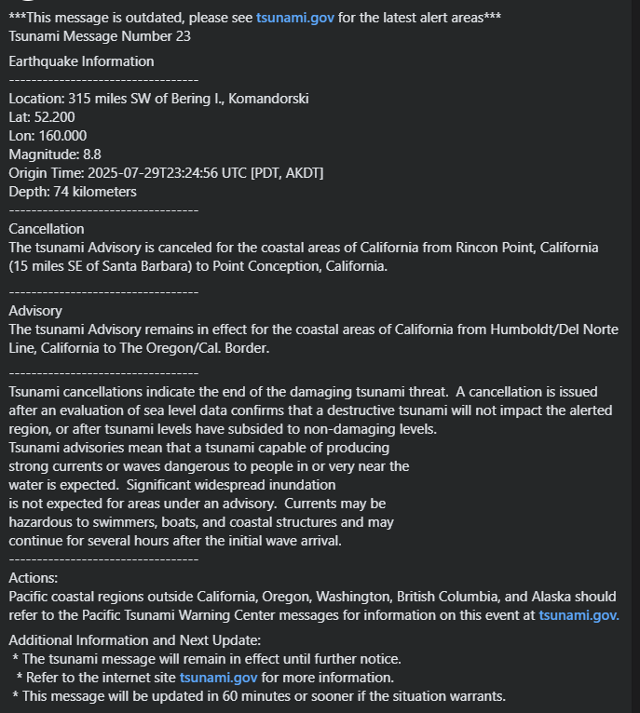

https://www.facebook.com/share/p/168kEaDT1z/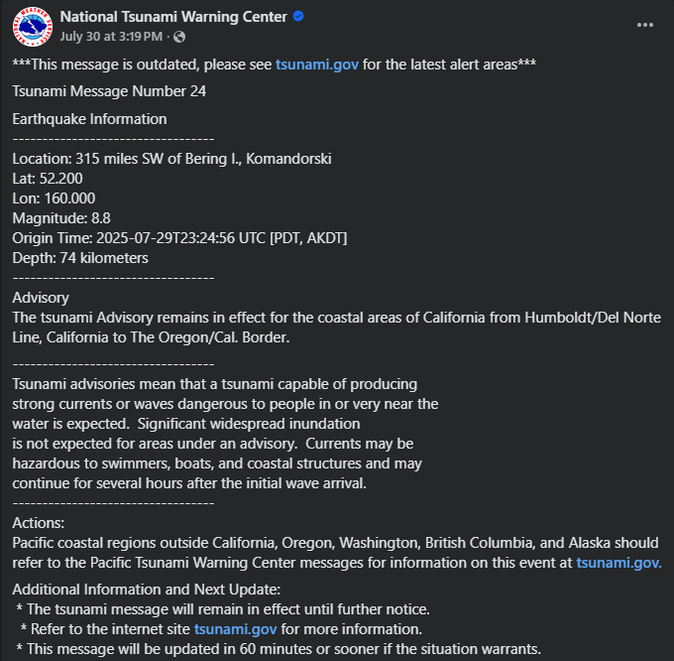

https://www.facebook.com/NWSNTWC/posts/pfbid031fQ2SxZj9ZweeTb3eMmv7swUCNYdTBcTqczvsEukE9YzRw7qRmKrso9cQjKQQWSbl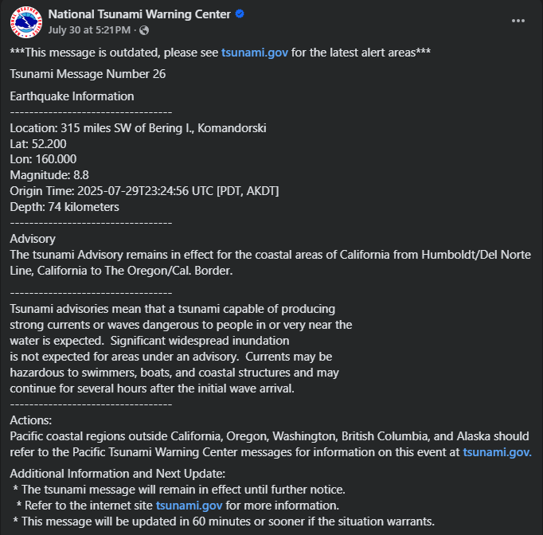

https://www.facebook.com/share/p/19Rz7iZTvy/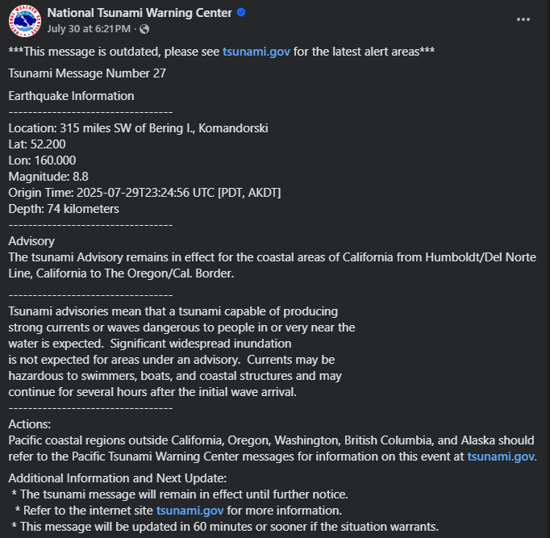

https://www.facebook.com/share/p/14GVrNZHpUY/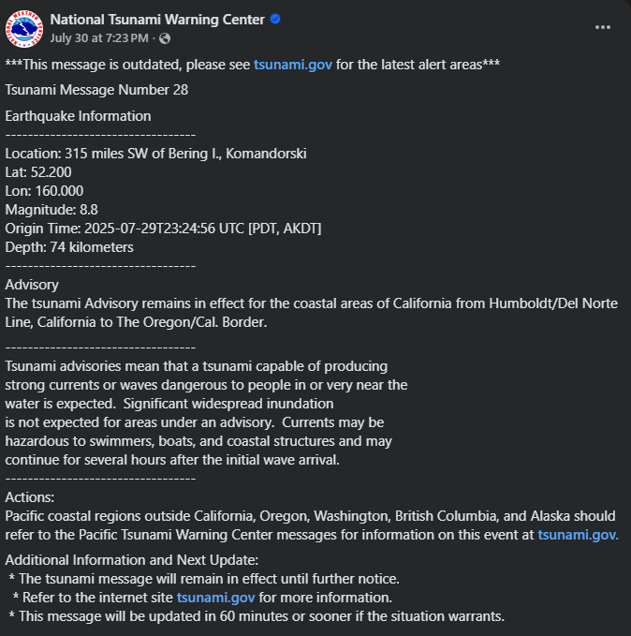

https://www.facebook.com/share/p/1723H9AJtQ/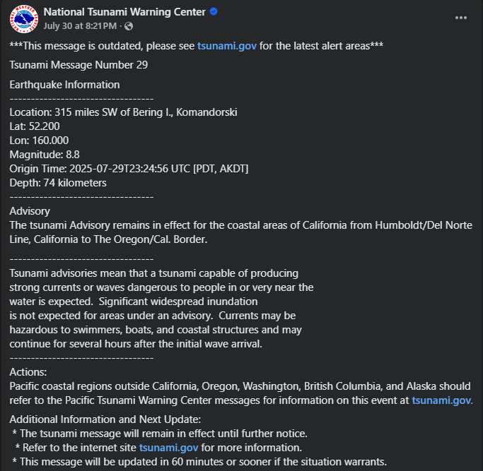

https://www.facebook.com/share/p/19XKt33E2j/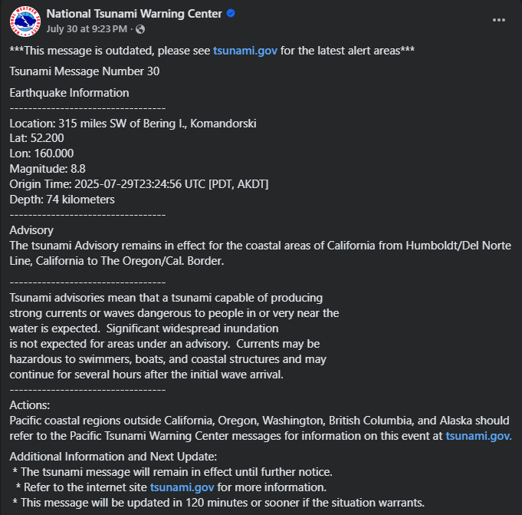

https://www.facebook.com/share/p/1CEkWyDKtT/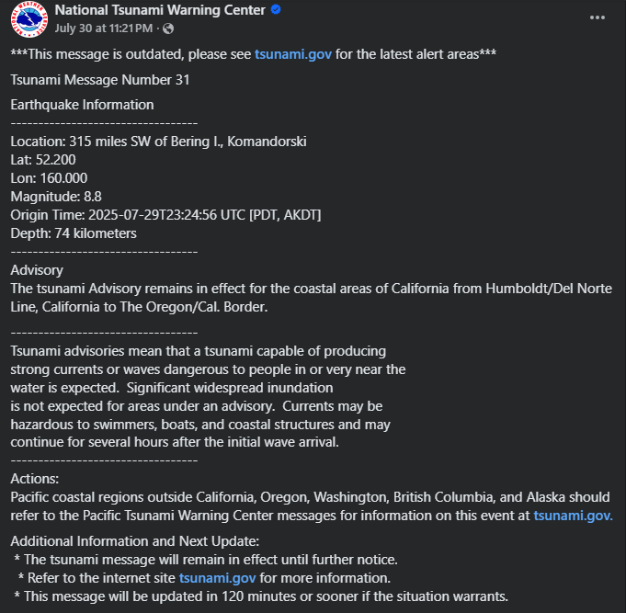https://www.facebook.com/share/p/172is6JTg5/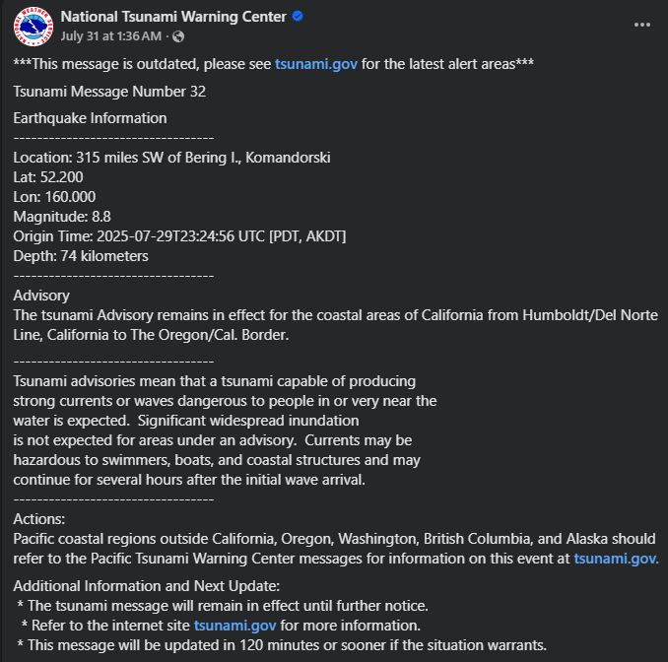

https://www.facebook.com/share/p/1CNAv1xNaw/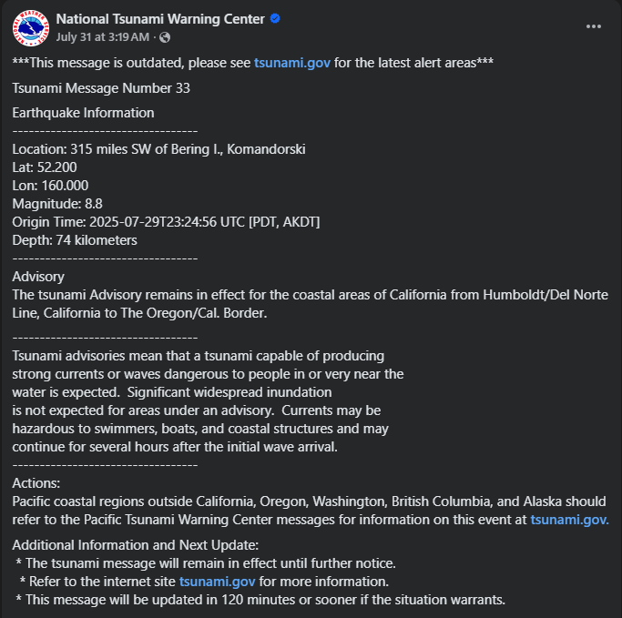https://www.facebook.com/share/p/1E92RXXwAV/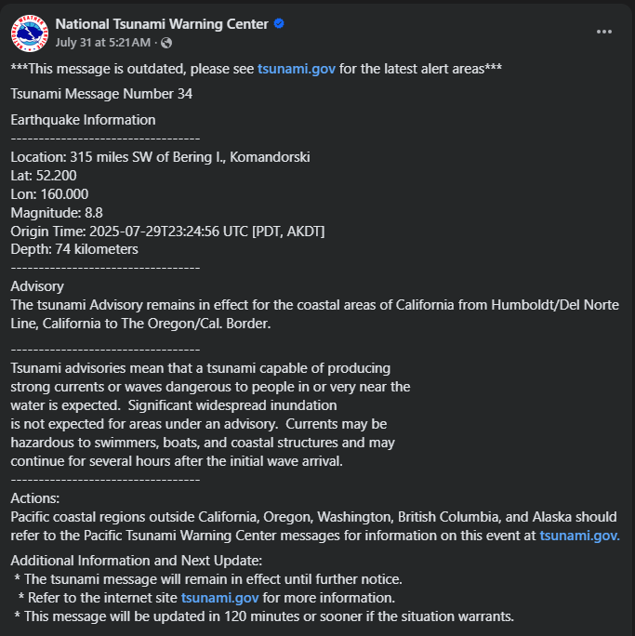

https://www.facebook.com/share/p/1CpgH1fHjS/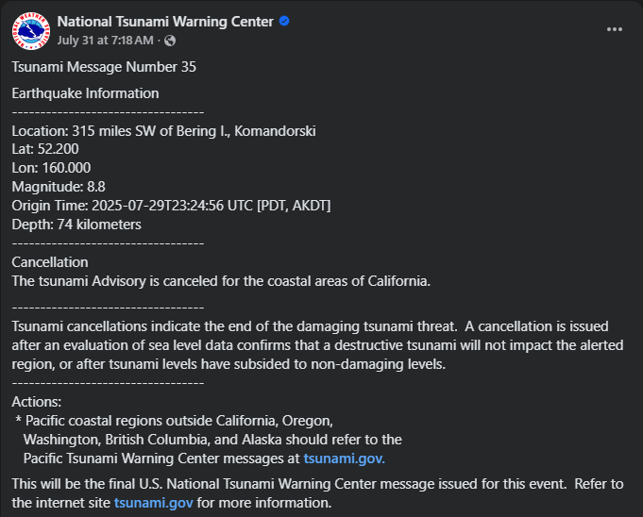https://www.facebook.com/share/p/15r6aGv9Ad/