[https://x.com/NWS_NTWC/status/1950341812574392445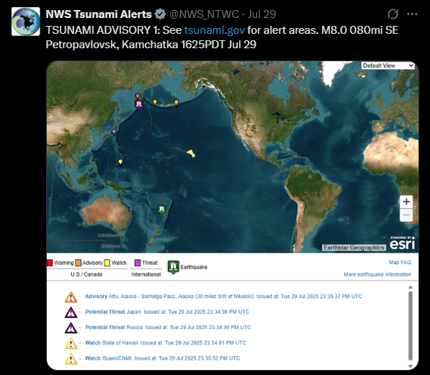https://x.com/NWS_NTWC/status/1950351676390424674](https://x.com/NWS_NTWC/status/1950341812574392445*https://x.com/NWS_NTWC/status/1950351676390424674)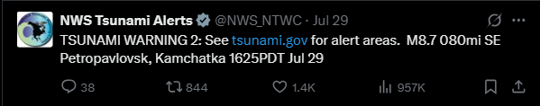

https://x.com/NWS_NTWC/status/1950368641121173752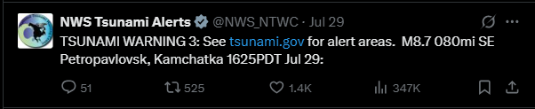

[https://x.com/NWS_NTWC/status/1950383386578866439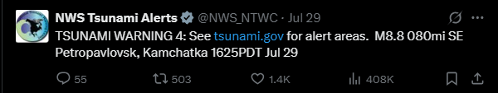https://x.com/NWS_NTWC/status/1950401466369237104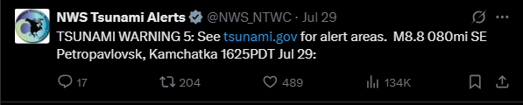https://x.com/NWS_NTWC/status/1950413297993277658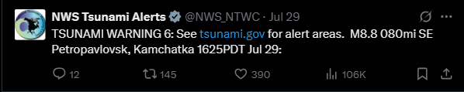https://x.com/NWS_NTWC/status/1950428092725370898](https://x.com/NWS_NTWC/status/1950383386578866439*https://x.com/NWS_NTWC/status/1950401466369237104*https://x.com/NWS_NTWC/status/1950413297993277658*https://x.com/NWS_NTWC/status/1950428092725370898)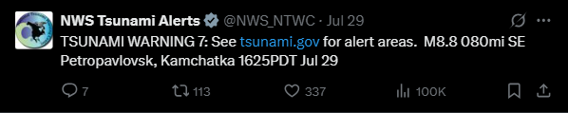

https://x.com/NWS_NTWC/status/1950442845837332703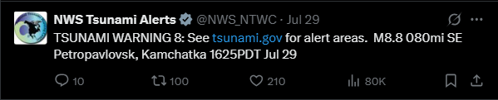https://x.com/NWS_NTWC/status/1950457239933771964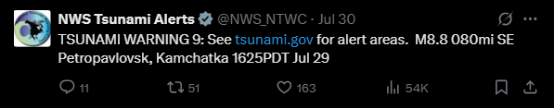

https://x.com/NWS_NTWC/status/1950472064093028837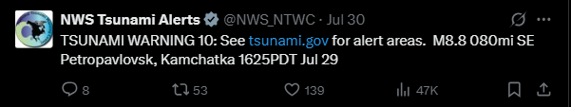https://x.com/NWS_NTWC/status/1950487402096599198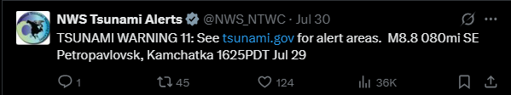

<https://x.com/NWS_NTWC/status/1950502788116742217>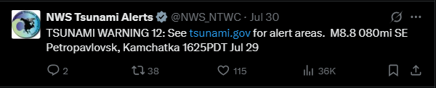

https://x.com/NWS_NTWC/status/1950517661831512239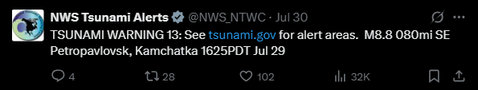https://x.com/NWS_NTWC/status/1950532286971056478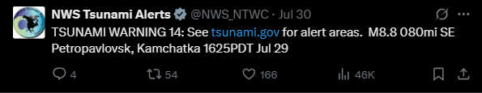https://x.com/NWS_NTWC/status/1950548218263064944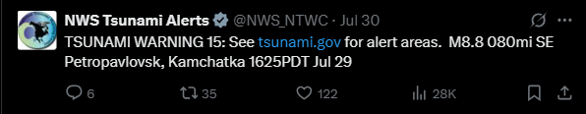

[https://x.com/NWS_NTWC/status/1950562351268376835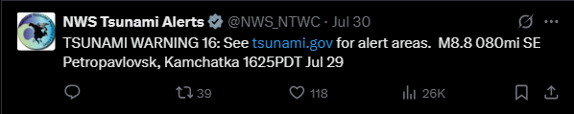https://x.com/NWS_NTWC/status/1950578275744366943](https://x.com/NWS_NTWC/status/1950562351268376835*https://x.com/NWS_NTWC/status/1950578275744366943)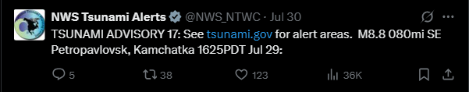

https://x.com/NWS_NTWC/status/1950596491321487573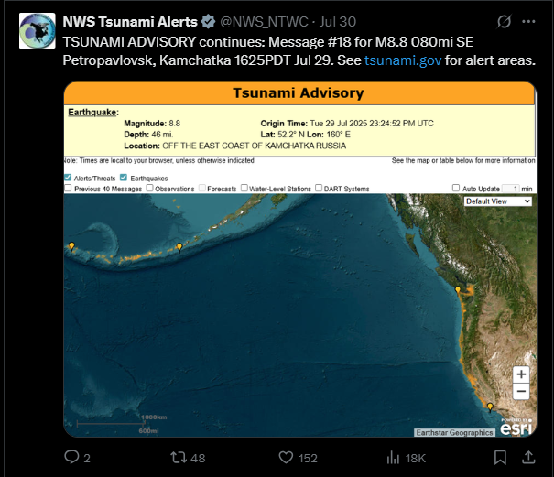https://x.com/NWS_NTWC/status/1950610667616239865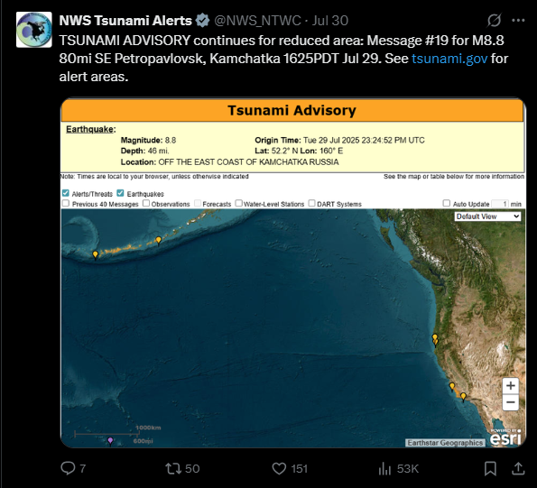

https://x.com/NWS_NTWC/status/1950625111653880196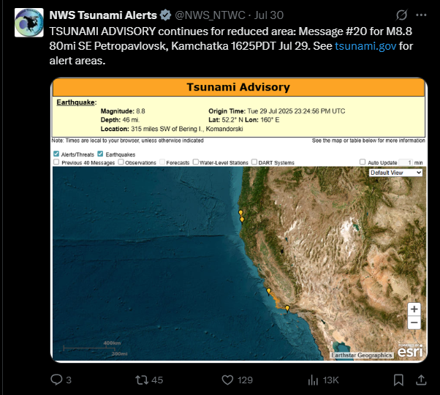https://x.com/NWS_NTWC/status/1950644082864443423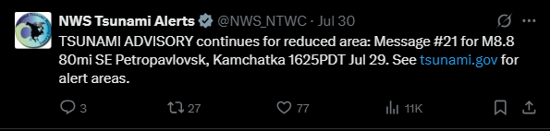

https://x.com/NWS_NTWC/status/1950653537974927851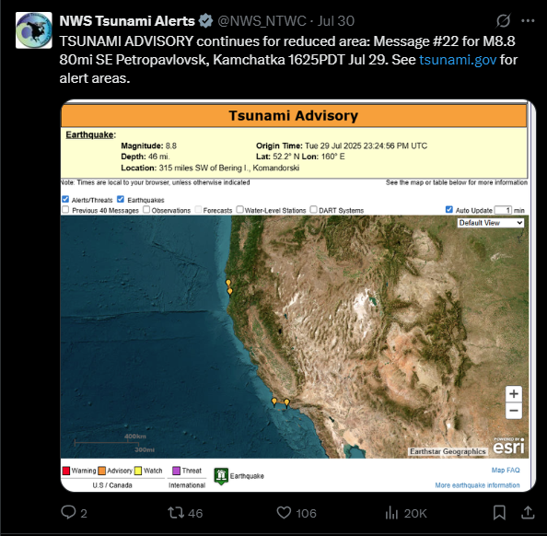https://x.com/NWS_NTWC/status/1950670824278815048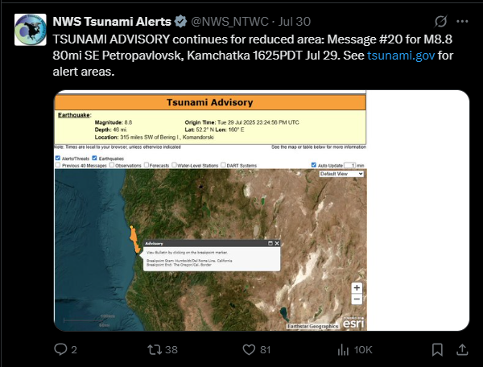

https://x.com/NWS_NTWC/status/1950684331367960902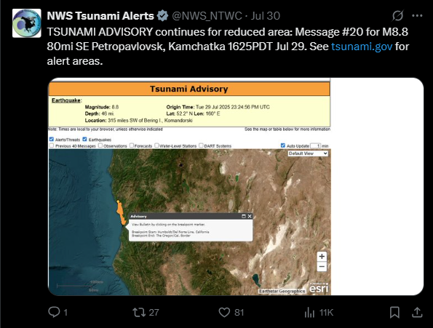

https://x.com/NWS_NTWC/status/1950698757797879983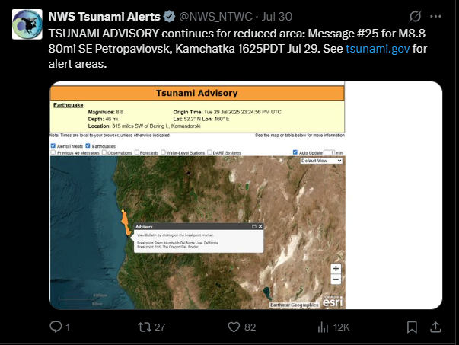https://x.com/NWS_NTWC/status/1950716053954109575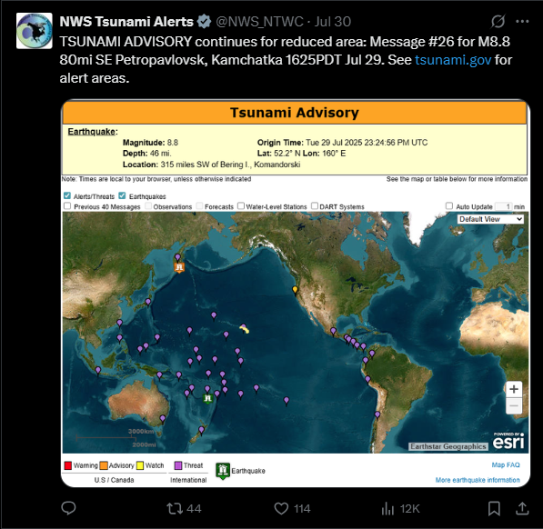

https://x.com/NWS_NTWC/status/1950730954240102725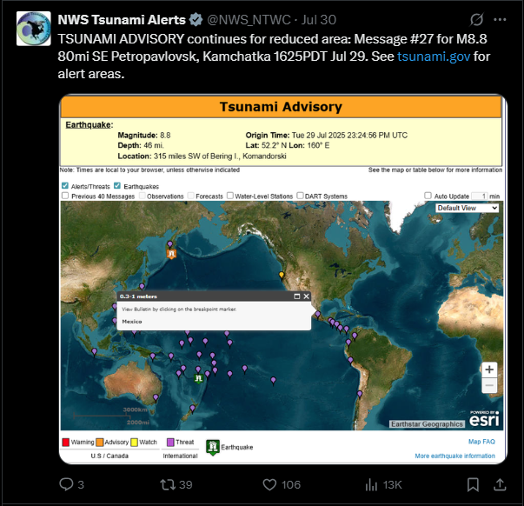https://x.com/NWS_NTWC/status/1950762441069195695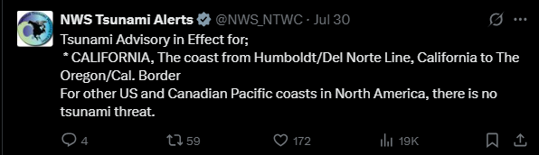

https://x.com/NWS_NTWC/status/1950777505717293475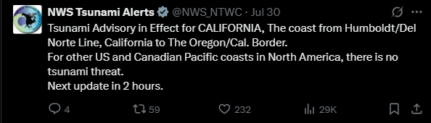https://x.com/NWS_NTWC/status/1950805254481510593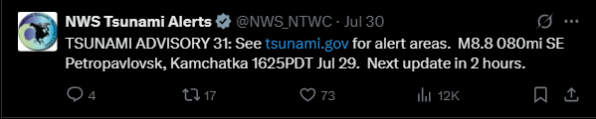https://x.com/NWS_NTWC/status/1950838703024414920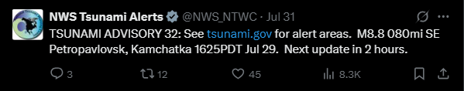https://x.com/NWS_NTWC/status/1950864670102896901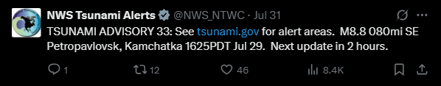https://x.com/NWS_NTWC/status/1950894954928132170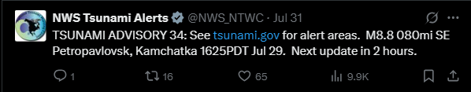

https://x.com/NWS_NTWC/status/1950924372899991616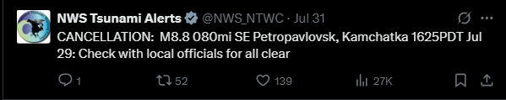

https://x.com/NWS_NTWC/status/1951043246710476859