

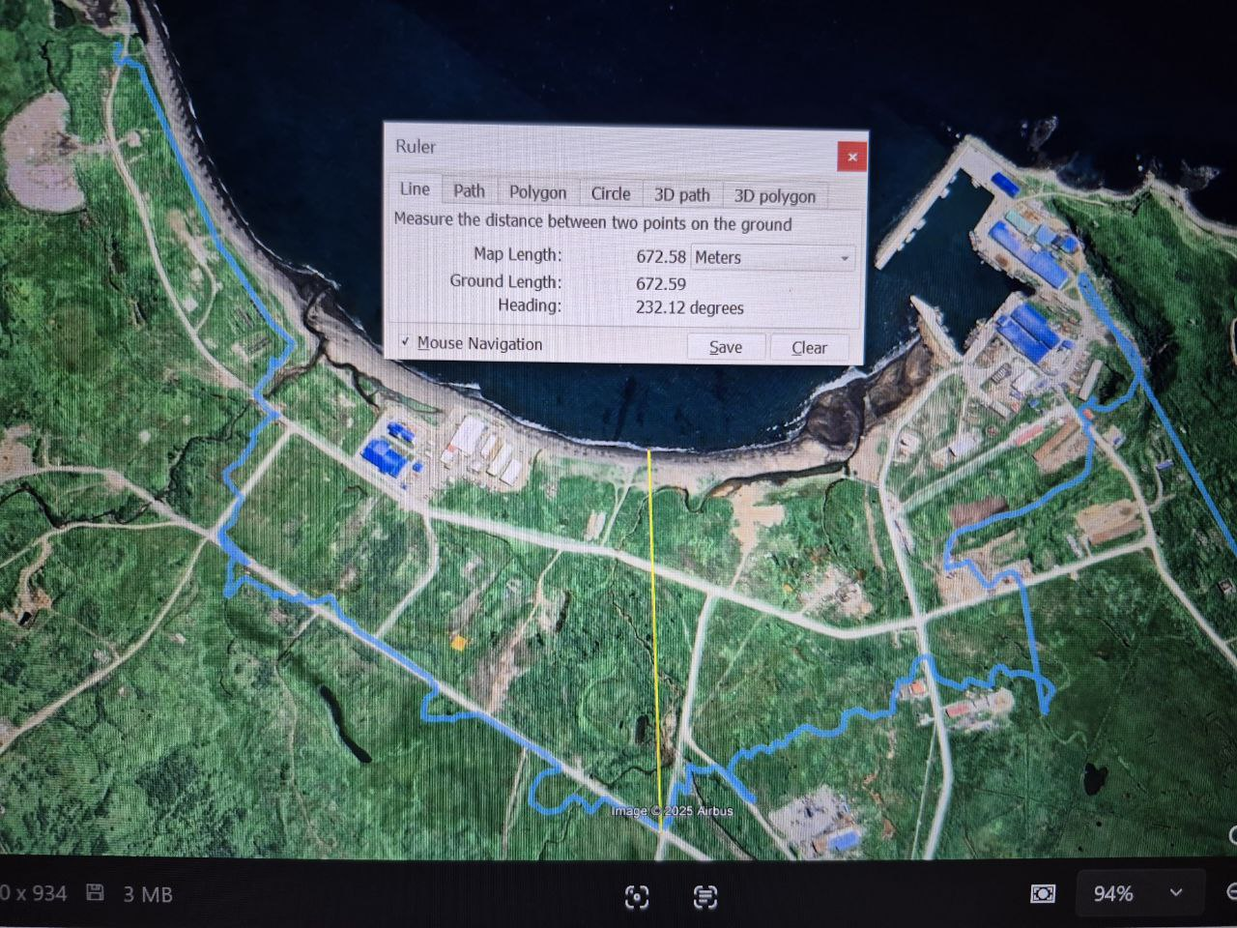

Dear TSUNAMI BB Colleagues,

The following is the short report, which presents the data from the post tsunami field survey after the tsunami (29.07.2025) in Severo-Kurilsk (Paramushir Island, Northern Kuriles) conducted at Severo Kurislky Morskoy port (156.140176oE 50.6790oN). The survey was conducted on August 1, 2025

Using high-precision GPS, we traced the track along the line of maximum flooding (blue line in the Figure). Then the data was superimposed on a high-resolution topographic survey. Note that the topographic survey data is relative to the zero tide level (Baltic system). The tsunami wave arrived during low tide. The level of tidal fluctuations was 1 m or more on Paramushir Island.

As you can see, the maximum runup height (splash) is 17 m.

Tatiana Kotenko [kotenko@sakhalin.ru](mailto:kotenko@sakhalin.ru)

Andrey Zaytsev [aizaytsev@mail.ru](mailto:aizaytsev@mail.ru)

Efim Pelinovsky [pelinovsky@gmail.com](mailto:pelinovsky@gmail.com)