**Pierce County and Southeast Appling County Georgia Christmas Eve Tornado**

...STORM SURVEY FOR THE PIERCE COUNTY AND SOUTHEAST APPLING COUNTY GEORGIA EF-1 TORNADO...

RATING: EF-1

PATH LENGTH /STATUTE/: 9.64 MILES

PATH WIDTH /MAXIMUM/: 60-100 YARDS

FATALITIES: 0

INJURIES: 0

START DATE: DEC 24 2014

START TIME: 1250 PM EST

START LOCATION: 8 MILES NORTH OF BLACKSHEAR / PIERCE / GA

LAT/LON: 31.406 / -82.251

END LOCATION: 8 MILES NORTH OF PATTERSON / APPLING / GA

END_LAT/LON: 31.505 / -82.137

[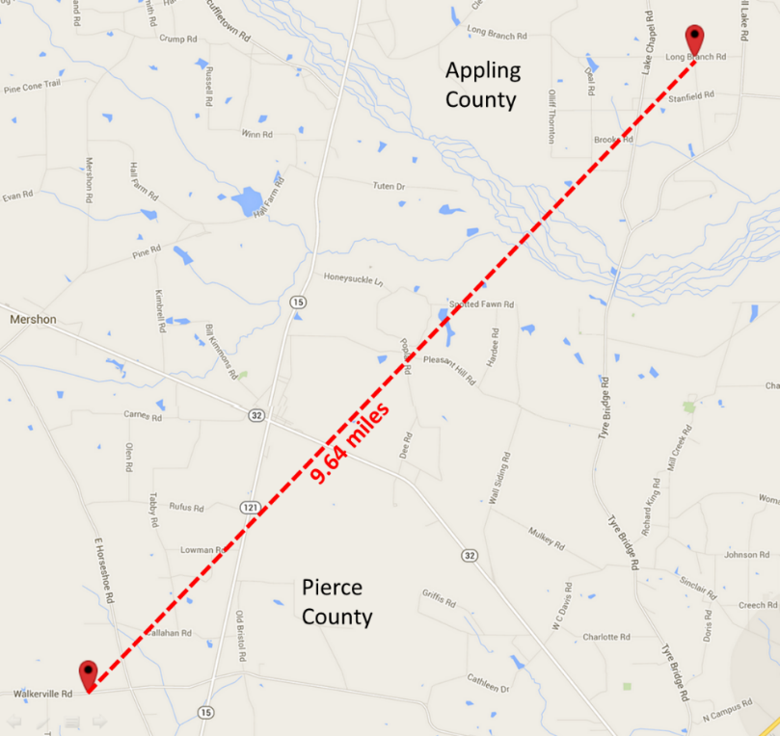](https://web.archive.org/web/20210403032325/http:/nws.weather.gov/blog/nwsjacksonville/wp-content/uploads/sites/7/2014/12/Updatedmap31Dec2014.png)

SURVEY SUMMARY: THE NATIONAL WEATHER SERVICE IN JACKSONVILLE CONDUCTED A STORM SURVEY LATE CHRISTMAS EVE AFTERNOON IN PIERCE COUNTY AND APPLING COUNTY GEORGIA. THE METEOROLOGIST IN CHARGE CONDUCTED THE SURVEY...DETERMINING THAT THE TORNADO TOUCHED DOWN APPROXIMATELY 8 MILES TO THE NORTH OF BLACHSHEAR ALONG WALKERVILLE ROAD IN BETWEEN TAYLOR FARM ROAD AND EAST HORSESHOE ROAD AROUND 1250 PM EST. LOW-END EF-1 DAMAGE WITH TORNADIC WINDS OF 100 TO 105 MPH WAS NOTED ALONG THE TORNADO PATH AS IT CROSSED GEORGIA STATE ROAD 121/15 INTO BRISTOL...INCLUDING DAMAGE TO 7 HOMES... POWERLINES DOWNED...AND LARGE TREES SNAPPED. EF-0 DAMAGE WAS NOTED AFTER THE TORNADO CROSSED GEORGIA STATE ROAD 121/15...WITH THE TORNADO CONTINUING ITS PATH NEAR SPOTTED FARM ROAD AND SONGBIRD PLACE...OR ABOUT 14 MILES NORTH OF BLACKSHEAR...THE TORNADO CONTINUED TO MOVE NORTHEAST CROSSING SALTILLA CREEK INTO SOUTHEAST APPLING COUNTY INTO THE LONG BRANCH COMMUNITY. THE MAXIMUM WIDTH OF THE TORNADO WAS ESTIMATED TO BE 60-100 YARDS. PIERCE COUNTY EMERGENCY MANAGEMENT REPORTED NUMEROUS POWER OUTAGES IN THE VICINITY OF THE TORNADO. A SKYWARN SPOTTER IN APPLING COUNTY REPORTED TREES DOWNED, DEBRIS IN YARDS, ROOF OFF OF FARMING EQUIPMENT, LARGE SHINGLES OFF OF A LARGE PORTION OF A ROOF AND A SNAPPED POWER POLE. [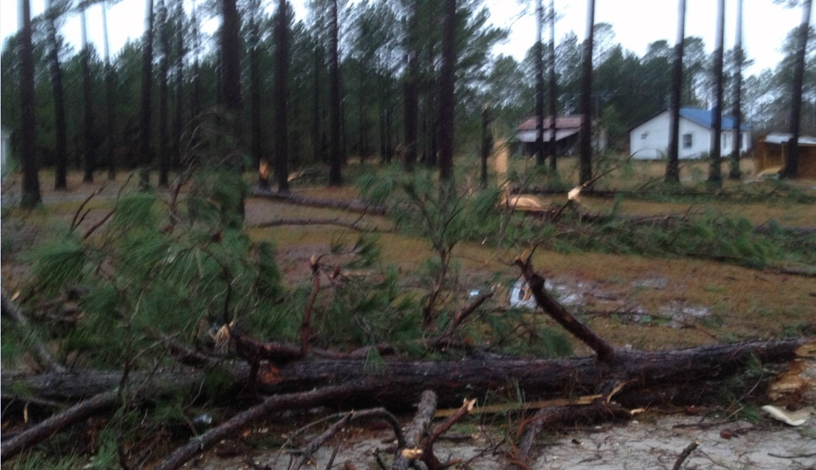](https://web.archive.org/web/20210403032325/http:/nws.weather.gov/blog/nwsjacksonville/wp-content/uploads/sites/7/2014/12/photo.jpg) [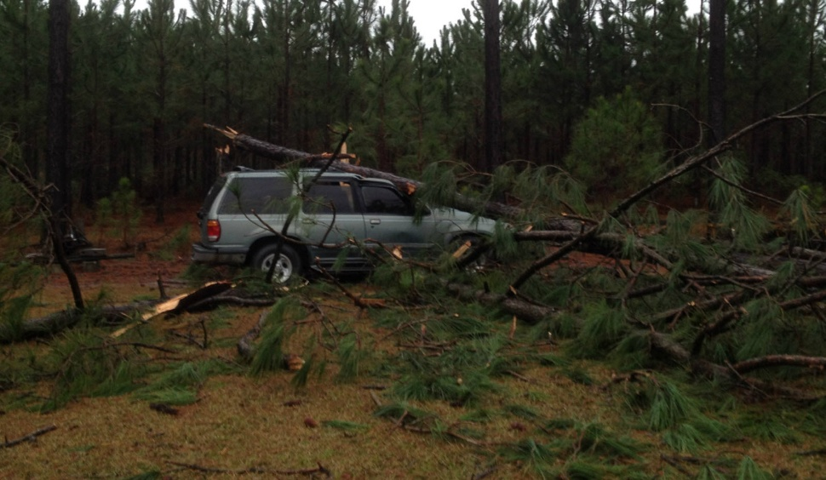](https://web.archive.org/web/20210403032325/http:/nws.weather.gov/blog/nwsjacksonville/wp-content/uploads/sites/7/2014/12/PIC2.jpg) [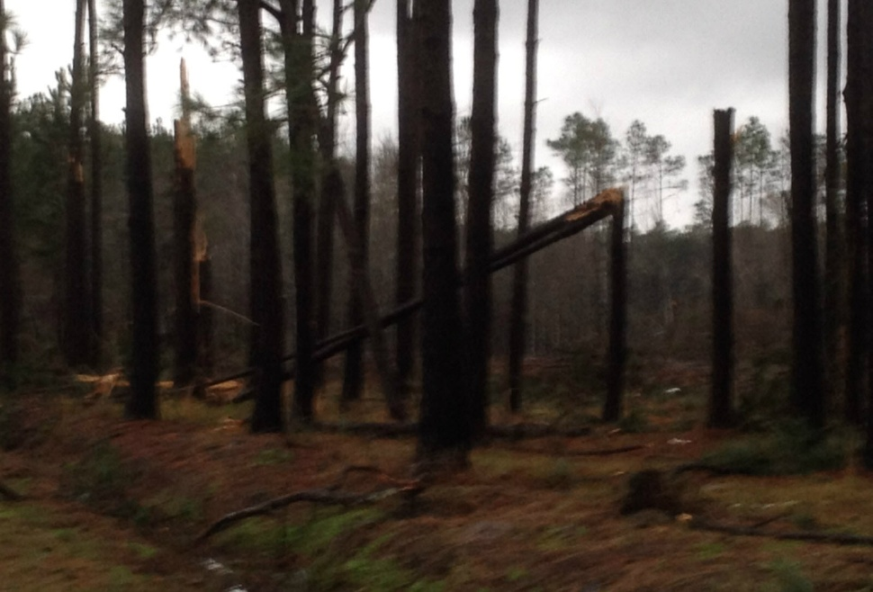](https://web.archive.org/web/20210403032325/http:/nws.weather.gov/blog/nwsjacksonville/wp-content/uploads/sites/7/2014/12/PIC4.jpg)

[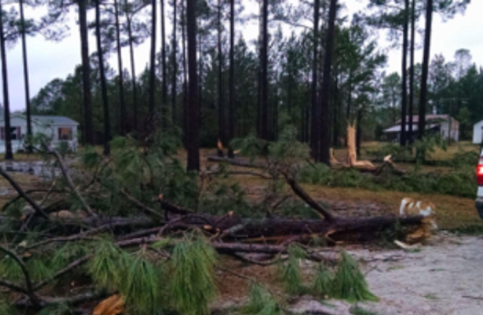](https://web.archive.org/web/20210403032325/http:/nws.weather.gov/blog/nwsjacksonville/wp-content/uploads/sites/7/2014/12/pic5.png) [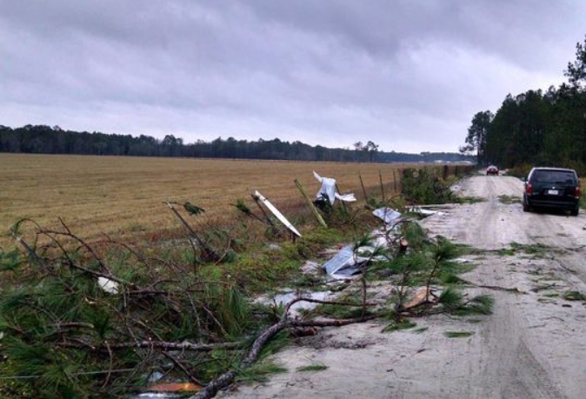](https://web.archive.org/web/20210403032325/http:/nws.weather.gov/blog/nwsjacksonville/wp-content/uploads/sites/7/2014/12/pic6.png) [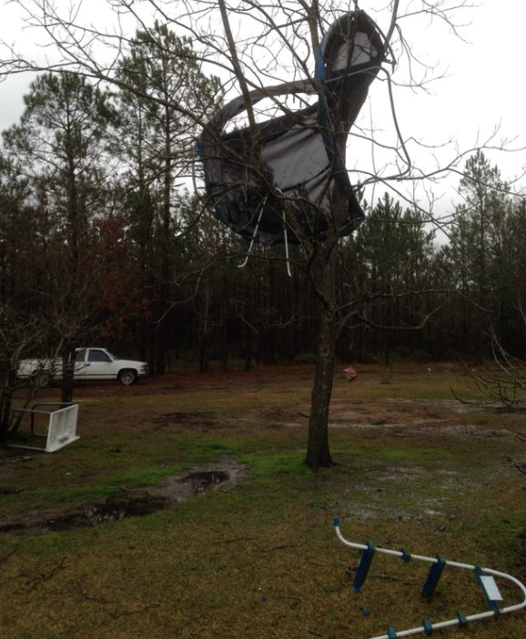](https://web.archive.org/web/20210403032325/http:/nws.weather.gov/blog/nwsjacksonville/wp-content/uploads/sites/7/2014/12/pic7.png) [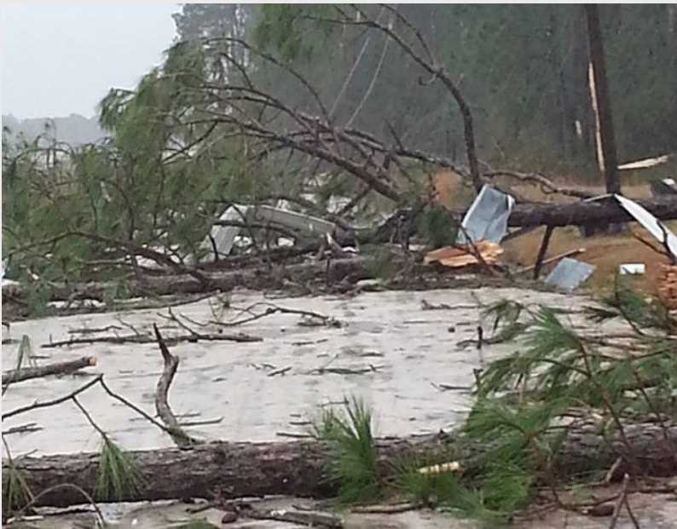](https://web.archive.org/web/20210403032325/http:/nws.weather.gov/blog/nwsjacksonville/wp-content/uploads/sites/7/2014/12/pic8.png)

[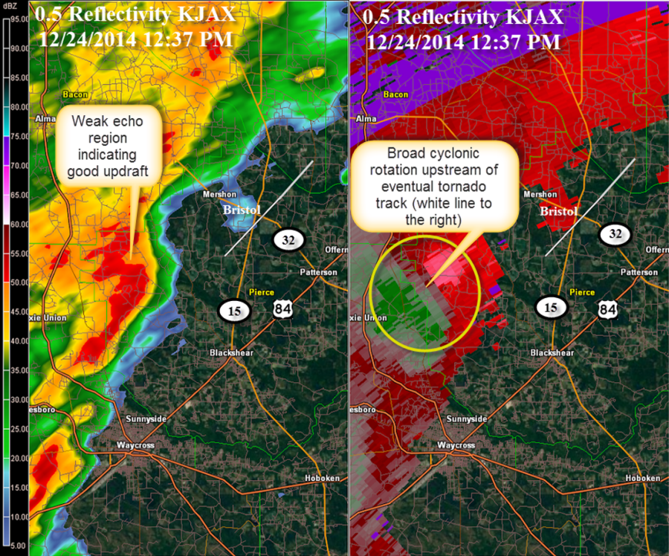](https://web.archive.org/web/20210403032325/http:/nws.weather.gov/blog/nwsjacksonville/wp-content/uploads/sites/7/2014/12/1237PM_KJAX_24Dec2014_SRM_Reflectivity_Update.png)

[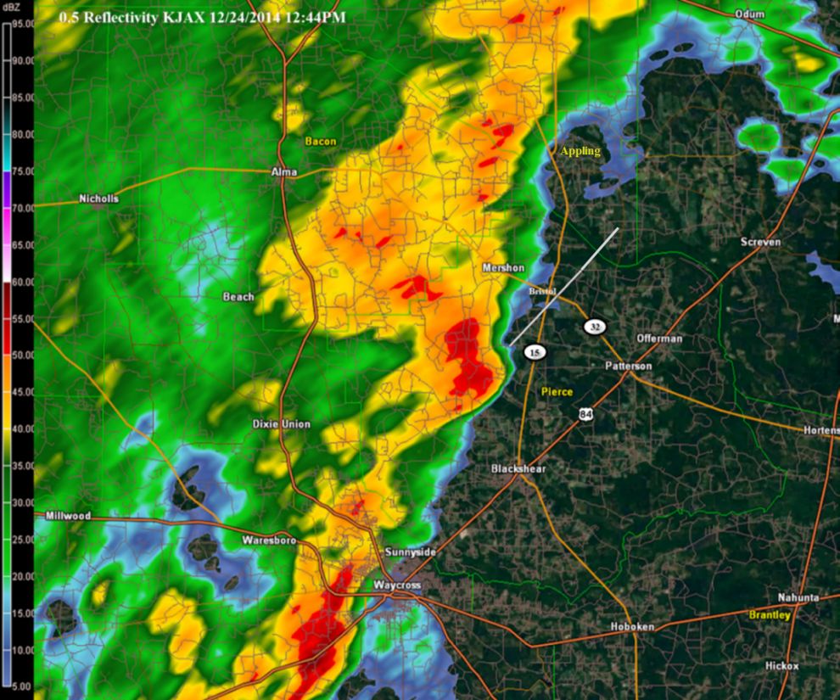](https://web.archive.org/web/20210403032325/http:/nws.weather.gov/blog/nwsjacksonville/wp-content/uploads/sites/7/2014/12/24Dec2014_1244PM_0.5ReflectivityKJAX_Update.png)

[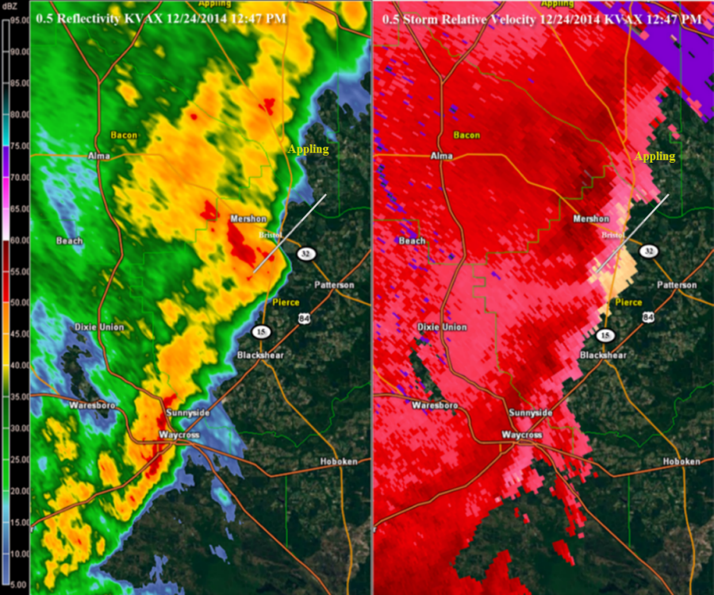](https://web.archive.org/web/20210403032325/http:/nws.weather.gov/blog/nwsjacksonville/wp-content/uploads/sites/7/2014/12/1247PM_KVAX_24Dec2014_SRM_Reflectivity_Update.png)