**Bacon County, Georgia January 4 EF-1 Tornado**

…STORM SURVEY FOR THE BACON COUNTY GEORGIA EF-1 TORNADO…

RATING:                 EF-1  
PATH LENGTH /STATUTE/:  6.2 MILES (10 KM)  
PATH WIDTH /MAXIMUM/:   30-50 YARDS  
FATALITIES:             0  
INJURIES:               2 (1 CRITICAL)

START DATE:             JAN 4 2015  
START TIME:             103 PM EST  
START LOCATION:         3 MILES ESE OF ALMA / BACON / GA  
LAT/LON:                31.5345 / -82.4286  
END LOCATION:           3 MILES NE OF NEW LACY / BACON / GA  
END_LAT/LON:            31.5719 / -82.3597

[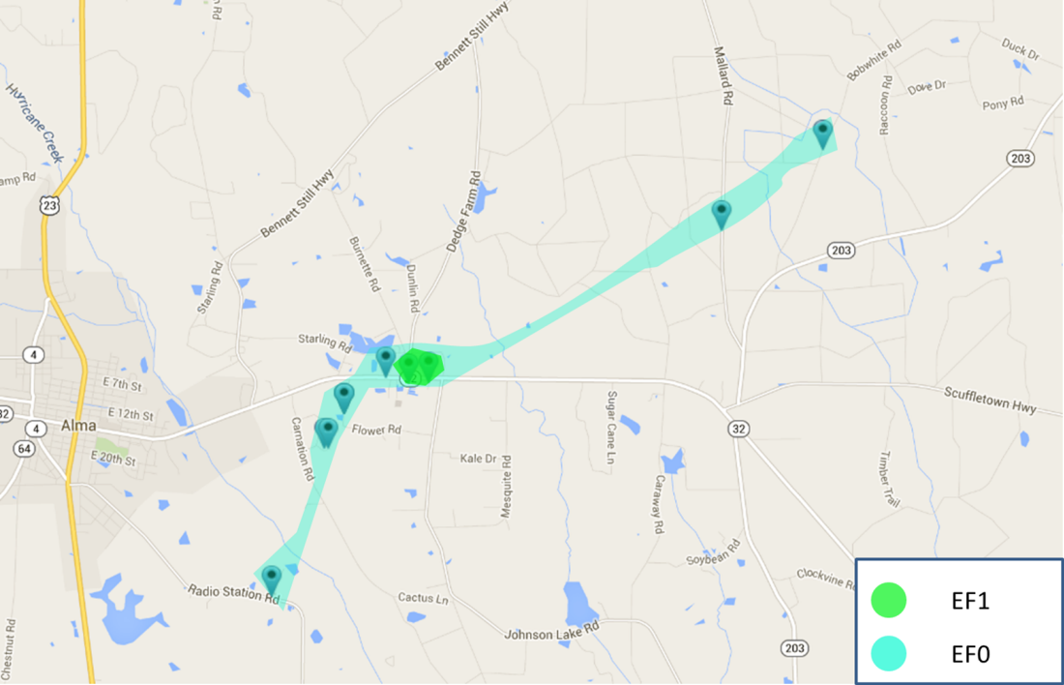](https://web.archive.org/web/20210402025322/http:/nws.weather.gov/blog/nwsjacksonville/wp-content/uploads/sites/7/2015/01/tornado-path1.png)

SURVEY SUMMARY: THE NATIONAL WEATHER SERVICE IN JACKSONVILLE  
CONDUCTED A STORM SURVEY ON JANUARY 5TH IN BACON COUNTY GEORGIA. OUR  
WARNING COORDINATION METEOROLOGIST CONDUCTED THE SURVEY…WITH ALMA-BACON  
COUNTY EMERGENCY MANAGEMENT…DETERMINING THAT THE TORNADO TOUCHED DOWN  
APPROXIMATELY 3 MILES EAST-SOUTHEAST OF ALMA NEAR RADIO STATION ROAD  
AROUND 103 PM EST JANUARY 4, 2015. HIGH END EF-1 DAMAGE WAS NOTED AND  
CONFINED ALONG THE TORNADO PATH EAST OF JOHNSON LAKE ROAD ALONG GEORGIA  
STATE ROAD 32. IN THIS PATH OF THE TORNADO THERE WERE TWO MOBILE  
HOMES THAT HAD ENHANCED DAMAGE INCLUDING A DOUBLEWIDE TRAILOR WHERE THE  
WALLS WERE SEPARATED…FRAME BENT AND FLIPPED ON ITS SIDE. THERE WERE  
ALSO LARGE TREES SNAPPED ALONG THE PATH. EF-0 DAMAGE WAS NOTED ALONG  
MOST OF THE PATH AS THE TORNADO WENT FROM RADIO STATION ROAD TO MCCARTY  
LANE TO FLOWER ROAD…WITH THE TORNADO STRENGTHENING TO EF-1 INTENSITY  
AS THE STORM APPROACHED GEORGIA STATE ROAD 32. THE TORNADO CONTINUED TO  
MOVE NORTHEAST AND WEAKENED AS IT CROSSED TEN MILE CREEK INTO MALLARD  
ROAD AND TERMINATED ITS TRACK BY BOBWHITE ROAD. THE MAXIMUM WIDTH OF  
THE TORNADO WAS ESTIMATED TO BE 30 TO 50 YARDS NEAR GEORGIA STATE ROAD  
32. BACON COUNTY EMERGENCY MANAGEMENT REPORTED THAT 2 MOBILE HOMES WERE  
DESTROYED WITH TWO INJURIES…ONE WAS CRITICAL IN THE VICINITY OF WHEN  
THE TORNADO WAS THE STRONGEST AS AN EF-1…WITH WINDS OF 100 TO 110  
MPH. THE ONE CRITICAL INJURY WAS FEMALE AND HAD TO BE LIFE-FLIGHTED TO  
SAVANNAH.

[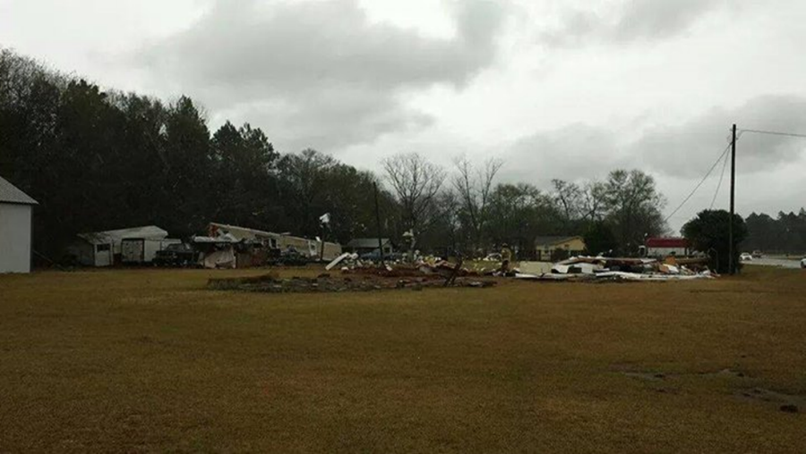](https://web.archive.org/web/20210402025322/http:/nws.weather.gov/blog/nwsjacksonville/wp-content/uploads/sites/7/2015/01/PIC11.png)

[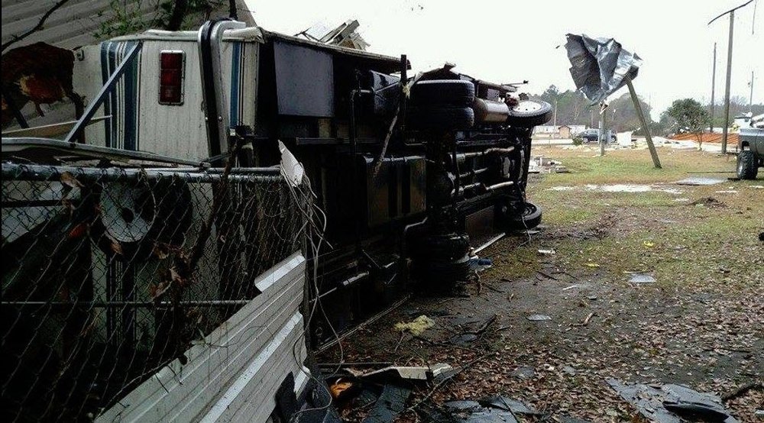](https://web.archive.org/web/20210402025322/http:/nws.weather.gov/blog/nwsjacksonville/wp-content/uploads/sites/7/2015/01/PIC21.png)

[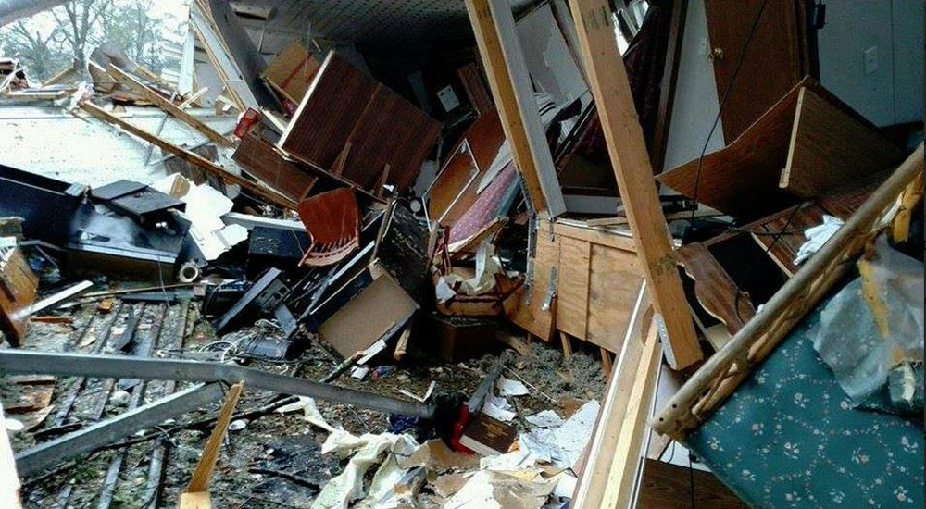](https://web.archive.org/web/20210402025322/http:/nws.weather.gov/blog/nwsjacksonville/wp-content/uploads/sites/7/2015/01/PIC31.png)

Below is a home video of a possible tornado that moved through Bacon County east of Alma. This video was sent by WSAV in Savannah via one of their TV viewers.

Bacon County falls “in between” Doppler Radar sites at Moody Air Force Base near Valdosta, GA, Jacksonville, FL, and Robins Air Force Base near Warner Robins, GA.  The closest radar data to this event was from Moody Air Force Base, with the lowest available scan sampling data from more than 4,000 feet above the ground in Bacon County.  Storm relative velocity scans from the Moody Air Force Base Doppler Radar revealed at least two short-lived and broad rotational signatures in Bacon County at the time of the tornado. Much of the rotation within this broken squall line of showers and thunderstorms moving through Bacon County was likely occurring below 4000 feet.

[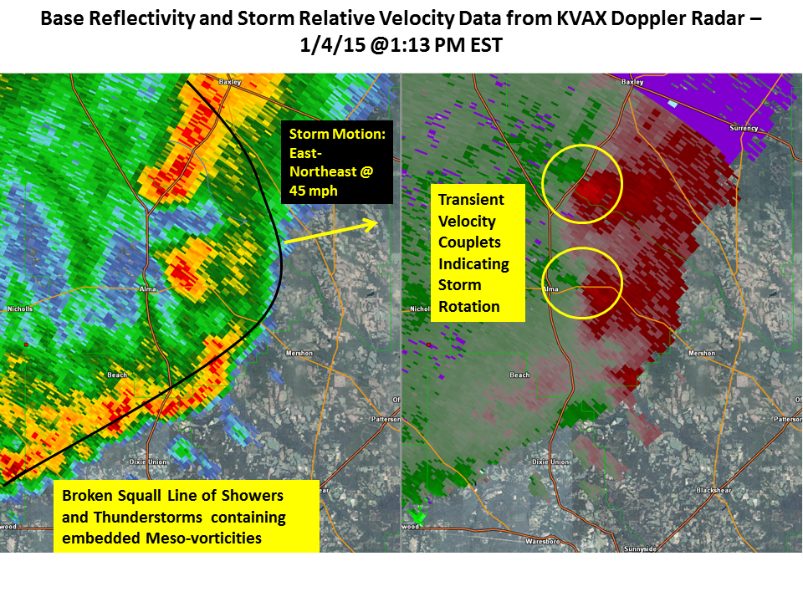](https://web.archive.org/web/20210402025322/http:/nws.weather.gov/blog/nwsjacksonville/wp-content/uploads/sites/7/2015/01/VAX_Radar.png)