**…NWS DAMAGE SURVEY RESULT FOR 4/19/15 COFFEE COUNTY TORNADO EVENT…**

NWS METEOROLOGISTS HAVE CONFIRMED A TORNADO ACROSS CENTRAL COFFEE COUNTY GEORGIA FROM THE AFTERNOON OF SUNDAY APRIL 19 2015. NWS JACKSONVILLE FLORIDA WOULD LIKE TO EXPRESS APPRECIATION TO COFFEE COUNTY EMA DIRECTOR FOR ASSISTING OUR TEAM DURING THE SURVEY WHERE HE WAS INSTRUMENTAL IN OUR RURAL COMMUTE ACROSS SATURATED DIRT ROADS OF THE COUNTY AND HELPING US IDENTIFY AND PIN POINT DAMAGE ALONG THE TORNADO PATH LIST BELOW. ALSO…THANK YOU TO THE COFFEE COUNTY GEORGIA POLICE SCANNER FACEBOOK PAGE FOR SOME OF THE PHOTOS FROM THE TORNADO.

THE TORNADO WAS SPAWNED AND MIGRATED OVER WEST CENTRAL COFFEE  COUNTY IN THE RURAL OUTSKIRTS WEST OF THE CITY OF DOUGLAS GEORGIA BY A SHORT-LIVED SUPERCELL THUNDERSTORM. THERE WAS DAMAGE TO HOUSE SIDING, SHALLOW ROOTED PINES WERE PUSH OVER, LARGE BRANCHES WERE BROKEN OFF TREES, MINOR ROOF DAMAGE, AND LOSS OF WOOD AND METAL PANELS ON SMALL FARM OUTBUILDINGS.

RATING:                                             EF-0  
ESTIMATED PEAK WINDS:  75-85 MPH  
PATH LENGTH/STATUTE:     4.0 MILES  
PATH WIDTH/MAXIMUM:   60 YARDS  
FATALITIES:                                     0  
INJURIES:                                         0

START DATE:                     APRIL 19 2015  
START TIME:                     201 PM EDT  
START LOCATION:       6 MILES SSE OF AMBROSE  
START LAT/LON:           31.514679/-82.960982

END DATE:                       APRIL 19 2015  
END TIME:                       205 PM EDT  
END LOCATION:         5 MILES SSW OF BROXTON  
END LAT/LON:              31.547234/-82.906651

[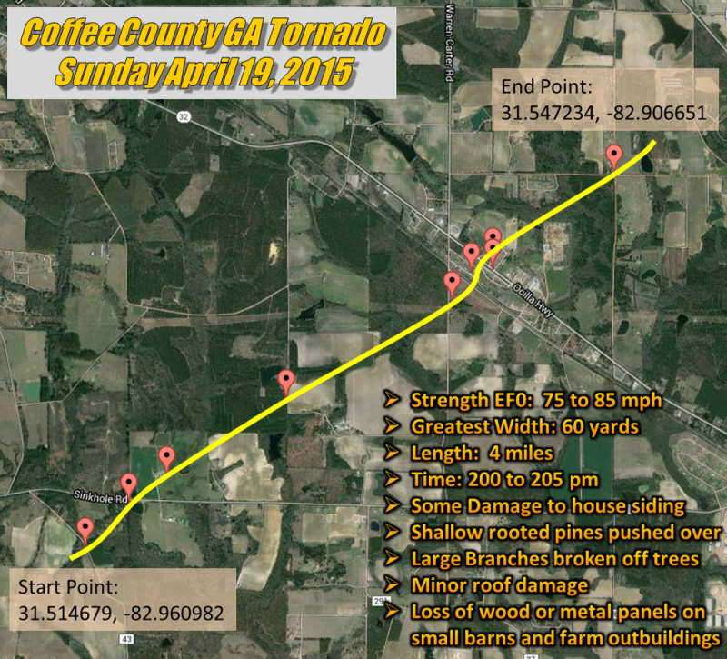](https://web.archive.org/web/20210403203343/http:/nws.weather.gov/blog/nwsjacksonville/wp-content/uploads/sites/7/2015/04/COFFEE1.png)

[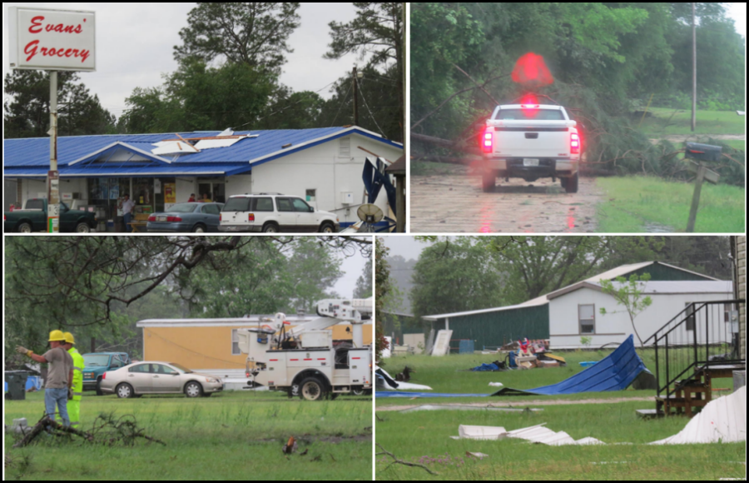](https://web.archive.org/web/20210403203343/http:/nws.weather.gov/blog/nwsjacksonville/wp-content/uploads/sites/7/2015/04/COFFEE3.png) [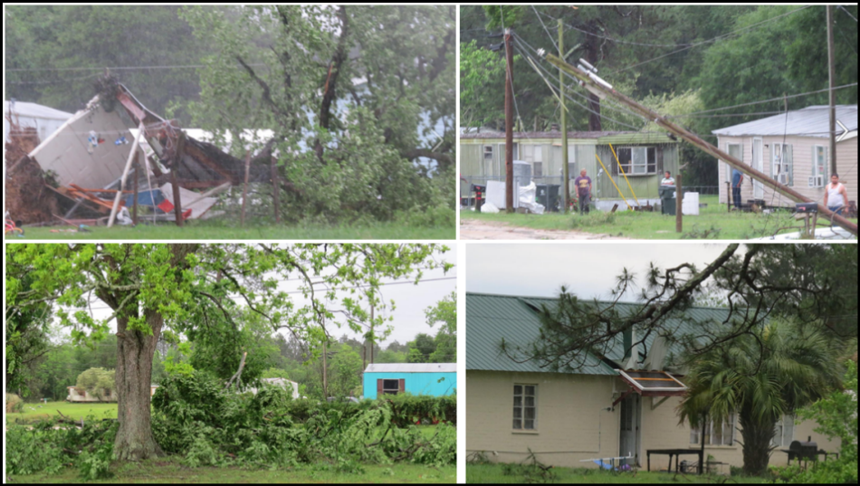](https://web.archive.org/web/20210403203343/http:/nws.weather.gov/blog/nwsjacksonville/wp-content/uploads/sites/7/2015/04/COFFEE4.png) [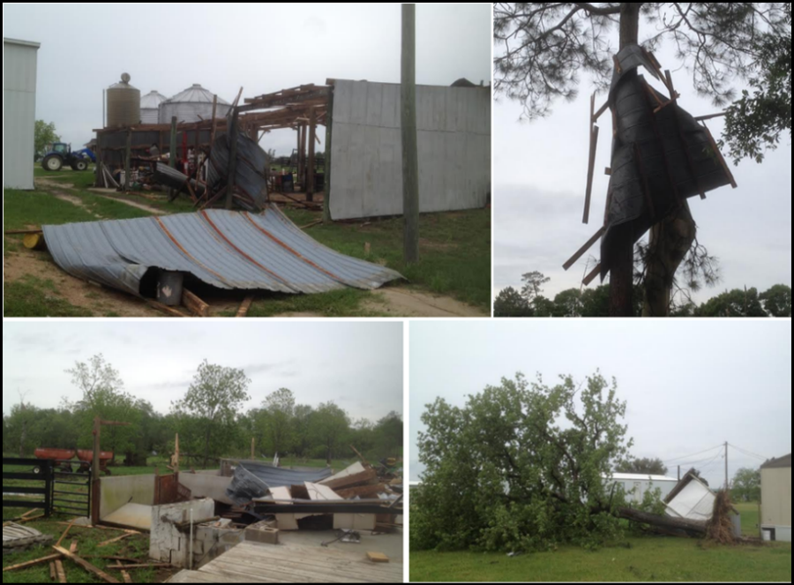](https://web.archive.org/web/20210403203343/http:/nws.weather.gov/blog/nwsjacksonville/wp-content/uploads/sites/7/2015/04/COFFEE5.png) [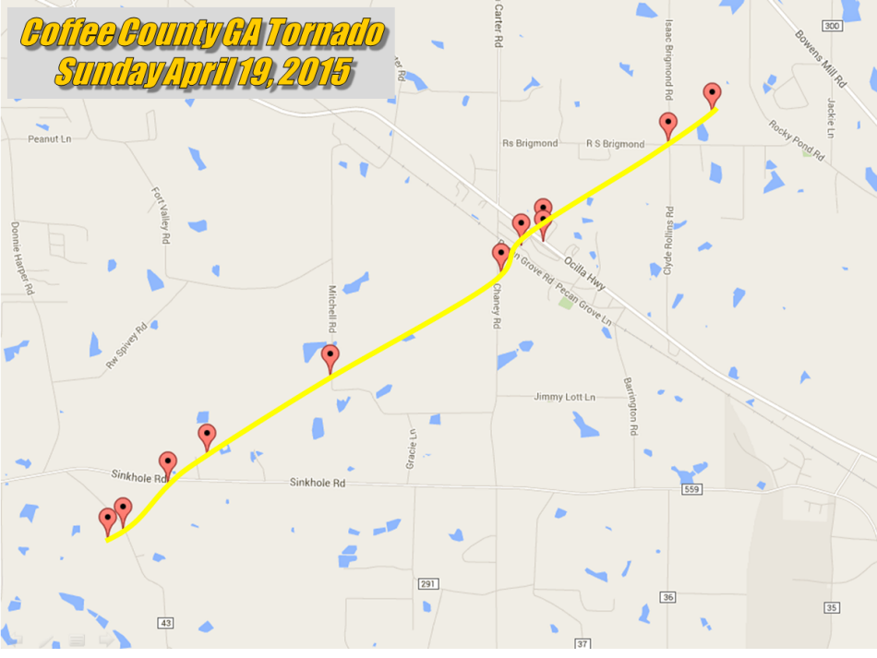](https://web.archive.org/web/20210403203343/http:/nws.weather.gov/blog/nwsjacksonville/wp-content/uploads/sites/7/2015/04/COFFEE2.png)