**Storm Survey for Palm Cay (Marion County) EF-1 Tornado – April 20, 2015**[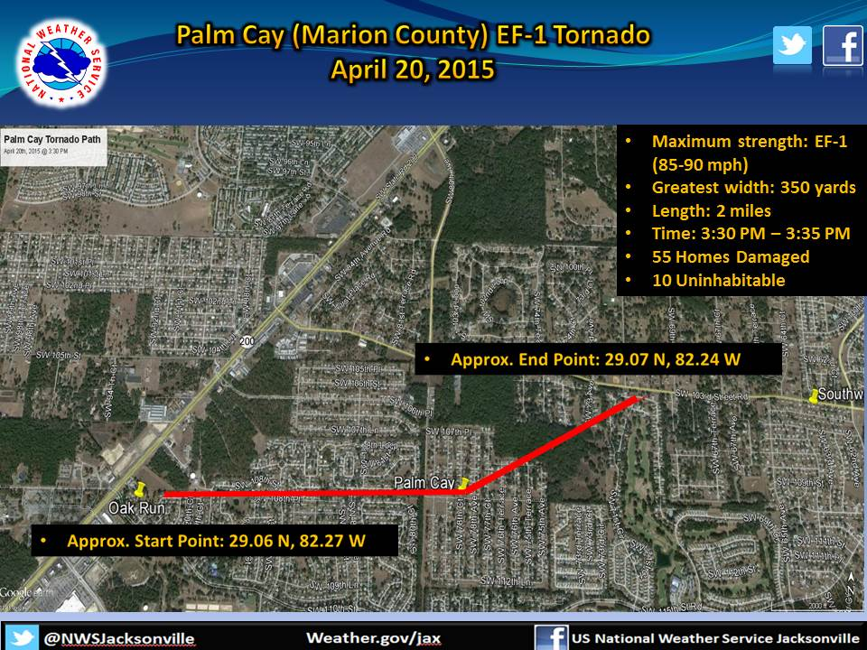](https://web.archive.org/web/20210403213659/http:/nws.weather.gov/blog/nwsjacksonville/wp-content/uploads/sites/7/2015/04/Damage_map.jpg)

NWS METEOROLOGISTS HAVE CONFIRMED A TORNADO ACROSS SOUTHWESTERN MARION COUNTY ON THE AFTERNOON OF MONDAY APRIL 20 2015. THE NATIONAL WEATHER SERVICE JACKSONVILLE WOULD LIKE TO EXPRESS APPRECIATION TO MARION COUNTY EMERGENCY  MANAGEMENT FOR ASSISTING OUR TEAM DURING THE SURVEY.

THE TORNADO TOUCHED DOWN SHORTLY AFTER 330 PM EDT MONDAY JUST EAST OF STATE ROAD 200 AT THE OAK RUN COUNTRY CLUB. SPOTTY EF-0 DAMAGE WAS NOTED THROUGHOUT THE OAK RUN COUNTRY CLUB NEIGHBORHOOD. THE TORNADO CONTINUED ON AN EAST TO EAST-NORTHEAST PATH INTO THE PALM CAY SUBDIVISION, REACHING ITS MAXIMUM INTENSITY OF EF-1.  SPOTTY EF-0 DAMAGE WAS NOTED JUST SOUTH OF SOUTHWEST 103RD STREET ROAD AT THE CONCLUSION OF THE TORNADO  
PATH, WHICH WAS APPROXIMATELY 2 MILES IN LENGTH. THE DURATION OF THIS TORNADO WAS LIKELY LESS THAN 5 MINUTES.  MARION COUNTY EMERGENCY MANAGEMENT REPORTS THAT 55 HOMES WERE DAMAGED, WITH 10 OF THOSE HOMES DEEMED UNINHABITABLE.

RATING: EF-1  
ESTIMATED PEAK WINDS: 85-90 MPH  
PATH LENGTH/STATUTE: 2.0 MILES  
PATH WIDTH/MAXIMUM: 350 YARDS  
FATALITIES: 0  
INJURIES: 0

START DATE: APRIL 20 2015  
START TIME: 331 PM EDT  
START LOCATION: 11.8 MILES SOUTHWEST OF OCALA  
START LAT/LON: 29.06087/-82.27132

END DATE: APRIL 20 2015  
END TIME: 335 PM EDT  
END LOCATION: 10.2 MILES SOUTHWEST OF OCALA  
END LAT/LON: 29.06900/-82.24051

[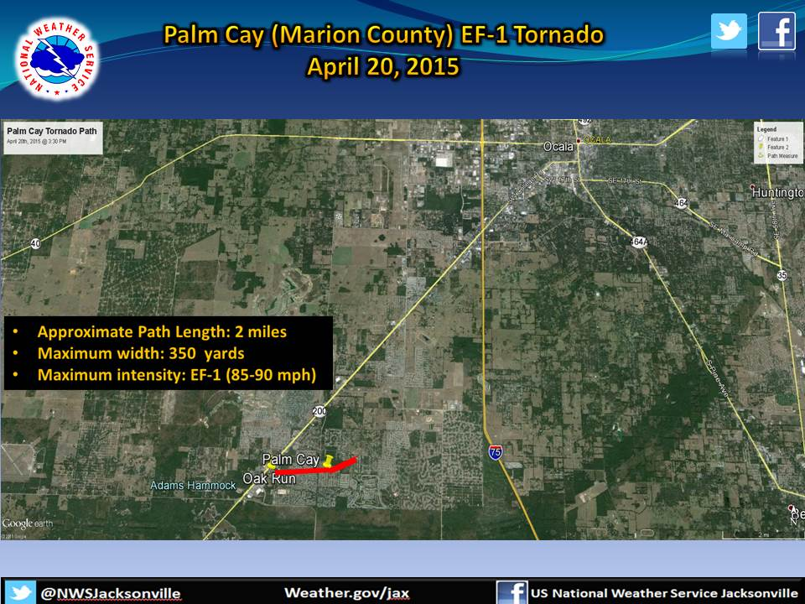](https://web.archive.org/web/20210403213659/http:/nws.weather.gov/blog/nwsjacksonville/wp-content/uploads/sites/7/2015/04/Damage_map_zoom_out.jpg)

We thank Marion County Emergency Management and WCJB-TV in Gainesville for providing the following photos of the damage caused by this EF-1 tornado:

[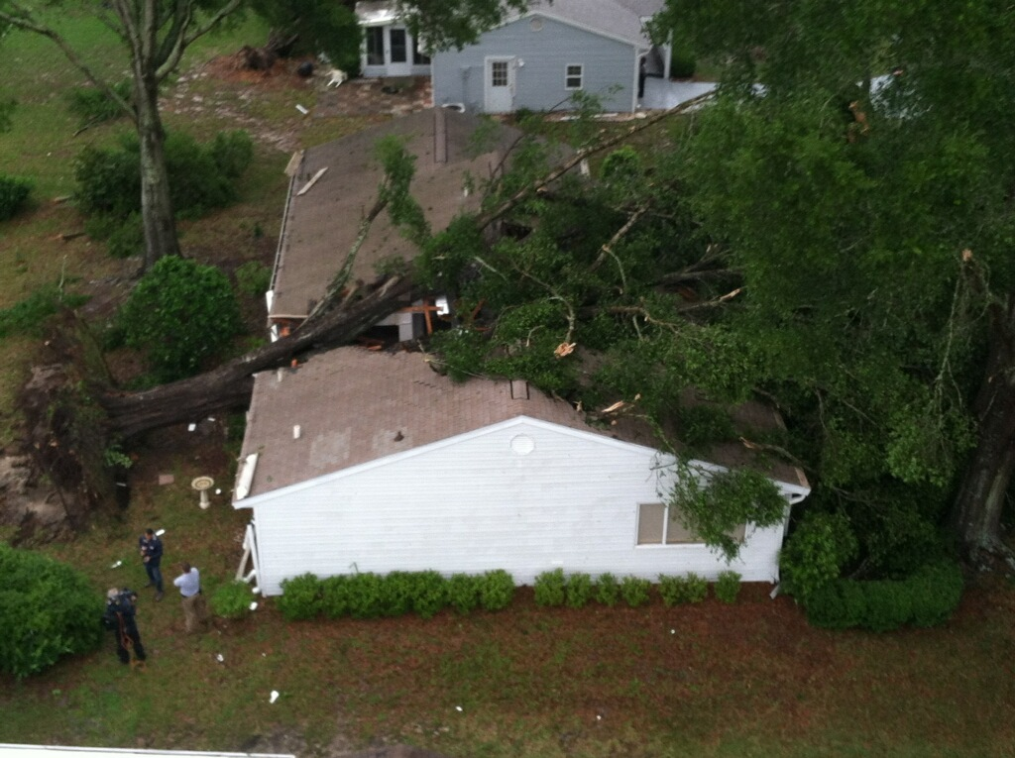](https://web.archive.org/web/20210403213659/http:/nws.weather.gov/blog/nwsjacksonville/wp-content/uploads/sites/7/2015/04/marion-tree-house-aerial-042015.jpg) [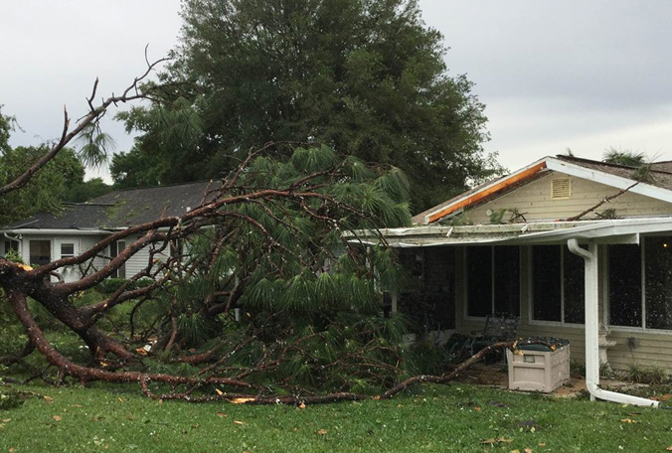](https://web.archive.org/web/20210403213659/http:/nws.weather.gov/blog/nwsjacksonville/wp-content/uploads/sites/7/2015/04/marion-storm-9-042115.jpg)

[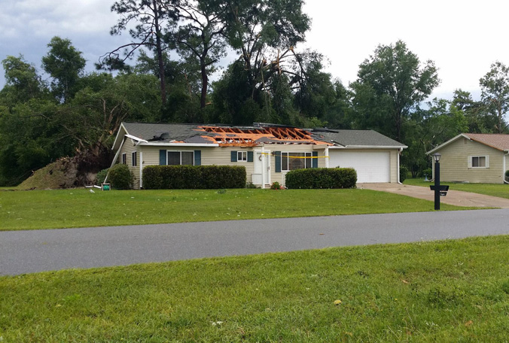](https://web.archive.org/web/20210403213659/http:/nws.weather.gov/blog/nwsjacksonville/wp-content/uploads/sites/7/2015/04/marion-storm-8-042115.jpg) [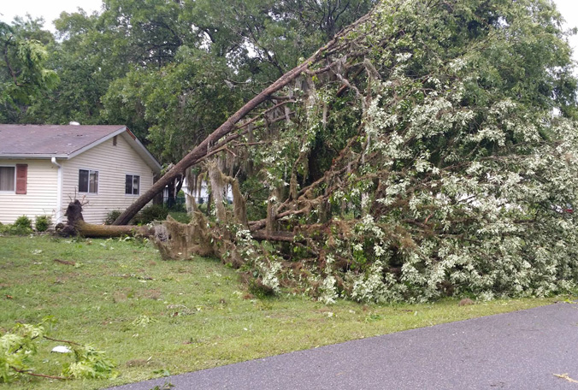](https://web.archive.org/web/20210403213659/http:/nws.weather.gov/blog/nwsjacksonville/wp-content/uploads/sites/7/2015/04/marion-storm-7-042115.jpg) [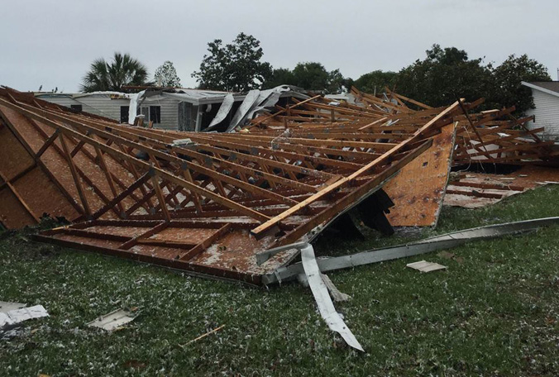](https://web.archive.org/web/20210403213659/http:/nws.weather.gov/blog/nwsjacksonville/wp-content/uploads/sites/7/2015/04/marion-storm-6-0421151.jpg)  [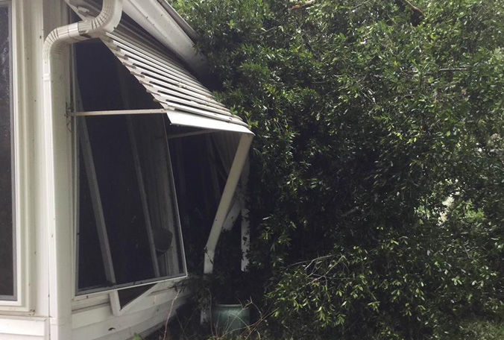](https://web.archive.org/web/20210403213659/http:/nws.weather.gov/blog/nwsjacksonville/wp-content/uploads/sites/7/2015/04/marion-storm-5-042115.jpg) [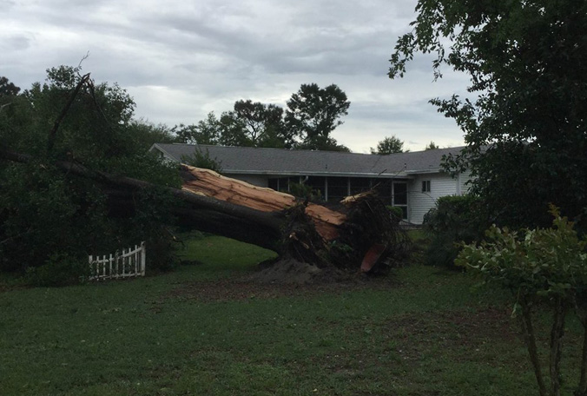](https://web.archive.org/web/20210403213659/http:/nws.weather.gov/blog/nwsjacksonville/wp-content/uploads/sites/7/2015/04/marion-storm-4-042115.jpg) [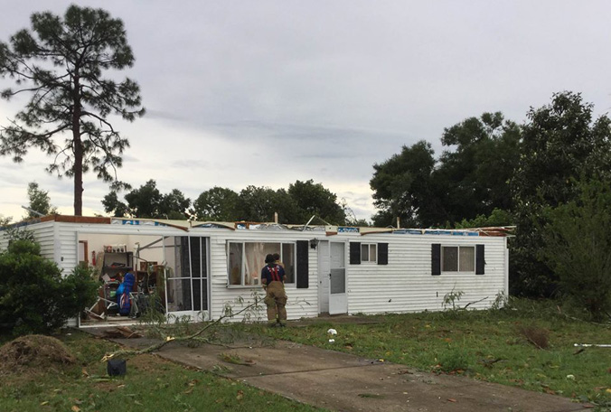](https://web.archive.org/web/20210403213659/http:/nws.weather.gov/blog/nwsjacksonville/wp-content/uploads/sites/7/2015/04/marion-storm-3-042115.jpg) [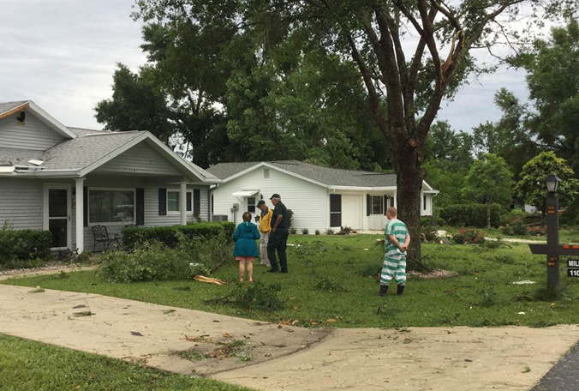](https://web.archive.org/web/20210403213659/http:/nws.weather.gov/blog/nwsjacksonville/wp-content/uploads/sites/7/2015/04/marion-storm-2-042115.jpg) [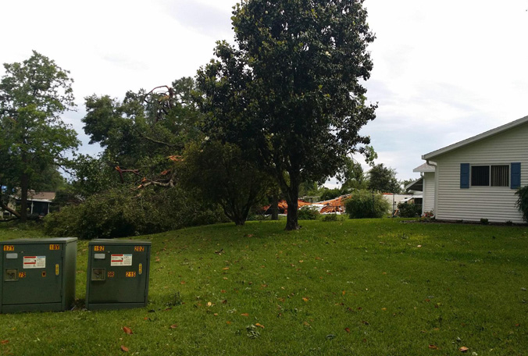](https://web.archive.org/web/20210403213659/http:/nws.weather.gov/blog/nwsjacksonville/wp-content/uploads/sites/7/2015/04/marion-storm-1-042115.jpg) [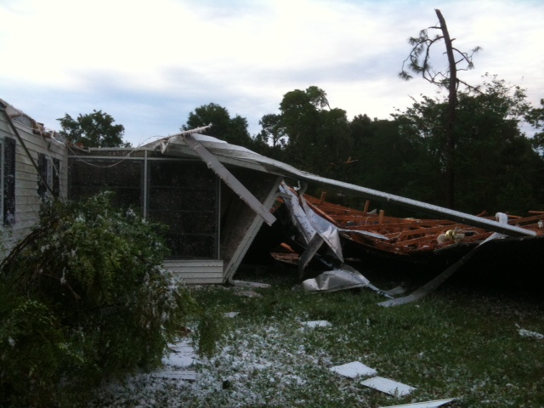](https://web.archive.org/web/20210403213659/http:/nws.weather.gov/blog/nwsjacksonville/wp-content/uploads/sites/7/2015/04/marion-roof-storms-042015.jpg) [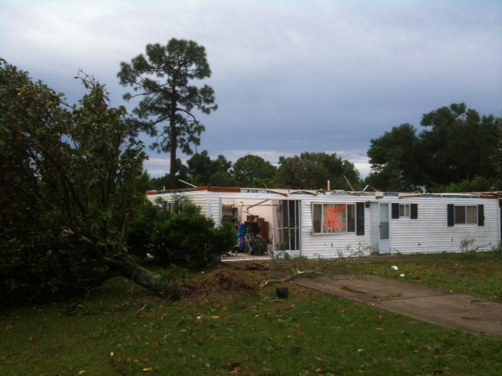](https://web.archive.org/web/20210403213659/http:/nws.weather.gov/blog/nwsjacksonville/wp-content/uploads/sites/7/2015/04/marion-roof-house-storm-042015.jpg)

The National Weather Service in Jacksonville issued a severe thunderstorm warning for Marion County at 3:31 PM.  As you can see from available base reflectivity and storm relative velocity data from the JAX Doppler Radar near the Jacksonville International Airport at that time,  the lowest available elevation for that radar to sample data in southwestern Marion County is at nearly 10,300 feet above ground level (agl).  Most tornadoes that form from rotating wall clouds exhibit strong rotation in the Storm Relative Velocity data (image to the right on the slide below) below 10,000 feet. The velocity data below displayed broad mid-altitude rotation (right image) embedded within a strong reflectivity core (left image).

[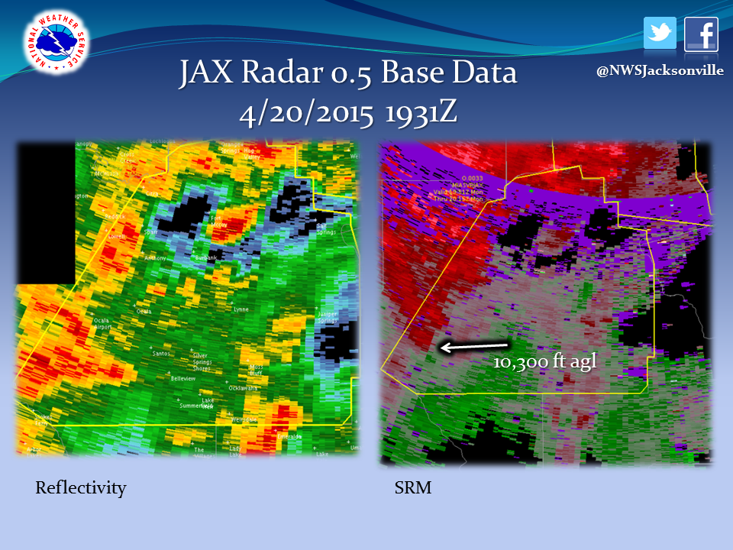](https://web.archive.org/web/20210403213659/http:/nws.weather.gov/blog/nwsjacksonville/wp-content/uploads/sites/7/2015/04/marion_base.png)

The radar that is able to sample the lowest elevations in southwest Marion County is located in Ruskin, FL (Tampa Bay region).  However, even this radar is unable to sample data below about 8,500 feet.  This Storm Relative Velocity data image from a few minutes before the tornado (image below) depicts broad rotation and converging winds at 8,500 feet, with green returns indicating winds blowing towards the TBW Doppler Radar site located to the south-southwest, while red returns indicate winds blowing away from the TBW radar.  Futhermore, the National Weather Service in Ruskin was dealing with severe weather impacting their area of responsibility and thus chose a scanning pattern that focused closer in on their local area, providing limited velocity data for much of Marion County. This is evident by the purple data region, which is known as range folding.  This tornado essentially formed within a range folded, or “no available velocity data” region, rendering use of the Ruskin Doppler Radar data suspect for issuing warnings despite being slightly closer in geographic range to southwest Marion County.

[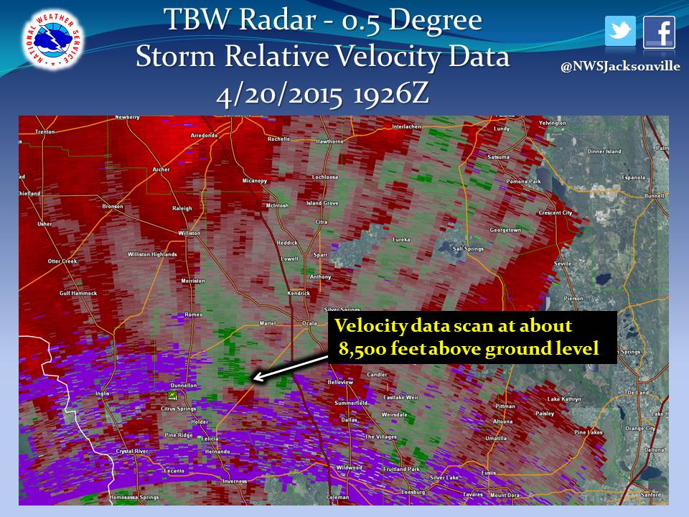](https://web.archive.org/web/20210403213659/http:/nws.weather.gov/blog/nwsjacksonville/wp-content/uploads/sites/7/2015/04/TBW_SRV_042015_1926z.jpg)

This scenario underscores several facts:

1) Marion County and much of north central Florida is not adequately sampled amongst JAX, TBW, and MLB (Melbourne, FL) Doppler Radars in situations where tornado formation is considered, given that much of the precursor low level rotation prior to a tornado touchdown occurs at elevations below which these Doppler Radars are able to scan.

2) Storm Spotters are vital in these severe weather situations when locations are too far removed from Doppler Radar data for reliable detection of low level rotation.  A severe thunderstorm watch was issued for much of north and north central Florida by the Storm Prediction Center at 11 am EDT on April 20 (http://www.spc.noaa.gov/products/watch/ww0086.html) , meaning that available Storm Spotters were activated to provide vital ground truth.  National Weather Service offices throughout the nation provide basic and advanced storm spotter training sessions in-person and sometimes virtually.

3) This tornado formed, touched down, traveled about 2 miles on the ground, and then lifted back into the clouds within the span of about 5 minutes.  Even with perfect available velocity data, it is difficult for meteorologists manning a Doppler Radar to issue a tornado warning with lead time for such a short-lived event. Even at its shortest scanning mode, National Weather Service Doppler Radars take approximately 4 minutes to complete a full data scan.  This is why it is so important for the public and first responders to be aware of the potential for severe weather during the watch phase, particularly in a state like Florida where short-lived tornadoes are the norm rather than the larger, longer lived twisters that are found in the Midwest.