**Storm Survey for Southside Jacksonville (Duval County) EF-1 Tornado – April 25, 2015**

[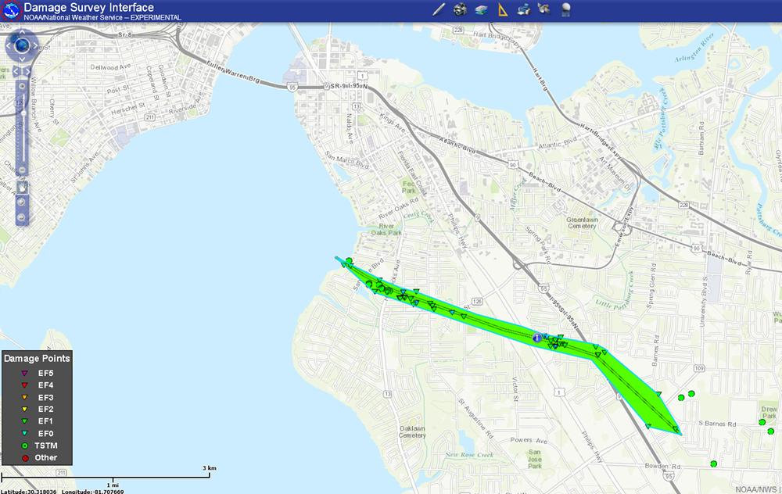](https://web.archive.org/web/20210403221119/http:/nws.weather.gov/blog/nwsjacksonville/wp-content/uploads/sites/7/2015/04/DAT_path.png)

[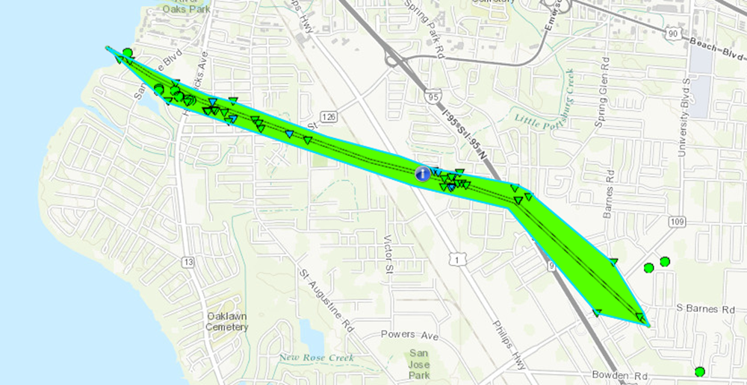](https://web.archive.org/web/20210403221119/http:/nws.weather.gov/blog/nwsjacksonville/wp-content/uploads/sites/7/2015/04/path_zoom.png)

…NWS DAMAGE SURVEY RESULT FOR 4/25/15 SOUTHSIDE TORNADO IN DUVAL COUNTY…

NWS METEOROLOGISTS HAVE CONFIRMED A TORNADO DEVELOPED AND MOVED ASHORE IN THE SOUTHSIDE AREA OF DUVAL COUNTY JUST SOUTH OF RIVER  
OAKS PARK AROUND 552 PM ON APRIL 25TH.

A SEVERE THUNDERSTORM PUSHED ESE THROUGH THE JAX METRO AREA AT ABOUT 50 MPH AND INTENSIFIED AS IT MOVED OVER THE ST. JOHNS RIVER. RADAR IMAGERY INDICATES A BRIEF TIGHT ROTATION DEVELOPED ON THE NORTH END OF A DEVELOPING DOWNBURST.

THE TORNADO MOVED ASHORE AND PUSHED JUST SOUTH OF HENDRICKS ELEMENTARY SNAPPING TREES AND POWERLINES. SEVERAL STRUCTURES WERE IMPACTED BY FALLING TREES AND LIMBS. INITIAL DAMAGE WAS TIGHTLY CLUSTERED WITH A PATH OF APPROXIMATELY 200 YARDS. AS THE TORNADO CROSSED PHILLIPS HIGHWAY SEVERAL BUSINESSES SUSTAINED ROOF DAMAGE. TRAILERS IN THE PINE OAKS MOBILE HOME PARK WERE DAMAGED AS WELL.

THE TORNADO BEGAN TO TURN MORE TO THE SOUTHEAST AS IT PASSED I-95 AND WIDENED TO 350 YARDS AS IT NEARED ENGLEWOOD HIGH SCHOOL.  AT ABOUT 5:58 PM THE TORNADO BEGAN TO WEAKEN AND DISSIPATE. A WIDE  
SWATH OF STRAIGHT LINE WINDS CONTINUED TO CAUSE DAMAGE FURTHER TO THE SOUTH AND EAST OF THE PATH UNTIL SHORTLY AFTER 6 PM. THE PATH WIDTH VARIED FROM 200-350 YARDS ALONG A 3.45 MILE PATH. THE TORNADO  
LASTED 5 OR 6 MINUTES WITH THE MAXIMUM WIND SPEEDS REACHING 104 MPH.

RATING:               EF-1  
ESTIMATED PEAK WINDS: 104 MPH  
PATH LENGTH/STATUTE:  3.45 MILES  
PATH WIDTH/MAXIMUM:   350 YARDS  
FATALITIES:           0  
INJURIES:             0

START DATE:           APRIL 25 2015  
START TIME:           552 PM EDT  
START LOCATION:       4 MILES SOUTHWEST OF ARLINGTON  
START LAT/LON:        30.2910/-81.6565

END DATE:             APRIL 25 2015  
END TIME:             558 PM EDT  
END LOCATION:         5 MILES SOUTH OF ARLINGTON  
END LAT/LON:          30.2688/-81.6058

[](https://web.archive.org/web/20210403221119/http:/nws.weather.gov/blog/nwsjacksonville/wp-content/uploads/sites/7/2015/04/radarloop3.gif)[](https://web.archive.org/web/20210403221119/http:/nws.weather.gov/blog/nwsjacksonville/wp-content/uploads/sites/7/2015/04/Possible-Funnel.jpg)[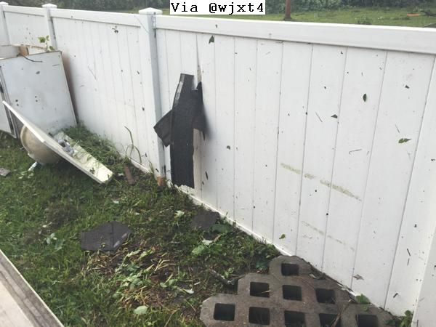](https://web.archive.org/web/20210403221119/http:/nws.weather.gov/blog/nwsjacksonville/wp-content/uploads/sites/7/2015/04/Shingles-in-Fence-San-Jose.jpg)[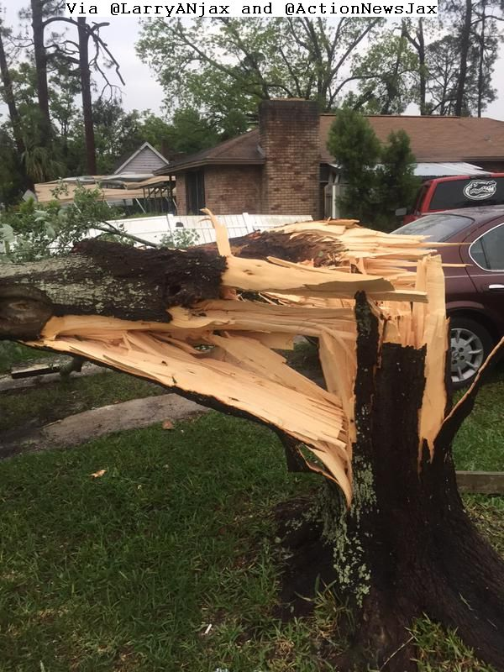](https://web.archive.org/web/20210403221119/http:/nws.weather.gov/blog/nwsjacksonville/wp-content/uploads/sites/7/2015/04/San-Marco-Tree.jpg)[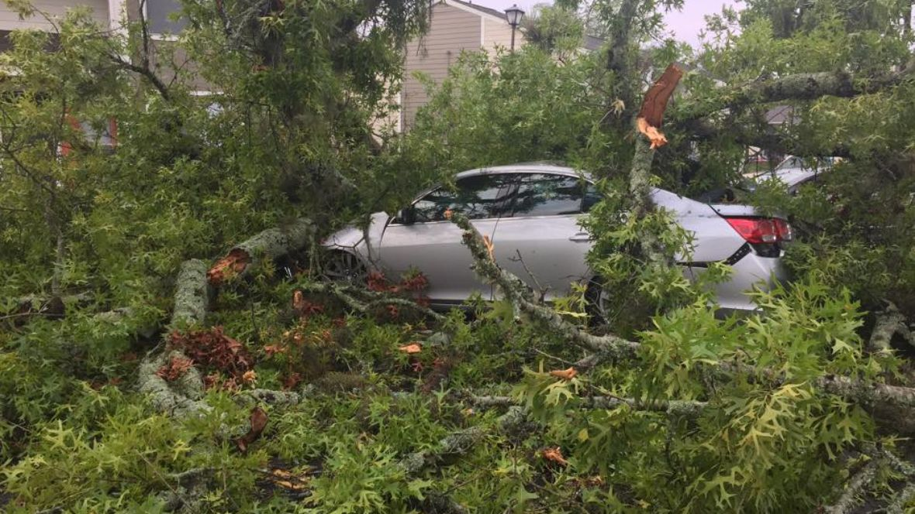](https://web.archive.org/web/20210403221119/http:/nws.weather.gov/blog/nwsjacksonville/wp-content/uploads/sites/7/2015/04/casocardamage.jpg)[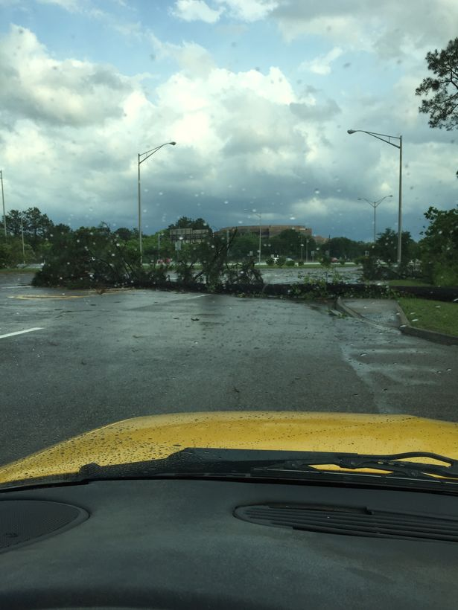](https://web.archive.org/web/20210403221119/http:/nws.weather.gov/blog/nwsjacksonville/wp-content/uploads/sites/7/2015/04/tree_down_blocking_AC_Skinner_pkwy.jpg)[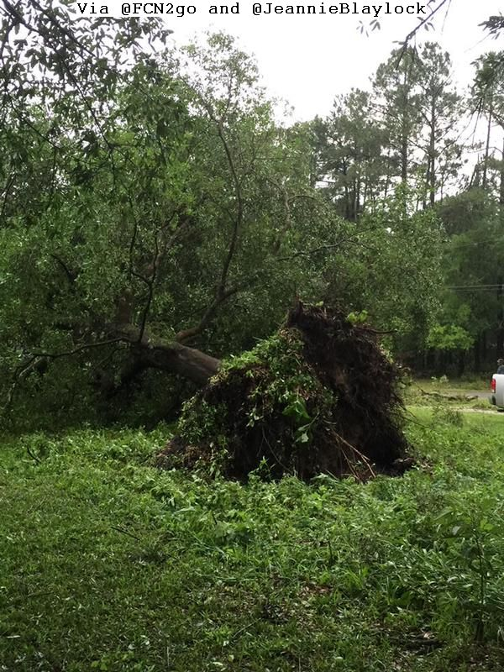](https://web.archive.org/web/20210403221119/http:/nws.weather.gov/blog/nwsjacksonville/wp-content/uploads/sites/7/2015/04/GrantEmerson-Tree-Down.jpg)