**Neptune Beach Severe Weather Event 22 July 2015**

During the afternoon of Wednesday, July 22nd, 2015, a severe thunderstorm swept over the eastern portion of Duval County which caused damage in the City of Neptune Beach and very southern portions of Atlantic Beach. In particular, the damage path began near Neptune Beach Elementary School and extended east-northeast in a narrow path ending near East Coast Drive and 1st Street in Atlantic Beach (Figure 1). The damage began around 3:50 p.m. and continued until approximately 4:15 p.m.

[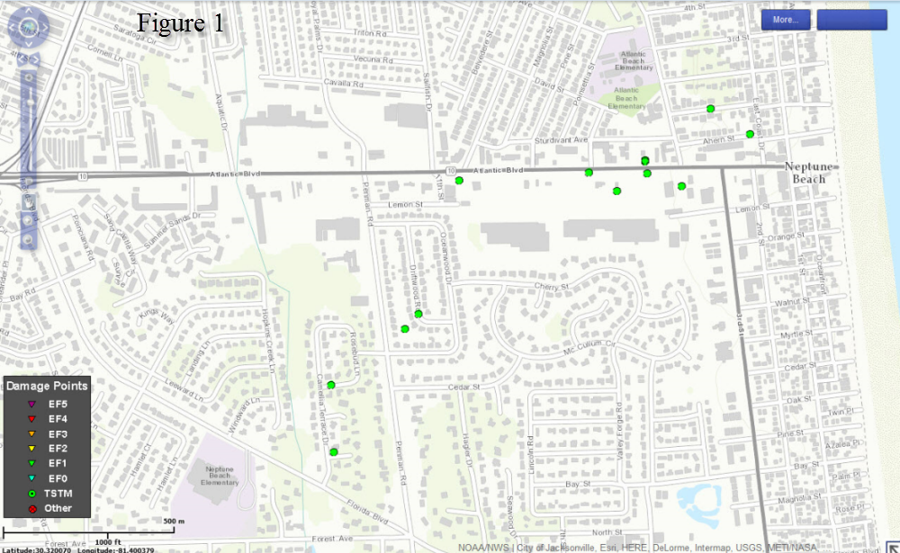](https://web.archive.org/web/20210404083653/http:/nws.weather.gov/blog/nwsjacksonville/wp-content/uploads/sites/7/2015/07/Figure1_neptune.png)

National Weather Service Doppler Radar (Figure 2), located at Jacksonville International Airport (JIA), indicated a distinct downburst signature at that time with the brighter green colored winds moving toward the radar (located at JIA) and the bright red winds moving away from the radar. The damage pattern observed was consistent with a downburst with much of the damage being confined to trees and weaker and/or weakened infrastructure.

[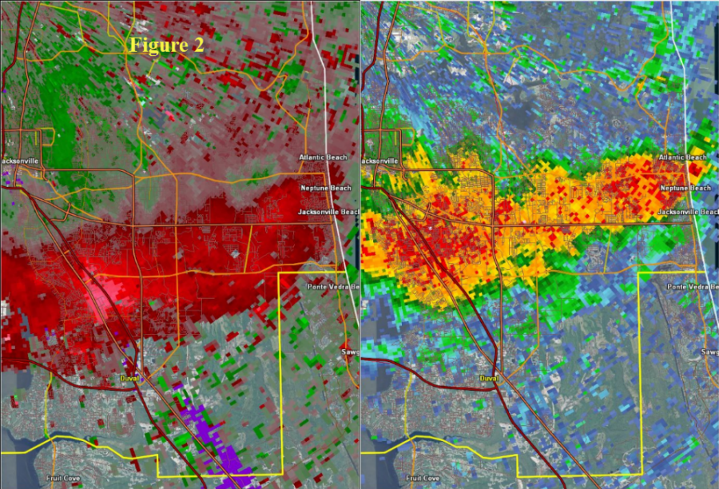](https://web.archive.org/web/20210404083653/http:/nws.weather.gov/blog/nwsjacksonville/wp-content/uploads/sites/7/2015/07/Figure2_neptune.png)

Many of the downed light poles, signs, and fences exhibited signs of corrosion at their bases (Figures 3, and 4, Credit Mr. Miller Norton, Duval County Emergency Management).

[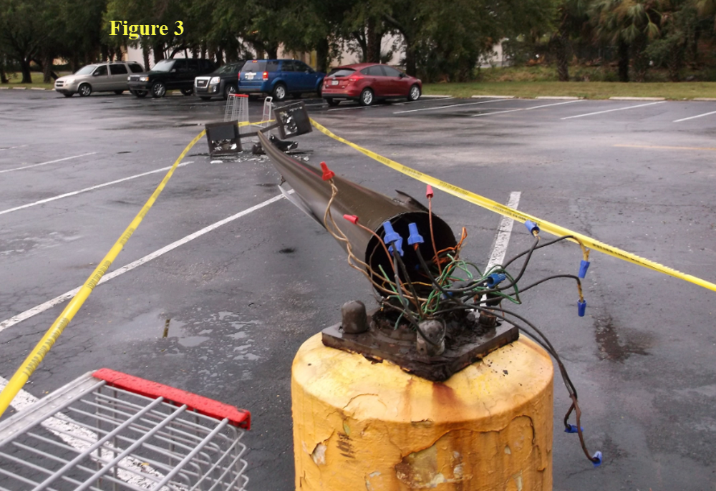](https://web.archive.org/web/20210404083653/http:/nws.weather.gov/blog/nwsjacksonville/wp-content/uploads/sites/7/2015/07/Figure3_neptune.png)

[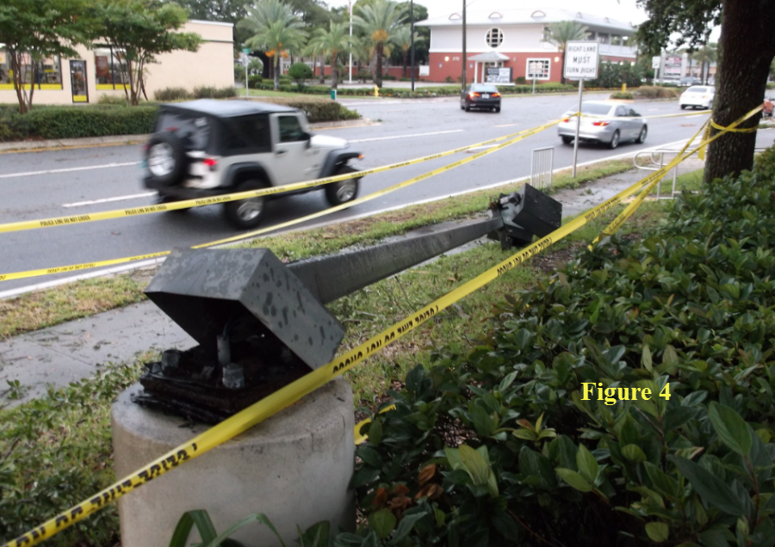](https://web.archive.org/web/20210404083653/http:/nws.weather.gov/blog/nwsjacksonville/wp-content/uploads/sites/7/2015/07/Figure4_neptune.png)

The large signs brought down such as the McDonalds sign and the Aqua East Surf Shop sign were signs with large surface areas and were located at an altitude where they would be expected to feel stronger winds, making them more prone to wind damage at lower wind speeds (Figures 5, and 6, Credit Mr. Miller Norton, Duval County Emergency Management).

[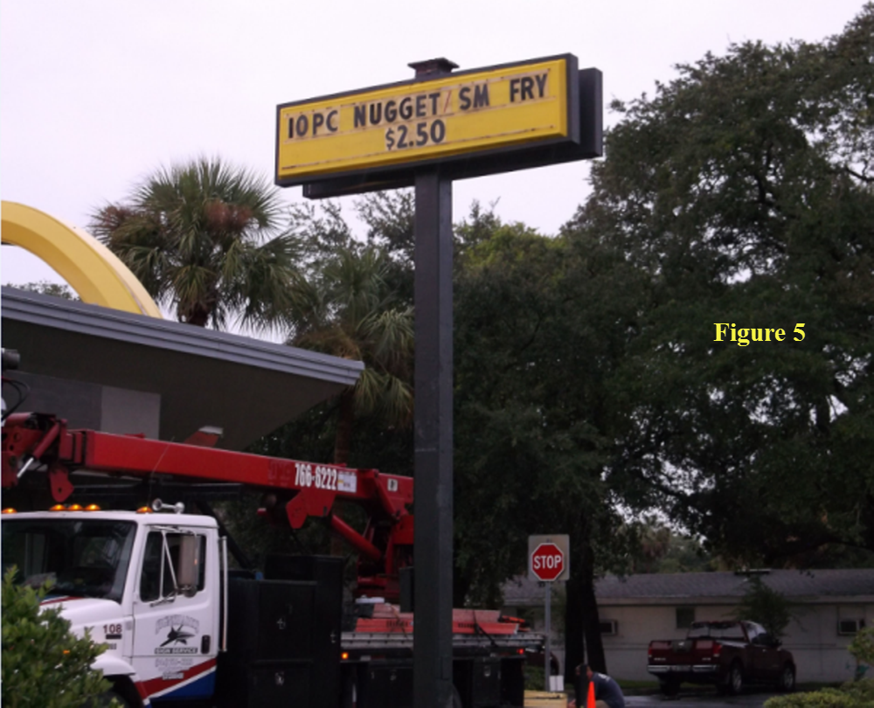](https://web.archive.org/web/20210404083653/http:/nws.weather.gov/blog/nwsjacksonville/wp-content/uploads/sites/7/2015/07/Figure5_neptune.png)

[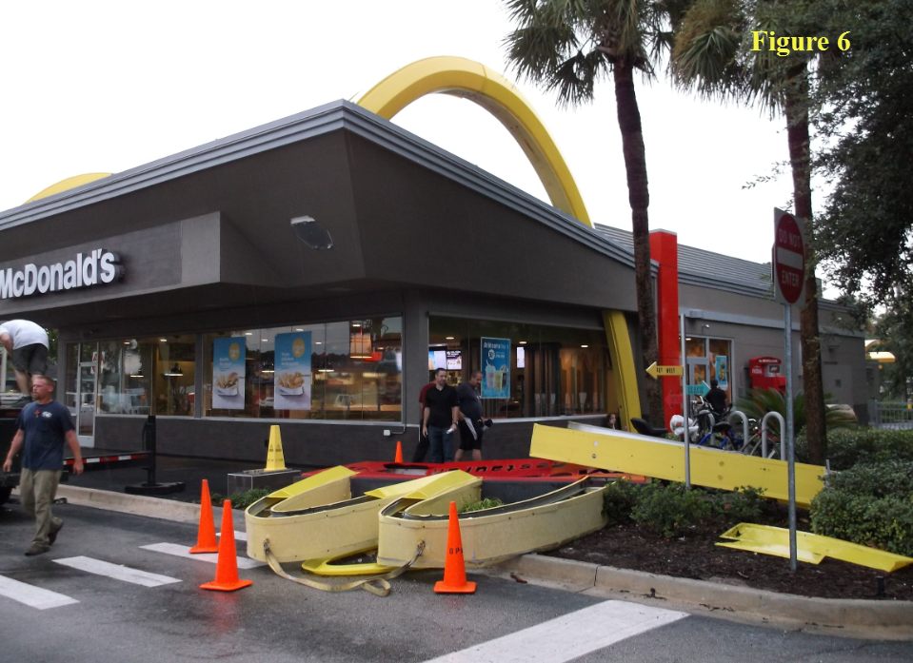](https://web.archive.org/web/20210404083653/http:/nws.weather.gov/blog/nwsjacksonville/wp-content/uploads/sites/7/2015/07/Figure6_neptune.png)

Overall, wind speeds were estimated to have been in the 75 to 90 mph range. These magnitudes are consistent with winds from a category 1 hurricane. Also of note were several structures in the damage area which were under construction, and other structures had scaffolding alongside of them. These types of structure would be vulnerable in a tornado event, yet none had apparent damage from yesterday’s strong winds.