**Southeast Georgia April 1st EF-1 Tornadoes**

[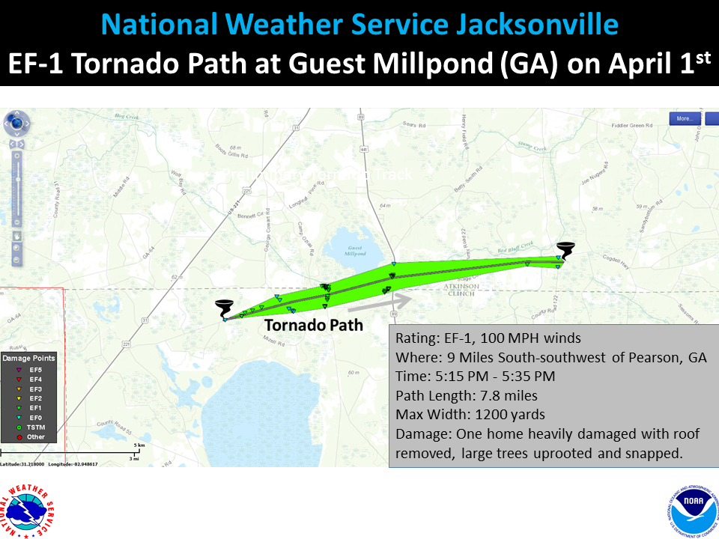](https://web.archive.org/web/20210325072527/http:/nws.weather.gov/blog/nwsjacksonville/wp-content/uploads/sites/7/2016/04/GA_TornadoTracks.png)[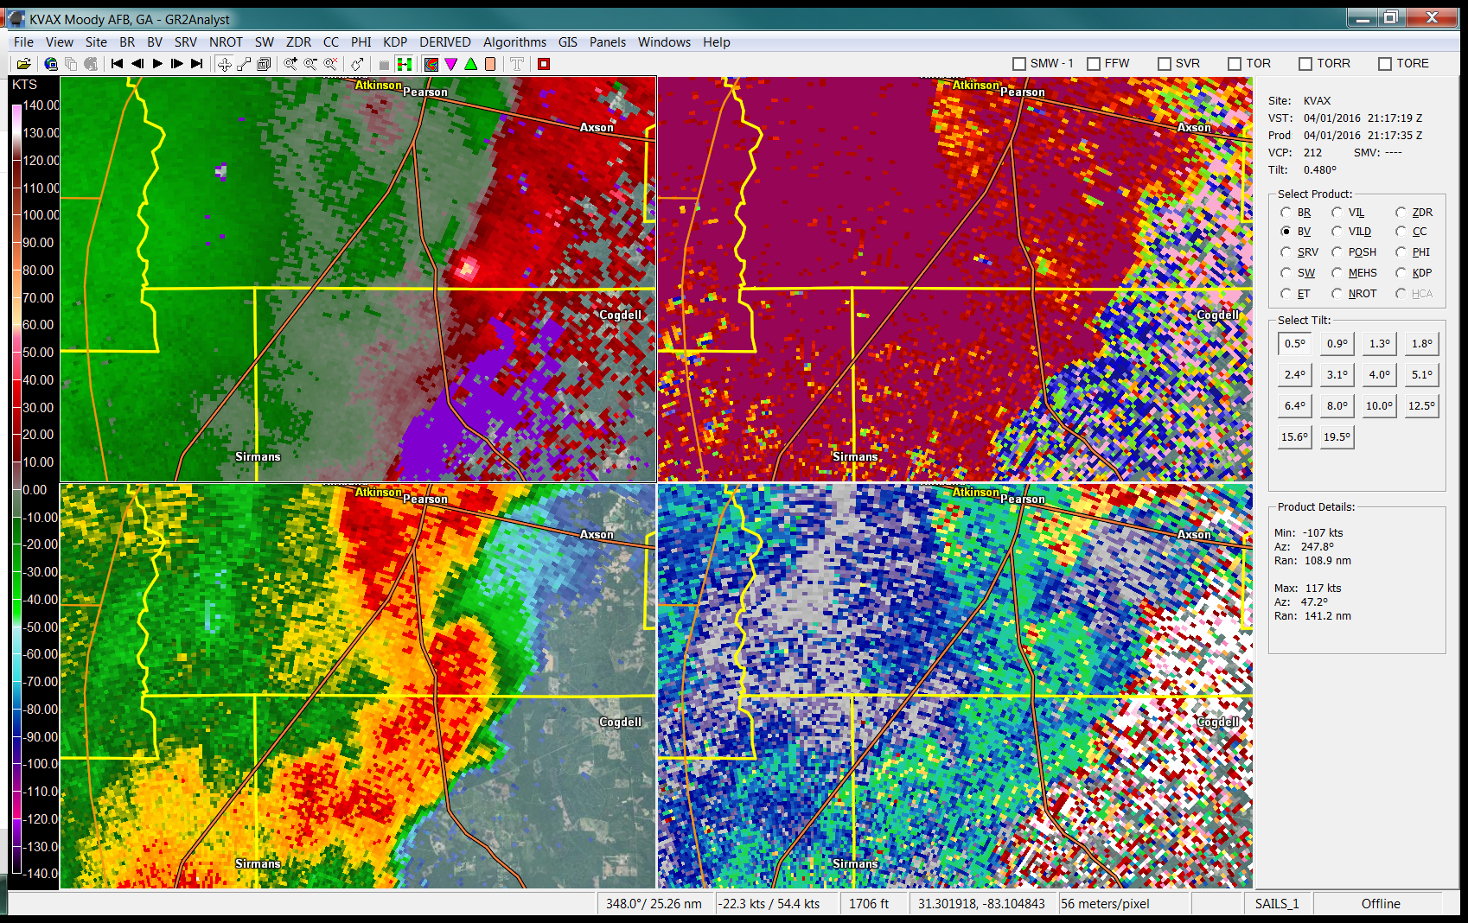](https://web.archive.org/web/20210325072527/http:/nws.weather.gov/blog/nwsjacksonville/wp-content/uploads/sites/7/2016/04/clinch_tor5.png)

**…EF-1 TORNADO AT GUEST MILLPOND AT THE CLINCH/ATKINSON COUNTY LINE…**

RATING:                                               EF-1  
ESTIMATED PEAK WIND:       100 MPH  
PATH LENGTH /STATUTE/:     7.8 MILES  
PATH WIDTH /MAXIMUM/:   0.7 MILE  
FATALITIES:                                        0  
INJURIES:                                             1

START DATE:                                     APRIL 1 2016  
START TIME:                                      515 PM EDT EST  
START LOCATION:                        9 MILES SSW OF PEARSON GA  
START LAT/LON:                            31.17/-82.91

END DATE:                                         APRIL 1 2016  
END TIME:                                          535 PM EDT  
EST END LOCATION:                  4 MILES WNW OF COGDELL GA  
END_LAT/LON:                               31.19/-82.78

NATIONAL WEATHER SERVICE STORM SURVEY HAS CONFIRMED A TORNADO NEAR THE CLINCH AND ATKINSON COUNTY BORDER. THE PRELIMINARY INTENSITY WAS A HIGH END EF-1 TORNADO WITH MAXIMUM WINDS OF 100 MPH. THE TORNADO TOUCHED DOWN JUST EAST OF HWY 221 AND WAS ON THE GROUND FOR 20 MINUTES. THE PATH LENGTH WAS ABOUT 7.8 MILES AND IT WAS MOVING EAST  AT ABOUT 25 MPH. MAXIMUM WIDTH WAS ABOUT 0.7 MILES WIDE.

ONE HOME WAS HEAVILY DAMAGED WITH MOST OF THE ROOF REMOVED. THIS WAS A STRUCTURE OF OLDER CONSTRUCTION WITH WOOD LATH ROOFING  CONSTRUCTION AND NO BRACING IN THE RAFTERS. MAJOR TREE BLOW DOWN  OCCURRED IN TWO AREAS: THE FIRST NEAR THARPE ROAD, NORTH OF ARABIA BAY, AND THE SECOND NEAR KEATON FARM ROAD AND THE GUEST MILLPOND AREA OFF U.S. HIGHWAY 441.

FROM THE GUEST MILLPOND AREA THE FUNNEL TRAVELED NEAR AND NORTH OF STAGE COACH ROAD AND WEAKENED NEAR COGDELL AND SANDY BOTTOM IN  ATKINSON COUNTY, BY MEXICO ROAD. IT IS POSSIBLE THE FUNNEL MAY HAVE LIFTED PRIOR TO REACHING COGDELL AND THE DAMAGE THERE MAYBE ATTRIBUTED TO THE REAR FLANK DOWNDRAFT (RFD), AS IT IS IMPOSSIBLE TO ASCERTAIN WHETHER THE RFD CAUSED THE DAMAGE NEAR COGDELL WE WILL MAINTAIN THE TORNADO PATH TO THAT LOCATION. THE STORM WAS CONSIDERABLY WEAKER IN THAT AREA WITH EF-0 SCALE DAMAGE OBSERVED.

ONE INDIRECT INJURY OCCURRED WHEN AN INDIVIDUAL CLEARING HIS ROOF WAS INJURED POST STORM.

[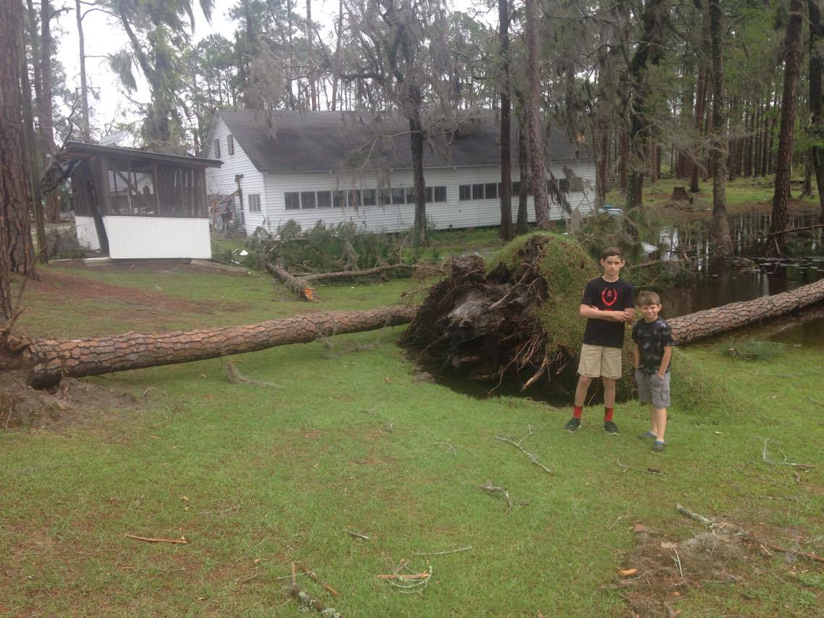](https://web.archive.org/web/20210325072527/http:/nws.weather.gov/blog/nwsjacksonville/wp-content/uploads/sites/7/2016/04/Guest_Millpond_52.jpg)[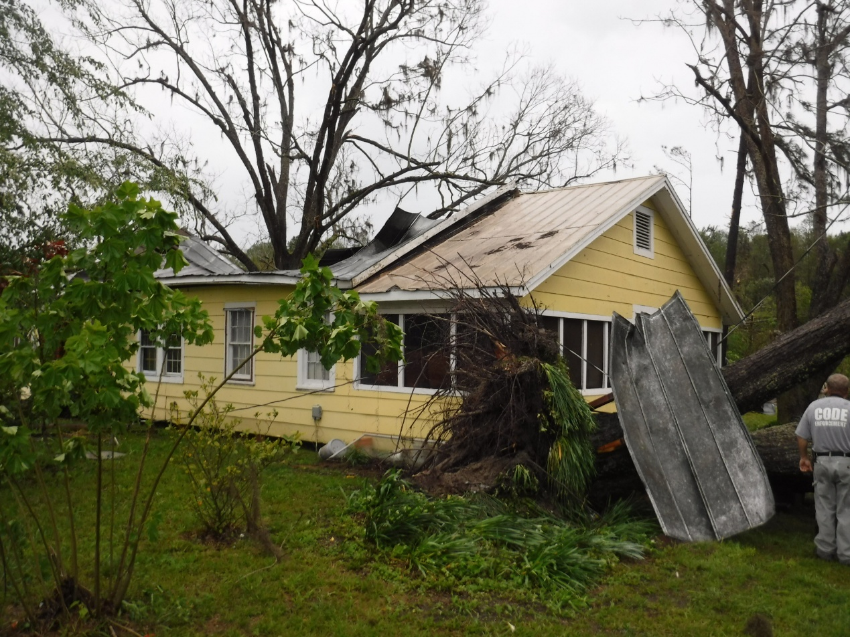](https://web.archive.org/web/20210325072527/http:/nws.weather.gov/blog/nwsjacksonville/wp-content/uploads/sites/7/2016/04/Clinch_102.jpg)[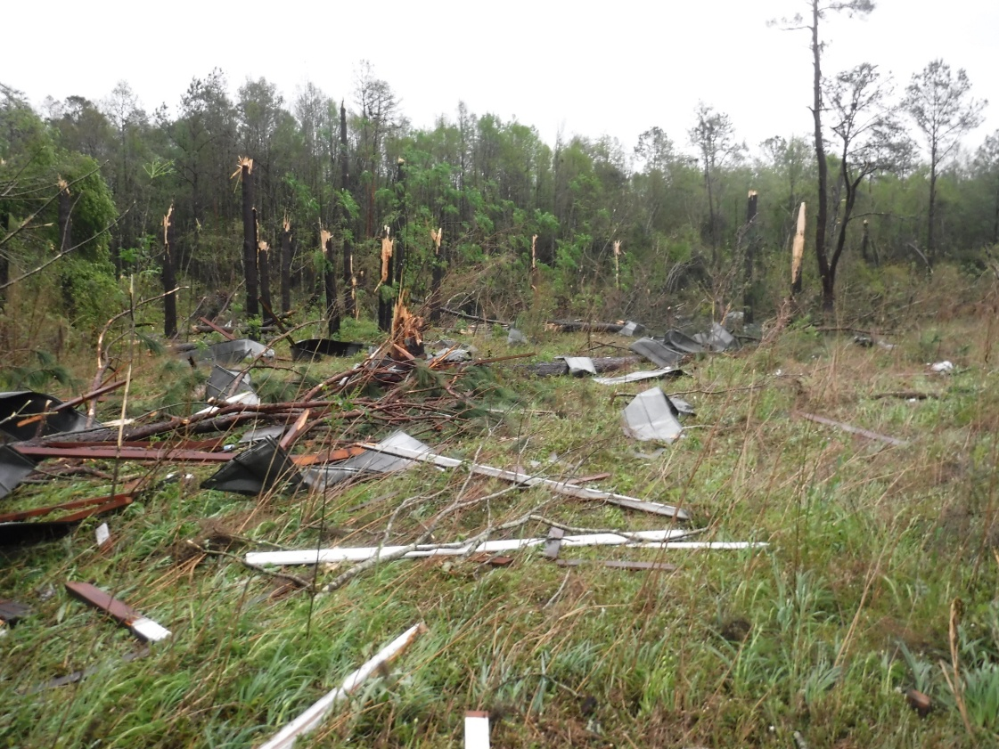](https://web.archive.org/web/20210325072527/http:/nws.weather.gov/blog/nwsjacksonville/wp-content/uploads/sites/7/2016/04/Clinch_92.jpg)[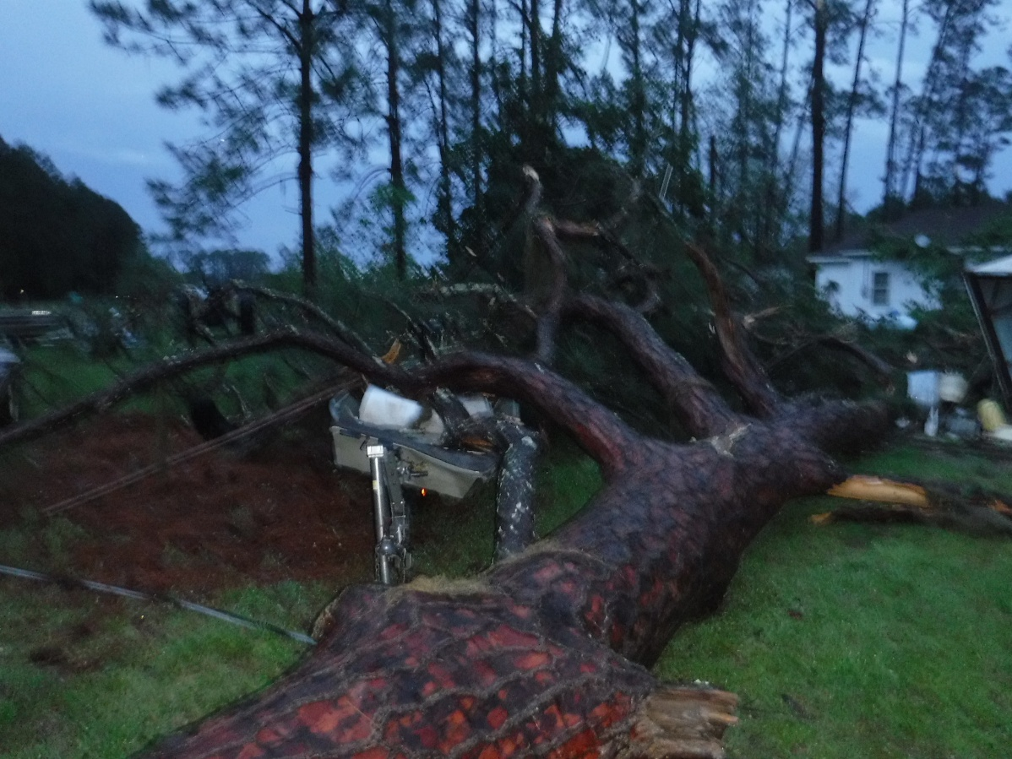](https://web.archive.org/web/20210325072527/http:/nws.weather.gov/blog/nwsjacksonville/wp-content/uploads/sites/7/2016/04/Clinch_51.jpg)[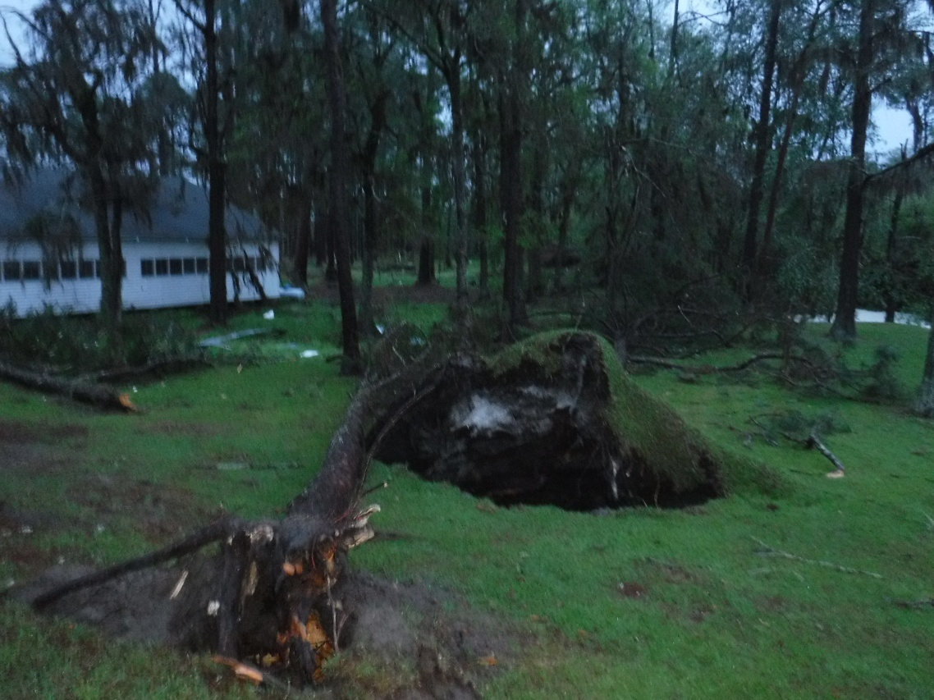](https://web.archive.org/web/20210325072527/http:/nws.weather.gov/blog/nwsjacksonville/wp-content/uploads/sites/7/2016/04/Clinch_41.jpg)

[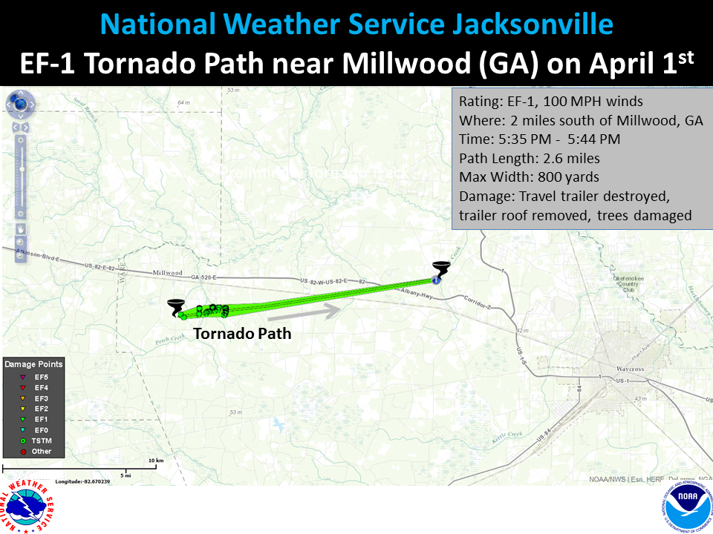](https://web.archive.org/web/20210325072527/http:/nws.weather.gov/blog/nwsjacksonville/wp-content/uploads/sites/7/2016/04/GA_TornadoTracks21.png)

**…EF-1 TORNADO NEAR MILLWOOD (WARE COUNTY)…**

RATING:                                                     EF-1  
ESTIMATED PEAK WIND:             100 MPH  
PATH LENGTH /STATUTE/:          2.6 MILES  
PATH WIDTH /MAXIMUM/:        0.45 MILES  
FATALITIES:                                            0  
INJURIES:                                                 0

START DATE:                                         APRIL 1 2016  
START TIME:                                          535 PM EDT  
START LOCATION:                            2 MILES S OF MILLWOOD GA  
START LAT/LON:                                31.24/-82.66

END DATE:                                               APRIL 1 2016  
END TIME:                                                544 PM EDT  
ESTIMATED END LOCATION:     2.9 MILES SOUTHEAST OF  MILLWOOD  
END_LAT/LON:                                      31.25/-82.62

NATIONAL WEATHER SERVICE CONFIRMS A TORNADO JUST SOUTH OF U.S. HIGHWAY 82 IN MILLWOOD. THE PRELIMINARY INTENSITY WAS EF-1 WITH MAXIMUM WINDS NEAR 100 MPH. THE TORNADO WAS ON THE GROUND FOR APPROXIMATELY 9 MINUTES AND TRAVELED 2.6 MILES AND WAS MOVING ABOUT 20 MILES PER HOUR. MAXIMUM WIDTH WAS JUST UNDER ONE HALF MILE WIDE.  RADAR IMAGERY INDICATES, AND THE DAMAGE SURVEY CONFIRMS THAT THE MILLWOOD TORNADO WAS PRODUCED BY A SEPARATE THUNDERSTORM CELL AND IS NOT A CONTINUATION OF THE CLINCH-ATKINSON COUNTY TORNADO EVENT ABOVE.

MINOR DAMAGE BEGAN NEAR INDIAN MOUND ROAD AND BECAME MORE SIGNIFICANT AS THE SYSTEM MOVED OVER THE MANOR-MILLWOOD ROAD NORTH. DAMAGE TO STRUCTURES AND TREES BECAME MORE SIGNIFICANT NEAR MULLIS ROAD WITH A OLDER TRAVEL TRAILER ROLLED AND DESTROYED AND A TRAILER NEAR A POND HAD ITS ROOF REMOVED. EAST OF MULLIS ROAD SIGNIFICANT DAMAGE OCCURRED NEAR AND NORTH OF PERCH CREEK ROAD EASTWARD TO THE ZION HILL FREEWILL BAPTIST CHURCH. SEVERAL SMALL FARM STRUCTURES IN THIS AREA WERE THROWN NORTHWARD ACROSS THE STORMS FORWARD PATH INDICATING A TORNADO RATHER THAN STRAIGHT LINE WINDS IN THIS LOCATION. ADDITIONALLY, THE DAMAGE PATTERN WAS CONVERGENT WITH TREES IN THE SOUTH PORTION OF THE PATH LAYING TOWARD THE NORTHEAST AND TREES IN THE NORTHERN PORTION OF THE STORM PATH LAYING MORE EASTWARD.

FROM THE ZION HILL FREEWILL BAPTIST CHURCH AREA THE STORM PATH SHIFTED TO THE RIGHT WITH MAJOR TREE BLOW DOWN AT A FARM NORTH OF THE ZION HILL ROAD. THE STORM WAS LIKELY LIFTING IN THIS AREA WITH NO SIGNIFICANT DAMAGE OBSERVED EAST OF THIS POINT ALONG FAIRFAX ROAD.

SEVERAL HORSES WERE TRAPPED BY BLOWN DOWN TREES AND AND TWO BEAGLES WERE MISSING FOLLOWING THE STORM. OTHER THAN THOSE INCIDENTS NO ONE WAS DIRECTLY INJURED BY THE STORM.

Video of this tornado near Fat Daddy’s ATV Park was posted to social media and First Coast News by Derrick Martin: [Video of the EF-1 Tornado near Millwood](https://web.archive.org/web/20210325072527/http:/www.firstcoastnews.com/news/possible-tornado-spotted-in-southern-georgia/115050566)[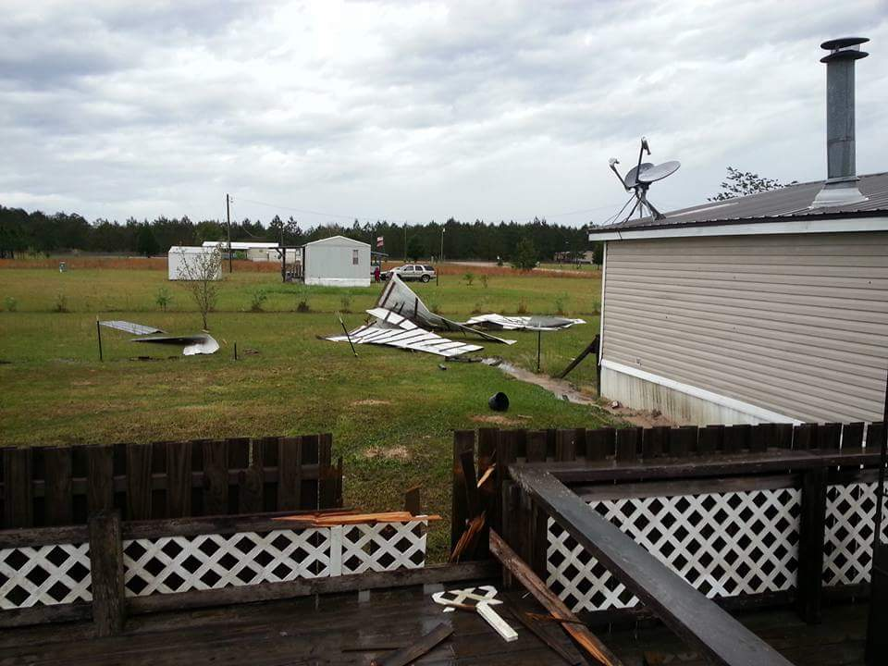](https://web.archive.org/web/20210325072527/http:/nws.weather.gov/blog/nwsjacksonville/wp-content/uploads/sites/7/2016/04/Dixie_Union31.jpg)[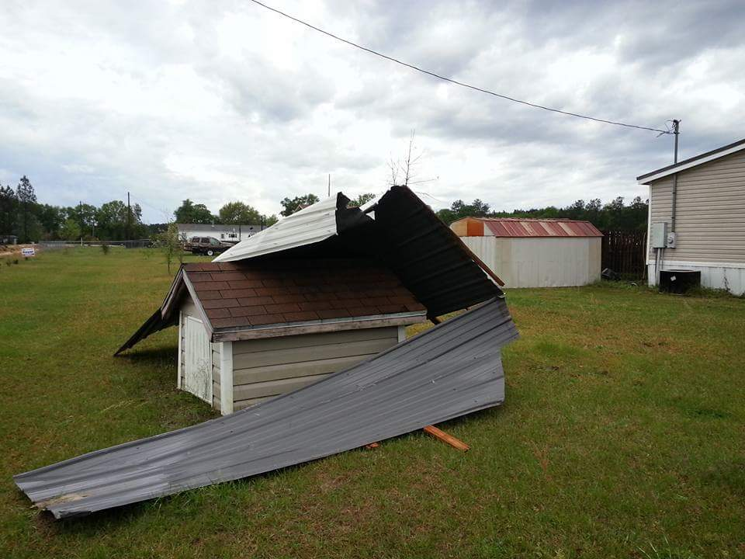](https://web.archive.org/web/20210325072527/http:/nws.weather.gov/blog/nwsjacksonville/wp-content/uploads/sites/7/2016/04/Dixie_Union21.jpg)[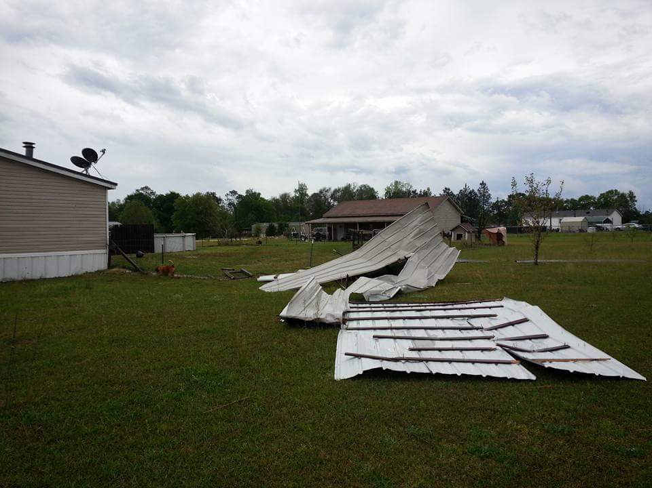](https://web.archive.org/web/20210325072527/http:/nws.weather.gov/blog/nwsjacksonville/wp-content/uploads/sites/7/2016/04/Dixie_Union1.jpg)