**Hail Occurred across Flagler County Wednesday Morning (5/4/2016)**

A moist airmass at the surface ahead of a cold front combined with cooler temperatures aloft. This allowed a thunderstorm over Flagler County to produce widespread pea size to quarter size hail Wednesday morning across Bunnell and parts of Palm Coast between 815 and 830 am on May 4, 2016.  Some resident reported hail the size of half dollars. Also hail reports continued be received along SR100 and parts of central Palm Coast.  Flagler County Sheriff’s Office reported a vehicle struck by lightning at SR100 and Interstate 95.

[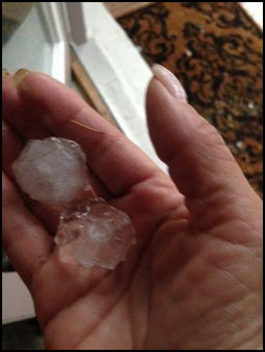](https://web.archive.org/web/20210325073226/http:/nws.weather.gov/blog/nwsjacksonville/wp-content/uploads/sites/7/2016/05/flaglerhailpic.jpg)[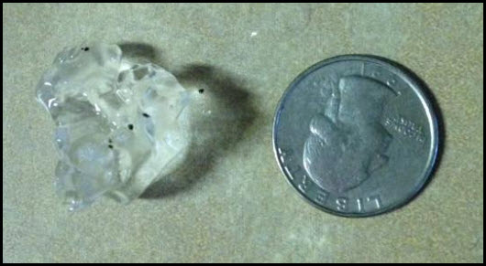](https://web.archive.org/web/20210325073226/http:/nws.weather.gov/blog/nwsjacksonville/wp-content/uploads/sites/7/2016/05/flaglerhailpic2.jpg)

[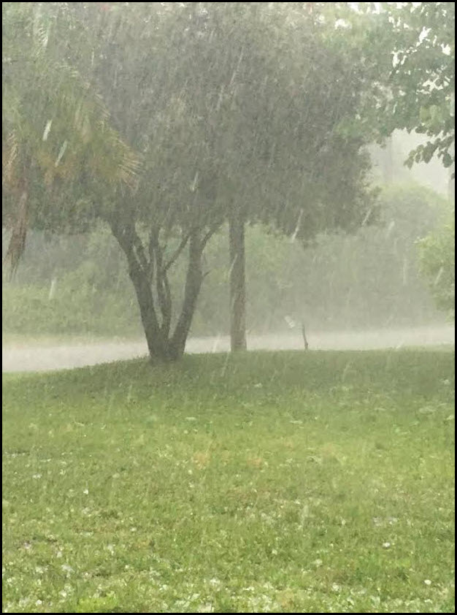](https://web.archive.org/web/20210325073226/http:/nws.weather.gov/blog/nwsjacksonville/wp-content/uploads/sites/7/2016/05/flaglerhailpic3.jpg)[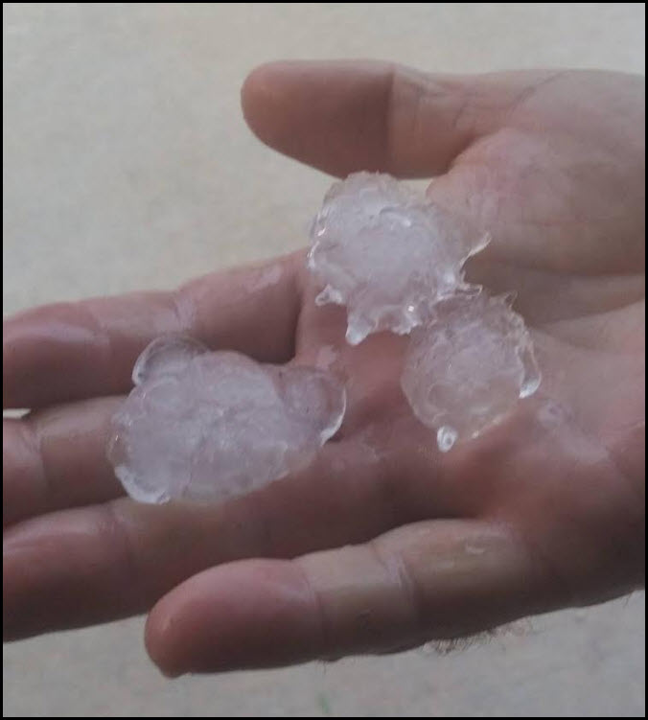](https://web.archive.org/web/20210325073226/http:/nws.weather.gov/blog/nwsjacksonville/wp-content/uploads/sites/7/2016/05/flaglerhailpic4.jpg)

Here is a radar loop of the event…

[](https://web.archive.org/web/20210325073226/http:/nws.weather.gov/blog/nwsjacksonville/wp-content/uploads/sites/7/2016/05/FlaglerHail.gif)