**Yulee, FL EF-1 Tornado, 8/4/16**

[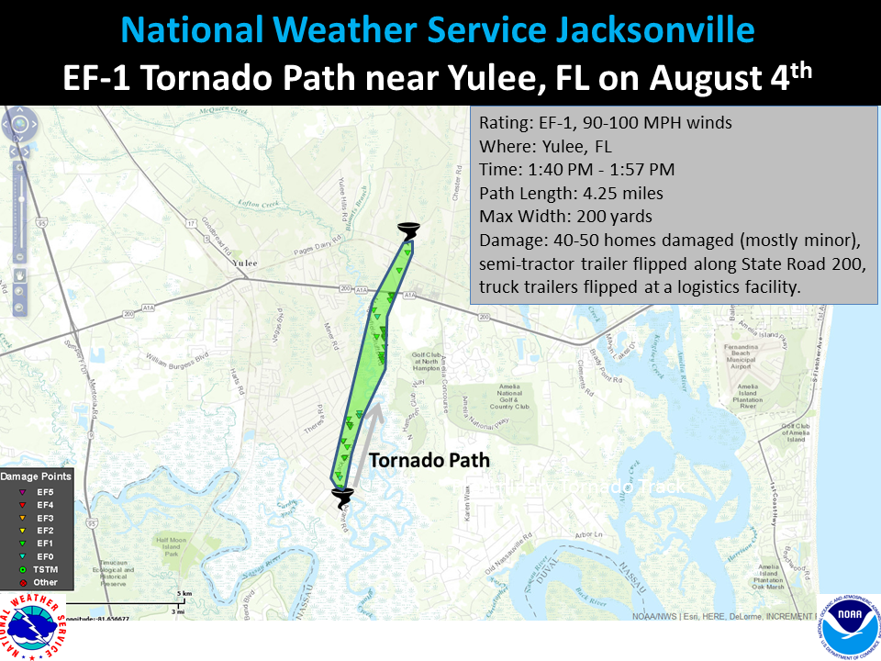](https://web.archive.org/web/20210228124349/http:/nws.weather.gov/blog/nwsjacksonville/wp-content/uploads/sites/7/2016/08/Yulee_TOR_path.png)[](https://web.archive.org/web/20210228124349/http:/nws.weather.gov/blog/nwsjacksonville/wp-content/uploads/sites/7/2016/08/Base_velocity_anim.gif)

EF-1 Tornado Confirmed Near Yulee in Nassau County Florida

Date:  August 4th 2016  
Start Time: 1:40 PM  
End Time: 1:57 PM  
Maximum EF-Scale Rating: EF-1  
Estimated Maximum Wind Speed: 90-100 MPH  
Maximum Path Width: 200 yards  
Path Length: 4.25 miles  
* Fatalities…0  
* Injuries…0

Summary  
The National Weather Service in Jacksonville FL has confirmed a  
tornado near Yulee in Nassau County, Florida on August 4th 2016.

Snapped trees were noted just north of Lofton Creek along Avant Road, with significant tree and some damage to shingles taking place in the Meadowfield Bluff subdivision as the tornado progressed northward. The tornado flipped an unanchored structure  just south of State Road 200, or A1A, on the property of Yulee  United Methodist Church. The tornado reached its peak intensity, estimated near 100 mph, along A1A as it flipped a semi-tractor trailer on its side. The tornado continued northward, crossing Gene Lassere Boulevard, where it flipped unanchored truck trailers at RDL logistics facility. The tornado caused significant tree and shingle damage to a few homes along Pages Dairy Road before it lifted and dissipated. Nassau County Emergency Management estimates damage to 40-50 homes, concentrated in the Meadowfield Bluff subdivision.

For reference…the Enhanced Fujita Scale classifies tornadoes  
into the following categories:

EF0…wind speeds 65 to 85 mph.  
EF1…wind speeds 86 to 110 mph.  
EF2…wind speeds 111 to 135 mph.  
EF3…wind speeds 136 to 165 mph.  
EF4…wind speeds 166 to 200 mph.  
EF5…wind speeds greater than 200 mph.

[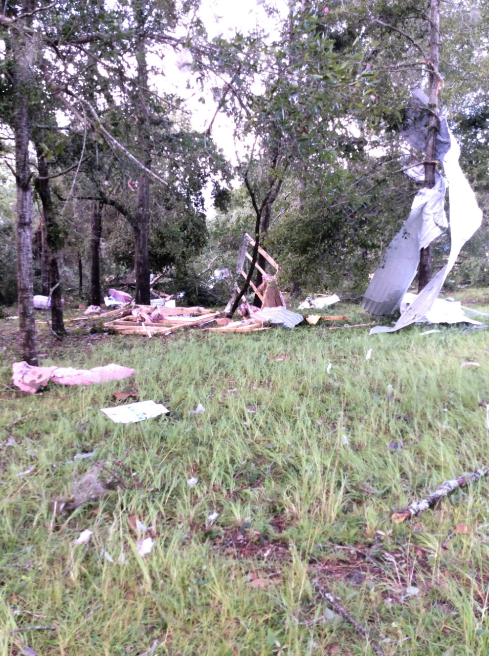](https://web.archive.org/web/20210228124349/http:/nws.weather.gov/blog/nwsjacksonville/wp-content/uploads/sites/7/2016/08/Church_1.jpg)[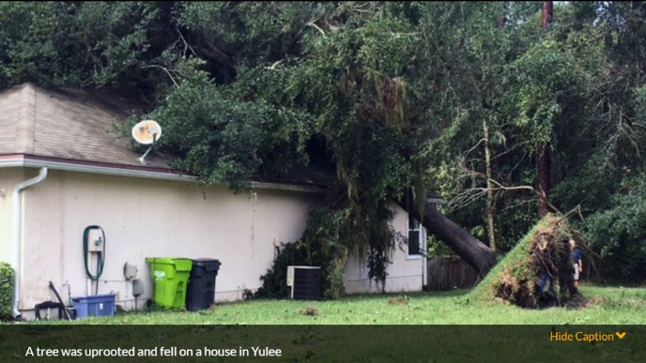](https://web.archive.org/web/20210228124349/http:/nws.weather.gov/blog/nwsjacksonville/wp-content/uploads/sites/7/2016/08/Tree_on_house.jpg)[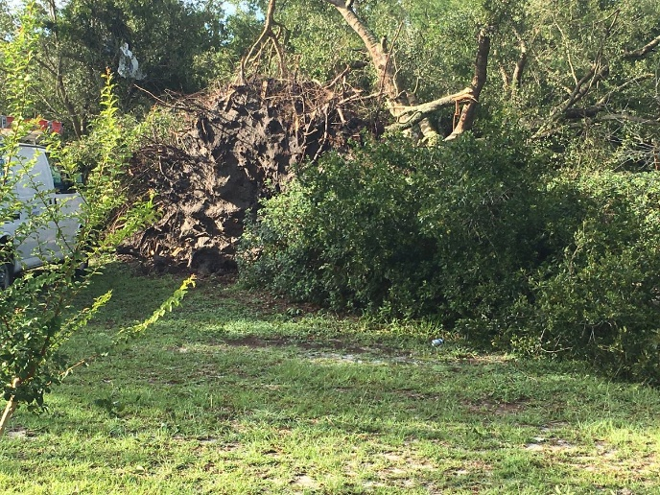](https://web.archive.org/web/20210228124349/http:/nws.weather.gov/blog/nwsjacksonville/wp-content/uploads/sites/7/2016/08/Tree_DickKingDr.jpg)[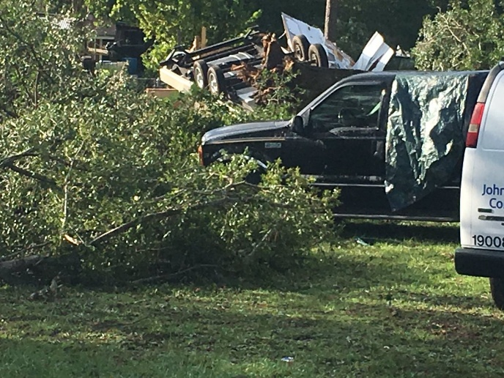](https://web.archive.org/web/20210228124349/http:/nws.weather.gov/blog/nwsjacksonville/wp-content/uploads/sites/7/2016/08/TrailerFlip_DickKingDr.jpg)[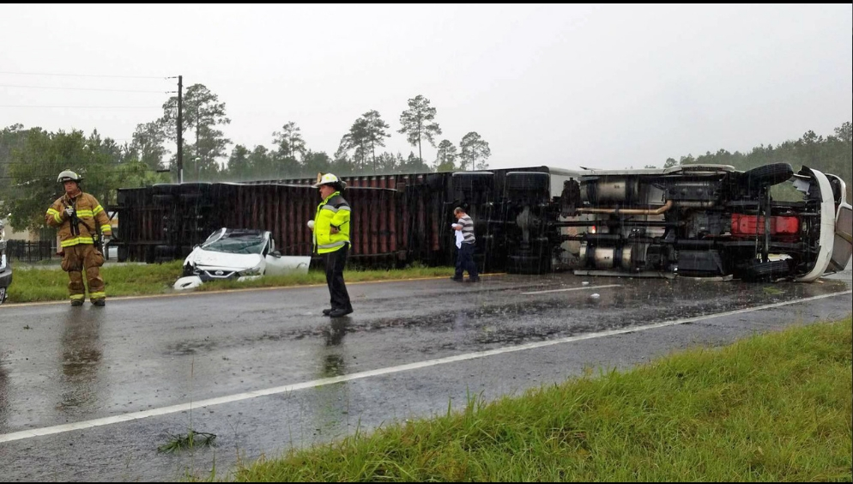](https://web.archive.org/web/20210228124349/http:/nws.weather.gov/blog/nwsjacksonville/wp-content/uploads/sites/7/2016/08/Tractor_overturn_2.jpg)[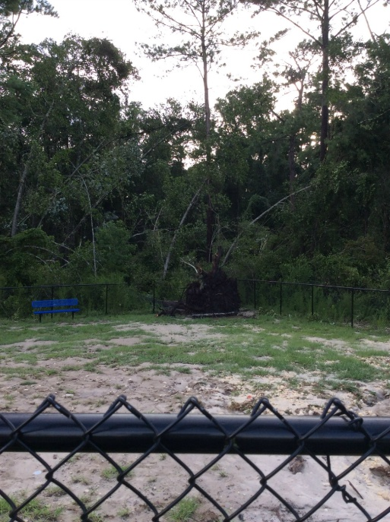](https://web.archive.org/web/20210228124349/http:/nws.weather.gov/blog/nwsjacksonville/wp-content/uploads/sites/7/2016/08/SR200Apts_1.jpg)[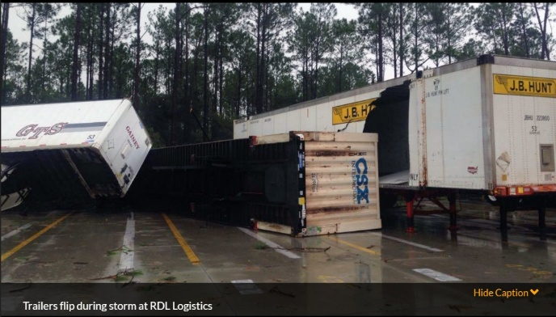](https://web.archive.org/web/20210228124349/http:/nws.weather.gov/blog/nwsjacksonville/wp-content/uploads/sites/7/2016/08/RDL_Log_5.jpg)[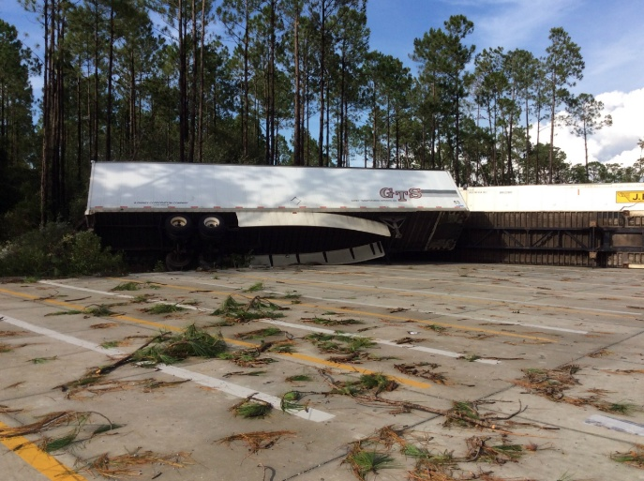](https://web.archive.org/web/20210228124349/http:/nws.weather.gov/blog/nwsjacksonville/wp-content/uploads/sites/7/2016/08/RDL_Log_4.jpg)[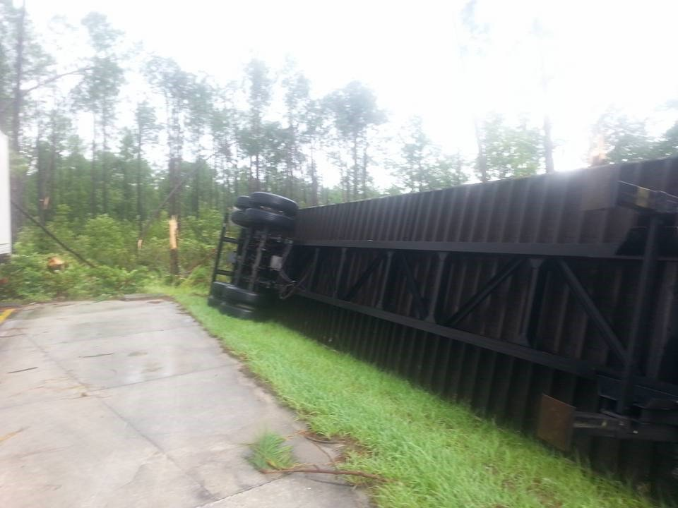](https://web.archive.org/web/20210228124349/http:/nws.weather.gov/blog/nwsjacksonville/wp-content/uploads/sites/7/2016/08/RDL_Log_3.jpg)[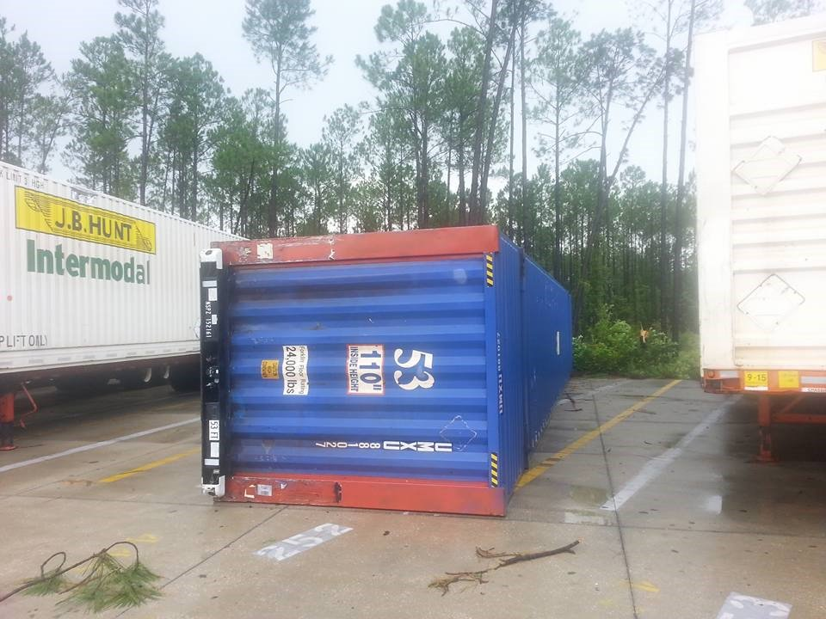](https://web.archive.org/web/20210228124349/http:/nws.weather.gov/blog/nwsjacksonville/wp-content/uploads/sites/7/2016/08/RDL_Log_2.jpg)[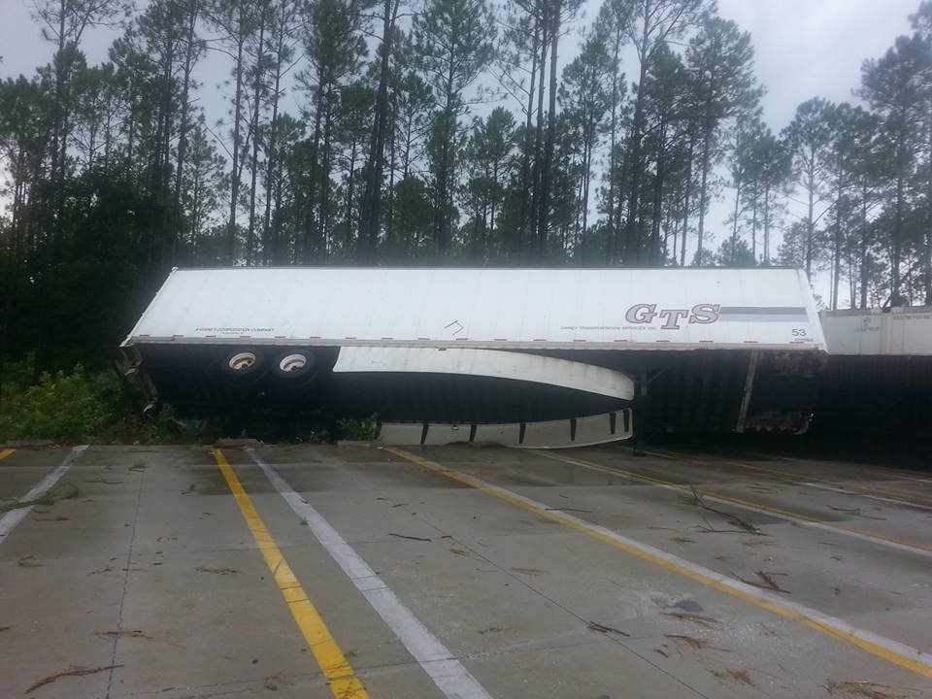](https://web.archive.org/web/20210228124349/http:/nws.weather.gov/blog/nwsjacksonville/wp-content/uploads/sites/7/2016/08/RDL_Log_1.jpg)[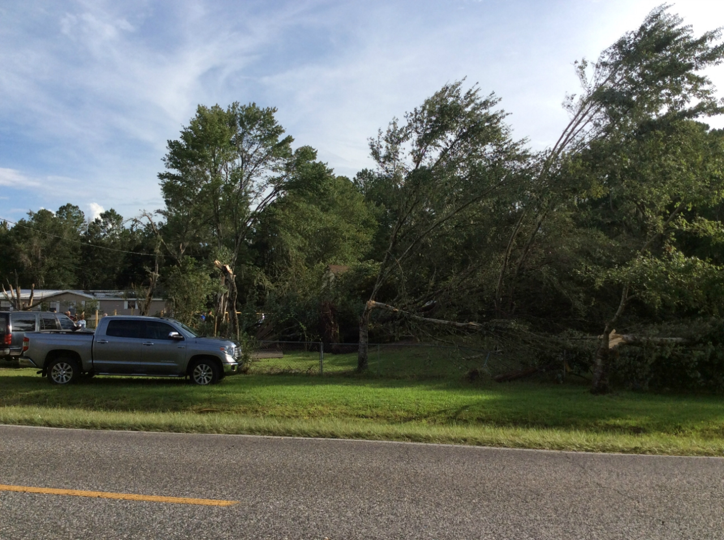](https://web.archive.org/web/20210228124349/http:/nws.weather.gov/blog/nwsjacksonville/wp-content/uploads/sites/7/2016/08/PageDairyRd.jpg)[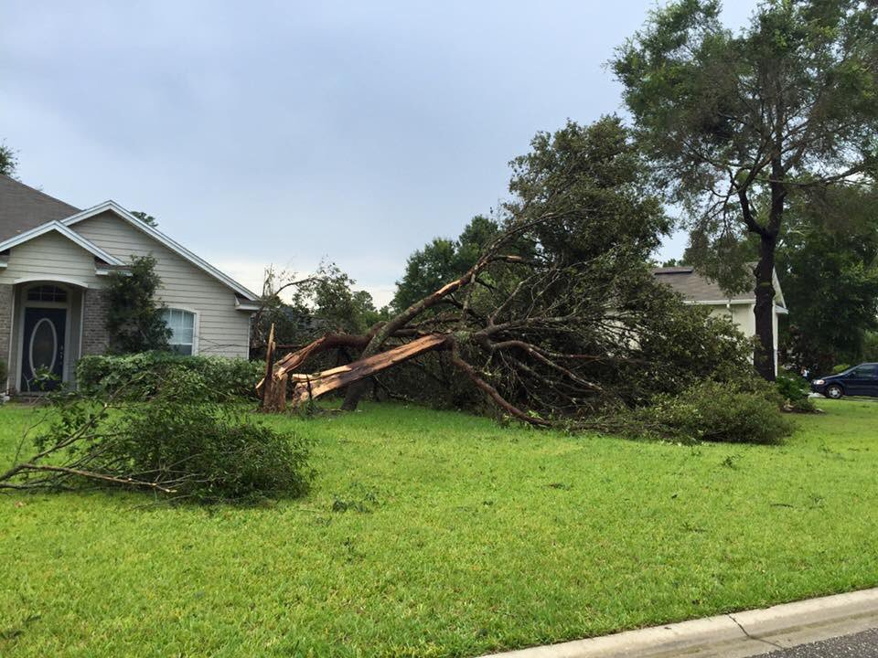](https://web.archive.org/web/20210228124349/http:/nws.weather.gov/blog/nwsjacksonville/wp-content/uploads/sites/7/2016/08/MeadowfieldBluffs_7.jpg)[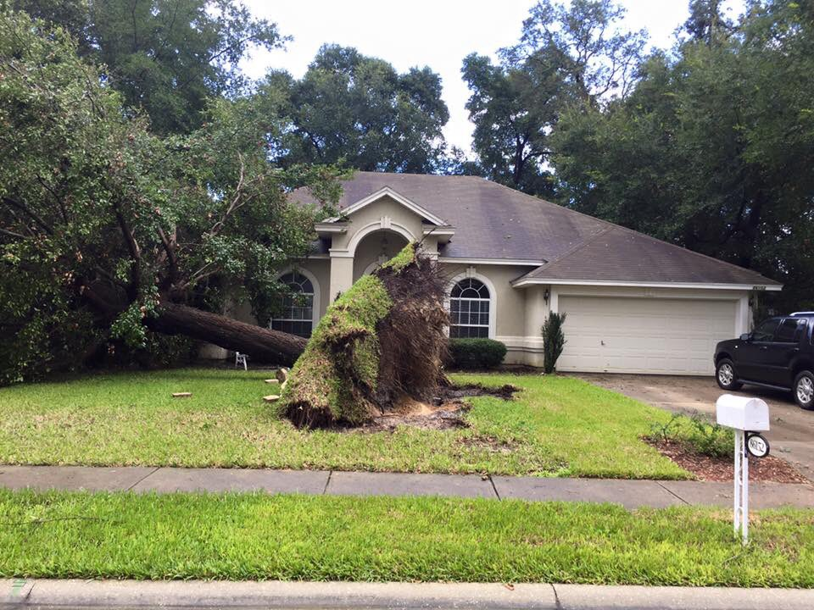](https://web.archive.org/web/20210228124349/http:/nws.weather.gov/blog/nwsjacksonville/wp-content/uploads/sites/7/2016/08/MeadowfieldBluffs_6.jpg)[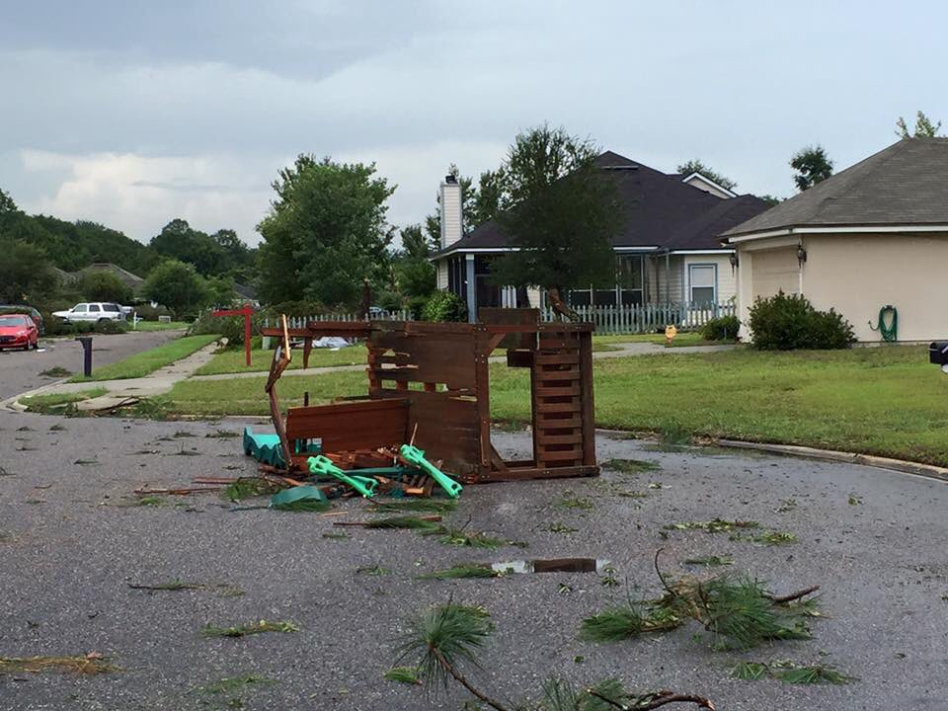](https://web.archive.org/web/20210228124349/http:/nws.weather.gov/blog/nwsjacksonville/wp-content/uploads/sites/7/2016/08/MeadowfieldBluffs_5.jpg)[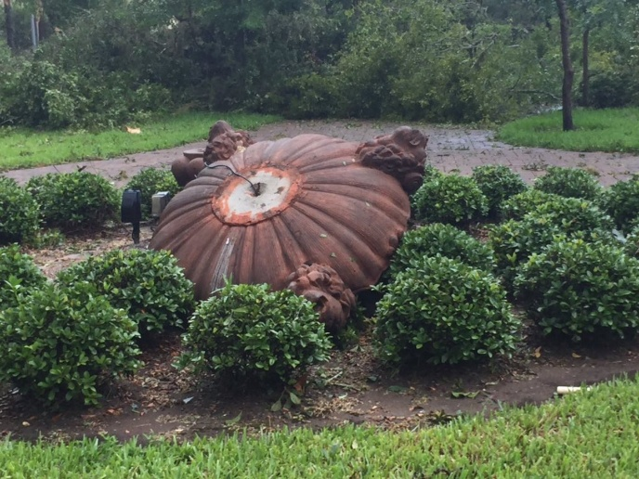](https://web.archive.org/web/20210228124349/http:/nws.weather.gov/blog/nwsjacksonville/wp-content/uploads/sites/7/2016/08/MeadowfieldBluffs_4.jpg)[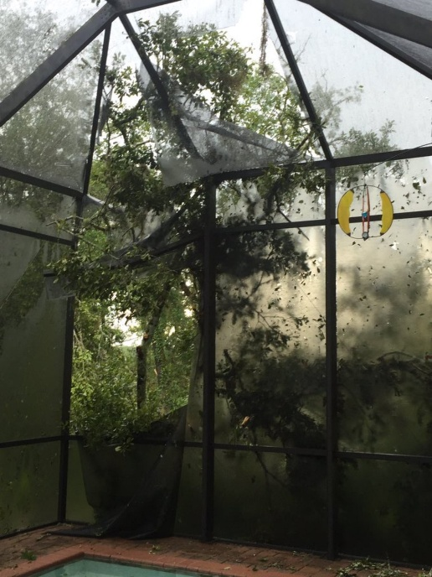](https://web.archive.org/web/20210228124349/http:/nws.weather.gov/blog/nwsjacksonville/wp-content/uploads/sites/7/2016/08/MeadowfieldBluffs_3.jpg)[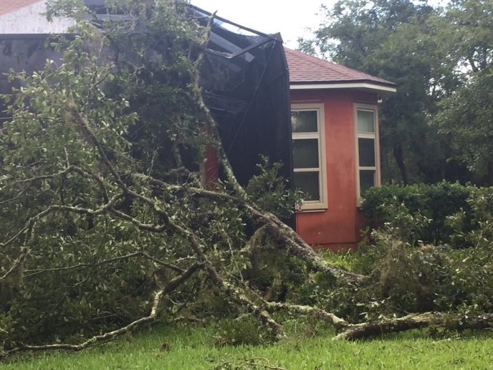](https://web.archive.org/web/20210228124349/http:/nws.weather.gov/blog/nwsjacksonville/wp-content/uploads/sites/7/2016/08/MeadowfieldBluffs_2.jpg)[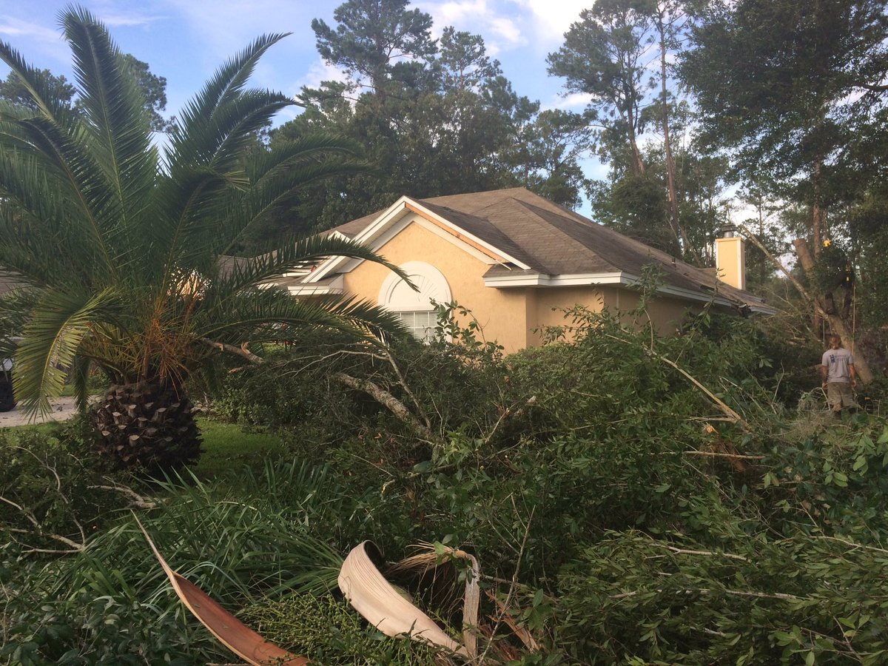](https://web.archive.org/web/20210228124349/http:/nws.weather.gov/blog/nwsjacksonville/wp-content/uploads/sites/7/2016/08/MeadowfieldBluffs_1.jpg)