Dangerous Weather Condition & Safety Tip
2 of 5
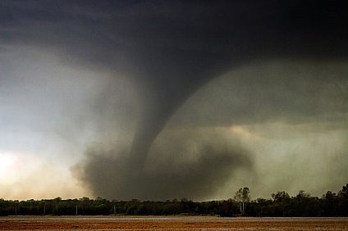

TORNADOES

What is it?
Tornadoes are violently rotating columns of air descending from thunderstorms. They can strike the ground with winds up to 200 miles per hour. That is four times faster than a car!

How will you know it is coming?
Tornadoes pop up very quickly, and often we have only a short amount of time to get warnings. Watch your local television news, listen to the radio, check www.weather.gov, and purchase a NOAA Weather Radio. If you are outdoors, look for a dark, greenish sky, large hail, dark, low clouds, and loud roaring sounds.

Safety Tips
- If indoors - get to the lowest room of the building; or a room with no windows (an interior hallway, bathroom or closet).
- If in a car - get out right away - go into a sturdy building.
- If outside - get inside. If you can’t, go to a low ditch, lie down, cover your head.

