Dangerous Weather Condition & Safety Tip
5 of 5
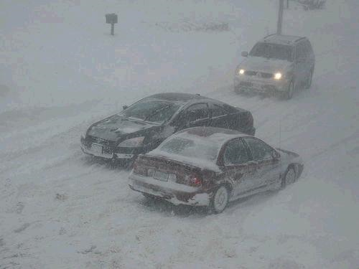

WINTER STORMS

What is it?
Many places in the United States have winter storms every year. Even places that often have mild winters can be surprised by a winter storm! Winter storms can bring heavy snowfall and lots of ice. Winter storms can bring very cold air.

How will you know it is coming?
Watch your local television and listen to radio newscasts, check www.weather.gov, and purchase a NOAA Weather Radio.

Safety Tips
- Have a winter kit ready, complete with blankets, winter clothes (hats, gloves, etc.,) and items for the car such as a shovel, snow brush, window scraper, and a bag of sand or kitty litter
- Stay inside if at all possible. If you must go outside, wear layers of warm clothing
- If you start to shiver a lot, go inside right away

