Interactive Verification Program User’s Manual

- Overview

The Interactive Verification Program (IVP) is a tool for verifying hydrologic forecasts. It provides the ability to view pairs of observations and forecasts, compute statistics by category, and transform the data into normalized space. This manual describes how to operate the IVP.

- Notation

The following notational conventions are used in this document:

- A GUI component, including a window, panel, menu, menu item, or button, is displayed in bold.
- <key> indicates a keyboard key. For example <shift> means the shift key.
- Text to be entered at a command line is displayed in this font.

- Execution

To execute the IVP, enter:

cd $(get_apps_defaults vsys_scripts)
ivp

Upon execution, the Select Data Source window, an example of which is shown in Figure 1.

- Apps-defaults Tokens

The following apps-defaults tokens are used by the IVP:

- verify_dir : $(apps_dir)/rfc/verify
- vsys_dir : $(verify_dir)
- vsys_output : $(vsys_dir)/output

The first token should be defined in the national apps-defaults file and is used to located the system settings file (see Appendix A). The second token is used in constructing the third token, which is used to determine the initial directory to search for pairs files.

- Select Data Source Window

The Select Data Source window, shown in Figure 1, is used to select the forecast-observed pairs to use in verification. It is opened when the IVP first executes or when either of the Open Data Source or Change Data Source menu items within the Actions menu of the Data Source Display window (see Section 6.0) is selected. This section describes the components of the Select Data Source window.

  - Files To Load List

The Files To Load list is displayed in the upper text area. Forecast-observed data pairs used in verification must be loaded from verification pairs files. These files are constructed via the Verify program of release OB3 and earlier, or via the PAIRS_FILE command used by the verification function of the IVP Batch Program (see the IVP Batch Program User’s Manual for Verification). More than one file can be included in the list of files. Adding and removing files from the list are accomplished via the Add File and Remove File buttons.
Figure 1: Select Data Source window.

  - Available LIDS List

The Available LIDS list is displayed in the lower text area. It is a list of the location ids (lids) and physical elements available for verification, as well as the number of pairs found within the files of the Files to Load list for each combination of lid and physical element. The list is a complete listing of lids and physical elements for which at least one forecast-observed data pair exists. The list is constructed whenever the Fill LIDs button is clicked.

  - The Buttons

Managing the Files to Load list and the Available LIDS is accomplished through the use of seven buttons in the window. The buttons are as follows:

- Add File
Add a file to the Files to Load list. Clicking on this button spawns a file browser dialog. Find the file you wish to add and click on the Open button within the dialog. The only requirement is that the file’s name contains the phrase “.pairs” in it somewhere. If the Verify program (OB3 and earlier) is used to build the pairs file, this will be handled automatically.

- Remove File
Remove a file from the Files to Load list. Selecting a file and clicking on this button will remove the selected file from the list.

- Fill LIDs
Construct the Available LIDS list using the pairs within the files of the Files to Load list. This list never changes unless the Fill LIDs button is clicked.

- Select All
Select all entries in the Available LIDS list.

- Clear
Unselect all entries in the Available LIDS list.

- Okay
Open up a Data Source Display window using the selected pairs. By selecting entries in the Available LIDS list and clicking on this button, a Main Display window is opened displaying, as a scatter plot, the forecast-observed data pairs.

- Cancel
Close the Select Data Source window and do nothing. If this Select Data Source window was opened upon execution of the IVP, then the program will exit. Otherwise, the window will close and the Data Source Display window that spawned this window will become active.

- Data Source Display Window

The Data Source Display window, shown in Figure 2, is opened when the user clicks the Okay button in the Select Data Source window. It displays the forecast-observed data pairs to be used in verification as a scatter plot. The different lids and physical element combinations that make up the scatter plot are used to build the legend to the right of the scatter plot.
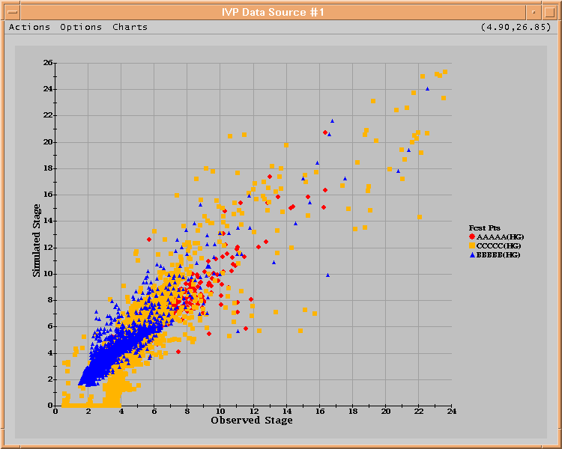
Figure 2: Data Source Display window.
The title of the window is constructed as follows:

IVP Data Source #<num>

where <num> is the identification number for the Data Source Display. The menu bar for this window is displayed above the plot. To the right of the menu bar is the Data Tracker, which displays the coordinates currently pointed to by the mouse cursor.

The following sections describe the menus that make up the menu bar.

  - The Actions Menu

The Actions menu, shown in Figure 3, contains menu items associated with opening and changing the data source, closing the data source, saving the current display as a gif, and exiting the program. The menu items are as follows:

- Open New Data
Open a new data source. Selecting this menu item will spawn a Select Data Source window and allow the user to open up a new data source.
- Change Data Source
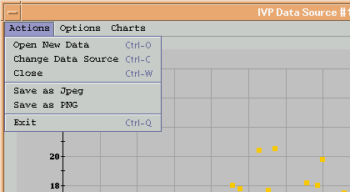
Figure 3: Actions menu of the Data Source Display window.
Change this data source. Selecting this menu item will spawn a Select Data Source window and allow the user to change the data displayed in this Data Source Display window and reset the categories defined in the Bounds Editor window (see Section 7.0). Note that any Chart windows spawned by this Data Source Display will not change automatically. To change the chart display, the user must select the Refresh menu item from the Actions menu of the Chart window (see Section 9.1).

- Close
Close this Data Source Display window. If this is the only Data Source Display window that is currently open, the IVP will exit.

- Save as Jpeg/Save as PNG
Save the current plot displayed in this Data Source Display window to a jpeg or png file. This will spawn a file dialog. Specify the name of the file to create (without extension) and click Open. The image file will be created with an appropriate extension (.jpg or .png).

- Exit
Exit the IVP.

  - The Options Menu

The Options menu, shown in Figure 4, is used change the appearance of the scatter plot display in some way. The menu items are as follows:

- Apply NQT…
Apply the Normal Quantile Transform (NQT) to the scatter plot data. Selecting the Apply NQT... menu item applies the NQT, described in Appendix B, to both the observed and simulated (forecast) stage values, transforming each into standard normal variables. It has two sub-menu items, one of which must be selected for anything to happen:

By Segment: Apply the NQT for each lid independently. This is the recommended approach.
For All: Apply the NQT for all the lids lumped together.
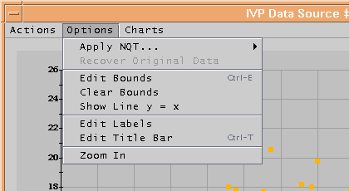
Figure 4: Options menu of the Data Source Display window.
Upon selecting one of the two sub-menu items, the following will happen: (1) the scatter plot will change to display the transformed data, (2) the Bounds Editor window will refresh, and (3) the Apply NQT... menu item will be disabled while the Recover Original Data menu item will be enabled.

- Recover Original Data
Recover the original data before application of the NQT. Selecting the Recover Original Data will result in the following: (1) the scatter plot will change to display the original data, (2) the Bounds Editor window will refresh, and (3) the Recover Original Data menu item will be disabled while the Apply NQT... menu item will be enabled.

- Edit Bounds
Open the Bounds Editor window associated with this Data Source Display window. See Section 7.0.

- Clear Bounds
Reset the categories displayed within the Bounds Editor window.

- Show Line y = x / Hide Line y = x
Show or hide the line y = x (i.e. the line where the observed and simulated values are equal) in the scatter plot. Selecting this menu item will result in a green line being added to the plot (for Show) or removed (for Hide) from the plot. Upon selecting Show Line y = x, the menu item will change to Hide Line y = x, and vice versa.

- Edit Labels
Open up a Chart Label Mgr window to allow for editing the labels on the current chart. See Section 8.0.

- Edit Title Bar
Edit the title of the window. Selecting this menu item will result in an Edit Title Bar dialog being opened. To change the title, type in the desired new title and click Okay.

- Zoom In / Zoom Out
Zoom in or out in the current scatter plot. Selecting the Zoom In/Zoom Out menu item either turns on zoom mode, which allows the user to zoom in on a region of the scatter plot, or recovers the original plot dimensions. Which of these actions it performs is decided according to the current label of the menu item. Instructions on how to zoom in on a region are given in Section 10.2.
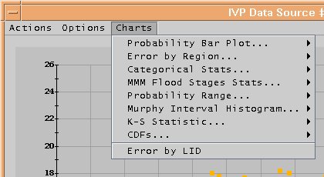
Figure 5: Charts menu of the Data Source Display window.
  - The Charts Menu

The Charts menu, shown in Figure 5, is used to select different types of charts available in the IVP. Selecting any menu item (and sub-menu item) within this menu will result in a Chart window being spawned. The categories used by the Chart window, where appropriate, are determined by this Data Source Display window’s associated Bounds Editor window. See Section 11.0 for the different charts.

- Bounds Editor Window

The Bounds Editor window, shown in Figure 6, is opened when the user selects the Edit Bounds menu item in the Options Menu of the Data Source Display window. The categories are displayed in mathematical notation in two lists, the left list for the x-axis (or observed data) and the right list for the y-axis (or simulated/forecast data). Initially, these two lists each contain only one entry: (-∞,∞). Whenever either of these two lists change, the scatter plot within the associated Data Source Display window will change, with blue lines being drawn for each of the category boundaries.
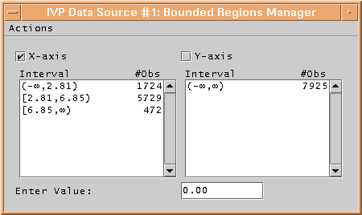
Figure 6: Bounds Editor window.

The title of the window is constructed as the title of the Data Source Display window associated with this Bounds Editor window, with a “: Bounded Regions Manager” attached at the end. The X-axis and Y-axis checkboxes determine which categories are currently selected for editing. For a set of categories to be edited, the corresponding check box must be checked. The Enter Value text field is an input mechanism used by the Actions menu items Create Default… and Add Value To Regions, both described in Section 7.1.

The Actions menu is described in the following section.

  - The Actions Menu

The Actions menu, shown in Figure 7, provides menu items associated with managing the categories displayed in the Bounds Editor. The menu items are as follows:

- Create Default…
Calculate default categories. Selecting the Create Default… menu item will setup default categories for the currently selected axis or axes. It has three sub-menu items, one of which must be selected for the categories to be calculated:

Minimum Size: Selecting the Minimum Size sub-menu item will read in an integer from the Enter Value text field and create a set of categories such that no category has fewer pairs than the integer.
Number of Regions: Selecting the Number of Regions sub-menu item will read in an integer from the Enter Value text field and create a set of categories such that the number of categories is that integer and each interval is of equal size, or as close as possible.
Flood Stages: Selecting the Flood Stages sub-menu item will attempt to set the categories based on the floodcat table of the IHFS database specified by the apps-defaults token “db_name”. This will only work if the IHFS database is accessible from the machine on which IVP is being run (typically OB3 and earlier versions of IVP).

Once one of the three sub-menu items it selected, the categories for the selected axis or axes will be removed and the default categories will be added. The scatter plot in the associated Data Source Display window will be redrawn to show the new category bounds.
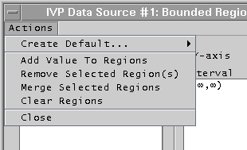
Figure 7: Actions menu of the Bounds Editor window.

- Add Value to Regions
Define a new category boundary. Selecting the Add Value to Regions menu item will create a new category defining boundary based on the value in the Enter Value text field. See Section 10.3 for instructions on how to create a new category defining boundary.

- Remove Selected Region(s)
Remove selected categories from the list of categories for the selected axis or axes.

- Merge Selected Categories
Merge the selected categories into one large category for the selected axis or axes. The categories must be adjacent in order to be merged.

- Clear Regions
Clear all of the categories for the selected axis or axes.

- Close
Close the Bounds Editor window. The categories cannot be edited while this window is closed.

- Chart Label Mgr Window

The Chart Label Mgr window, shown in Figure 8 with its Actions menu, is used to edit the labels displayed in the plot within the associated Data Source Display window or Chart window. The title of the window is constructed as the title of the Data Source Display window or Chart window associated with this Chart Label Mgr window, with a “: Chart Label Mgr” attached at the end.
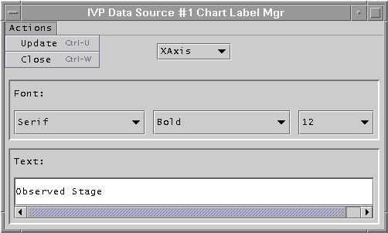
Figure 8: Chart Label Mgr window with Actions menu.

There are three components to this window. The first is the Label Selection choice box at the top. From this choice box, the label to change can be selected. The second is the Font Selection panel. In this panel are choice boxes that can be used to select the font to use. The third is the Text Value panel. In this panel is displayed the current text for the label. See Section 10.4 for instructions on how to edit the labels.

The Actions menu is described in the following section.

  - The Actions Menu

There are only two menu items within the Actions menu of the Chart Label Mgr window.

- Update
Update the associated Data Source Display window or Chart window to display the new labels.

- Change Data Source
Close the Chart Label Mgr window.

- Chart Window

The Chart window, examples of which are shown in Figures 10 – 17, displays verification graphics calculated for the associated Data Source Display window using categories from the associated Bounds Editor window, where appropriate. It is spawned when one of the menu items (and possibly sub-menu items) within the Chart menu of the Data Source Display window is selected. If the chart includes a legend, it will be drawn at the right. See Section 11.0 for a description of each individual chart.

Each type of Chart window displays a different chart, but they do have similarities. First, the title of all Chart windows is constructed as the title of the Data Source Display window associated with this Chart window, with a chart descriptor appended to the end. Second, each type of Chart window provides the same Actions menu. That menu is described in the following section.

  - Actions Menu

The Actions menu of a Chart window, shown in Figure 9, provides five menu items, three of which are identical to the similarly named menu items in the Data Source Display window. The menu items are as follows:

- Refresh
Redraw the chart. Selecting the Refresh menu item will result in the chart being redrawn using the data provided in the associated Data Source Display window scatter plot and the categories in its associated Bound Editor window. This will allow the plot to be redrawn if the data source changes or if the categories change.

- Edit Labels
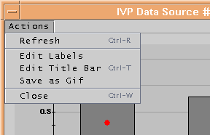
Figure 9: Actions menu of a Chart window.
Edit the labels on the chart. See Section 6.2 for a description.

- Edit Title Bar
Edit the title bar of this Chart window. See Section 6.2 for a description.

- Save as Gif
Save the current chart display as a gif file. See Section 6.1 for a description.

- Close
Close this Chart window.

- Instructions

This section provides instructions for various actions that a user can take while running IVP.

  - Build Verification Data Set

To build a verification data set, do the following within the Select Data Source window (see Section 5.0):

- Decide on which pairs files you wish to use as a source of the forecast-observed pairs.
- For each file, do the following:
  - Click on the button Add File. This opens up a file browser dialog.
  - Navigate to and select the file you wish to use as a source of pairs.
  - Click Open within the file browser dialog. The dialog will close and the file will be added to the Files To Load list.
- Click on the Fill LIDs button. The files will be searched for all unique lid and physical elements pairs. The Available LIDS list will be filled accordingly.
- While holding down the <ctrl> key, click on every lid and physical element pair you wish to verify together. Optionally, you may use the Select All button to choose them all.
- Click on Okay.

Upon completing Step 5, either a new Data Source Display window will be spawned providing a scatter plot of the pairs, or an existing window will be changed to display a scatter plot of the pairs. The later will occur only if the Change Data Source menu item (see Section 6.1) within the Data Source Display window resulted in spawning the Select Data Source window. Otherwise the former will occur.

  - Zooming In and Out

Within the Data Source Display window, to zoom-in or zoom-out on a section of scatter plot, do the following:

- Click and drag on the scatter plot to draw a rectangle encompassing the area you want to zoom in on.
- Select the Zoom In menu item within the Options Menu. This will redraw the plot, zooming in on the area within the drawn rectangle. Also, the Zoom In menu item will become a Zoom Out menu item.
- To zoom back out, select the Zoom Out menu item within the Options Menu.

Only one level of zooming in can be performed within this program.

  - Defining Categories

To define categories within the Data Source Display window for either the x-axis (observed) values or the y-axis (simulated or forecasted) values, do the following:

- Select the Edit Bounds menu item from the Options menu. The Bounds Editor window associated with this Data Source Display window will open.
- Click on the X-axis and/or Y-axis check box for the axis or axes for which you wish to create categories.
- Boundaries specifying the categories can be created by doing one of the following:

- Selecting the Create Default... menu item of the Actions menu (see Section 7.1),
- selecting the Add Value to Regions menu item of the Actions menu (see Section 7.1) to construct the categories one boundary at a time,
- selecting the Flood Stages menu item of the Actions menu (see Section 7.1) to construct categories corresponding to flood stages for a location (if only one lid is involved), or
- clicking where you wish the boundary to be within the scatter plot of the Data Source Display window to construct the categories one boundary at a time.

It is recommended you use the Data Tracker to guide you selecting category boundaries using the scatter plot (see Section 6.0).

Step 3 should be performed until every desired category is defined.

  - Editing Plot Labels

To edit the labels for the plot associated with the Data Source Display window or a Chart window, do the following:

- Select the Edit Labels menu item within the Options menu of the Data Source Display window or the Actions menu of a Chart window. This will spawn a Chart Label Mgr window described in Section 8.0.
- For each label you wish to edit, do the following:
  - Select the label to edit from the Label Selection choice box.
  - Select the font for the label from the choice boxes within the Font Selection panel.
  - Set the text value within the text field in the Text Value panel.
- Once label editing is complete, select the Update menu item from the Actions menu (see Section 8.1).

Upon completing Step 3, the labels should change on the plot within the corresponding window accordingly.

- The Charts

This section describes each of the charts and how they are constructed. Creating a chart requires, first, defining categories as described in Section 10.3, and then selecting the corresponding menu item (or sub-menu item) of the Charts menu in the Data Source Display window. A description of how the data sets are prepared will now be provided, followed by a description of each type of available chart.

  - Data Set Preparation

The statistics generated by the IVP are calculated using categories that are defined using the Bounds Editor window. The algorithm used to prepare the data for statistics calculation begins with identifying the category variable. The category variable is that variable which is used to determine to which category a pair belongs. For example, the user may wish to break down the pairs based on the observed value. Hence, the observed value becomes the category variable. Other potential category variables include the forecast value or the location id (see Error By Lid Chart).

Statistics are calculated independently for each category by calculating the subset of the pairs that belong to the category and calculating the statistics for that subset. Continuing with the previous example, suppose the user defines the categories (-∞, 5.5), [5.5, 6.5), and [6.5, +∞) for the observed values. Then three sets of statistics will be produced, one for each category, where the pairs included in the statistics for the first category are those pairs for which the observed value is less than 5.5. The pairs included in the statistics for the second category will be those pairs for which the observed value is at least 5.5 and less than 6.5. The third category will include pairs for which the observed value is at least 6.5.

This is the general mode of computation for all charts, with the exception of the Categorical Statistics Chart. For that chart, both the forecast and observed values are used in categorizing pairs and calculating statistics. See Section 11.4 for more detail.

Lastly, the Error By Lid Chart uses the combination of location id and physical element to break down the pairs into categories. See Section 11.7 for more details.

  - Probability Bar Plot Chart
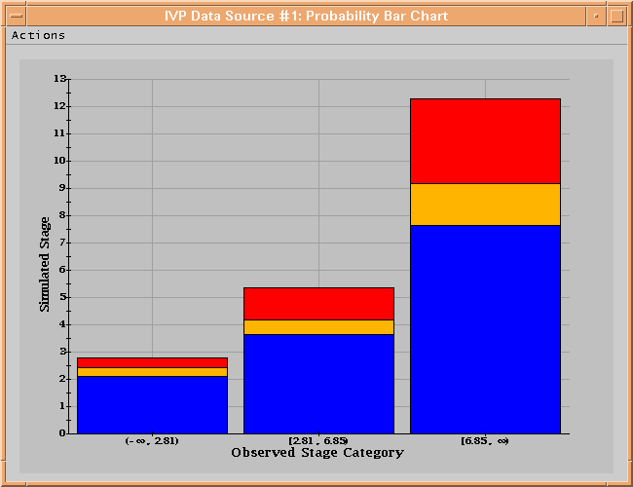
Figure 10: Probability Bar Plot Chart.

The Probability Bar Plot Chart, shown in Figure 10, is calculated using whichever variable is not the category variable. For example, if the user has selected that the observed regions are used, the statistics are computed based on the forecasted values. The statistics computed are the 0.25, 0.50, and 0.75 probability quantiles, where for probability p the probability quantile is x_{p} such that P(X ≤ x_{p}) = p. The quantiles are displayed in the form of a bar chart, which is interpreted as,

“When the observed value is within a specific interval, the forecast has a 25% chance of being in blue region, a 25% chance of being in the yellow region (or 50% chance of being in the yellow or blue regions), a 25% chance of being in the red region (or 75% chance of being in the red, yellow, or blue regions), and a 25% chance of being above the red region.”

  - Error By Region Chart

The Error By Region Chart, shown in Figure 11, displays the following verification statistics:

- root mean squared error (RMSE),
- maximum error (MaxErr),
- mean absolute error (MAE), and
- mean error (ME).

The legend will show which symbol corresponds to which error statistic.

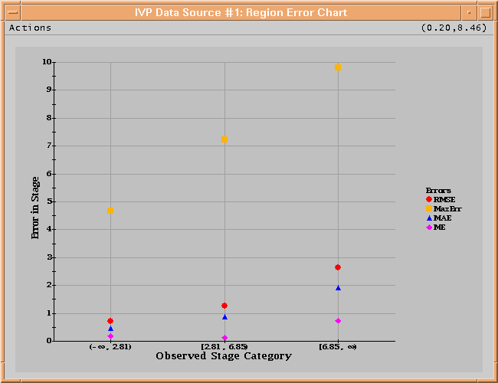
Figure 11: Error By Region Chart.
  - Categorical Statistics Chart

The Categorical Statistics Chart, shown in Figure 12, is constructed using both forecast and observed categories, requiring that both be equal. Hence, the sub-menu items using Observed Regions and using Simulated Regions only specify what categories to use. The following table will be used to describe the computation of each categorical statistic:

 | Observed was...
Forecast was... | below | within | above
above | A | B | C
within | D | E | F
below | G | H | I

The table reads as, “B is the number of pairs for which the observed is within the interval and the forecast is above the interval”. The statistics plotted against the left y-axis are as follows:

- Probability of Detection (POD): The probability that, given an observed value is within the category, the forecast value is also within the category, or E/(B+E+H).
- Traditional False Alarm Rate (TFAR): The probability that, given a forecast value is within the category, the observed value is not within the category (either above or below), or (D+F)/(D+E+F).
- Hydrologic False Alarm Rate (HFAR): The probability that, given a forecast value is within the category, the observed value is below the category (useful when categories represent flood levels), or D/(D+E+F).
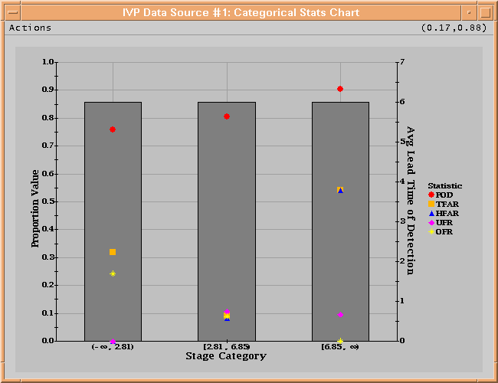
Figure 12: Categorical Statistics Chart.
- Under Forecast Rate (UFR): The probability that, given an observed value is within the category, the forecast value is below the category, or H/(B+E+H).
- Over Forecast Rate (OFR): The probability that, given an observed value is within the category, the forecast value is above the category, or B/(B+E+H).
- Critical Success Index (CSI): Commonly used in verification, the CSI integrates information from the POD and FAR, and is calculated as (D+E+G+H)/(A+B+D+E+F+G+H+I). Currently, this is only available in the IVP Batch Program.

The average lead time of detection is provided as a gray bar plotted against the right y-axis. This statistic is computed by averaging the difference between the basis time and valid time for each of the detections, or pairs for which the forecast and observed are both within the category.

The usefulness of the HFAR is best described through an example. Suppose for a specific lid, a minor flood stage and a major flood stage are available. Then, the HFAR over the interval from minor to major flood stage will tell the user the rate at which a minor flood is forecasted but no flooding occurs. Similarly, the HFAR over the interval above major flood stage will tell the user the rate at which a major flood is forecasted but either no flooding or minor flooding occurs.

  - Probability Range Chart

The Probability Range Chart, shown in Figure 13, is similar to the Probability Bar Plot Chart except that the quantiles are displayed as points. The statistics displayed are the probability quantiles (see Section 11.2) as well as the minimum and maximum. The legend will show which symbol corresponds to which quantile, minimum, or maximum.
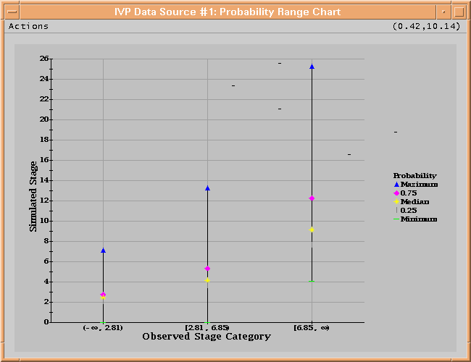
Figure 13: Probability Range Chart.
  - Murphy Interval Histogram Chart

The Murphy Interval Histogram Chart, shown in Figure 14, is a means by which the ability of the forecaster to discriminate between the categories can be ascertained. There are no statistics produced. Rather, the density function of the variable for which the statistics are normally produced is displayed. By displaying the density function, the spread of the statistics variable can be seen. The density is approximated by performing the following algorithm for each user selected category, where the statistics variable is that variable which is not the category variable:

- Break down the total range of the statistics variable into 10 equal intervals.
- Count the number of values of the statistics variable within each interval.
- Divide the count by the total number of pairs within the user selected category.
- Plot the proportion from Step 3 against the midpoint of the interval.

For example, suppose the user selected the observed categories, and one of the intervals is [5.5, 6.5). The first step is to create a subset of the pairs for which the observed value is within [5.5, 6.5). Next, suppose that the forecasted values for the pairs in this subset range from 4 to 8. For this chart, the interval [4, 8] is broken down into 10 sub-intervals of equal size, which means each sub-interval has a width of 0.4, or (8 - 4)/10. Then, for each sub-interval, the number of forecasted values within that interval is counted and divided by the total number of points within the interval [4, 8]. Then, that proportion is plotted against the midpoint of the sub-interval. So, a proportion is generated for [4, 4.4] and plotted against 4.2, for (4.4, 4.8] and plotted against 4.6, for (4.8, 5.2] and plotted against 5.0, and so on.
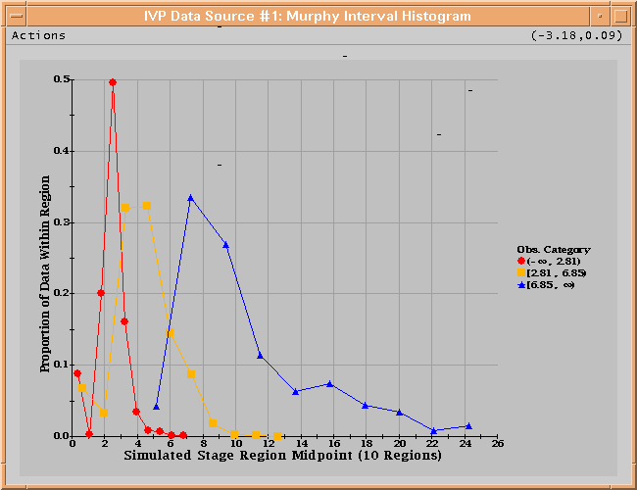
Figure 14: Murphy Interval Histogram Chart.
  - Error By LID Chart

The Error By LID Chart, shown in Figure 15, is constructed using the lid to determine the categories. The statistics computed are the exact same as the Error By Region Chart.

  - Kolmogorov-Smirnov Chart

The Kolmogorov-Smirnov Chart, shown in Figure 16, is a means by which the ability of the forecaster to discriminate between the categories can be ascertained. The statistics displayed are the Kolmogorov-Smirnov (K-S) Test Statistics is the maximum vertical difference between the distributions shown in the Cumulative Distribution Chart, and indicates the similarity of the conditional distribution in one Subset with the conditional distributions in the other subsets.

One important characteristic of forecasts is discrimination. When forecasts are skillful, the distribution of the forecast (or observed) values for different observed (or forecasted) categories will be distinct from each other. When the forecasts are unskillful, the distributions will not differ much and the densities approximated in the Murphy Interval Histogram chart will overlap.

  - Cumulative Distribution Chart

The Cumulative Distribution Chart, provided in Figure 17, shows the conditional distributions derived using the Interval Subset Approach as cumulative distribution functions. They are shown in the Murphy Interval Histogram Chart as density functions.

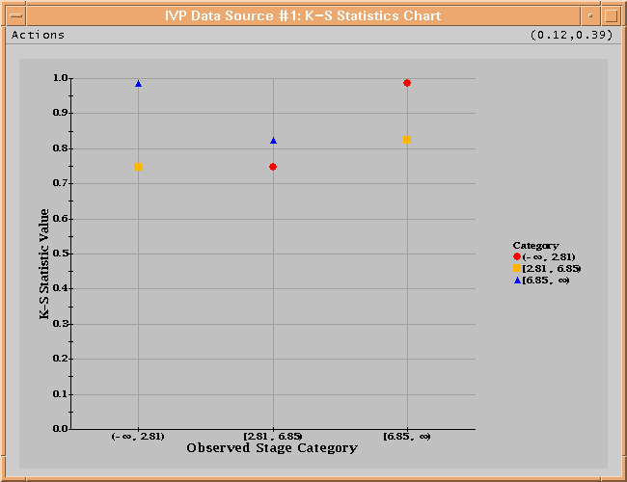
Figure 15: Kolmogorov-Smirnov Chart.
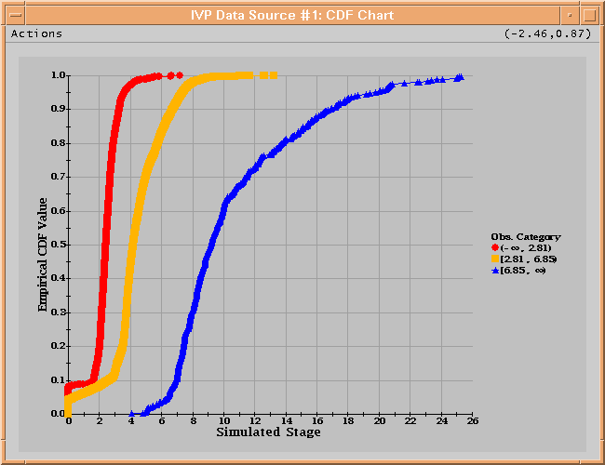
Figure 16: Cumulative Distribution Chart.
Appendix A: System Settings File

A.1 Overview

The format of the IVP windows look different on different operating systems. A system settings file allows the user to change the appearance of the windows. This appendix describes that file.

A.2 Location

The following apps-defaults token must be set in order for the system settings file to be found:

vsys_dir

The file is assumed to exist in the directory $(vsys_dir)/app-defaults with the name “IVP_SYSTEM_FILE.txt”.

A.3 System Settings File

The system settings file uses the same file format as an IVP Batch Program batch file. However, rather than being read in sequentially, it is processed and stored at run-time so that each GUI component can extract the settings that pertain to it. If a command is given more than once within the system settings file, the last instance will over-ride the earlier instances.

A.3.1 Commands

Commands, indicated in bold, set parameter values that control the appearance of Vfyruninfo Editor. The <value> on the line of the batch input file that contains the command is usually restricted, depending on that command. Acceptable Values are listed for each command. The default value shown is the value assumed if the system settings command is not found.

The following are IVP system settings commands:

ButtonFont = <font>
Description: Controls the font used on button labels in the windows.
Acceptable Values: Any font string (see Section A.4)
Default Value: "Courier;plain;12"

ChartLabelMgrWindowHeight = <number>
Description: Controls the pixel height of the Chart Label Mgr window.
Acceptable Values: positive integer value.
Default Value: 300

ChartLabelMgrWindowWidth = <number>
Description: Controls the pixel width of the Chart Label Mgr window.
Acceptable Values: positive integer value.
Default Value: 500

ChartWindowHeight = <number>
Description: Controls the default height of a Chart window.
Acceptable Values: positive integer value.
Default Value: 500

ChartWindowWidth = <number>
Description: Controls the default width of a Chart window.
Acceptable Values: positive integer value.
Default Value: 650

LabelFont = <font>
Description: Controls the default font used on labels within the various windows.
Acceptable Values: Any font string (see Section A.4)
Default Value: "Courier;plain;12"

LegendFont = <font>
Description: Controls the default font used within the legend of the various Chart windows and Data Source Display window.
Acceptable Values: Any font string (see Section A.4)
Default Value: "Serif;bold;9"

ListFont = <font>
Description: Controls the font used in the lists within the Select Data Source window and the Bounds Editor window.
Acceptable Values: Any font string (see Section A.4)
Default Value: "Courier;plain;12"

MainChartWindowHeight = <number>
Description: Controls the default height of a Data Source Display window.
Acceptable Values: positive integer value.
Default Value: 600

MainChartWindowWidth = <number>
Description: Controls the default width of a Data Source Display window.
Acceptable Values: positive integer value.
Default Value: 750

MenuFont = <font>
Description: Controls the font used in the menus of the various windows.
Acceptable Values: Any font string (see Section A.4)
Default Value: "Courier;plain;12"

SegmentWindowHeight = <number>
Description: Controls the height of a Select Data Source window.
Acceptable Values: positive integer value.
Default Value: 625

SegmentWindowWidth = <number>
Description: Controls the width of a Select Data Source window.
Acceptable Values: positive integer value.
Default Value: 400

TitleFont = <font>
Description: Controls the default font used for the title in the Chart windows and the Data Source Display window.
Acceptable Values: Any font string (see Section A.4)
Default Value: "Serif;bold;12"

XAxisLabelFont = <font>
Description: Controls the default font used for the x-axis in the Chart windows and the Data Source Display window.
Acceptable Values: Any font string (see Section A.4)
Default Value: "Serif;bold;12"

YAxisLabelFont = <font>
Description: Controls the default font used for the left y-axis in the Chart windows and the Data Source Display window.
Acceptable Values: Any font string (see Section A.4)
Default Value: "Serif;bold;12"

YAxis2LabelFont = <font>
Description: Controls the default font used for the right y-axis in the Chart windows and the Data Source Display window.
Acceptable Values: Any font string (see Section A.4)
Default Value: "Serif;bold;12"

A.4 Generic Font Format

All font settings for the Vfyruninfo Editor must be entered in the system settings file with the following value format:

<font name>;<font style>;<font size>

where each component can have the following values:

<font name>: "Serif", "SanSerif", "TimesRoman" or "Courier"
<font style>: "plain", "bold", "italics" or "bold-italics"
<font size>: any integer representing a valid size for that font

If an invalid size is specified, the system will use the default value, which varies based on the font.

Appendix B: The Normal Quantile Transform
The NQT is applied by first computing an empirical estimate, F, of the cumulative distribution function for the data set X. Then, for every sample value, x, in the data set X, a new sample value is generated as

z = Q⁻¹(F(x)),

where Q is the standard normal cumulative distribution function. The data set Z containing all the transformed values from X is then the NQT transformed data set.

