Interactive Verification Program
User’s Manual

By

Henry Herr
Office of Hydrologic Development
National Weather Service
Table Of Contents

1.0 Overview 5
1.1 Using This Manual 5
2.0 Notation 5
3.0 Execution 6
4.0 Directory Structure 6
5.0 Apps-defaults Tokens 6
6.0 File Types 7
7.0 Instructions 8
8.0 Verification Group Manager 9
8.1 Start Time and End Time 9
8.2 Time Step 9
8.3 Lead Time Start, Lead Time End, and Lead Time Step 10
8.4 Fcst Type Sources 10
8.5 Physical Elements 10
8.6 River Responses 10
8.7 Persistence 10
8.8 Buttons 10
9.0 Choose Date/Time Window 12
9.1 Specifying a Date 12
9.2 Buttons 12
10.0 Choose Relative Date/Time Window 13
10.1 Specifying a Relative Date 13
10.2 Buttons 13
11.0 Select FCST_TS and Select PE Windows 14
11.1 Buttons 14
12.0 Verification Location Manager 15
12.1 Terminology 15
12.2 The Table 15
12.3 Buttons 16
13.0 Observed and Forecast Category Editor 17
13.1 Boundary List 17
13.2 Specifying a Boundary String 17
13.3 Buttons 18
14.0 IVP Data Display 19
14.1 Highlighted Location 19
14.2 Data Tracker 19
14.3 Zooming In and Out 19
14.4 Menu Items 20
15.0 Verification Pairs Data Manager 22
15.1 Sorting the Rows 22
15.2 Visible Rows 22
15.3 Buttons 23
16.0 Verification Plot Definition Manager 24
16.1 Primary and Secondary Statistics 24
16.2 Primary and Secondary Statistic Plot Types 24
16.3 X-Axis Variable 25
16.4 Analysis Interval and Lead Time Interval Used 25
16.5 Observed Category and Forecast Category 25
16.6 Graph Template File 26
16.7 Buttons 26
17.0 IVP Statistic Chooser Manager 27
17.1 Buttons 27
18.0 IVP Statistic Display 28
18.1 Menu Items 28
19.0 IVP Statistics Data Viewer 30
19.1 Buttons 30
20.0 IVP Batch File Save Manager 31
20.1 File Name Text Fields 31
20.2 Buttons 31
21.0 IVP Chart Properties Manager 33
21.1 Template Files 34
21.2 Default Values 34
21.3 All Titles (Chart Titles) 34
21.4 All Numerical Axis Limits (Chart Others) 35
21.4.1 Buttons 36
21.5 Legend (Chart Titles) 37
21.5.1 Buttons 37
21.6 X-Axis Labels (Chart Others) 37
21.6.1 Buttons 38
22.0 Tips and Information 39
22.1 System Settings File 39
22.2 NOAA and NWS Logos 39
22.3 Performance 39
22.4 Running IVP on AWIPS LX Machines 40
22.5 Debugging 40
Appendix A: System Settings File 41
A.1 Overview 41
A.2 Location 41
A.3 System Settings File 41
A.3.1 Commands 41
A.4 Generic Font Format 48
A.4 Generic Color Format 49
Appendix B: The Statistics 50
B.1 Error Statistics 50
B.2 Categorical Statistics 50
B.3 Quantiles and Extremes 51
B.4 Leadtime Statistics 51
B.5 Sample Size 52
B.6 References 52

- Overview

The Interactive Verification Program (IVP) is a tool for verifying hydrologic forecasts. It provides the ability to do the following:

- Define and view forecast-observed data pairs for use in verification according to the location, physical element, forecast validtime, forecast leadtime, forecast value, observed value, and forecast type source. Data can be viewed graphically and in a table format.
- Save the forecast-observed data pairs to a properly formatted pairs file.
- Define and view verification statistics, including error statistics, categorical statistics, quantiles, extremes, and sample sizes. Statistics can be viewed in a table and in a plot. More than one statistic can be displayed against a single y-axis if those statistics have the same scale, and two y-axes can be included in the plot. Statistics can be plotted against location, analysis (or validtime) interval, lead time interval, forecast category, and observed category.
- Save plot to an image file (jpg or png).
- Save table containing the statistics to a file.
- Save a batch file that can be processed by the IVP Batch Program in order to regenerate graphics visible in the IVP.

This manual provides instructions on how to use the IVP.

  - Using This Manual

Section 7 provides instructions on how to use this software to generate verification graphics. Sections 8-21 provide information on each window of the IVP. It is recommended that the user follow the instructions in Section 7 when first using this software, and, as the user interacts with the IVP, refer to the Section pertaining to a window if he or she has a question about it (see the Table of Contents for the page number).

Screenshots for each window are included at the END of the section pertaining to the window.

- Notation

The following notational conventions are used in this document:

- A GUI component, including a window, panel, menu, menu item, or button, is displayed in bold.
- A menu item within a menu is displayed as [menu name] >> [menu item name]. For example, Actions >> Close is the Close menu item within the Actions menu.
- Terms to remember and NOTEs will be denoted in italics.
- <key> indicates a keyboard key. For example <shift> means the shift key.
- Text to be entered at a command line is displayed in this font.
- Directories and file names are in this font.
- A directory corresponding to an apps-defaults token is denoted $(token).

- Execution

To execute the IVP, enter:

cd $(get_apps_defaults vsys_dir)/scripts
ivp

Upon execution, the Verification Group Manager window will open up.

- Directory Structure

The following directory structure must be in place for the IVP to execute properly:

$(vsys_dir)/bin/RELEASE/rfc.ob7.2.jar
$(vsys_dir)/bin/RELEASE/dbgen.jar
$(vsys_dir)/input/
$(vsys_dir)/files/$(LOGNAME)/templates/
$(vsys_dir)/output/$(LOGNAME)/
$(vsys_dir)/scripts/ivp

$(vsys_dir) refers to the value of the apps-defaults token vsys_dir, which points to the base directory, typically /rfc_arc/verify. $(LOGNAME) refers to the user name; any directory above with this in it should be created for each user who is to use the software.

- Apps-defaults Tokens

The following apps-defaults tokens are used by the IVP:

- adb_name : <depends upon RFC>
- verify_dir : /rfc_arc/verify
- vsys_dir : $(verify_dir)
- vsys_input : $(vsys_dir)/input
- vsys_output : $(vsys_dir)/output
- vsys_files : $(vsys_dir)/files
- rax_pghost : ax <optional; if not present, it uses the PGHOST environment variable, instead>
- pguser : pguser <optional; if not present, it uses the PGUSER environment variable, instead>
- pgport : 5432 <optional; if not present, it uses th PGPORT environment variable, instead>

Each of the above directories must exist for the IVP to run properly. It is also recommended that the following directory be created for each user:

$(vsys_input)/$LOGNAME

If this recommendation is followed, then the apps-defaults site file should override the setting of vsys_input as follows:

- vsys_input : $(vsys_dir)/input/$(LOGNAME)

All of these directories should be constructed prior to running IVP.

- File Types

The following types of files are used within the IVP (recommended file extensions are given in parentheses; for the output image files, the extensions are required)

- Batch Input Files (.bat): These files are input files to the IVP Batch Program, and can be loaded by the GUI in order to specify parameters of the data used and plots generated. These files are, by default, assumed to be in the $(vsys_input) directory.
- Graph Template Files (.txt): These files specify properties of the charts to create, including labels, fonts, colors, sizes, axis limits, and others. These files are, by default, assumed to be in the $(vsys_files)/$LOGNAME/templates directory.
- Output Image Files (.png, .jpg, .jpeg): These files are images of the charts generated by the IVP or IVP Batch Program. These files are, by default, assumed to be in the $(vsys_output)/$LOGNAME directory. Any such file MUST have one of the extensions listed.
- Output Data Files (.dat): These files are ASCII format files that provide the data plotted to a chart in a tabular format. These files are, by default, assumed to be in the $(vsys_output)/$LOGNAME directory.
- System Settings File: This file is an ASCII format file used to specify defaults for the appearance of the IVP and its charts. The file must be in the directory $(vsys_dir)/app-defaults and have the name IVP_SYSTEM_FILE.txt. See Appendix A for more details.

- Instructions

Prior to using the IVP to generate a verification graphic, the user should know the answers to the following:

- Which locations are to be included in the verification analysis? What are the location ids for those locations?
- Over what analysis time period is the verification analysis to be performed? Is it to be broken down into intervals? If so, what is the width of the intervals?
- For which forecast lead times is verification to be performed? Is the overall lead time period to be broken down into smaller intervals? If so, what is the width of the intervals?
- Are any restrictions to be placed on the physical elements or forecast types of the forecasts to be analyzed?
- Are persistence forecasts to be included in the analysis?
- Is performance relative to categories (e.g. above flood stage, below flood stage) to be analyzed? If so, what categories are to be used?

To generate a verification graphic, do the following:

- Start the IVP (see Section 3.0).
- Enter the analysis interval information, lead time information, and any other restrictions into the Verification Group Manager window.
- Click on Edit Locations to open up the Verification Location Manager window.
- Select the desired locations from the Locations List.
- Set the categories using the Observed Category Editor and Forecast Category Editor.
- Click on Create Display in the Verification Group Manager to create the IVP Data Display.
- Examine the data for a general feeling about the skill of the forecasts.
- Click on Actions >> Show Plot Mgr to open up the Verification Plot Definition Manager.
- Specify a desired graphic by changing the settings in the Verification Plot Definition Manager.
- Click on Create Plot to create an IVP Statistics Display.
- Many graphics can be produced. At this point, the data used in verification is already loaded into memory. So producing a graphic is relatively fast and the user should feel free to produce as many graphics as needed to do a proper verification analysis.
- If the user would like to produce a particular graphic on a regular basis, the user should save a batch file by clicking on Actions >> Save Batch File and fill out the fields in the IVP Batch File Save Manager as desired. It is important to use relative dating for the start and end times in the Verification Group Manager window if the user would like this plot to be generated in batch mode for different analysis intervals.
- Save any desired graphics by clicking on Actions >> Save Image File in either the IVP Data Display or IVP Statistic Display.

- Verification Group Manager

The Verification Group Manager window provides tools to manage and edit parameters of a verification group. A verification group is a collection of locations and parameters that define how to do statistic calculations, for which one set of verification statistics is to be calculated. Parameters of a verification group include:

- locations: collection of locations within which a forecast-observed data pair’s location must exist in order for it to be included in the calculations
- analysis intervals: start time and end time defining the period of analysis, and a time step breaking down the period into subintervals
- lead time intervals: start lead time and end lead time defining a range that restricts the lead time of the forecast, and a time step breaking down the range into subintervals
- forecast type sources: list of type sources for forecasts to include in the calculations
- physical elements: list of physical elements for the observed and forecast data to include in the calculations
- response time: list of response times, restricting data to include in verification by the corresponding location’s response time
- persistence: parameter defining if persistence forecasts (those with a type source of “FR”) are to be included in the analysis

Each parameter is managed in a graphical way, using components of the Verification Group Manager.

NOTE: It is recommended that, if you have an appropriate batch file already constructed that defines the group for which you wish to compute statistics, then you should use the Load From Batch button to load the parameters from the file. This is easier than specifying each field manually.

  - Start Time and End Time

The start time and end time of the analysis interval specify a range within which the forecast valid time of a forecast-observed data pair must exist in order to be included in the verification computations. In the Verification Group Manager, the start time is given in the Start Time text field and the end time is given in the End Time text field. Both can be specified manually or via a Choose Date/Time Window or Choose Relative Date/Time Window.

NOTE: See Section 8.0 of the IVP Batch Program User’s Manual for Verification for acceptable formats for the text field.

  - Time Step

The time step specifies a time interval that breaks down the overall analysis interval (start to end) into equal sized subintervals. In the Verification Group Manager, the time step is given by the Time Step Quantity spinner and Time Step Unit choice box. The former specifies an integer value greater than 0, and the latter specifies a unit of time (“weeks”, “days”, “hours”) or “NONE”. A unit of “NONE” implies that no subintervals are to be used and the Time Step Quantity is to be ignored. Combined, the quantity and unit define an interval of time.

  - Lead Time Start, Lead Time End, and Lead Time Step

The lead time start, lead time end, and lead time step specify a range within which the forecast lead time (valid time – basis time) of a forecast-observed data pair must exist in order to be included in the verification computations, and further breaks down that interval into equal sized subintervals. In the Verification Group Manager, each is specified using a spinner and choice box: Lead Time Start Quantity spinner, Lead Time Start Unit choice box, etc.

  - Fcst Type Sources

The fcst type sources define a list of type sources within which the forecast’s type source of a forecast-observed data pair must exist in order to be included in the verification computations. In the Verification Group Manager, it is specified as a comma delimited list in the Forecast Type Sources text field. It is edited manually or via a Select FCST_TS Window.

  - Physical Elements

The physical elements define a list of physical elements within which the physical element of a forecast-observed data pair must exist in order to be included in the verification computations. In the Verification Group Manager, it is specified as a comma delimited list in the Physical Elements text field. It is edited manually or via a Select PE Window.

  - River Responses

The river responses define a list of response times within which a locations response time must be in order for points for that location to be included in the verification computations. In the Verification Group Manager, it is specified using Response Time radio buttons that allow for a setting of “ALL” or a setting that can include any combination of “SLOW”, “MEDIUM”, and “FAST”.

NOTE: If the current river response setting is “ALL”, then the other three radio buttons will be deactivated and cannot be selected. To make them active, first deselect “ALL”.

  - Persistence

The persistence flag defines if forecast-observed data pairs that are for persistence forecasts are to be included in the verification computation. In the Verification Group Manager, it is specified by using Persistence radio buttons that allow for a setting of “ON” or “OFF”.

NOTE: Setting the Persistence to “ON” is equivalent to including the type source “FR” in the Forecast Type Sources text field.

NOTE: If calculations are only to be made for persistence forecasts, then set the Forecast Type Sources text field to “FR” and set this radio button to either “ON” or “OFF” (it doesn’t matter, since the text field includes “FR”).

  - Buttons

- Start Time Fixed button: Opens up a Choose Date/Time Window for editing the Start Time text field.
- Start Time Rel button: Opens up a Choose Relative Date/Time Window for editing the Start Time text field.
- End Time Fixed button: Opens up a Choose Date/Time Window for editing the End Time text field.
- End Time Rel button: Opens up a Choose Relative Date/Time Window for editing the End Time text field.
- Fcst Type Sources Edit List button: Opens up a Select FCST_TS Window for editing the Forecast Type Sources text field.
- Physical Elements Edit List button: Opens up a Select PE Window for editing the Physical Elements text field.
- Edit Locations button: Opens up the Verification Location Manager to allow for changing categories for locations and choosing locations to be displayed in the IVP Data Display.
- Load From Batch button: Opens up a file browser that can be used to find a previously created batch file for the IVP Batch Program and set the parameters within this Verification Group Manager according to that file. It will read parameters until the first verification group is defined (via a DEF_GRP batch file action; see the IVP Batch Program User’s Manual) and sets the parameters herein according to those read in.
- Create Display button: Creates an IVP Data Display, showing forecast-observed data pairs specified by this Verification Group Manager and the Verification Location Manager. Pairs shown correspond to chosen locations in the Verification Location Manager and all chosen locations.

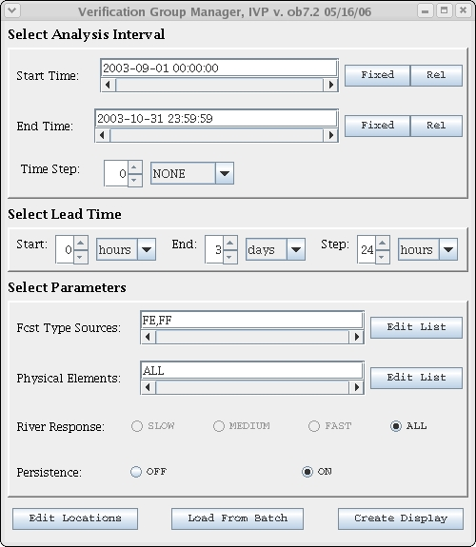
- Choose Date/Time Window

The Choose Date/Time Window is used to specify a date in the format

yyyy-mm-dd hh:mm:ss TZC

  - Specifying a Date

The date is chosen as follows:

- Select a month from the Month choice box.
- Select a year from the Year choice box.
- Click on the desired day of the month.
- Specify the hour in the Hour spinner either manually or by using the up and down arrows.
- Specify the minute in the Minute spinner.
- Specify the second in the Second spinner.
- Select a time zone in the Time Zone choice box.
- Click OK.

  - Buttons

- OK button: Closes the window and updates the corresponding date text field in the Verification Group Manager.
- Cancel button: Closes the window with no change in the Verification Group Manager.

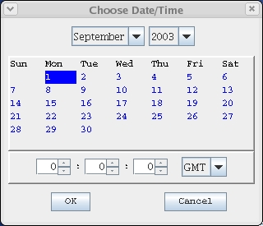

- Choose Relative Date/Time Window

The Choose Relative Data/Time Window is used to specify a date relative to the current time. It is a string of this format:

* <+/-> <quantity> <unit> <quantity> <unit>...

where <quantity> is a positive integer and <unit> is “weeks”, “days”, or “hours”. For example, “* - 2weeks” is valid, and is equal to “* - 14 days” or “* - 1 weeks 7 days” or “* - 1weeks 6 days 24 hours”.

  - Specifying a Relative Date

A relative date is chosen as follows:

- Select either the Plus (+) Radio button or the Minus (–) Radio button.
- Into the Quantity text field, enter the quantity to use.
- From the Unit choice box, select the unit to use.
- Click on the >> button. The quantity and unit will enter into the Value text field.
- Repeat steps 2 and 3 until the relative date/time is completely specified.
- Click on OK.

  - Buttons

- OK button: Closes the window and updates the corresponding date text field in the Verification Group Manager.
- Cancel button: Closes the window with no change in the Verification Group Manager.

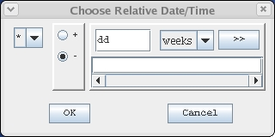

- Select FCST_TS and Select PE Windows

The Select FCST_TS Window and Select PE Window perform similar functions: they allow the user to select items to use from a list of items, or select “ALL” if all items are to be used. To select an item for use, click on the desired items in the list of items. To deselect the item, click on the selected item again. When finished, the user must click OK to accept the list or Cancel to return without accepting the list.

  - Buttons

- OK button: Closes the window and updates the corresponding date text field in the Verification Group Manager.
- Cancel button: Closes the window with no change in the Verification Group Manager.

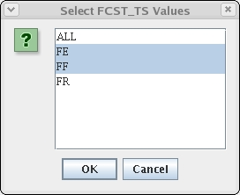

- Verification Location Manager

The Verification Location Manager provides tools to manage the list of verification locations to be included in the computation of verification statistics. A verification location is uniquely identified by a location id (lid from the IHFS and archive databases) and physical element, and also contains a response time, various critical stages found in the rivercrit table of the archive data, and categories for both the observed and forecast value.

  - Terminology

These terms must be defined in order to describe the Verification Location Manager:

- selected location: a selected location is a verification location that is currently selected from the table by clicking on the location’s row. Selected locations are highlighted in blue.
- chosen location: A chosen location is a verification location that is chosen to be displayed in the IVP Data Display. A location is chosen by first selecting the row and then clicking on Choose. Chosen locations are highlighted in pink and red. All chosen locations must have the same number of forecast categories and the same number of observed categories.

NOTE: Verification locations must be chosen in order for the Create Display button of the Verification Group Manager to build the IVP Data Display. All chosen locations MUST have the same number of observed categories and forecast categories. If not, the display will not be created.

  - The Table

The Location Table displays the verification locations defined in the vfyruninfo table. Each row of the table lists the following attributes of a location:

- location: The 8-character identifier for a location, which along with the pe uniquely defines the verification location to which this row corresponds. Often called the lid in the IHFS and archive databases.
- pe: The 2-character physical element, which along with the location uniquely defines the verification location to which this row corresponds.
- as: The action stage, defined for this location in the rivercrit table. If this stage is not defined, it will be -999.0.
- fs: The flood stage, defined for this location in the rivercrit table. If this stage is not defined, it will be -999.0.
- modfs: The moderate flood stage, defined for this location in the rivercrit table. If this stage is not defined, it will be -999.0.
- majfs: The major flood stage, defined for this location in the rivercrit table. If this stage is not defined, it will be -999.0.
- rs: The record stage, defined for this location in the rivercrit table. If this stage is not defined, it will be -999.0.
- Forecast Category: The string defining the categories for the forecast value. This field can be edited via the Forecast Category Editor window.
- Observed Category: The string defining the categories for the observed value. This field can be edited via the Observed Category Editor window.

Within the table, locations are selected by clicking on the corresponding row. Multiple locations can be selected by clicking and dragging, or by using the <ctrl> and <shift> buttons while clicking. A selected location can be deselected by pressing <ctrl> while clicking on its corresponding row.

Clicking on a column header within the table will sort the table entries by the column, either descending or ascending depending on which sort was last performed (ascending is the initial sort order).

  - Buttons

- Edit Fcst Cat button: Opens the Forecast Category Editor to allow for editing forecast categories for the selected locations.
- Edit Obs Cat button: Opens the Observed Category Editor to allow for editing forecast categories for the selected locations.
- All button: Selects all locations. This may require two clicks for it to work.
- None button: Deselects all locations.
- Choose button: Chooses all currently selected locations for display. After clicking, the selected rows will have a pink and red background and all rows will be deselected.
- Clear button: Unchooses all currently selected locations. After clicking, the selected rows will have a white and gray background and all rows will be deselected.
- Clear All button: Unchooses all locations. Any currently selected rows will be deselected.
- Show button: Highlights the currently selected location in the IVP Data Display. This button will do nothing if the selected location is not chosen or if more than one row is currently selected.

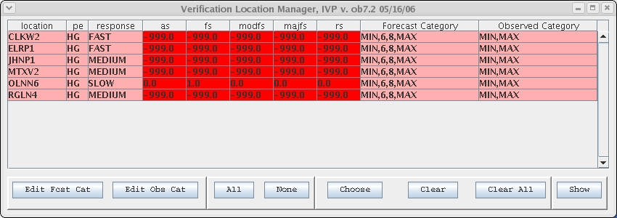

- Observed and Forecast Category Editor

The Observed Category Editor and Forecast Category Editor are used to specify categories for verification locations. The categories are defined by a comma delimited list, where each delimited item is a boundary string specifying a boundary of a category. A boundary string must one of the following:

- MIN: -INFINITY (no lower bound)
- MAX: INFINITY (no upper bound)
- <absolute number>: Any fixed number (i.e. for stage data, 6 means 6 feet)
- <scalar>*<stage>: A multiple of one of the stages associated with a verification location. The scalar can be any fixed number. The stage must be one of AS (action stage), FS (flood stage), ModFS (moderate flood stage), MajFS (major flood stage), and RS (record stage).

For example, the following string defines two categories: above flood stage and below flood stage:

“MIN, 1*FS, MAX”

The following defines three categories: below flood stage, between flood stage and 12 ft (assuming the data’s units is in feet), and above flood stage:

“MIN, 1*FS, 12, MAX”

NOTE: The category boundaries are sorted into ascending order when determining the categories, implying that the order of boundary strings within the category string does not matter. So, in the second example above, if 12 were less than the flood stage for a location, the middle category would include stages larger than 12 ft and less than the flood stage.

  - Boundary List

The Boundary List lists the currently specified boundary strings defining the category string. It is a list of strings on the right-hand side of the window above the Delete button with one boundary string per line. List items can be selected by clicking on them and deselected by clicking on them a second time.

  - Specifying a Boundary String

A boundary string is constructed by doing the following:

- Click on the MIN button if one of the categories is to have no lower bound.
- Click on the MAX button if one of the categories is to have no upper bound.
- For each absolute number that defines a boundary, type the number into the Absolute text field and click on the Absolute >> button (the >> button next to the Absolute text field).
- For each multiple of a stage that defines a boundary, type the scalar into the Scalar text field, select the stage from the Stage choice box, and click on the Scalar >> button (the >> button next to the Stage choice box).
- Select the locations to which you wish to apply these categories.
- Click on OK to make the changes to the Verification Location Manager.

After clicking on the OK button, the Boundary List will be turned into a comma delimited string and displayed in the appropriate column of the Location Table. The Category Editor window will also close.

  - Buttons

- Add MIN button: Adds the MIN string to Boundary List.
- Add MAX button: Adds the MAX string to the Boundary List.
- Absolute >> button: Adds an <absolute number> to the Boundary List. This is the >> button next to the Absolute text field.
- Scalar >> button: Adds a <scalar>*<stage> to the Boundary List. This is the >> button next to the Scalar choice box.
- Delete button: Removes the currently selected boundary strings from the Boundary List.
- OK button: Converts the Boundary List into a comma delimited category string and inserts the category string into the appropriate column within the Location Table for the currently selected locations. Also closes the window.
- Close button: Closes the window. Upon opening the window again, the Boundary List displayed upon last closing the window will again be visible.

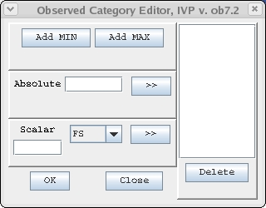

- IVP Data Display

The IVP Data Display graphically displays all of the forecast-observed data pairs specified by the parameters in the Verification Group Manager and locations chosen in the Verification Location Manager. The y-axis of the plot is the forecast value, the x-axis is the observation. Any data pair that would be included in the verification is shown in the plot.

By default, the title of the plot provides the RFC name of the data, the overall analysis interval, the overall lead time interval, and a list of the ids of the locations chosen for display. Also, by default, the NOAA logo is displayed in the upper left corner and the NWS logo in the upper right corner.

Associated with the IVP Data Display chart are chart properties, including the title, axis labels, legend, fonts, etc. These properties can be customized via the Chart Properties Manager.

NOTE: The IVP Data Display is directly linked with, and must be consistent with, the Verification Group Manager and Verification Location Manager. If parameters in either window are changed, then the IVP Data Display must be re-created (i.e. click on the Create Display button in the Verification Group Manager). The next time the mouse pointer passes over the window, the user will be told this and the IVP Data Display, and all related windows including the Verification Pairs Data Manager and Verification Plot Definition Manager, will close.

  - Highlighted Location

By selecting one and only one location and then clicking on the Show button of the Verification Location Manager, the user can highlight a location in the IVP Data Display. A highlighted location is displayed in yellow, and the boundaries defining the categories for the location are drawn with blue lines. The forecast category boundaries will be displayed as horizontal lines, and the observed will be displayed as vertical lines.

  - Data Tracker

The Data Tracker consists of coordinates displayed in the upper right corner of the window in the menu bar. When the mouse pointer passes over the plot, the Data Tracker displays the values currently pointed to by the mouse pointer.

  - Zooming In and Out

To zoom in on portion of the IVP Data Display plot, put the mouse pointer at one corner of the region you want to zoom in on, move the mouse to the opposite corner, and release the button. This will draw a box on the plot. Then click on Options >> Zoom in. The plot will be redrawn to show only the selected region, and the Options >> Zoom in menu item will change to Options >> Zoom out.

To zoom back out, click on Options >> Zoom out. The plot will be redrawn to look as it originally did, and the Options >> Zoom out menu item will revert to Options >> Zoom in.

NOTE: Zooming in and out can also be done by changing the axis limits in the Chart Properties Manager.

  - Menu Items

- Actions >> Show Plot Mgr menu item: Opens up the Verification Plot Definition Manager and makes it the active window.
- Actions >> Show Group Mgr menu item: Makes the Verification Group Manager visible and active.
- Actions >> Show Location Mgr menu item: Makes the Verification Location Manager visible and active.
- Actions >> Show Pairs Data menu item: Open up the Verification Pairs Data Manager and makes it active.
- Actions >> Save Image File menu item: Open up a file browser to allow the user to select a jpeg or png file name to which to save the image. If the file name does not end in either a “.jpg” or “.jpeg” extension for JPEG images, or a “.png” extension for PNG images, then the file type will be unrecognized and no image will be saved.
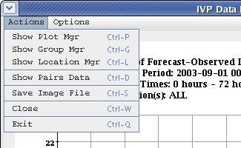
- Actions >> Close menu item: Close the IVP Data Display window.
- Actions >> Exit menu item: Exit the IVP program.
- Options >> Show line y=x (Hide line y=x) menu item: Draws the line y = x (i.e. forecast = observation) on the plot. The line will be green.
- Options >> Edit Chart Properties menu item: Opens up the Chart Properties Manager for this chart and makes it active, enabling a user to change the properties of this chart.
- Options >> Save Properties Template menu item: Opens up a file browser to save the current chart properties for this chart to a template file.
- Options >> Load Properties Template menu item: Opens up a file browser to select a template file and apply the settings to the chart properties for this chart.
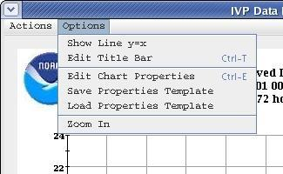
- Options >> Zoom in (Zoom out) menu item: Zooms in on a region of the plot, or zooms out to the original plot. See Section 11.3, above.

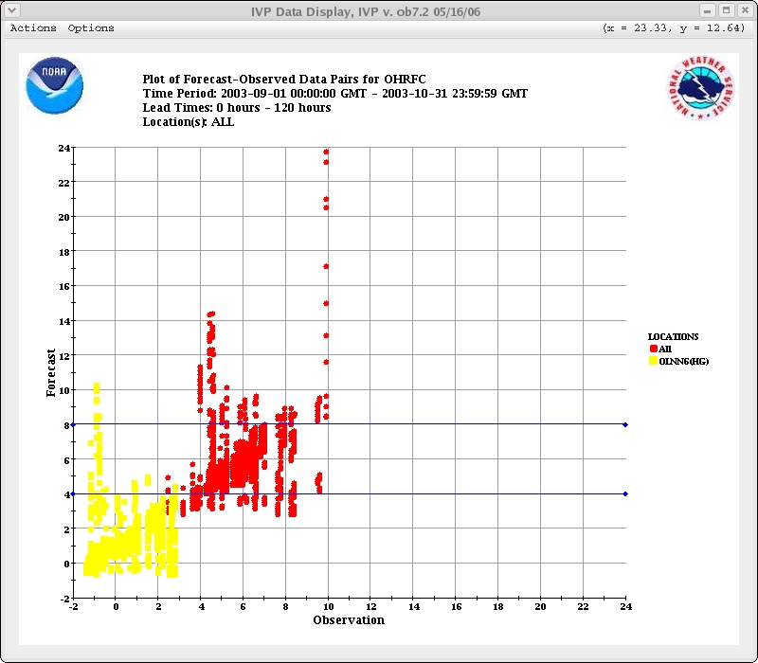
- Verification Pairs Data Manager

The Verification Pairs Data Manager shows in a table the forecast-observed pairs currently displayed and visible in the IVP Data Display. Each row corresponds to a record of the vfypairs table in the archive database. Each field of the record is displayed as a column of the table in the Verification Pairs Data Manager. The columns are:

- Index: The original row number. After sorting the table, the original ordering of the rows can be reacquired by sorting by the index column.
- Vis: If the point displayed on the row is currently visible in the IVP Data Display plot, then this column value will be ‘Y’. Otherwise, the value will be ‘N’. This is useful if the user has zoomed in on a region of the plot.
- location: 8-character location id
- pe: physical element (SHEF PEdtsep)
- dur: duration (SHEF peDtsep)
- idur: integer representation of the duration
- fts: forecast type source (SHEF pedTSep)
- e: extremum (SHEF pedtsEp)
- p: probability (SHEF pedtseP)
- validtime: forecast valid time
- basistime: forecast basis time
- ots: observation type source (SHEF pedTSep)
- obstime: observed time
- fcst value: forecast value (for stage data, the unit is feet)
- obs value: observed value
- quality code: the integer quality code stored with the forecast value

  - Sorting the Rows

To sort the table by a given column, just click on the header for that column. For example, to sort alphabetically by location, click on the “location” column header. The first time the table is sorted by a particular column, the sort will be in ascending order. The second time, it will be in descending order. After that, the sort order will continue to alternate between ascending and descending.

To retrieve the original order of the rows, sort by the “Index” column.

  - Visible Rows

If a row is visible in the current IVP Data Display plot, then the background of the row will include colors, such as yellow, green, and gray, and the “Vis” column will be ‘Y’. If the row is not visible, the background will be white, and the “Vis” column will be ‘N’. To more easily focus on visible or not-visible rows, sort by the “Vis” column.

The rows that are visible and displayed in color within the table changes whenever the user zooms-in on a region of the IVP Data Display plot.

  - Buttons

- Save to File button: Opens up a file browser to allow the user to select the file to which to save the data within this table. The format of the file will be that of a pairs file (see the IVP Batch Program User’s Manual for Verification).
- Close button: Close the Verification Pairs Data Manager.

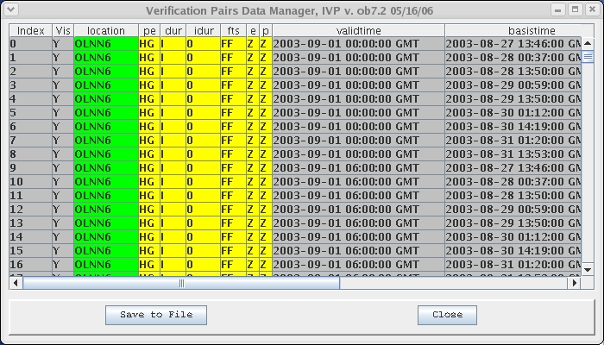

- Verification Plot Definition Manager

The Verification Plot Definition Manager provides tools to manage parameters of an IVP statistic plot. Parameters of the plot include the following:

- primary statistics: statistics displayed against the left hand y-axis of the generated plot.
- primary plot type: the plot type of the primary statistics (line, scatter, or bar plot).
- secondary statistics: statistics displayed against the right hand y-axis of the generated plot.
- secondary plot type: the plot type of the secondary statistics.
- x-axis variable: the variable to display along the x-axis (location, analysis interval, lead time interval, observed category, forecast category).
- analysis interval used: the analysis interval used in the plot, as dictated by the x-axis variable.
- Leadtime interval used: the lead time interval used in the plot, as dictated by the x-axis variable.
- observed category: the observed category used to restrict what pairs are included in the analysis.
- forecast category: the forecast category used to restrict what pairs are included in the analysis.

Each parameter is managed in a graphical way, using components of the Verification Plot Definition Manager.

NOTE: It is recommended that, if you have an appropriate batch file already constructed that defines the parameters of the graphic you wish to produce, then you should use the Load From Batch button to load the parameters from that file. This is easier than specifying each field manually.

  - Primary and Secondary Statistics

The primary statistics and secondary statistics define the statistics displayed on the left-hand and right-hand y-axes, respectively. All of the statistics displayed against a single axis must have the same scale. For example, the mean absolute error and mean error can be displayed against the same y-axis, because both have the same units (feet, in the case of stage data). However, mean absolute error and probability of detection cannot be displayed against the same y-axis, because the probability of detection is a probability, between 0 and 1.

Selecting primary and secondary statistics is done through an IVP Statistic Chooser Manager, which ensures only statistics with the same scale can be displayed against a single axis. The IVP Statistic Chooser Manager is opened by clicking on the corresponding Choose Stat button. The Primary Statistics text field displays the currently selected primary statistics, and the Secondary Statistics text field displays the secondary statistics.

  - Primary and Secondary Statistic Plot Types

The plot type for a statistic can be one of the following:
- Scatter: Statistic values are plotted as points. A scatter plot is good when the x-axis does not show trends (i.e. location).
- Line: statistic values are plotted as points and are connected by lines. A line plot is good when the x-axis does show trends (i.e. analysis interval, lead time interval).
- Bar: statistic values are plots as vertical bars rising to the statistic value from the bottom of the plot. A bar plot is good when the y-axis value is a count, such as the statistic sample size or average lead time of detection.

The primary statistic plot type is chosen from the Primary Plot Type choice box. The secondary statistic plot type is chosen from the Secondary Plot Type choice box.

  - X-Axis Variable

The x-axis variable for a plot can by one of the following:

- Location: Statistic values are plotted for each location separately in the order in which the locations appear within the Verification Location Manager (top to bottom).
- Analysis Interval: Statistic values are plotted against each interval defined by the start time, end time, and time step of the Verification Group Manager.
- Lead Time Interval: Statistic values are plotted against each interval defined by the lead time start, lead time end, and lead time step of the Verification Group Manager.
- Observed Category: Statistic values are plotted against each category defined for the observed value in the Verification Location Manager.
- Forecast Category: Statistic values are plotted against each category defined for the forecast value in the Verification Location Manager.

  - Analysis Interval and Lead Time Interval Used

The analysis interval used and the lead time interval used inform the user what intervals are being used to compute the statistics. For example, if the x-axis variable is location, observed category, or forecast category, then the analysis interval used will be the entire interval, from start time to end time. Also, the lead time interval used will be the entire interval, from lead time start to lead time end. If the x-axis variable is analysis interval, then the analysis interval used will be “All user-defined intervals will be used.” If the x-axis variable is lead time interval, then the lead time interval used will be “All user-defined intervals will be used.”

  - Observed Category and Forecast Category

The observed category and forecast category define any restrictions on the data to use in verification, based on the observed or forecast value. The choice is made by selecting an item from the Observed Category choice box or Forecast Category choice box. The choices are the following:

- Do Not Use: Do not use this category to add a restriction to the data. If chosen, then the corresponding choice box will be disabled and the other category choice box will become enabled, allowing a selection to be made.
- All Categories Combined/Use Only Category: If only one category is defined, then data pairs must be in that category in order to be used in the computations. If multiple categories are defined, then the data must be in at least one of the categories in order to be used in the computations.
- Category #: The data pair must be in the category chosen for the corresponding data value (i.e. observed or forecast) in order to be used in the computations.

If the x-axis variable is observed category or forecast category, then the two choice boxes are disabled, since the x-axis variable dictates how the categories are used. Only one of the two choice boxes can be active at a time. If the observed category is Do Not Use, then the forecast category must be chosen as something else, and vice versa.

NOTE: To make it so that all data is used in computing statistic regardless off category, one of the two choice boxes must be “Do Not Use” and the other must be “All Categories Combined”/”Use Only Category”. Also, the categories must include boundary strings MIN and MAX.

  - Graph Template File

The graph template file specifies properties (that are not default) of the chart to create, including labels, fonts, colors, sizes, axis mins and maxes, and others. For more information on the graph template file, see the section on the Chart Properties Manager (Section 21). The text field specifies the template file to use when the IVP Statistic Display is first created. If the text field is empty or “NONE”, then default chart properties will be used to construct the display.

  - Buttons

- Primary Statistic Choose Stat button: Opens up the IVP Statistic Chooser Manager for selecting the primary statistics.
- Secondary Statistic Choose Stat button: Opens up the IVP Statistic Chooser Manager for selecting the secondary statistics.
- Graph Template Select button: Opens up a file browser for selecting the template file.
- Load From Batch button: Opens up a file browser that can be used to find a previously created batch file for the IVP Batch Program and set the parameters within this Verification Plot Definition Manager according to that file. It will read parameters until the first graphic is generated (via a GEN_GRAPH batch file action; see the IVP Batch Program User’s Manual) and sets the parameters herein according to those read in.
- Create Plot button: Creates the IVP Statistic Display showing the plot specified by this Verification Plot Definition Manager. If no primary statistics are selected to be displayed, then the plot will not be constructed.

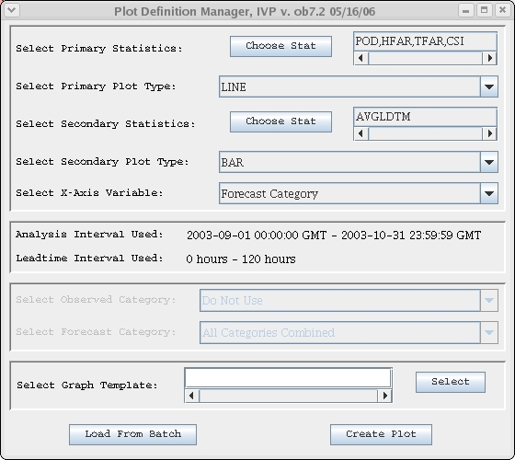
- IVP Statistic Chooser Manager

The IVP Statistic Chooser Manager is used to select primary or secondary statistics for the IVP statistic plot. The statistics are placed in groups, so that all of the statistics in a group have the same scale or unit. Each group is given a master check box, with an appropriate name, so that if that checkbox is checked, then all statistics within the group will be checked.

The statistic groups are as follows (the short hand notation for the statistic in the IVP Batch Program output file is given in parentheses):

- Error Statistics: root mean squared error (RMSE), maximum error (MAXERR), mean absolute error (MAE), and mean error (ME)
- Categorical Statistics: probability of detection (POD), hydrologic false alarm rate (HFAR), traditional false alarm rate (TFAR), over forecast rate (OFR), under forecast rate (UFR), and critical success index or Gilbert score (CSI)
- Quantiles and Extremes: minimum (MIN), 25% quantile (QUAN 0.25), median (MEDIAN), 75% quantile (QUAN 0.75), and maximum (MAX)
- Lead Time Statistics: average lead time of detection (AVGLDTM)
- Sample Size: statistic sample size (NUM SAMPLES)

Statistics are chosen by clicking on checkboxes. If a statistic of one group is checked, then all statistics of all other groups will be unchecked. Only statistics of one group can be checked at a time.

The statistics are defined in Appendix B.

  - Buttons

- OK button: Close the window and update the corresponding text field of the Verification Plot Definition Manager to list the chosen statistics.
- Cancel button: Close the window and do nothing else.

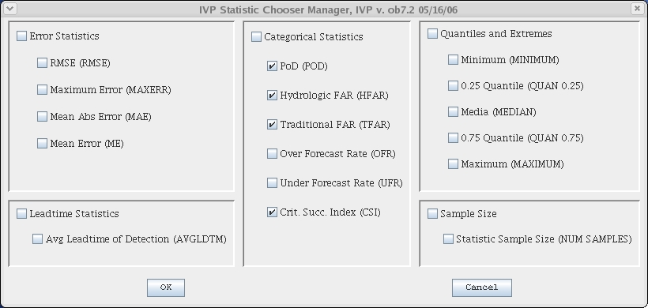
- IVP Statistic Display

The IVP Statistic Display graphically displays statistics calculated by the IVP software according to parameters of the Verification Plot Definition Manager, Verification Group Manager, and Verification Location Manager. The legend defines what statistics are displayed, with the left (or only) column of the legend displaying the primary statistics, and the right column displaying the secondary statistics.

Associated with the chart in the IVP Statistic Display window are chart properties, including the chart title, axis labels, legend title, fonts, colors, etc. Default values for the chart properties are constructed based on the data and user settings. These properties can be customized via the Chart Property Manager. They can also be loaded from an existing template file via Actions >> Load Chart Properties.

The following features are the same as those in the IVP Data Display (see Section 11):

- Data Tracker (Section 14.2)
- Actions >> Edit Chart Properties (Section 14.4)
- Actions >> Save Properties Template (Section 14.4)
- Actions >> Load Properties Template (Section 14.4)
- Actions >> Save Image File (Section 14.4)
- Actions >> Close (Section 14.4)

Additional features are given below.

  - Menu Items

In addition to the menu items identical to those in the IVP Data Display, the following menu items are available:

- Actions >> Save Batch File menu item: Opens up an IVP Batch File Save Manager for saving a batch file to reconstruct the image within the IVP Statistic Display.
- Actions >> Show Data: Opens up IVP Statistics Data Viewer for this plot.
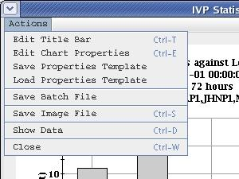
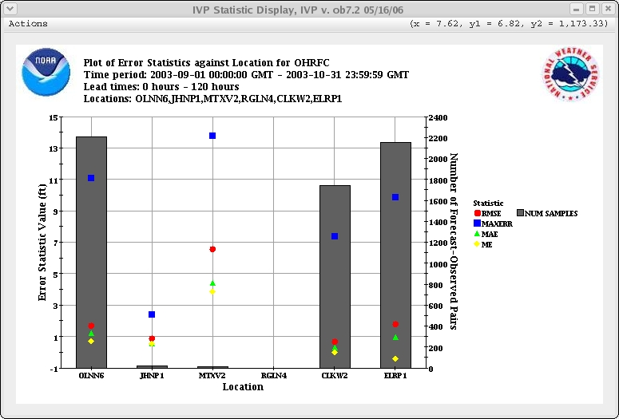
- IVP Statistics Data Viewer

The IVP Statistics Data Viewer shows in a table the statistics currently displayed in the IVP Statistic Display. The columns of the table are as follows:

- Index: An indexing number shows the order in which the rows were initially given in the table.
- <X-axis Variable>: The value of the variable displayed along the x-axis. This column has a pink background.
- <statistic values>: One column per statistic displayed on the plot. These columns have a gray background.

  - Buttons

- Save to File button: Opens up a file browser to allow the user to select the file to which to save the data within this table. The file produced will include group information at the top and the table at the bottom.
- Close button: Closes the IVP Statistics Data Viewer.

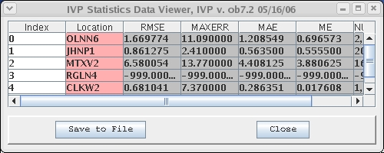

- IVP Batch File Save Manager

The IVP Batch File Save Manager is used to complete specification of the batch file to construct that will allow for the IVP Batch Program to reconstruct the image in the corresponding IVP Statistic Display. To build the batch file, the names of the image file and data file to create must be specified, the template file must be specified (if used), and the batch file name must be given. The image file is the file to contain the image in the IVP Data Display, being either a PNG or JPEG file. The data file is the text file to contain the contents of the IVP Statistics Data Viewer. The template file is the file containing information about the chart properties to use when constructing the chart. The batch file is the batch file for the IVP Batch Program that will reconstruct the image file, and optionally the data file.

  - File Name Text Fields

There are three file names that must be specified:

- Image file: The name of the image file the IVP Batch Program is to construct using this batch file. Unless specified, this file is assumed to be in the directory $(vsys_input). This file is required.
- Data file: The name of the data file the IVP Batch Program is to construct using this batch file. Unless specified, this file is assumed to be in the directory $(vsys_output)/$LOGNAME. This file is optional. If it is not used, the data file should be left blank or set to “NONE”.
- Template file: The name of the graph template file the IVP Batch Program is to use when constructing the chart. Unless otherwise specified, this file is assumed to be in the directory $(vsys_files)/$LOGNAME/templates. This file is optional. If it is not to be used, then the radio button Use Defaults should be selected, or the template file should be left blank or set to “NONE”. If the template file needs to be created, the button Create New Template should be selected. If the template file already exists, the button Use Existing Template should be selected.
- Batch File Name: The name of the batch file, itself. Unless specified, this file is assumed to be below the directory corresponding to the vsys_input apps-defaults token.

  - Buttons

- Select buttons: Each select button opens up a file browser to choose the name of the file. Clicking on the Open or Save button of the browser will close the window and update the corresponding text field. Clicking on Cancel will close the window, with no updates.
- OK button: Closes this window and creates the file, using parameters specified in the Verification Group Manager, Verification Location Manager, Verification Plot Definition Manager, and in this window. The template file will also be created if the Create New Template radio button is selected.
- Cancel button: Closes this window and do nothing else.

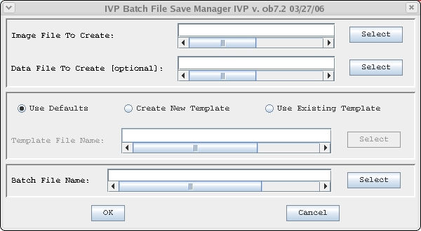
- IVP Chart Properties Manager

The IVP Chart Properties Manager window is used to customize the appearance of a displayed chart. It allows for customizing the following chart components:

- Chart Title: The text, font, and color of the chart title can be changed.
- X-Axis Title: The text, font, and color of the x-axis title can be changed.
- Primary Y-Axis Title: The text, font, and color of the primary (left-hand) y-axis title can be changed.
- Secondary Y-Axis Title: The text, font, and color of the secondary (right-hand) y-axis title can be changed.
- Legend Title: The text and font of the legend title can be changed.
- Legend Components: The text and color of the legend components can be changed. The font is always equal to the legend title font.
- Tick Mark Font: The fonts of the tick marks used for all of the axes can be changed. All three axis tick mark labels are in the same font.
- X-Axis Limits or Labels: If the x-axis is numerical (as with the IVP Data Display), then the minimum and maximum values of the axes can be changed. If the x-axis is by label (as with the IVP Statistics Display), then the labels along the x-axis can be changed.
- X-Axis Annotation: The direction of printing for the x-axis labels can be changed.
- Primary Y-Axis Limits: The minimum and maximum for the primary y-axis can be changed.
- Secondary Y-Axis Limits: The minimum and maximum for the secondary y-axis can be changed.
- Chart Dimensions: The dimensions (height and width) of the window containing the chart can be changed.

The IVP Chart Properties Manager window is organized into two panels, each of which has a tab on it: Chart Titles and Chart Others. These two panels further contain other tabbed panels. The organization of these other tabbed panels, and the chart component each panel is associated with, is as follows:

Chart Title (Chart Titles): Chart Title
Y-Axis 1 Title (Chart Titles): Primary Y-Axis Title
Y-Axis 2 Title (Chart Titles): Secondary Y-Axis Title
X-Axis Title (Chart Titles): X-Axis Title
Legend Title (Chart Titles): Legend Title
Legend (Chart Titles): Legend Components
Tick Mark Font (Chart Titles): Tick Mark Font
Chart Dimension (Chart Others): Chart Dimensions
Primary Y-Axis (Chart Others): Primary Y-Axis Limits
Secondary Y-Axis (Chart Others): Secondary Y-Axis Limits
X-Axis (Chart Others): X-Axis Limits or Labels
X-Axis Annotation (Chart Others): X-Axis Annotation

Each tabbed panel provides tools to edit the corresponding chart component of the chart. The tabbed panels are described below, with a small screenshot of the appearance of the panel within the Chart Property Manager window.

  - Template Files

A template file is a file that records the properties corresponding to the Chart Property Manager. Specifically, it records the properties of a graphic that differ from the default properties. This file can be created by clicking on Options >> Save Properties Template in the IVP Data Display, clicking on Actions >> Save Properties Template in the IVP Statistics Display, or by choosing to create a new template within the IVP Batch File Save Manager. The settings within a template file can be applied to a chart by clicking on Options >> Load Properties Template in the IVP Data Display, clicking on Actions >> Load Properties Template in the IVP Statistics Display, or by specifying the template file in the Verification Plot Definition Manager.

Template files allow for a user to customize the appearance of a graphic, save the chart properties, and then apply those properties when generating other images, both in the IVP and IVP Batch Program.

  - Default Values

Every property of a chart has a default value associated with it. Initially, all chart properties are assumed to be their default. For all tabbed panels except for those associated with labels, the radio button Default specifies if a default value is being used. For those associated with labels, the radio button Default (Text & Font) specifies if both the text and font of the label are default, and Default (Text Only) specifies if the text is default but the font is not.

In any case, if a change is made in a panel, the corresponding Default radio button will be deselected. To reacquire the default value, the user may click on the corresponding Default radio button. Note that, for labels, clicking on Default (Text Only) will only recover the default label text. Clicking on Default (Text & Font) will recover both the default label text and font.

  - All Titles (Chart Titles)

The Chart Title, X-Axis Title, Y-Axis 1 Title, Y-Axis 2 Title, and Legend Title panels, as well as the Tick Mark Font panel, all have the same basic appearance, so only the Chart Title panel is shown here. The exceptions are that neither the Legend Title panel nor the Tick Mark Font panel have a Text Color button. Also, the text within the Tick Mark Font panel is ignored; it is only there to show what the font looks like for numbers. Furthermore, only the chart title on a chart can display multiple lines of text. For the others, if multiple lines of text are present, they will be merged into one line (new-lines will be removed) prior to use.

The Font is specified by choosing a font name from the Font choice box, a size from the Font Size choice box, and selecting bold or italics using the Bold and Italics buttons. The text color is chosen by clicking on the Text Color button and selecting a color from the Choose Color window that pops up.

The text area will display the text as it will be seen on the chart.

    - Buttons

- Bold button: Selects the font to be bold, if toggled (i.e. shaded).
- Italics button: Selects the font to be italics, if toggled.
- Text Color button: Opens up a Choose Color window for selecting the color of the text.

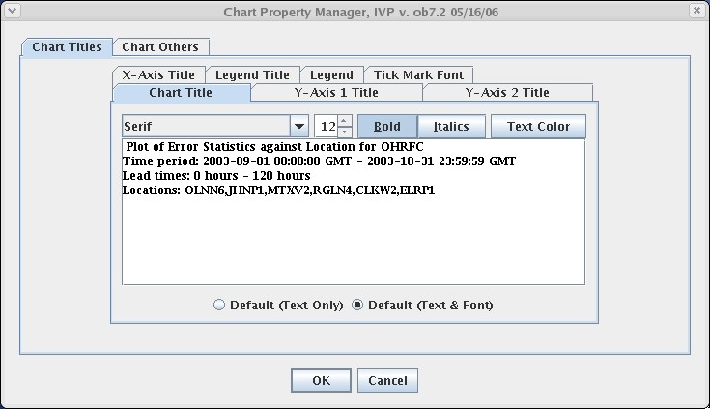

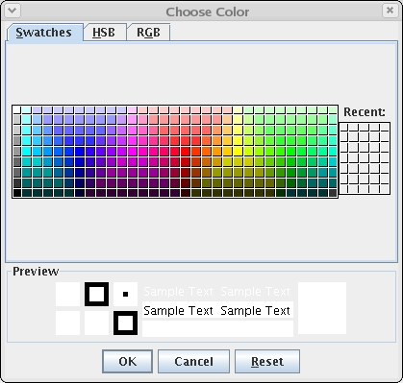

  - All Numerical Axis Limits (Chart Others)

The X-Axis limits (for the IVP Data Display), Primary Y-Axis limits, Secondary Y-Axis limits, and Chart Dimensions panels all have the same basic appearance, so only the Primary Y-Axis limits panel is shown here. Each contains two sliders: one for the upper limit (or chart height) and one for the lower limit (or chart width). The value of a limit (or dimension) can be changed by using the slider (click on it and drag, or click to either side of it) or by entering the desired number into the text field and pressing <Enter>.

NOTE: To specify a limit outside the slider’s minimum and maximum range, type the limit value into the text field and press <Enter>. Do not use the slider in these cases.

The slider itself can also be customized by clicking on Reset, which will pop up a Reset Slider window. This window allows for setting the slider’s minimum value, maximum value, initial value, major tick spacing, minor tick spacing, and scale.

NOTE: Any changes to the slider will be lost when the window closes.

    - Buttons

- Reset button: Opens up the Reset Slider window, allowing for customizing the slider.

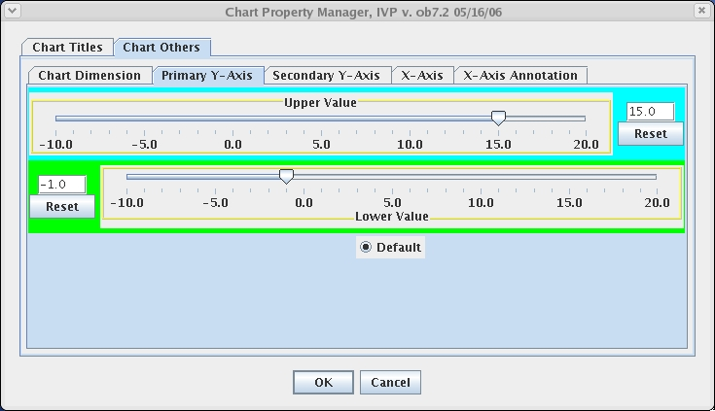

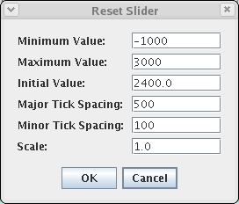

  - Legend (Chart Titles)

The Legend panel is used to change the color and text of legend components. Each component is provided in a Legend Component List, with the background color being the color used within the legend. To change a legend component, do the following:

- Click on the corresponding item in the List.
- Type the name of the legend component into the text field.
- Click on Update. A Choose Color window will pop up.
- Select the desired color and click on OK.

After completing the last step, the Legend Component List should change to reflect the new component.

NOTE: The shapes used in the charts cannot be edited via the Chart Property Manager. However, they can be edited via the IVPStatChartPrimarySymbols and IVPStatChartSecondarySymbols settings of the System Settings file (see Section A.3.1).

    - Buttons

- Update button: Opens up a Choose Color window for choosing the legend component color.

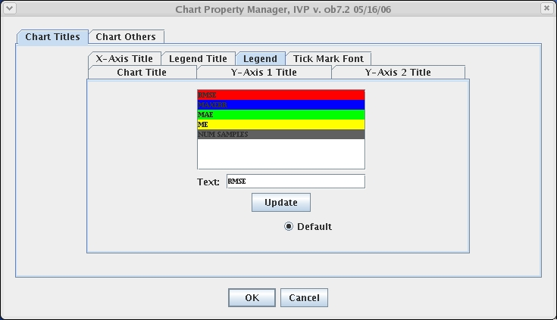

  - X-Axis Labels (Chart Others)

The X-Axis (Chart Others) panel is used to change the x-axis tick mark labels for the IVP Statistics Display. The current x-axis labels are provided in an X-Axis Label List. To change an x-axis label, do the following:

- Click on the corresponding item in the List.
- Type in the desired label in the text field.
- Click on Update.

After completing the last step, the X-Axis Label List should be updated to display the new label.

    - Buttons

- Update button: Updates the selected x-axis label in the X-Axis Label List to be the text currently in the text field.

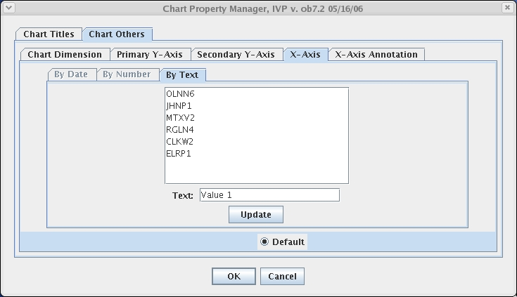

- Tips and Information

This section provides tips about how to operate the IVP and how the windows interact.

  - System Settings File

An IVP system settings file exists allowing for customization of the various windows and plots. It is described in Appendix A. If you need to change the size of windows, fonts used, column names in tables, or other items, check the appendix to see if it can be done and edit the system settings file appropriately. The system settings file is located at the following directory:

$(vsys_dir)/app-defaults/IVP_SYSTEM_FILE.txt

where $(vsys_dir) is the directory corresponding to apps-defaults token vsys_dir.

  - NOAA and NWS Logos

The NOAA logo is displayed in the upper left corner of any graphic within the IVP, and the NWS logo is displayed in the upper right corner. These images are drawn from these two jpeg files, respectively:

$(vsys_dir)/app-defaults/ivp_noaa.jpg
$(vsys_dir)/app-defaults/ivp_nws.jpg

If you need to change the logos, then just edit these files. If you need to remove the logos, then just remove these files or change their names.

  - Performance

For large scale (tens of thousands of points or more) verification projects, the IVP can be a slow, memory intensive program. Two factors control the performance of the IVP: (1) system memory and (2) database usage. If the IVP performs very poorly (either being very slow or running out of memory), then you should take the following actions, in order, until the problem is resolved:

- Turn off the SHEF decoders and any other programs that are accessing the archive database.
- Run IVP on a computer with better hardware (i.e. more memory and faster processor) that can see the archive database (with the rax_pghost and pguser apps-defaults tokens being changed appropriately). See the next Section for how to setup IVP to run on an AWIPS LX machine.
- Decrease the size of the analysis interval in order to lessen the number of forecast-observed pairs included in the analysis. If the product must be produced for the larger, original analysis interval, then save a batch file using this smaller run (via Actions >> Save Batch File in the IVP Statistics Display), edit the batch file to be for the desired analysis interval (see the IVP Batch Program User’s Manual For Verification), and run the IVP Batch Program with the batch file. The IVP Batch Program is usually capable of handling more pairs than the IVP.
- Employ the –m option of the ivp script to increase the amount of memory in the Java heap space. Run ivp –hh to see how to use this option.

  - Running IVP on AWIPS LX Machines

Generally, the AWIPS lx machines have greater resources than the archive machines and can see the archive database. To run the IVP software on an AWIPS lx machine, do the following:

- Tar up the entire directory structure under the directory corresponding to apps-defaults token vsys_dir:

tar –cvf ivp.tar $(get_apps_defaults vsys_dir)/*

- Put the tar file on the system where the IVP software is to run.
- Select the directory where the software is to be located. The directory /awips/hydroapps/lx/rfc/verify may be a good choice. This directory will be denoted <basedir> below.
- Untar the tar file into that directory:

cd <basedir>
tar –xvf ivp.tar

- In your apps-defaults site file, change the token vsys_dir to point to that directory, or do the following:

export vsys_dir=<basedir>

- Set the rax_pghost apps-defaults token to be your archive (ax) machine. This usually works:

export rax_pghost=ax

- Set the pguser apps-defaults token to be a valid user.
- Make sure all apps-defaults tokens needed by the software are present on the AWIPS LX system.

At this point the software should execute using the command given in Section 3.

  - Debugging

The apps-defaults token vsys_debug can be used to acquire debugging output from all of the verification software (IVP, IVP Batch Builder, IVP Batch Program, Vfyruinfo Editor, etc.). To set it, export it as follows:

export vsys_debug=40

As the value of the vsys_debug goes up, the amount of output increases. Here are some common settings and what they will include in the screen output:

0 No screen output, except what is output from the wrapper scripts
1 Standard (default)
20 Additional progress info, including locations as they are being processed
40 Database queries and number of records found will be output to the screen
128 All output will be given, including every individual data pair used or created (not recommended)

Appendix A: System Settings File

A.1 Overview

The IVP windows appear different on different operating systems. Therefore, it is necessary to allow for user to adjust the default display to accommodate multiple operating systems. The system settings file allows the user to change the appearance of the windows. This appendix describes that file.

A.2 Location

The following apps-defaults token must be set in order for the system settings file to be found:

vsys_dir

The file is assumed to exist in the directory $(vsys_dir)/app-defaults with the name “IVP_SYSTEM_FILE.txt”.

A.3 System Settings File

The system settings file uses the same file format as an IVP Batch Program batch file. However, rather than being read in sequentially, it is processed and stored at run-time so that each GUI component can extract the settings that pertain to it. If a command is given more than once within the system settings file, the last instance will over-ride the earlier instances.

A.3.1 Commands

Commands, indicated in bold, set parameter values that control the appearance of various IVP windows. The <value> on the line of the system settings file that contains the command is usually restricted, depending on that command. Acceptable Values are listed for each command. The default value shown is the value assumed if the system settings command is not found.

The following are IVP system settings commands:

BatchSaveWindowHeight = <number>
Description: Controls the pixel height of the IVP Batch File Save Manager.
Acceptable Values: positive integer value.
Default Value: 225

BatchSaveWindowWidth = <number>
Description: Controls the pixel width of the IVP Batch File Save Manager.
Acceptable Values: positive integer value.
Default Value: 600

ButtonFont = <font>
Description: Controls the font used on button labels in the windows.
Acceptable Values: Any font string (see Section A.4)
Default Value: "Courier;plain;12"

CategoryEditorWindowHeight = <number>
Description: Controls the pixel height of the Forecast Category Editor and Observed Category Editor.
Acceptable Values: positive integer value.
Default Value: 250

CategoryEditorWindowWidth = <number>
Description: Controls the pixel width of the Forecast Category Editor and Observed Category Editor.
Acceptable Values: positive integer value.
Default Value: 320

ChartBGColor = <color>
Description: Controls the background color of the charts.
Acceptable Values: Any color string (see Section A.5)
Default Value: white

ChartCatLineColor = <color>
Description: Controls the category line color of the IVP Data Display.
Acceptable Values: Any color string (see Section A.5)
Default Value: blue

ChartFGColor = <color>
Description: Controls the foreground color of the charts.
Acceptable Values: Any color string (see Section A.5)
Default Value: black

ChartGridColor = <color>
Description: Controls the grid color of the charts.
Acceptable Values: Any color string (see Section A.5)
Default Value: “160,160,160”

ChartPairsColor = <color>
Description: Controls the scatter point color in the IVP Data Display.
Acceptable Values: Any color string (see Section A.5)
Default Value: red

ChartShownLocationColor = <color>
Description: Controls the scatter point color in the IVP Data Display for a highlighted location.
Acceptable Values: Any color string (see Section A.5)
Default Value: yellow

ChartXYLineColor = <color>
Description: Controls the line y = x color in the IVP Data Display.
Acceptable Values: Any color string (see Section A.5)
Default Value: green

ChartZLineColor = <color>
Description: Controls the color in the chart.
Acceptable Values: Any color string (see Section A.5)
Default Value: dark_gray

ChartWindowHeight = <number>
Description: Controls the default height of a Chart window.
Acceptable Values: positive integer value.
Default Value: 500

ChartWindowWidth = <number>
Description: Controls the default width of a Chart window.
Acceptable Values: positive integer value.
Default Value: 650

DateChooserWindowHeight = <number>
Description: Controls the default height of the Choose Date/Time window.
Acceptable Values: positive integer value.
Default Value: 275

DateChooserWindowWidth = <number>
Description: Controls the default width of a Choose Date/Time window.
Acceptable Values: positive integer value.
Default Value: 320

DestroyOldDisplayUponCreate = <ON/OFF>
Description: If set to ON, the IVP will destroy the old IVP Data Display before creating a new one.
Acceptable Values: ON or OFF.
Default Value: OFF, meaning that if the display fails to create, the old display will still be available.

IVPDataChart*Buffer = <number>
Description: Controls a buffer around the IVP Data Display, moving the position of the plot within the window.
Acceptable Values: positive integer value.
Default Value: 0

IVPDataChartWindowHeight = <number>
Description: Controls the default height of the IVP Data Display.
Acceptable Values: positive integer value.
Default Value: 700

IVPDataChartWindowWidth = <number>
Description: Controls the default width of the IVP Data Display.
Acceptable Values: positive integer value.
Default Value: 800

IVPDataTableMgrWindowHeight = <number>
Description: Controls the default height of the Verification Pairs Data Manager.
Acceptable Values: positive integer value.
Default Value: 400

IVPDataTableMgrWindowWidth = <number>
Description: Controls the default width of the Verification Pairs Data Manager.
Acceptable Values: positive integer value.
Default Value: 700

IVPStatChart*Buffer = <number>
Description: Controls a buffer around the IVP Statistics Display, moving the position of the plot within the window.
Acceptable Values: positive integer value.
Default Value: 0

IVPStatChartPrimaryColors = “<color>;<color>;...”
Description: Controls the colors used for primary statistics within the IVP Statistics Display. If more statistics are displayed than colors listed, they will be plotted using system defaults.
Acceptable Values: list of colors, each of which satisfies Appendix A.5 requirements
Default Value: “red;blue;green;yellow;orange;magenta”

IVPStatChartPrimaryLineSize = <number>
Description: Controls the width of lines drawn for primary statistics in the IVP Statistics Display.
Acceptable Values: positive integer value.
Default Value: 1

IVPStatChartPrimarySymbols = “<symbol>;<symbol>;...”
Description: Controls the symbols used for primary statistics within the IVP Statistics Display. If more statistics are displayed than symbols listed, they will be plotted using system defaults.
Acceptable Values: list of symbols, each of which is one of the following: “box”, “circle”, “cross”, “diamond”, “none”, “square”, “start”, “triangle”, “vert_line” (vertical line).
Default Value: “dot;box;triangle;diamond;square;star;cross”

IVPStatChartPrimarySymbolSize = <number>
Description: Controls the size of symbols drawn for primary statistics in the IVP Statistics Display.
Acceptable Values: positive integer value.
Default Value: 8

IVPStatChartSecondaryColors = “<color>;<color>;...”
Description: Controls the colors used for secondary statistics within the IVP Statistics Display. If more statistics are displayed than colors listed, they will be plotted using system defaults.
Acceptable Values: list of colors, each of which satisfies Appendix A.5 requirements
Default Value: “96,96,96;128,128,128;160,160,160”

IVPStatChartSecondaryLineSize = <number>
Description: Controls the width of lines drawn for secondary statistics in the IVP Statistics Display.
Acceptable Values: positive integer value.
Default Value: 1

IVPStatChartSecondarySymbols = “<symbol>;<symbol>;...”
Description: Controls the symbols used for secondary statistics within the IVP Statistics Display. If more statistics are displayed than symbols listed, they will be plotted using system defaults.
Acceptable Values: list of symbols, each of which is one of the following: “box”, “circle”, “cross”, “diamond”, “none”, “square”, “start”, “triangle”, “vert_line” (vertical line).
Default Value: “dot;box;triangle;diamond;square;star;cross”

IVPStatChartSecondarySymbolSize = <number>
Description: Controls the size of symbol drawn for secondary statistics in the IVP Statistics Display.
Acceptable Values: positive integer value.
Default Value: 8

IVPStatChooserWindowWidth = <number>
Description: Controls the default width of the IVP Statistics Chooser Manager.
Acceptable Values: positive integer value.
Default Value: 820

IVPStatChartWindowHeight = <number>
Description: Controls the default height of the IVP Statistics Display.
Acceptable Values: positive integer value.
Default Value: 525

IVPStatChartWindowWidth = <number>
Description: Controls the default width of the IVP Statistics Display.
Acceptable Values: positive integer value.
Default Value: 775

IVPStatChooserWindowHeight = <number>
Description: Controls the default height of the IVP Statistics Chooser Manager.
Acceptable Values: positive integer value.
Default Value: 390

IVPStatChooserWindowWidth = <number>
Description: Controls the default width of the IVP Statistics Chooser Manager.
Acceptable Values: positive integer value.
Default Value: 820

IVPStatTableMgrWindowWidth = <number>
Description: Controls the default width of the IVP Statistics Data Viewer.
Acceptable Values: positive integer value.
Default Value: 200

IVPStatTableMgrWindowHeight = <number>
Description: Controls the default height of the IVP Statistics Data Viewer.
Acceptable Values: positive integer value.
Default Value: 500

LabelFont = <font>
Description: Controls the default font used on labels within the various windows.
Acceptable Values: Any font string (see Section A.4)
Default Value: "Courier;plain;12"

LegendFont = <font>
Description: Controls the default font used within the legend of the various Chart windows and Data Source Display window.
Acceptable Values: Any font string (see Section A.4)
Default Value: "Serif;bold;9"

ListFont = <font>
Description: Controls the font used within lists in the program, including the Select FCST_TS Window, for example.
Acceptable Values: Any font string (see Section A.4)
Default Value: "TimesRoman;plain;12"

MainChartWindowHeight = <number>
Description: Controls the default height of a Data Source Display window.
Acceptable Values: positive integer value.
Default Value: 600

MainChartWindowWidth = <number>
Description: Controls the default width of a Data Source Display window.
Acceptable Values: positive integer value.
Default Value: 750

MenuFont = <font>
Description: Controls the font used in the menus of the various windows.
Acceptable Values: Any font string (see Section A.4)
Default Value: "Courier;plain;12"

RelDateChooserWindowHeight = <number>
Description: Controls the default height of the Relative Choose Date/Time window.
Acceptable Values: positive integer value.
Default Value: 160

RelDateChooserWindowWidth = <number>
Description: Controls the default width of a Relative Choose Date/Time window.
Acceptable Values: positive integer value.
Default Value: 320

SegmentWindowHeight = <number>
Description: Controls the height of a Select Data Source window.
Acceptable Values: positive integer value.
Default Value: 625

SegmentWindowWidth = <number>
Description: Controls the width of a Select Data Source window.
Acceptable Values: positive integer value.
Default Value: 400

TableFont = <font>
Description: Controls the default font used for table data, including the tables in the Verification Pairs Data Manager and IVP Statistics Data Viewer.
Acceptable Values: Any font string (see Section A.4)
Default Value: "Courier;plain;12"

TextFieldFont = <font>
Description: Controls the default font used for text fields within the software.
Acceptable Values: Any font string (see Section A.4)
Default Value: "TimesRoman;plain;12"

TickLabelFont = <font>
Description: Controls the default font used for the tick mark labels along all axes.
Acceptable Values: Any font string (see Section A.4)
Default Value: "Serif;bold;9"

TitleFont = <font>
Description: Controls the default font used for the title in the Chart windows and the Data Source Display window.
Acceptable Values: Any font string (see Section A.4)
Default Value: "Serif;bold;12"

VfyGrpMgrSectionLabelFont = <color>
Description: Controls font for the section labels in the Verification Group Manager.
Acceptable Values: Any font string (see Section A.4)
Default Value: “TimesRoman;bold;14”

VfyGrpMgrWindowHeight = <number>
Description: Controls the default height of the Verification Group Manager.
Acceptable Values: positive integer value.
Default Value: 575

VfyGrpMgrWindowWidth = <number>
Description: Controls the default width of the Verification Group Manager.
Acceptable Values: positive integer value.
Default Value: 500

VfyLocMgrWindowHeight = <number>
Description: Controls the default height of the Verification Location Manager.
Acceptable Values: positive integer value.
Default Value: 300

VfyLocMgrWindowWidth = <number>
Description: Controls the default width of the Verification Location Manager.
Acceptable Values: positive integer value.
Default Value: 850

VfyLocMgrColumnName<#> = <string>
Description: Sets the name of the <#>-th column of the Location Table within the Verification Location Manager to be the specified string.
Acceptable Values: a string, which must be in quotes if spaces are included
Default Value: depends upon <#>; see the Verification Location Manager

VfyLocMgrColumnWidth<#> = <number>
Description: Sets the width of the <#>-th column of the Location Table within the Verification Location Manager to be the specified string.
Acceptable Values: positive integer value
Default Value: depends upon <#>: {81, 30, 75, 60, 60, 60, 60, 60, 163, 163}.

VfyLocMgrChosenColor = <color>
Description: Controls the background color of the non-stage columns when a location is chosen for display in the Location Table of the Verification Location Manager.
Acceptable Values: a color (see Section A.5)
Default Value: pink

VfyLocMgrChosenStageColor = <color>
Description: Controls the background color of the stage columns when a location is chosen for display in the Location Table of the Verification Location Manager.
Acceptable Values: a color (see Section A.5)
Default Value: red

VfyLocMgrUnchosenColor = <color>
Description: Controls the background color of the non-stage columns when a location is not chosen for display in the Location Table of the Verification Location Manager.
Acceptable Values: a color (see Section A.5)
Default Value: white

VfyLocMgrUnchosenStageColor = <color>
Description: Controls the background color of the stage columns when a location is not chosen for display in the Location Table of the Verification Location Manager.
Acceptable Values: a color (see Section A.5)
Default Value: light_gray

VfyPlotDefWindowHeight = <number>
Description: Controls the default height of the Verification Plot Definition Manager.
Acceptable Values: positive integer value.
Default Value: 440

VfyPlotDefWindowWidth = <number>
Description: Controls the default width of the Verification Plot Definition Manager.
Acceptable Values: positive integer value.
Default Value: 540

XAxisLabelFont = <font>
Description: Controls the default font used for the x-axis in the Chart windows and the Data Source Display window.
Acceptable Values: Any font string (see Section A.4)
Default Value: "Serif;bold;12"

YAxisLabelFont = <font>
Description: Controls the default font used for the left y-axis in the Chart windows and the Data Source Display window.
Acceptable Values: Any font string (see Section A.4)
Default Value: "Serif;bold;12"

YAxis2LabelFont = <font>
Description: Controls the default font used for the right y-axis in the Chart windows and the Data Source Display window.
Acceptable Values: Any font string (see Section A.4)
Default Value: "Serif;bold;12"

A.4 Generic Font Format

All font settings for the IVP must be entered in the system settings file with the following value format:

<font name>;<font style>;<font size>

where each component can have the following values:

<font name>: "Serif", "SanSerif", "TimesRoman" or "Courier"
<font style>: "plain", "bold", "italics" or "bold-italics"
<font size>: any integer representing a valid size for that font

If an invalid size is specified, the system will use the default value, which varies based on the font.

A.4 Generic Color Format

All color settings for the IVP must be entered in the system settings file with the following value format:

<color> -or- <red>,<green>,<blue>

where each component can have the following values:

<color>: black, blue, cyan, dark_gray, gray, green, light_gray, magenta, orange, pink, red, white, yellow.
<red>,<green>,<blue>: The red, blue, and green numerical specifiers for a color. Each component must be an integer.

If an invalid size is specified, the system will use the default value, which varies based on the font.

Appendix B: The Statistics

The statistics are computed numerically from a sample of forecast-observed data pairs. For the equations below, N is the number of samples satisfying the restrictions for a particular x-axis value, f_{i} is the forecast value in the i-th data pair, o_{i} is the observed value in the i-th data pair,

B.1 Error Statistics

Error statistics are calculated by using the difference between the forecast and observed value for each data pair in a formula of some kind. The statistics are calculated as follows:

RMSE = $\sqrt{\frac{\sum_{i=1}^{N}{{\left(f_{i}−o_{i}\right)}^{2}}}{N}}$
MaxErr =$\text{MAX}\left\{\left|f_{i}−o_{i}\right|:i=1,\text{.}\text{.}\text{.},N\right\}$
MAE = $\frac{\sum_{i=1}^{N}{\left|f_{i}−o_{i}\right|}}{N}$

ME =$\frac{\sum_{i=1}^{N}{\left(f_{i}−o_{i}\right)}}{N}$

B.2 Categorical Statistics

Categorical statistics are calculated relative to a particular category. Regardless of whether the user chooses to use forecast categories or observed categories, the equations used to compute categorical statistics are constant. This means that the user only controls the boundaries defining the categories. It is usually best to plot the categorical statistics with an x-axis of either forecast categories or observed categories. After creating the display, the x-axis label should be changed to “Categories”, and each of the x-axis tick marks should be given an appropriate label, such as “Below FS” (below flood stage).

The following table will be used to describe the computation of each categorical statistic:

 | Observed was...
Forecast was... | below | within | above
above | A | B | C
within | D | E | F
below | G | H | I

As an example, the above table can be read as: “B is the number of pairs for which the observed is within the interval and the forecast is above the interval”. The statistics plotted against the left y-axis are as follows:

- Probability of Detection (POD): The probability that, given an observed value is within the category, the forecast value is also within the category, or E/(B+E+H).
- Traditional False Alarm Rate (TFAR): The probability that, given a forecast value is within the category, the observed value is not within the category (either above or below), or (D+F)/(D+E+F).
- Hydrologic False Alarm Rate (HFAR): The probability that, given a forecast value is within the category, the observed value is below the category (useful when categories represent flood levels), or D/(D+E+F).
- Under Forecast Rate (UFR): The probability that, given an observed value is within the category, the forecast value is below the category, or H/(B+E+H).
- Over Forecast Rate (OFR): The probability that, given an observed value is within the category, the forecast value is above the category, or B/(B+E+H).
- Critical Success Index (CSI): Commonly used in verification, the CSI integrates information from the POD and FAR, and is calculated as (D+E+G+H)/(A+B+D+E+F+G+H+I). Currently, this is only available in the IVP Batch Program.

B.3 Quantiles and Extremes

The quantiles and extremes are computed by, first, building a set of points, and then calculating empirical probabilities based on the set. Given a probability p, a quantile is that value, x_{p}, for which P(X ≤ p) = x_{p}. The steps in computing the quantiles are as follows:

- Define which x-axis variable you wish to use.
- If you wish to calculate the forecast (observed) quantile, in the Verification Plot Definition Manager, select “Do Not Use” from the Forecast Category (Observed Category) choice box.
- For each x-axis variable, a set is built which includes all pairs that satisfy the condition placed on the category NOT chosen in Step 2, above. For example, if you wish to compute the forecast (observed) quantile, then the pairs used in calculations must be in the selected observed (forecast) category in order to be used in the computation.
- Estimate the quantiles by building an empirical cumulative distribution function using probability estimates based on Bayesian plotting positions (Krzysztofowicz, 1992) and using linear interpolation to find the forecast (or observed) value that satisfies the quantile definition.
- Calculate the minimum and maximum by finding the largest and smallest forecast (observed) value used in estimating the empirical cumulative distribution function.

B.4 Leadtime Statistics

The average lead time of detection is computed by finding all points within cell E of the categorical statistics table and averaging their lead time. The lead time is calculated as (valid time – basis time) of the forecast within a forecast-observed data pair. This is usually best plotted as a secondary statistic with a bar plot type. Its best paired with primary statistics that are categorical statistics.

B.5 Sample Size

The statistic sample size is the number of samples used to calculate a statistic; i.e. N. With an x-axis of location, it is the number of forecast-observed data pairs found for each location. With an x-axis of analysis interval or lead time interval, it is the number of pairs found for the interval. With an x-axis of observed category or forecast category, it is the number of pairs found for the category.

B.6 References

Krzysztofowicz, R., “A Bayesian Estimator of an Empirical Distribution,” working paper, University of Virginia, 1992.

