NATIONAL WEATHER SERVICE
OFFICE of HYDROLOGIC DEVELOPMENT

EXAMPLE DESIGN SPECIFICATION

Revision History

Date | Version | Description | Author
07/28/2008 | 1.0 | Initial Version | SISEPG

TABLE OF CONTENTS
Page
Revision History ii
TABLE OF CONTENTS iii
Design Specification Example 1
1 Overview 1
2 Architecture 2
2.1 Current OB7.2 Design 2
2.2 Proposed OB8.2 Design 2
3 Design 6
3.1 Pairing With Processed Values 6
3.1.1 Requirements Traceability Matrix or List 6
3.1.2 Software Design 6
3.1.3 User Interface Design 11
3.1.3.1 The Verification Group Manager 11
3.1.4 Data Design – Archive Database Changes 13
4 Other Interfaces 14
4.1 Interface 1 14
4.2 Interface 2 14
5 Other Design Features 14
6 References 14
7 Appendices 14
Appendix A – Design Diagrams 14

Design Specification Example

This example design specification is a companion to the Design Specification Template and is not intended to be used alone. The example text was taken from a real project (written prior to the creation of the template format). Certain sections are used to provide an idea of what should go into the template sections which may need design dependant subsections. The approach to this example was to identify a theme and to connect it through the software design, data design, and interface design sections at a high level. The detail would be left to the developer to establish subsections as directed in the template. Gray-out text from the source is not further discussed in this example.

Original text is modified where needed for relativity to this document (e.g., section numbers, Appendix letters, etc.). When this is done in sentences or text is inserted, it will be italicized and underlined like this to show it was not part of the original text.

Overview
The enhancements to be made to the verification software for OB8.2 are documented in the HOSIP CONOPS and Requirements Specification Document, and the design components needed to satisfy these new requirements can be broadly classified into the following groups:

- Additional data types
- Pairing with processed data
- New verification metrics
- Special plots
- ChartDirector change
- Comparison variable
- New variables used to select pairs
- Confidence intervals
- Vfyruninfo Editor enhancements
- IVP Batch Builder upgrades
- Design improvements
- Miscellaneous changes

Section 2.0 provides the general, overall design of the verification software. Sections 3.0 and later describe the design of software, data, and interface changes to be made for each group of requirements. The complete design diagrams can be found in Appendix A. [NOTE: Developers may integrate the diagrams within the document or in an appendix as needed]. In the following sections, references to the design diagrams will be provided based on their diagram numbers.

[NOTE: For this example, only the Software Function Category in bolded highlighted text in the list is the thread or design theme discussed in subsequent sections, (i.e., forecast-observed pairs at some location which acts as part of a verification group per the application example.]

Architecture
The high-level design of the Interactive Verification Program (IVP) for the AWIPS OB8.2 release does not differ much from that for the AWIPS OB7.2 release. An outline of the designs for OB7.2 and OB8.2 are provided in the next two sections.

Current OB7.2 Design
The system design of the OB7.2 verification software includes the following:
- Written in Java 1.5
- Forecast, observed, and processed data, verification forecast-observed pairs, and some location parametric information are stored in the archive database on the AWIPS RAX machines.
  - Forecast data is stored in the pedfsep table.
  - Observed data is stored in the pecrsep table.
  - Processed data is stored in pehpsep table.
  - Forecast-observed pairs are stored in the vfypairs table.
  - Verification location parametric information is stored in the vfyruninfo table.
  - Critical stages are stored in the rivercrit table.
  - RFC identity is stored in the location table.
  - Verification add-adjustment factors are stored in the vaddadjust table.
- Database access is provided by the JDBC API
  - Incorporates a postgres driver.
- The batch file interface, via the IVP Batch Program, provides the user the ability to (1) build pairs, (2) set parameters of a verification run, (3) compute verification statistics, and (4) generate graphics.
  - Commands are used to define parameters that specify what data to pair, what data to verify, how to do the verification, and how to build the graphic.
  - Actions are used to perform some kind of action, including building forecast-observed pairs, calculating statistics, and generating a graphic.
- The graphical user interface, via the IVP, provides tools to manage the same parameters provided in the batch file interface.
  - Internally, the GUI defines command token values corresponding to batch file commands and then executes actions as needed.
  - For a particular graphic, the GUI can be used to create a batch file for the IVP Batch Program that, when executed, will generate the same graphic and save it to a file.
- Chart rendering is done using JClass DesktopViews.
- Charts may be saved to files in PNG or JPEG format.

Proposed OB8.2 Design
The system design of the OB8.2 verification software includes the following (changes from OB7.2 are in red):
- Written in Java 1.5
- Forecast, observed, and processed data, verification forecast-observed pairs, and some location parametric information are stored in the archive database on the AWIPS RAX machines.
o Forecast data is stored in the pedfsep, pehfsep, and peqfsep tables.
o Observed data is stored in the pecrsep, pedrsep, and peoosep tables.
o Processed data is stored in pehpsep, pedpsep, peqpsep, and peoosep tables.
o Forecast-observed pairs are stored in the vfypairs table.
o Location parametric information is stored in the vfyruninfo table.
o Critical stages are stored in the rivercrit table.
o RFC identity is stored in the location table.
o Verification add-adjustment factors are stored in the vaddadjust table.
- Database access is provided by the JDBC API
o Incorporates a postgres driver.
- The batch file interface, via the IVP Batch Program, provides the user the ability to (1) build pairs, (2) set parameters of a verification run, (3) compute verification statistics, and (4) generate graphics.
o Commands are used to define parameters that specify what data to pair, what data to verify, and how to do the verification.
o Actions are used to perform some kind of action, including building forecast-observed pairs, calculating statistics, and generating a graphic.
- The graphical user interface, via the IVP, provides tools to manage the same parameters provided in the batch file interface.
o Internally, the GUI defines command token values corresponding to batch file commands and then executes actions as needed.
o For a particular graphic, the GUI can be used to create a batch file for the IVP Batch Program that, when executed, will generate the same graphic and save it to a file.
- Chart rendering is done using ChartDirector Version 4.0.
- Charts may be saved to files in PNG or JPEG format.
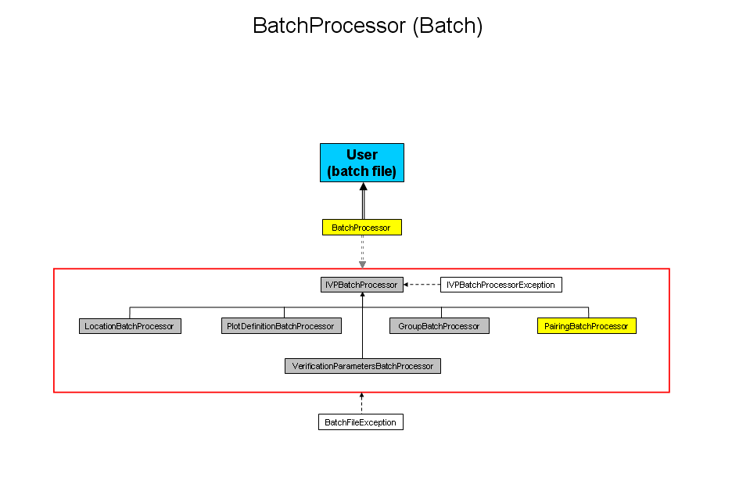
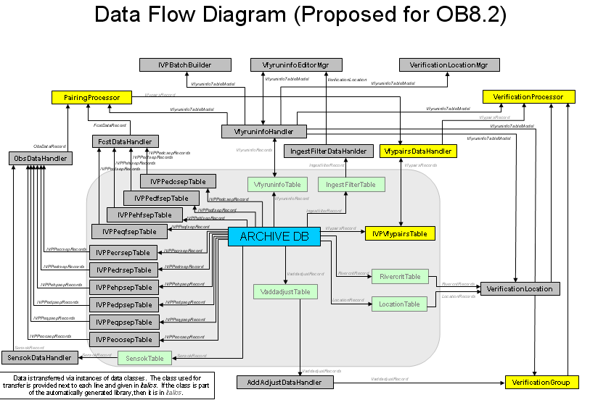

Design

Pairing With Processed Values
Pairing with processed values refers to forecast-observed data pairs that are generated where the observation comes from one of the tables accessed by the processed decoder on the RAX machines. This includes the pehpsep, pedpsep, and peqpsep tables.

Description
For pairing, through the new command OBS_TYPE, the user will be able to specify if pairs are to be constructed using either raw values, processed values, or both, independently (requiring two separate executions of the pairing algorithm, with the OBS_TYPE being different).

For statistics computation, both raw and processed pairs can be used independently (by defining the verification location twice, with the OBS_TYPE being different). However, since each location can only be defined once within a verification group, raw and processed pairs for one location may not be grouped or lumped together to compute one set of statistics.

For graphics, because building the plots depend upon identifying a location uniquely by its lid and SHEF forecast pedtsep, a single graphic built using the GUI cannot display statistics computed for the raw pairs and the processed pairs for one location simultaneously. Only one or the other can be used. In batch mode, if the location is defined twice for the different OBS_TYPE values, then the later definition takes precedence.

Requirements Traceability Matrix or List
The following new or changed requirements are part of this group:
- 1.2.1.12

Software Design
The following changes will be made to facilitate the software requirement(s):
- The PairingProcessor class will be updated so that the insert statement to insert new pairs will use the appropriate table based on the OBS_TYPE token value.
- The PairingBatchProcessor will have the new batch command OBS_TYPE added, which must be either “PROCESSED” or “RAW”.
- The VerificationLocation class will be changed to include a new attribute to be associated with a verification location. The new attribute is _observationType and will have one of three values:
- “PROCESSED”
- “RAW”

This field will tell the VerificationProcessor whether to load pairs constructed using processed or raw table data.
- The LocationBatchProcessor will have the new batch command OBS_TYPE added, as well, which will be used to specify the value of _observationType within the VerificationLocation class.
- The VfypairsDataHandler class will be changed to determine which table to query based on passed in parameters or the new _observationType attribute of the VerificationLocation class.
- The VerificationLocationJTableRowData classes will have a column added to the table with the name ‘obstype’. The column will have one of two values, depending on the location’s _observationType attribute setting: “proc” (for “PROCESSED”) or “raw”.
- A new button will be added to VerificationLocationMgr that will spawn a GenericRadioButtonSubCommandPanel. This panel will be used change the setting of the obstype column for all of the currently selected rows of the table.
Appendix A: See Refer to the BatchProcessor diagram (Diagram 1), PairingProcessor diagram (Diagram 2), VerificationProcessor diagram (Diagram 3), and VerificationLocationMgr diagram below (Diagram 4).

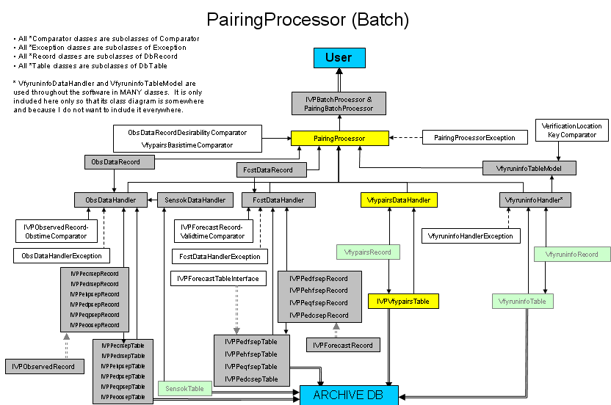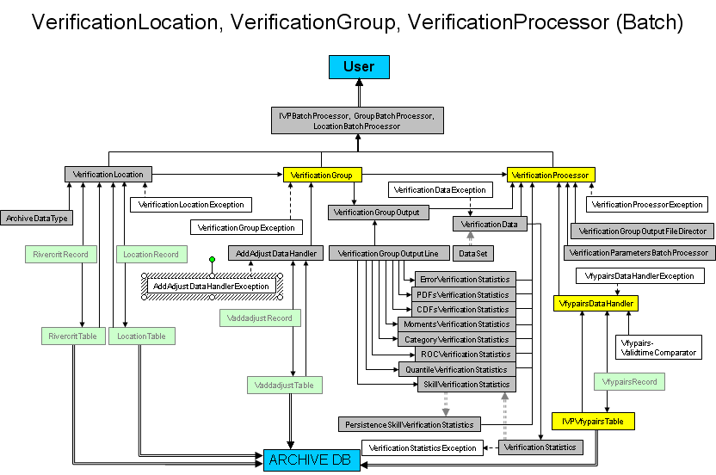

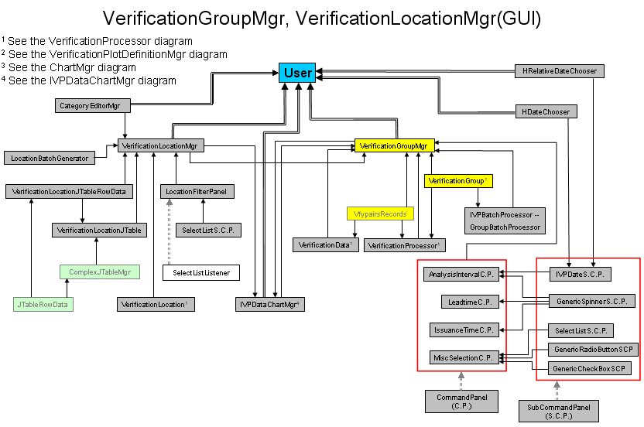

User Interface Design
This document section provides descriptions of how the user interface will change in order to satisfy the requirements outlined for AWIPS OB8.2 delivery of the RFC verification software suite. For the OB7.2 software, the user interface is described in the User’s Manuals, found at

http://www.nws.noaa.gov/oh/hrl/verification/verification_doc_ob7.php

Each sub-section that follows describes changes required to either a window of the Interactive Verification Program or the batch language used in the IVP Batch Program. Where possible, snapshots of a new prototype display will be provided.

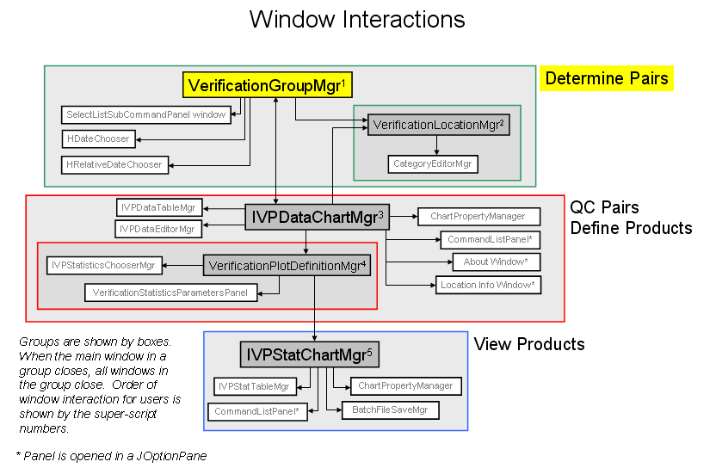

The Verification Group Manager
The Verification Group Manager must change to allow the user to input the following information:
- Issuance time-of-day interval and subinterval
- Active/in-active (or both) flag

The issuance time-of-day interval will be specified in a manner analogous to how the lead time intervals are specified. However, the spinner will only allow values from 0 to 24, and the choice box will only include NONE or hours (hour and hr, as well). The active/in-active flag, which restricts which locations are included in the verification group, will be set via radio buttons.
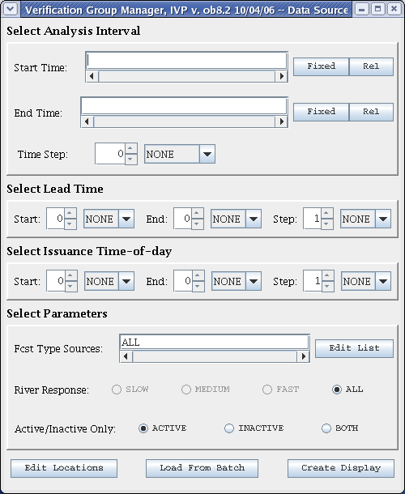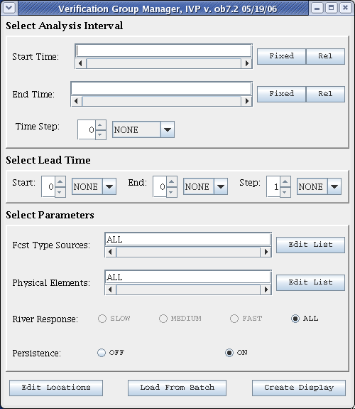
Figure 1a: Screenshot of Verification Group Managers for OB7.2.
Figure 1b: Prototype screenshot of Verification Group Manager for OB8.2.

Also, the persistence and physical element parts of the window will be removed. The user will still be able to specify if persistence forecasts are to be used by including the type source ‘FR’ in the Forecast Type Sources text field, or setting it to ‘ALL’. As for physical elements, the user can specify the physical elements by choosing appropriate locations via the Verification Location Manager.

Screenshots of the OB7.2 Verification Group Manager and a prototype OB8.2 Verification Group Manager are provided in Figures 1a and 1b.

Data Design – Archive Database Changes
A new table called vfyprocpairs will be added to the archive database. It will have the exact same schema as vfypairs, but will store only those pairs constructed from processed (as opposed to raw) values. In other words, it will store pairs when the command OBS_TYPE set to ‘PROCESSED’.

This is being done to address the problem that pairs constructed using observed values must not overwrite those constructed using processed values in order for requirement 1.2.1.12 to be satisfied. However, they still need to be able to overwrite pairs constructed using other observed values, in case the new observed value is preferable (based on its sensor type) or the old observed value is removed. There were two identified solutions: (1) add a column to vfypairs that records if the pair is build using observed or processed values, and (2) create a new table to store processed values. Option 2 has been selected due to simplicity of development.

The following fields will be added to the vfyruninfo table:
- dur: The forecast point’s duration code
- extremum: The forecast point’s extremum code
- active: A binary field defining if the forecast point is active or not.
- national: A binary field defining if the forecast point is to be used in computing national statistics.

The dur and extremum fields will become part of the primary key, since they, along with the location id and physical element, uniquely define a forecast point or location. Furthermore, the forecast type source will also become part of the key, so that it is possible to have different sensor preferences for each forecast type source. Previously, all forecast type sources for a given forecast point had to have the same sensor preference list.

Vfyruninfo Table Classes

The VfyruninfoRecord and VfyruninfoTable classes will be enhanced to read in and process the new dur, extremum, active, and national fields of the vfyruninfo table. The VfyruninfoTableModel class will be enhanced to display columns for all of the new fields in the table within the Vfyruninfo Editor. Other classes of the Vfyruninfo Editor will be enhanced, as needed, to account for the new columns. Lastly, the rows of the VfyruninfoTableModel class will be defined so that the forecast type source becomes part of the key for a given row, implying each row will have a single forecast type source.

Other Database Classes - Description and reference to diagram

Data Handler Classes - Description and reference to diagram

Pairing Algorithm Class - Description and reference to diagram

Verification Location Classes- Description and reference to diagram

Other Batch Classes - Description and reference to diagram

GUI Classes

Chart Classes
All drawn charts must be enhanced so that the labels match the data types. Previously, all data types were assumed to be stage. Now, it must be flexible based on the SHEF physical element of the data. Additionally, the units must be displayed for all axes. The class ArchiveDataType will be created which provides unit information based on the physical element of the pairs data.

Other Interfaces

Interface 1

Interface 2

Other Design Features

References
Document No. | Document Title | Date | Author

Appendices

Appendix A – Design Diagrams

