README File for New SAC-SMA A priori Parameter Grids
(7/20/2010)

A new set of 11 gridded a-priori SSURGO soil based SAC-SMA model parameters is now available for CONUS. The parameters included are UZTWM, UZFWM, UZK, ZPERC, REXP, LZTWM, LZFSM, LZFPM, LZSK, LZPK, and PFREE. STATSGO based a-priori SAC-SMA model parameters were the original ones that have been used by various organizations. Koren (2009) has recently modified some of them (LZTWM and UZTWM) by considering climate index/vegetation greenness factor. A new algorithm for estimating ZPERC has also been developed and applied (Koren, 2009) . Now both SSURGO and STATSGO-based a-priori SAC-SMA grids are climate adjusted. The ZPERC under SSURGO-based directory is linked to the one in STATSGO directory. In other words, ZPERC with new algorithm and derived using STATSGO data is used in both cases. In order to run the SAC-HT, two additional parameters frz_STXT and frz_TBOT are needed. The parameter frz_STXT is dependent on soil texture. During the SSURGO data processes, this parameter was not retained due to storage limitations. Thus, the STATSGO based frz_STXT needs be used for now. The parameter frz_TBOT assumes the temperature is in Kelvin. This document summarizes the differences in the two sets of a-priori SAC-SMA parameter grids that are now available. See appendix for how to download the two sets of data.

Koren et al. (2000) and Koren et al. (2003) detail the underlying assumptions made in deriving these a-priori SAC-SMA parameter grids. To derive parameter estimates at a single point, Koren’s method requires (1) an SCS curve number, (2) the total depth of the soil column, and (3) soil texture by layer. The new data sets (SSURGO-based) follow the Koren’s methodology but attempt to improve upon the implementation by using more detailed input data and climate related information. Key differences between the inputs and assumptions are described here.

- STATSGO and climate adjustment

The original parameter grids (Koren et al. 2000) were derived using only STATSGO soil data as input, as they were the only CONUS data set available. More specifically, Koren et al. (2000) used the Miller and White (1998) 1-km gridded version of STATSGO. Victor Koren derived curve numbers by using the hydrologic soil group data in each grid cell and associating a single curve number with each hydrologic soil group. Curve numbers were associated with each soil group using published values from McCuen (1982) and assuming ‘pasture or rangeland land use’ under ‘fair’ conditions. The SCS method also allows one to adjust curve numbers depending on antecedent moisture conditions. Victor experimented by generating two sets parameter grids, one assuming ‘average’ (CNII) and one ‘dry’ (CNI) antecedent conditions. Based on analysis of simulated and observed hydrographs generated from both these sets of a-priori parameters, he determined that curve numbers associated with dry antecedent conditions produced better results. Therefore, the use of curve numbers based on dry antecedent conditions has been assumed in subsequent analyses. Aggregate curve numbers for each 1 km grid cell were determined by weighting the curve numbers associated with each hydrologic soil group, by the percent of the soil group present in each grid cell. Victor took the required total soil column depth and texture properties directly from the Miller and White (1998) 1 km grids. Recently, Koren (2009) modified UZTWM by considering a climate index defined as the ratio of annual precipitation to annual potential evaporation demand (P/PE). The annual potential evaporation demand in turn was estimated as the surface water evaporation adjusted by vegetation greenness factor (Koren et al., 1998). Because of the changes in UZTWM, LZTWM was also modified. By utilizing Darcy’s infiltration theory, Koren (2009) also modified the ZPERC parameter estimation. This new algorithm requires use of an additional soil property, the capillary water potential.

The parameters were derived at the HRAP resolution. These parameters cover CONUS. Their headers read as:
ncols 1061
nrows 822
xllcorner 1.000000
yllcorner 1.000000
cellsize 1.000000

- SSURGO and climate adjustment

This analysis uses inputs with much higher resolution than the STATSGO -based approaches. Inputs are the Soil Survey Geographic database (SSURGO) and the 2001 National Land Cover Data Set (NLCD). SSURGO data provide much greater spatial detail than STATSGO. The mapping scales for SSURGO range from 1:12,000 to 1:63,360 compared with the mapping scale of 1:250,000 for STATSGO. This suggests anywhere from 4 to 20 times more spatial detail. NLCD, derived from Landsat images, are available at 30-m resolution. Given these increases in spatial detail, new, efficient processing routines were developed to generate SAC-SMA parameter grids over large areas (Zhang et al, 2007).

Gaps are present in the SSURGO parameter sets for areas where SSURGO data is unavailable. Although the USDA SSURGO project is set to complete by 2008, there are still areas especially in western states that data are not complete as shown in Figure 1. An example of parameter LZFPM map that many gaps exist in SSURGO based is shown in Figure 2. To enhance the utility of the parameter set at present, we used STATSGO parameters to fill in gaps. This effort yields SSURGO a priori parameter grids which are free of enclosed gaps (Figure 3 for LZFPM). However, locally, differences between STATSGO and SSURGO parameters can be large so this temporary solution was developed to avoid unnatural discontinuities. A mask grid was created to inform a user as to the source data for the values contained in each grid cell in Figure 4.

As in the STATSGO parameters, the climate adjustment was also applied to SSURGO parameters. Figure 5 shows the percentage differences of UZTWM before and after the climate adjustment.

Because of the new algorithm of estimating ZPERC was not ready during the derivation of SSURGO parameters, ZPERC in SSURGO-based data set was estimated using old algorithm.

For the SSURGO grids, parameters were initially derived at high resolution (native resolution the data inputs) and then aggregated to the ¼ HRAP, ½ HRAP, and HRAP resolution for use in distributed models.

For the grids with HRAP scale, their headers read as:
ncols 1080
nrows 841
xllcorner 1.000000
yllcorner 1.000000
cellsize 1.000000

Expected Benefits, Limitations, and Suggested Uses

The work by Koren et al. (2003) and additional studies using the original STATSGO-based a-priori parameters (e.g. DMIP -- Smith et al., 2004; Reed et al., 2004) show that these parameters are useful for parameter transferability to ungauged locations, parameter specification at interior points in distributed models, and as initial starting points for hydrologic model calibration at gauged locations.

For a limited number of basins in two regions of the country, Anderson et al. (2006) (parts of Ohio) and Zhang et al. (2006) (parts of Oklahoma) showed that explicitly including land cover data and more detailed soil data (SSURGO) can produce gains in uncalibrated simulations. These improvements from using higher resolution data lend additional credence to the physical reasoning behind the estimation equations.

Theory and the limited set of results from Anderson et al. (2006), and Zhang et al. (2006) and current internal study suggest that the SSURGO data should be the best set of parameters to use especially for smaller basins. Hydrologic validation of the new SSURGO parameters and the STATSGO parameters has still been fairly limited. Therefore, we are distributing them now with the hope that RFC users will help us to continue to evaluate and improve these parameter grids.

We recommend that RFCs make some comparisons among uncalibrated simulations using these parameter sets in your area so that you can choose the best starting point for further development. This is an easy task for both distributed and lumped models once the forcing data, observed streamflow data, and input decks are set up.

In our experience, these parameters can provide a good starting point for automatic or manual calibration. They can also be used in regional calibration to assist in maintaining spatial and physical consistency among neighboring basins. In addition, results from Reed et al. (2007) and Schmidt (2007) suggest that these parameters may be beneficial for flash flood modeling applications without calibration.

Since there were no parameter values derived for surface areas with open water body, a mask file named “land_mask” is provided in the ftp site at ftp://hydrology.nws.noaa.gov/pub/parameters/sac_par/. Users can use this mask to avoid “a missing parameter value” problem. Its head information reads as:
ncols 1060
nrows 807
xllcorner 1.000000
yllcorner 15.000000
cellsize 1.000000

How to Obtain the New Grids
ftp://hydrology.nws.noaa.gov/pub/parameters/sac_par/

References

Anderson, R.M., Koren, V.I., Reed, S.M., 2006. Using SSURGO Data to Improve Sacramento Model a-priori Parameter Estimates. Journal of Hydrology, 320(1): 103-116.
Koren, V.I., Smith, M.B. and Duan, Q., 2003. Use of a priori parameter estimates in the derivation of spatially consistent parameter sets of rainfall-runoff models. In: Q. Duan, S. Sorooshian, H. Gupta, H. Rosseau and R. Turcotte (Editors), Calibration of Watershed Models. Water Science and Applications. AGU, pp. 239-254.
Koren, V.I., Smith, M., Wang, D., Zhang, Z., 2000. Use of Soil Property Data in the Derivation of Conceptual Rainfall-Runoff Model Parameters, American Meteorological Society 15th Conference on Hydrology, Long Beach, CA, pp. 103-106.
Koren, V. I., 2009. Report on the project 'Paramerization of SAC-SMA model specially for dry basins' Part I: Derivation of Climate adjustment relationships, internal technical report and communications.
McCuen, R.H., 1982. A guide to hydrologic analysis using SCS methods. Prentic-Hall Inc., Englewood Cliffs, New Jersey.
Miller, D. and White, R., 1998. A conterminous United States multilayer soil characteristics dataset for regional climate and hydrology modeling. Earth Interactions, 2: 1-26.
NRCS-ARS, 2004. Hydraulics and Hydrology - Technical References NRCS National Engineering Handbook. In: N.R.C.S. U.S. Department of Agriculture (Editor).
Reed, S., Koren, V., Smith, M., Zhang, Z., Moreda, F., Seo-D.J., DMIP Participants, 2004. Overall distributed model intercomparison project results. Journal of Hydrology, 298: 27-60.
Reed, S., Schaake, J. and Zhang, Z., 2007. A distributed hydrologic model and threshold frequency-based method for flash flood forecasting at ungauged locations. Journal of Hydrology, 337(3-4): 402-420.
Schmidt, J.A., Anderson, A.J. and Paul, J.H., 2007. Spatially-variable, physically-derived flash flood guidance, AMS 21st Conference on Hydrology, San Antonio, TX, pp. 6B.2.
Smith, M.B. et al., 2004. The distributed model intercomparison project (DMIP): motivation and experimental design. Journal of Hydrology, 298: 4 - 26.
Zhang, Y., Zhang, Z., Reed, S. and Koren, V.I., 2010. An Enhanced and Automated Approach for Deriving a priori SAC-SMA Parameters from the Soil Survey Geographic Database, Computers & Geosciences. Accepted for publication
Zhang, Z., Koren, V.I., Reed, S., Smith, M.B. and Moreda, F., 2006. Comparison of Simulation Results Using SSURGO-based and STATSGO-based Parameters in a Distributed Hydrologic Model, 3rd Federal Interagency Hydrologic Modeling Conference, Reno, NV.

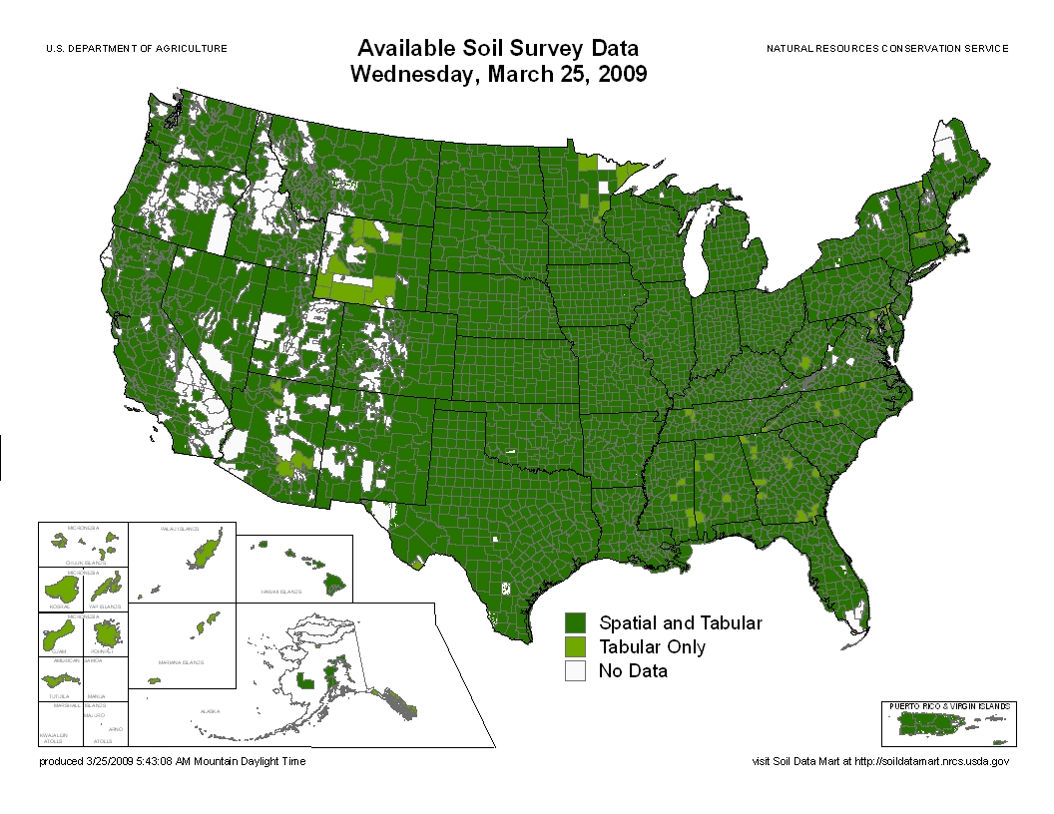
Figure 1. SSURGO data status map
0
.
0
2
4

-

5
0
5
0

-

1
0
0
1
0
0

-

1
5
0
1
5
0

-

2
0
0
2
0
0

-

2
5
0
2
5
0

-

3
0
0
3
0
0

-

3
5
0
3
5
0

-

4
0
0
4
0
0

-

8
1
2
N
o

D
a
t
a
LZFPM
Figure 2. LZFPM based on SSURGO data. Gaps exist within CONUS
0
.
0
2
4

-

5
0
5
0

-

1
0
0
1
0
0

-

1
5
0
1
5
0

-

2
0
0
2
0
0

-

2
5
0
2
5
0

-

3
0
0
3
0
0

-

3
5
0
3
5
0

-

4
0
0
4
0
0

-

8
1
2
N
o

D
a
t
a
LZFPM
Figure 3. LZFPM based on SSURGO data with gaps filled with STATSGO data
Figure 4. Mask map showing areas with SSURGO, STATSGO data or missing values
0

-

2
0
2
0

-

4
0
4
0

-

6
0
6
0

-

8
0
8
0

-

1
0
0
1
0
0

-

1
2
0
1
2
0

-

1
4
0
1
4
0

-

1
6
0
1
6
0

-

1
8
4
N
o

D
a
t
a
Percentage Change (UZTWM)
Figure 5. Percentage change of UZTWM between original grid and climate adjusted grid for SSURGO based area only. STATSGO based areas have been adjust already.

Appendix

How to download the two sets of parameter data

- in your browser type: ftp://hydrology.nws.noaa.gov/pub/parameters
- go to directory sac_par where you can see two subdirectories, statsgo and ssurgo for statsgo and ssurgo based parameters respectively.
- Get those files to your respective local directories
- Download the script ‘make_links.sh’ under pub/parameters/sac_par to your local ssurgo directory. After modifying the ‘path’ variable in the script you can run it to make links for those grids that are same for both statsgo and ssurgo directories.
- Be noticed that some of the routing parameters were derived specifically for ABRFC.

