Enhance NWSRFS Deterministic Verification Tools for AWIPS OB8.2
User Interface Change Document
OSIP 06-023

Hank Herr
Table of Contents
1.0 Overview 3
2.0 Verification Group Manager 3
3.0 Verification Location Manager 4
4.0 IVP Data Display 6
4.1 IVP Data Display: Scatter Plot View 6
4.2 IVP Data Display: Time Series View 7
5.0 Verification Plot Definition Manager 8
6.0 IVP Statistic Chooser Manager 9
7.0 IVP Statistic Display 10
8.0 IVP Batch File Creation Wizard 12
9.0 Vfyruninfo Editor 13
10.0 IVP Batch Language 13
11.0 IVP Batch Builder 16

- Overview

This document provides descriptions of how the user interface will change in order to satisfy the requirements outlined for AWIPS OB8.2 delivery of the RFC verification software suite. For the OB7.2 software, the user interface is described in the User’s Manuals, found at

http://www.nws.noaa.gov/oh/hrl/verification/verification_doc_ob7.php

Each section that follows describes changes required to either a window of the Interactive Verification Program or the batch language used in the IVP Batch Program. Where possible, snapshots of a new prototype display will be provided.

- Verification Group Manager

The Verification Group Manager must change to allow the user to input the following information:

- Issuance time-of-day interval and subinterval
- Active/in-active (or both) flag

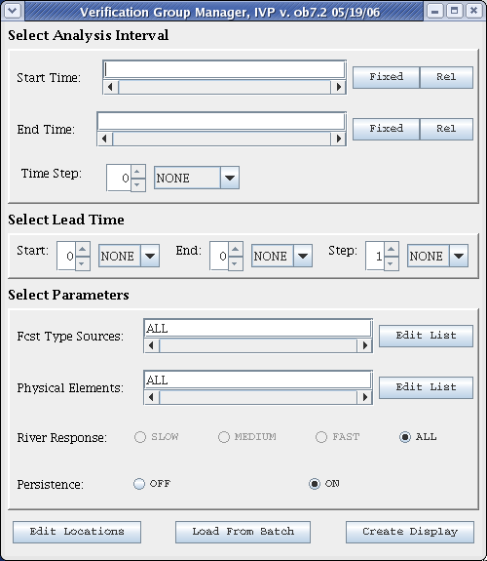
The issuance time-of-day interval will be specified in a manner analogous to how the lead time intervals are specified. However, the spinner will only allow values from 0 to 24, and the choice box will only include NONE or hours (hour and hr, as well). The active/in-active flag, which restricts which locations are included in the verification group, will be set via radio buttons.
Figure 1a: Screenshot of Verification Group Managers for OB7.2.
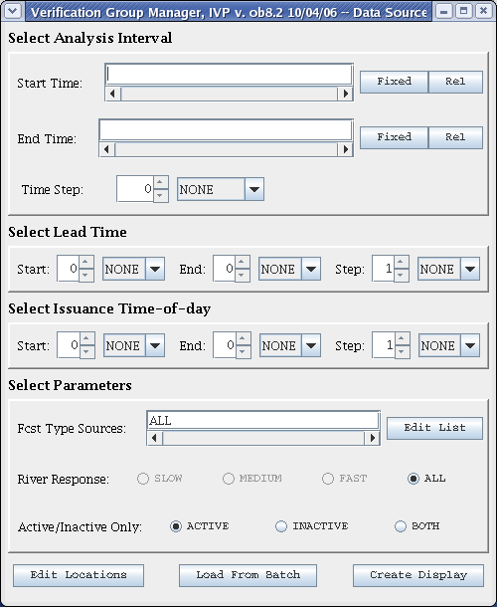
Figure 1b: Prototype screenshot of Verification Group Manager for OB8.2.
Also, the persistence and physical element parts of the window will be removed. The user will still be able to specify if persistence forecasts are to be used by including the type source ‘FR’ in the Forecast Type Sources text field, or setting it to ‘ALL’. As for physical elements, the user can specify the physical elements by choosing appropriate locations via the Verification Location Manager.

Screenshots of the OB7.2 Verification Group Manager and a prototype OB8.2 Verification Group Manager are provided in Figures 1a and 1b.

- Verification Location Manager

The Verification Location Manager will undergo significant changes in order to allow for additional data types. The changes are as follows:

- New columns will be created to display the duration, extremum, forecast type source, active state, and the observation type (raw or processed) for a location.
- Existing columns displaying the critical stages will be renamed to reflect that those columns will display critical flow values for flow data.
- The one table will be split into two tables: the upper table displays locations that can be chosen for display and the lower table will display locations currently chosen for display. The background colors for the table cells will remain the same: white/gray for unchosen locations, pink/red for chosen locations.
- A location filter panel will be added to the top that allows for users to filter out rows from the upper table that do not satisfy specified constraints, including physical element, duration, extremum, forecast type source, and whether the location has missing or non-missing critical stage/flow values.
- A Reset Filter button will be added that will reset the filter to include everything.
- Buttons will be rearranged, so that each table has its own buttons to select or deselect all locations. Other buttons will be placed between the two tables, meaning that they affect both tables. A new button, called Edit Obs Type will be added between the two tables. It will spawn a small GUI that contains two radio buttons labeled “RAW” and “PROCESSED”, as well as Okay and Cancel buttons. The Show button will be removed; its functionality will be added to the IVP Data Display.

Screenshots of the OB7.2 Verification Location Manager and a prototype OB8.2 Verification Location Manager are provided in Figure 2.
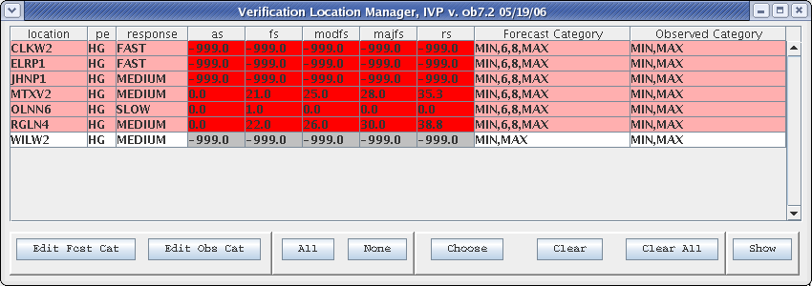
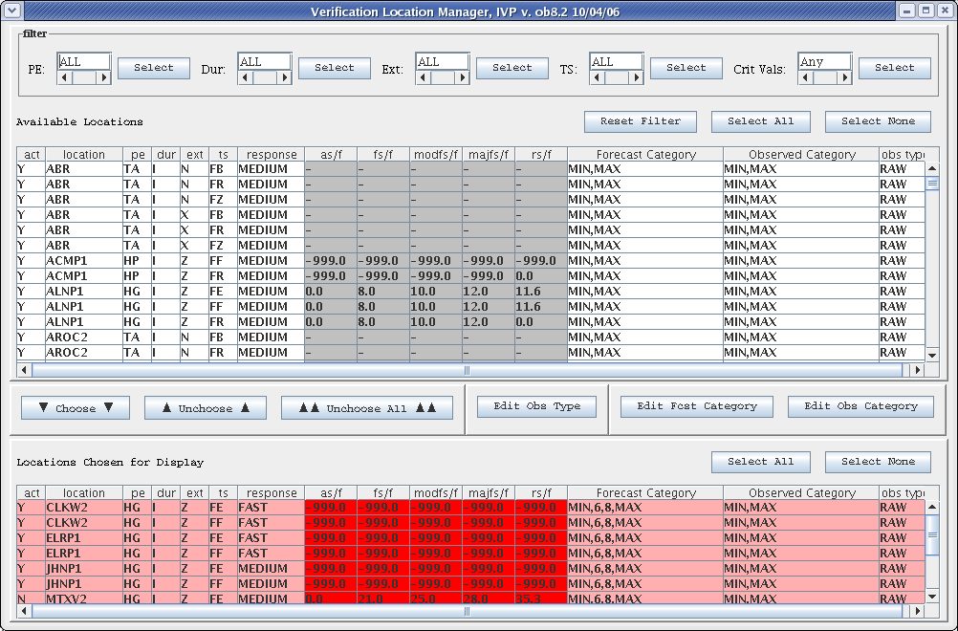
Figure 2: Screenshots of the Verification Location Manager for OB7.2 (top) and the prototype for OB8.2 (bottom).
- IVP Data Display

The IVP Data Display will change partly due to the change in chart rendering tool from JClass DesktopViews to ChartDirector. This will result in changes to the fonts, label positions, plot area position, and other aspects of the chart’s appearance. Also the following general changes will be made:

- The NOAA logo in the upper left corner and the NWS logo in the upper right corner of the displayed chart will be removed. Instead, a NOAA water mark will be placed in the background of every chart.
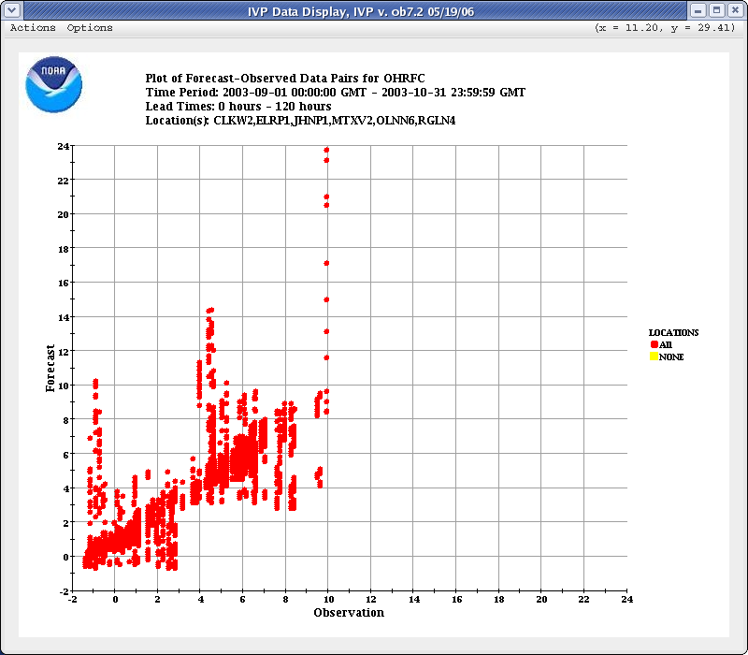
- A new menu item called “Create a New Display” will be created allowing the user to open up a new Verification Group Manager window and create a new IVP Data Display.
Figure 3a: Screenshot of the IVP Data Display for OB7.2.
- A new menu item called “View Batch Tokens” will be created allowing the user to view the tokens used in order to acquire the data displayed. As stated in the design document, the IVP GUI uses tokens in order to access the IVP Batch Program software components to acquire forecast-observed pairs and compute verification statistics.

  - IVP Data Display: Scatter Plot View

A Location List Panel will be added to the scatter plot view to allow for a user to focus on data and categories for a specific location. When a location is selected, it will be displayed exactly as if the Show button of the Verification Location Manager was click in the AWIPS OB7.2 version of IVP. Locations with data to view will have a green background within the list.

Screenshots of the OB7.2 IVP Data Display Scatter Plot View and a prototype OB8.2 IVP Data Display Scatter Plot View are provided in Figures 3a and 3b.
Figure 3b: Prototype screenshot of the scatter plot view for the IVP Data Display for OB8.2.
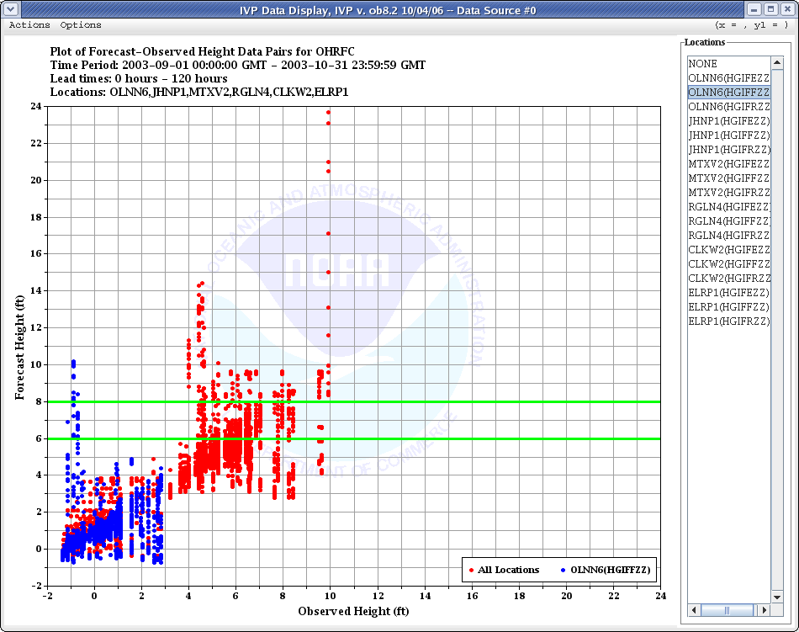
  - IVP Data Display: Time Series View

A new time series view will be added to the IVP Data Display, displaying forecast time series by location and forecast basis time. Also, users will be able to add observation time series to the display based on the observation type source. Finally, users will be able to emphasize any forecast time series by clicking on the legend entry for that time series. When emphasized, the forecast time series will be highlighted and the observations paired with each forecast time series will be shown.

A screenshot of the prototype OB8.2 IVP Data Display time series view is provided in Figure 3c.

- Verification Plot Definition Manager

The Verification Plot Definition Manager will undergo changes to account for the addition of a comparison variable and variables that can be used to breakdown statistics. The changes are as follows:

- A component to be used for specifying the comparison variable will be added. It will be similar to the component used to specify the x-axis variable.
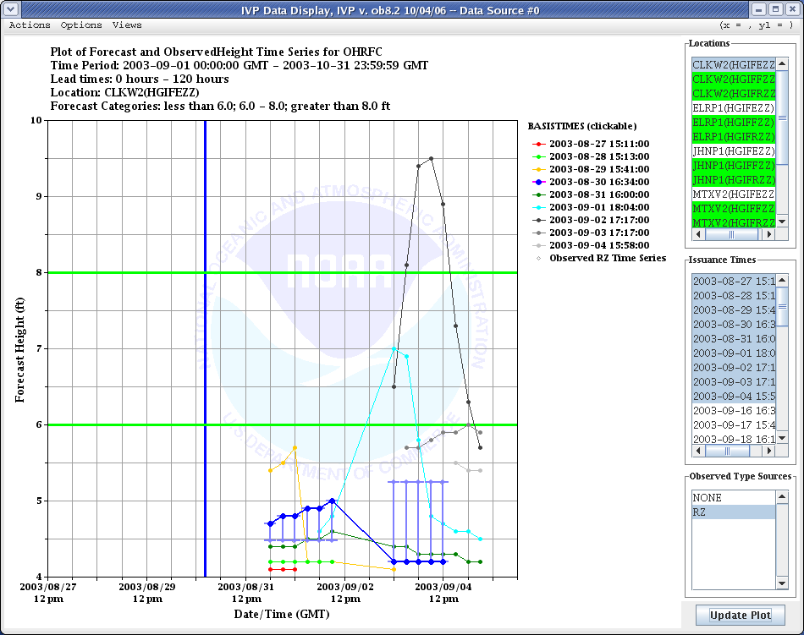
- New list items for both the x-axis variable and comparison variable will be created. These include “Issuance Time-Of-Day” and “Forecast Type Source”.
Figure 3c: Prototype screenshot of the time series view for the IVP Data Display for OB8.2.

Screenshots of the OB7.2 Verification Plot Definition Manager and a prototype OB8.2 Verification Plot Definition Manager are provided in Figure 4.

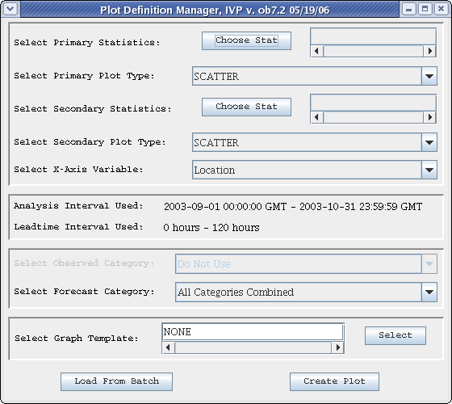
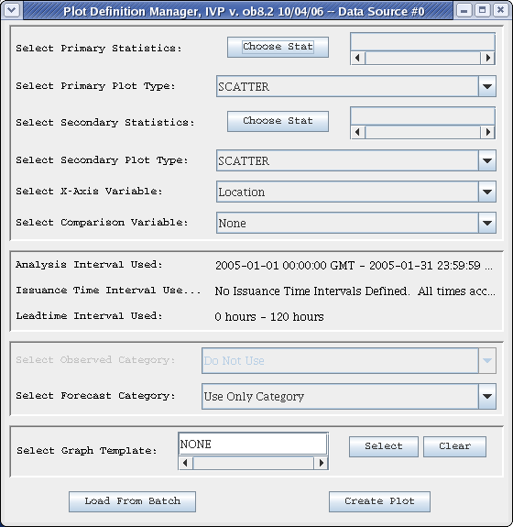
Figure 4: Screenshots of the Verification Plot Definition Manager for OB7.2 (top) and the prototype for OB8.2 (bottom).
- IVP Statistic Chooser Manager

The IVP Statistic Chooser Manager will undergo changes to include new statistics to be produced for OB8.2. Special plots must also be accounted for. The new statistics will be added to existing groups of statistics, where reasonable. Otherwise, new statistic groups will be created. Note that statistics are grouped together if they can be displayed against the same y-axis. Screenshots of the OB7.2 IVP Statistic Chooser Manager and a prototype OB8.2 IVP Statistic Chooser Manager are provided in Figure 6.

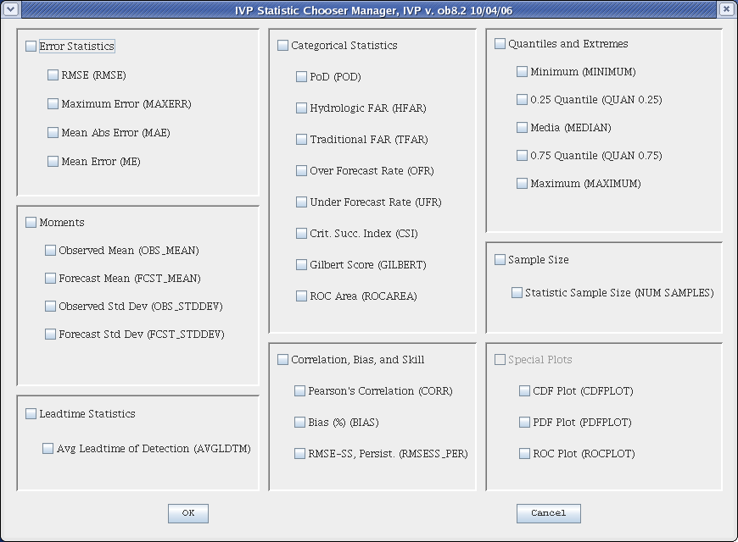
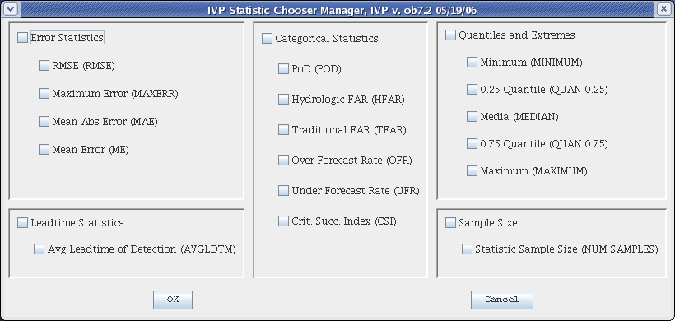
- IVP Statistic Display
Figure 5: Screenshots of the IVP Statistic Chooser Manager for OB7.2 (top) and the prototype for OB8.2 (bottom).

The IVP Statistic Display will change appearance primarily because the chart rendering engine will be changed from JClass DesktopViews to ChartDirector. This will result in changes to the fonts, label positions, plot area position, and other aspects of the chart’s appearance. Also the following changes will be made:

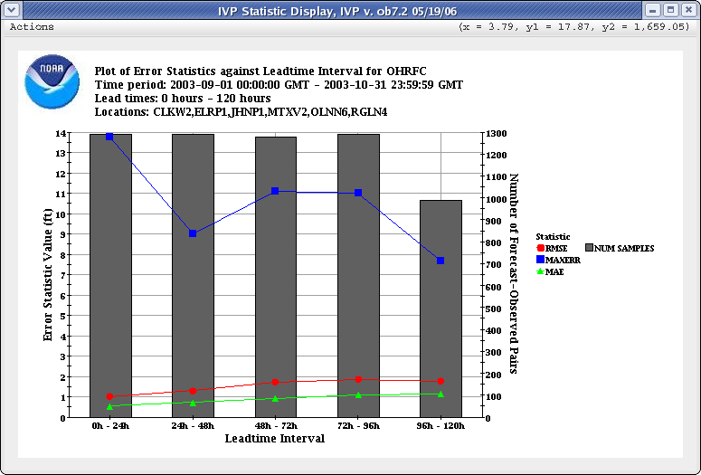
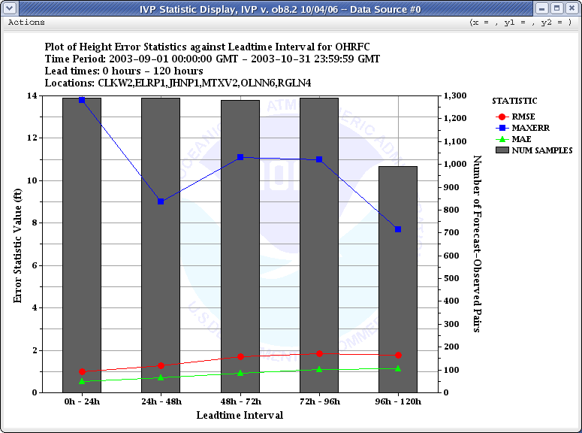
- The NOAA logo in the upper left corner and the NWS logo in the upper right corner of the displayed chart will be removed. Instead, a NOAA water mark will be placed in the background of every chart.
Figure 6: Screenshots of the IVP Statistic Display for OB7.2 (top) and prototype for OB8.2 (bottom).
- A new menu item called View Batch Tokens will be created allowing the user to view the batch program tokens used to acquire the data displayed. As stated in the design document, the IVP GUI uses tokens in order to access the IVP Batch Program software components to acquire forecast-observed pairs and compute verification statistics.

Screenshots of the OB7.2 IVP Statistic Display and a prototype OB8.2 IVP Statistic Display are provided in Figure 6.

- IVP Batch File Creation Wizard

The IVP Batch File Save Manager will be replaced by the IVP Batch File Creation Wizard. It will be made possible for the user to create one graphic displayed in the IVP Statistic Display, and create a batch file capable of generating the same graphic for a different analysis period or for many possible combinations of locations, saving each to a different file.

The user interface will follow a generic wizard design. It will consist of a sequence of steps, each specifying different aspects of the batch file. The last step, when completed, will result in the creation of a batch file.
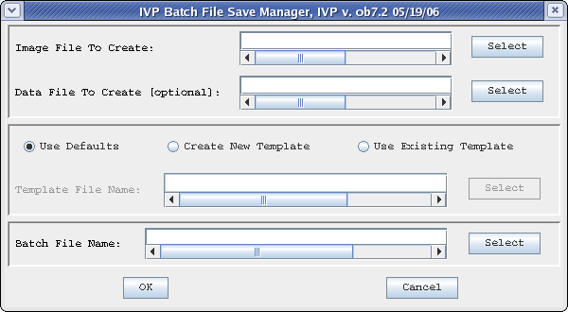
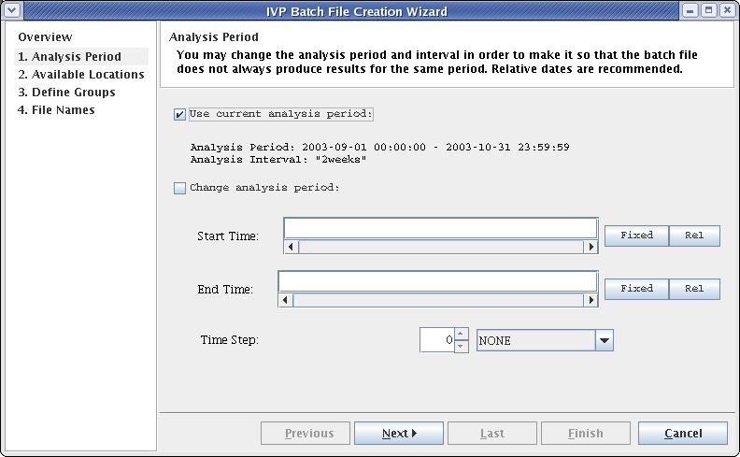
Figure 7: Screenshots of the IVP Batch File Save Manager for OB7.2 (top) and the IVP Batch File Creation Wizard for OB8.2 (bottom).
Screenshots of the OB7.2 IVP Batch File Save Manager and the prototype OB8.2 IVP Batch File Creation Wizard are provided in Figure 7.

- Vfyruninfo Editor

The Vfyruninfo Editor main window will be significantly changed to allow for greater usability and functionality. Specifically, the main window will be changed to include two tables:

- A bottom table displaying the user edited locations within the vfyruninfo table.
- A top table displaying verification locations found in the ingestfilter table that are not in the top table, and entries that were in the bottom table at some time but have been removed.

In addition to the columns of the OB7.2 Vfyruninfo Editor table, the two new tables will include new columns for the duration, extremum, active state (‘Y’ or ‘N’), and national flag (‘Y’ or ‘N’), as well as critical stages and flows as acquired from the rivercrit table, if appropriate. Furthermore, a location filter panel will be included at the top of the window, restricting the rows visible in the top table. Lastly, buttons will be included to allow for selecting rows from the tables, adding rows to or removing rows from the bottom table, and editing the sensor preferences, response time, active state, and national flag values of selected rows.

The Vfyruninfo Record Editor window will change to include text fields for the duration and extremum.

Screen shots of the OB7.2 Vfyruninfo Editor main window and the OB8.2 prototype are provided in Figure 8, and screenshots of the OB7.2 Vfyruninfo Record Editor and the OB8.2 prototype are provided in Figure 9.

- IVP Batch Language

The IVP Batch Program batch language shall include the following new commands:

- ACTIVE_STATUS: Restricts locations to only those that are active, inactive, or both (default). Used for pairing and statistics calculation.
- BREAKDOWN_BY_FCSTTS: Breaks down statistic computation based on the forecast type source. Used for statistics calculation.
- COMP_VARIABLE: Specifies the comparison variable used to further break down statistics computation and produce a graphic. The values of the comparison variable are shown in the graphic legend. Used for graphics.
- DUR: Restricts locations to only those that have a specified duration code. Used for pairing and statistics calculation.
- EXTREMUM: Restricts locations to only those that have a specified extremum code. Used for pairing and statistics calculation.
- ISSUANCE_START: The start time-of-day (0 – 24 hours) used to restrict the data used in computations based on the forecast basistime. Used for statistics calculation.
- ISSUANCE_END: The end time-of-day (0 – 24 hours) used to restrict the data used in computations based on the forecast basistime. Used for statistics calculation.
- ISSUANCE_STEP: The time step used to break down the issuance time-of-day interval into evenly spaced subintervals. Used for statistics calculation.
- OBS_TYPE: Specifies from where the observation is to be drawn for constructing and using a pair: “PROCESSED” or “RAW”. Used for pairing and statistic computation.
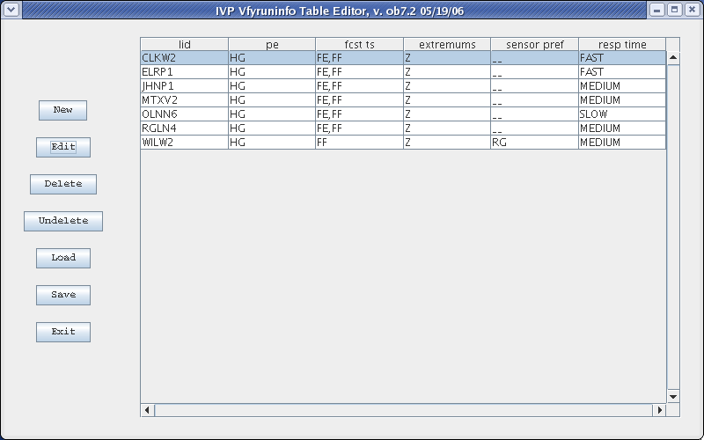
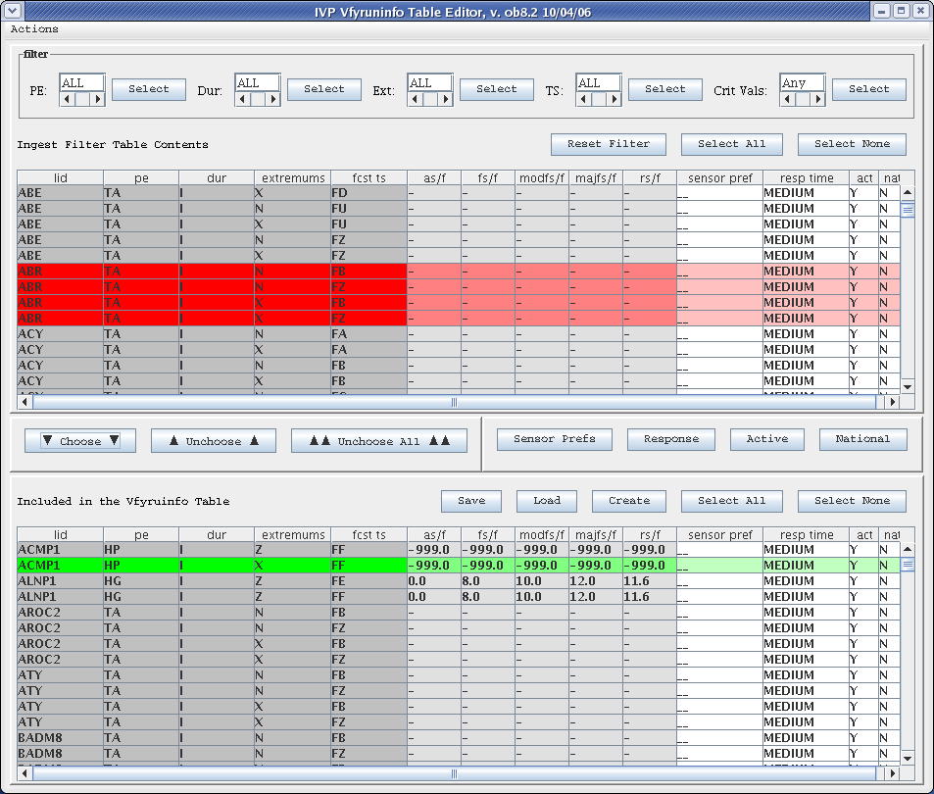
Figure 8: Screenshot of the Vfyruninfo Editor main window for OB7.2 (top) and prototype for OB8.2 (bottom).
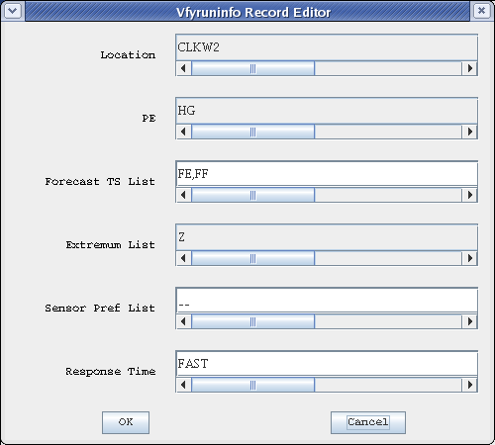
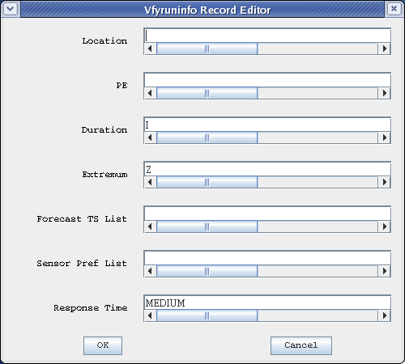
Possible values for some existing commands will also be enhanced. For example, acceptable CALCSTATS values will include new statistics (i.e. MOMENTS for all mean and standard deviation statistics) and acceptable XAXIS_VARIABLE values will include new variable values (for example, FCST_TS for forecast type source and ISSTIME for issuance time).
Figure 9: Screenshots of the Vfyruninfo Record Editor for OB7.2 (top) and prototype for OB8.2 (bottom).

The following commands are being removed from the batch language for OB8.2:

- OBSERVED_TABLE: Was used in OB7.2 to specify if the observations are to be drawn from the pehpsep table of the archive database, which is a processed table. By default, observations came from the pecrsep table, which is a raw table. This batch command is being replaced by OBS_TYPE. Whenever the OBSERVED_TABLE value was PEHPSEP, it is replaced by an OBS_TYPE value of PROCESSED.

- IVP Batch Builder

Every new command given in the previous section will have an appropriate editing tool provided in the IVP Batch Builder. Software for existing tools will be reused wherever possible. No prototype is currently available.

