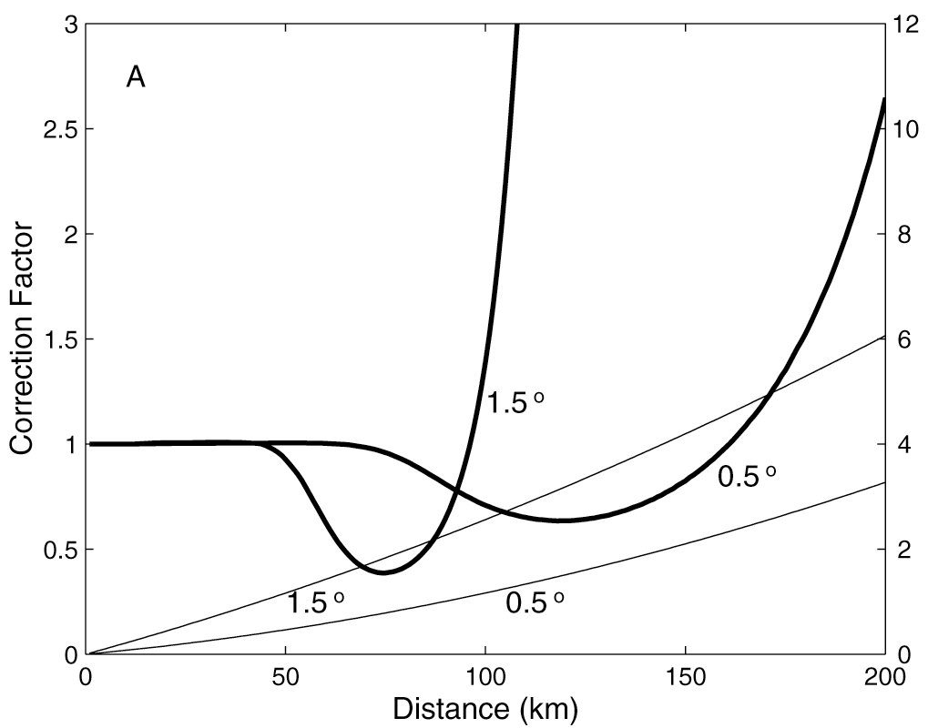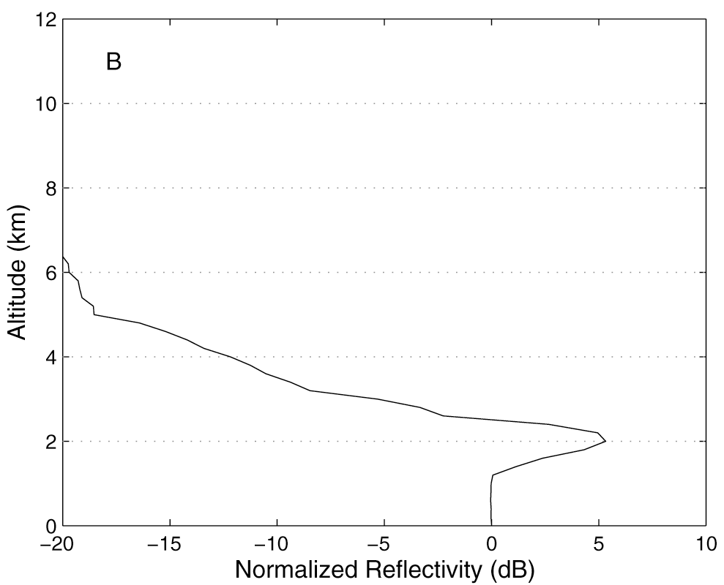

Figure 1. Illustration of VPR correction curves for two elevation angles (panel A) associated with an arbitrary vertical profile of reflectivity VPR (panel B).
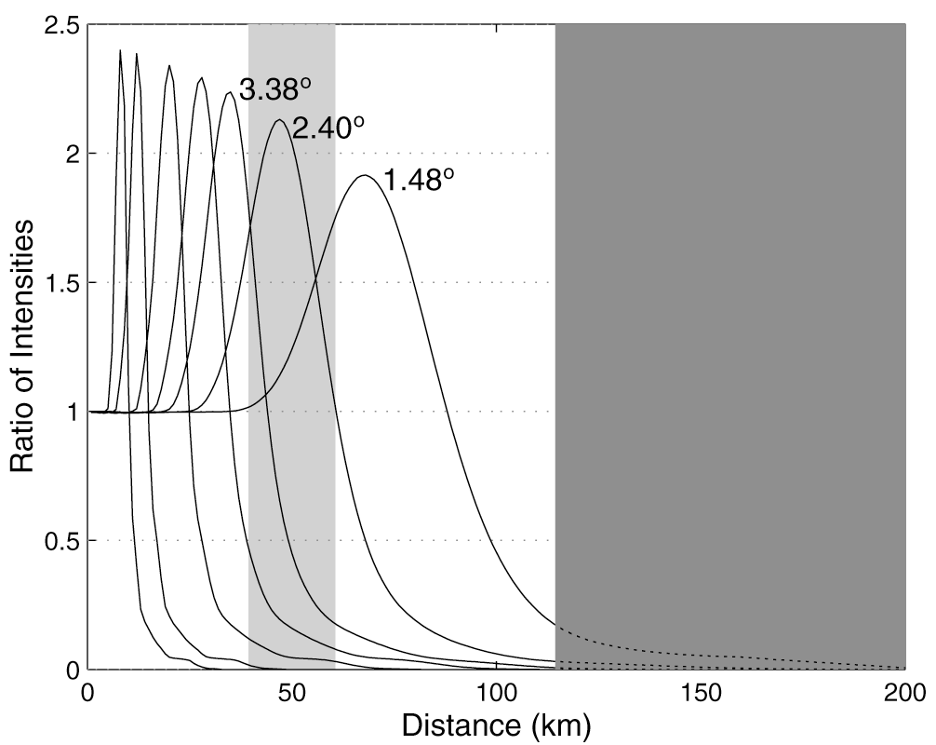

Figure 2. Example of ratio curves of radar data simulated using the VPR shown in Fig. 1B. The light shaded region corresponds to one 20 km interval used in LVPR correction calculations. The dark shaded region denotes distance over which no VPR corrections should be made as the lowest angle (0.5º) is not a good reference anymore.
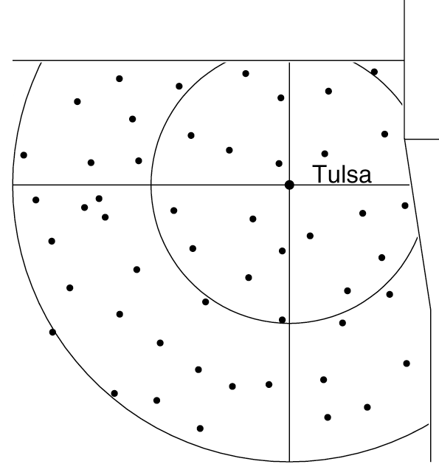

Figure 3. Locations of the Oklahoma Mesonetwork rain gauges used in this study (circles indicate 100 and 200 km range from radar site). Only Oklahoma part of the radar umbrella is shown.
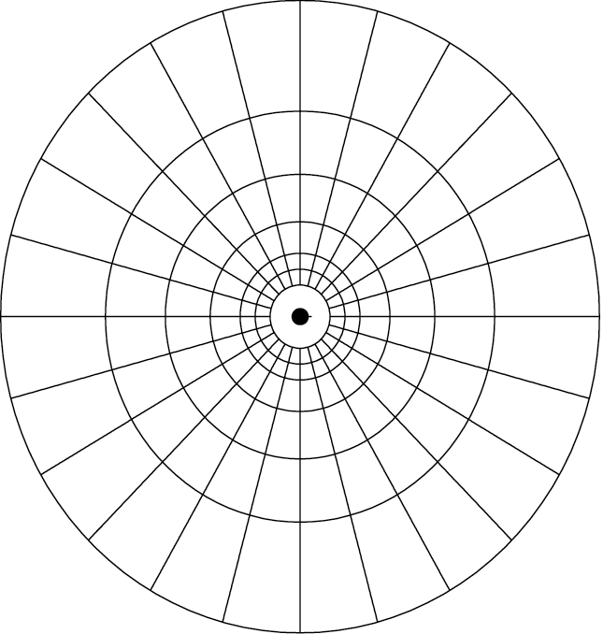

Figure 4. Regions of analysis used to estimate locally identified VPRs.
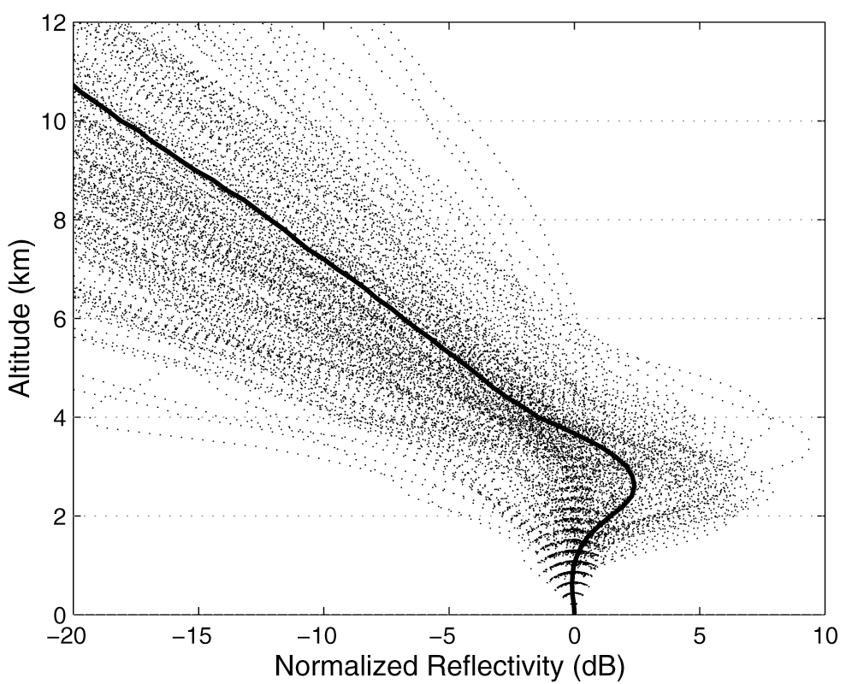

Figure 5. Two-year sample of the MVPRs and the climatological VPR (thick line).
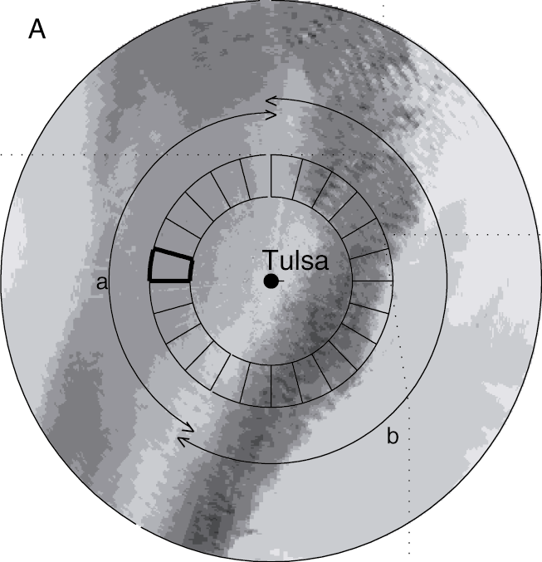
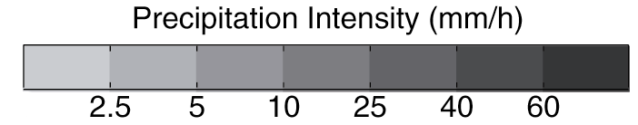
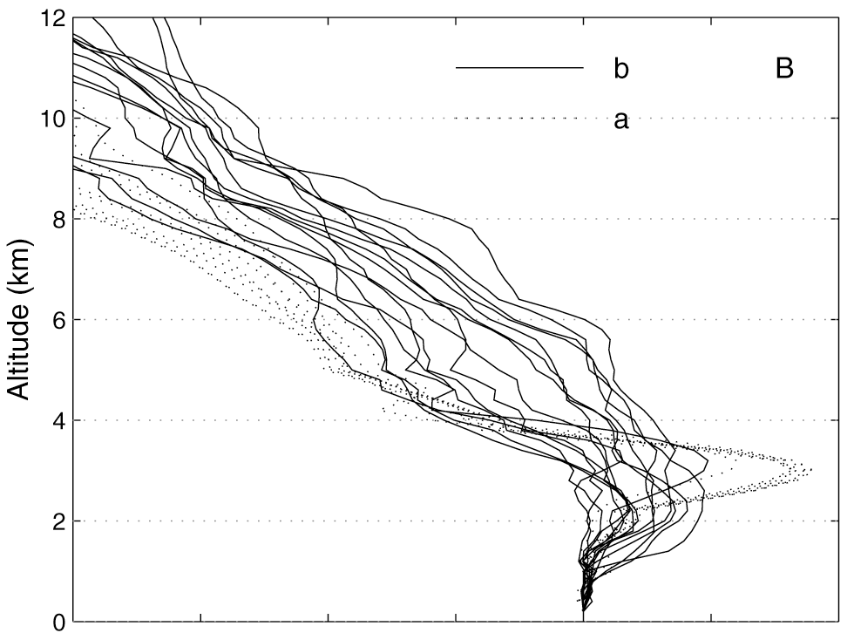
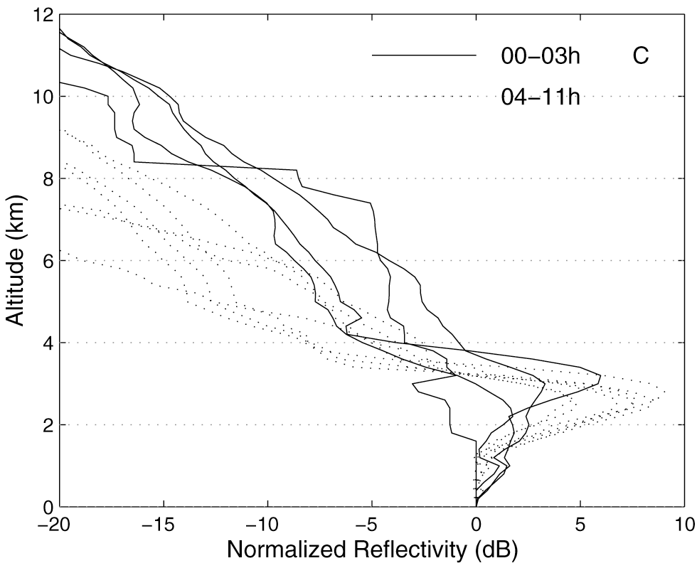

Figure 6. Illustration of the variability in time and space of the LVPRs. (A) Hourly mean rain-rate from radar data recorded at 0.5º (05/08/95 at 03:00 a.m.), also shown are 24 sectors are selected for illustrating the variability in space of the VPR. (B) Corresponding LVPRs, divided into two groups (group a corresponds to area of stratiform rain, group b corresponds to convective rain as marked in A). (C) Time series of the VPRs obtained over the bold-marked sector divided into two groups according to time during the same storm.

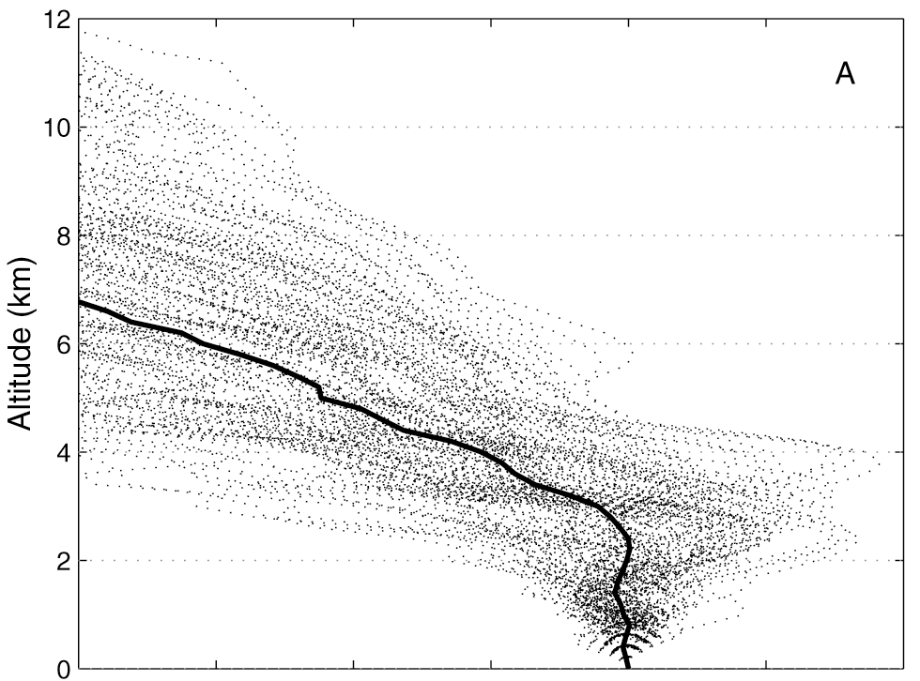
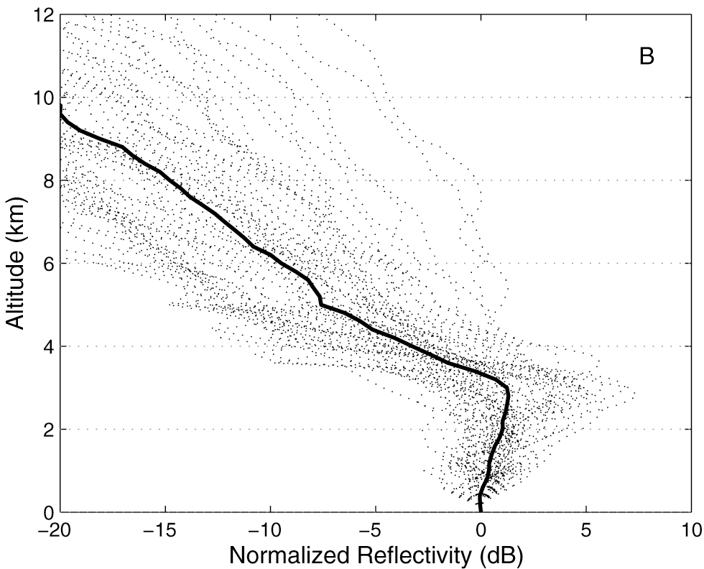

Figure 7. Conditional sample of locally identified VPRs obtained between 60-90 km from the radar. (A) VPR obtained on region of analysis where radar data at 0.5º reported an average rainfall between 0.75 to 1.25 mm/h. (B) VPR obtained on region of analysis where radar data at 0.5º reported an average rainfall between 9.50 to 10.50 mm/h.
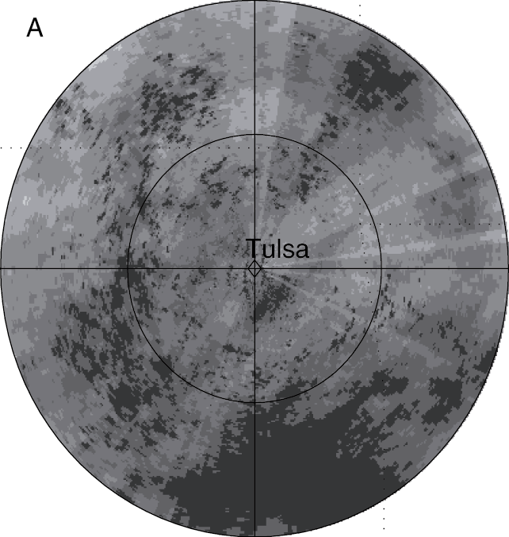
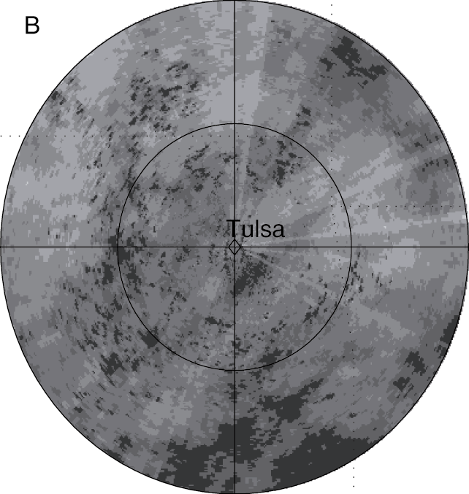
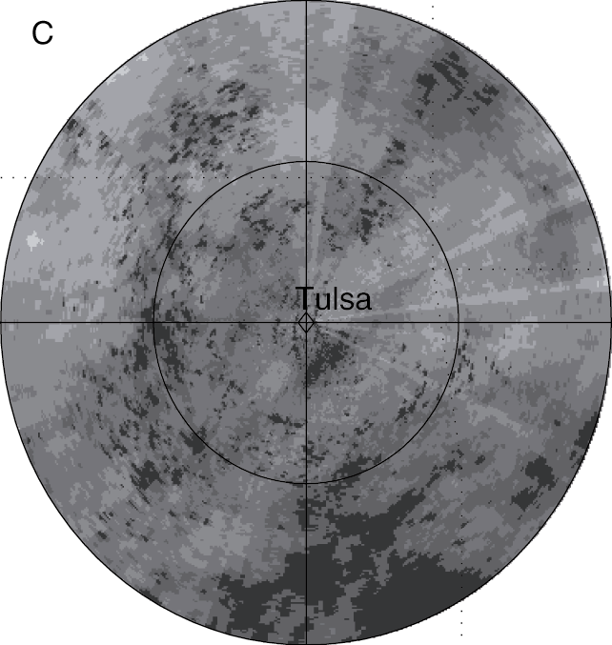
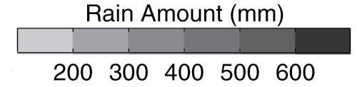

Figure 8. Two-year accumulation map based on radar data recorded at an elevation of 0.5º (A) without VPR correction; (B) corrected using MVPR; and (C) corrected using LVPR.
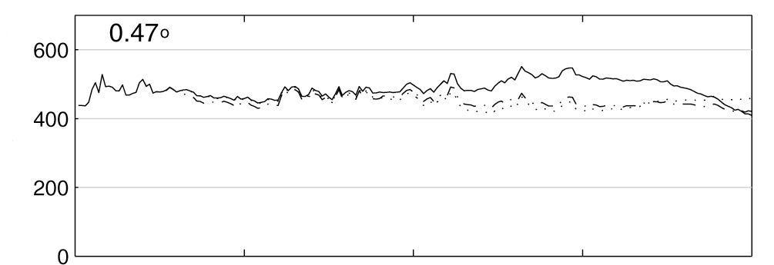
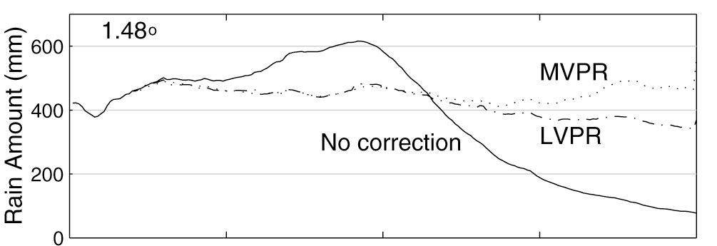
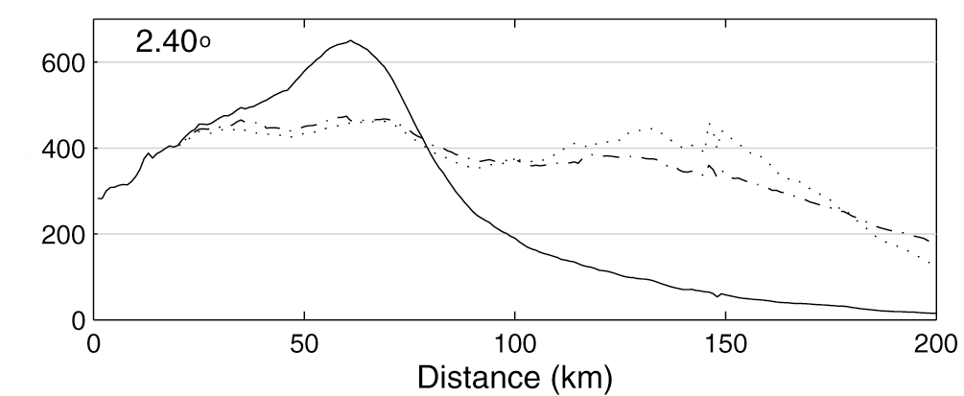

Figure 9. Azimuthally averaged two-year accumulation based on radar data recorded at (A) 0.5º; (B) 1.5º; and (C) 2.5º. Continuous lines are for radar data without VPR correction, dotted lines for radar data corrected using MVPRs and mixed lines for radar data corrected using LVPR.
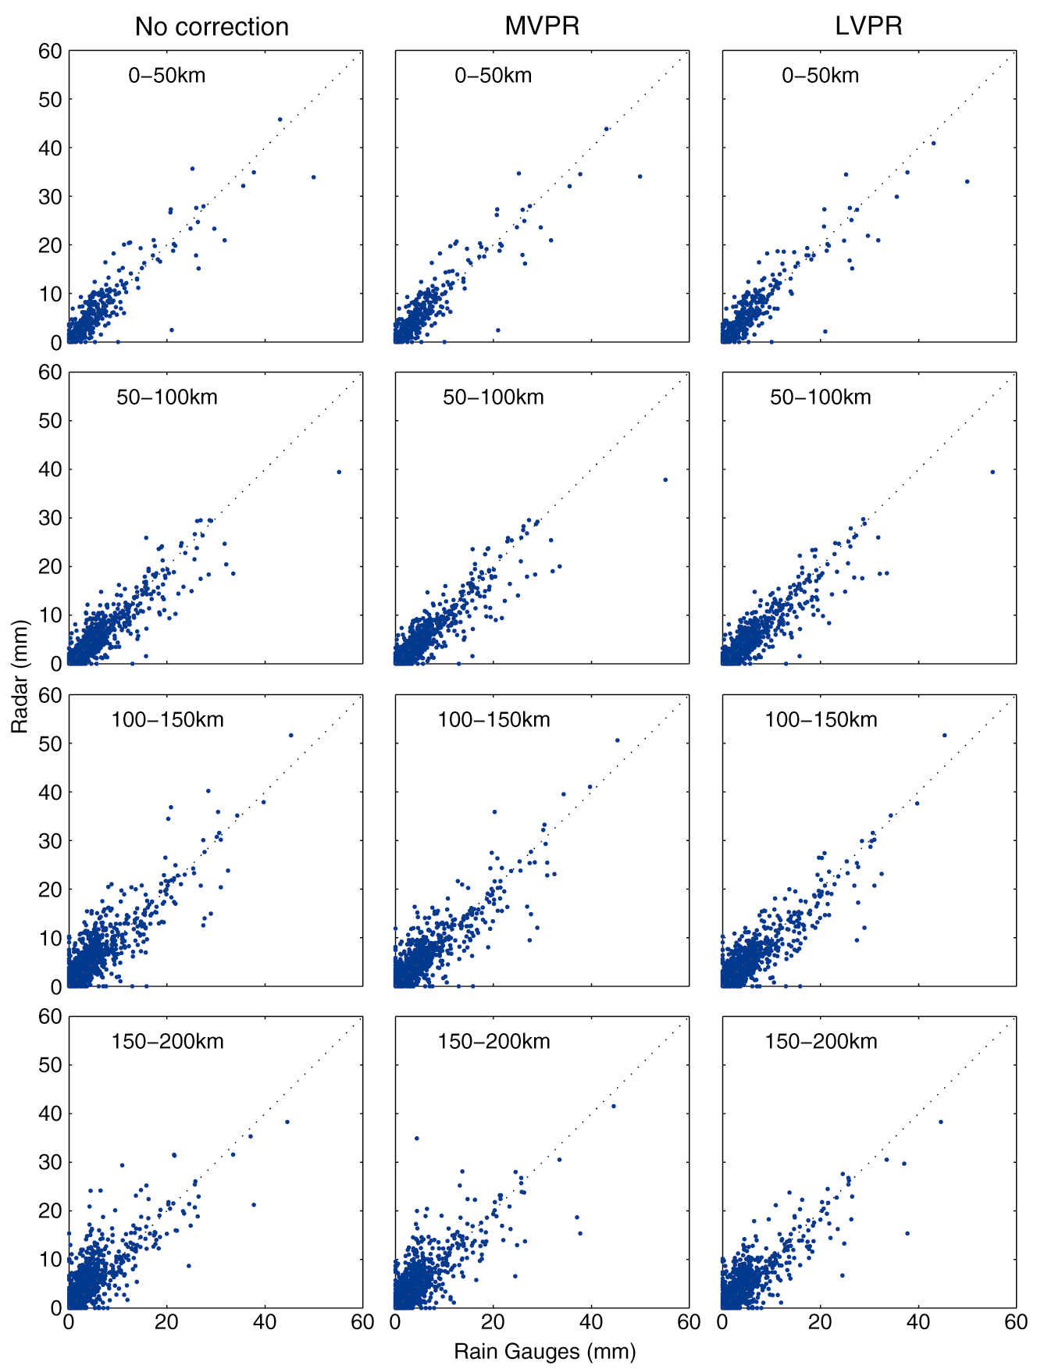

Figure 10. Comparisons of hourly accumulations based on gauges versus radar organized by distance from the radar.
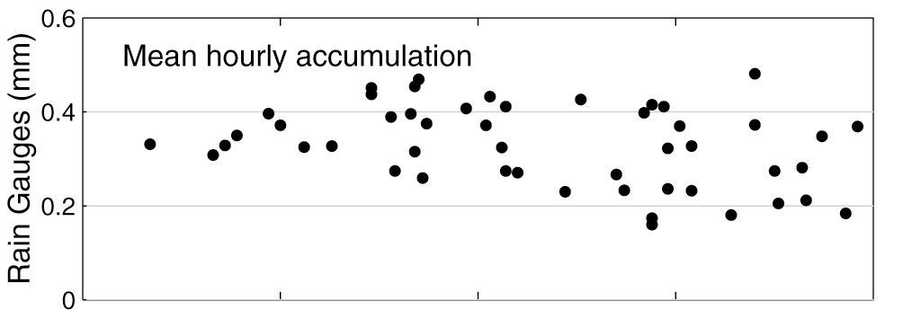

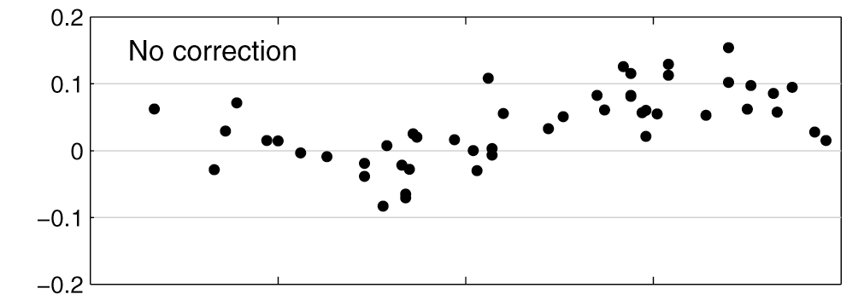
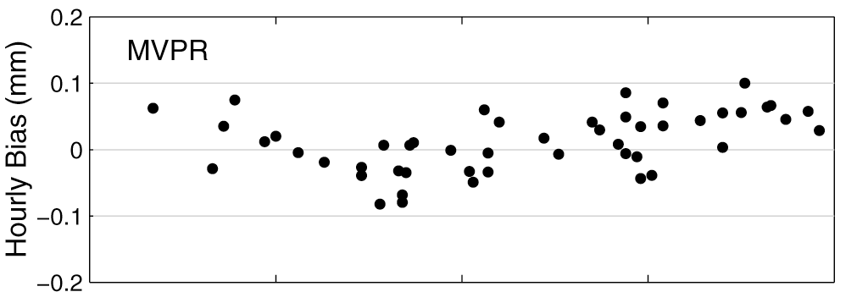
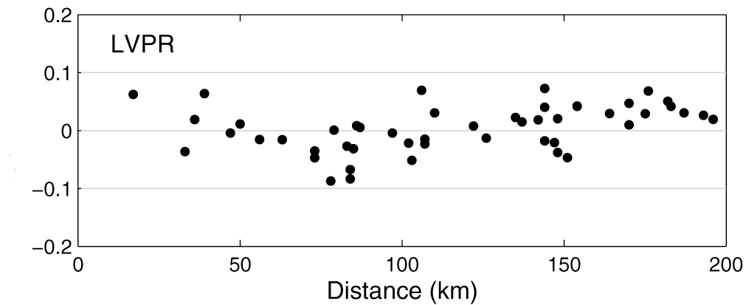

Figure 11. Gauge by gauge analysis of mean hourly bias as a function of the distance from the radar: (A) mean hourly accumulation from gauges; (B) mean hourly bias between gauge and radar without VPR correction; (C) between gauge and radar corrected using MVPR; and (D) corrected using LVPR.
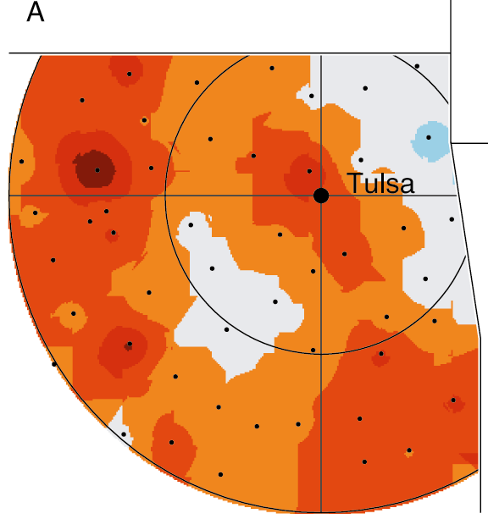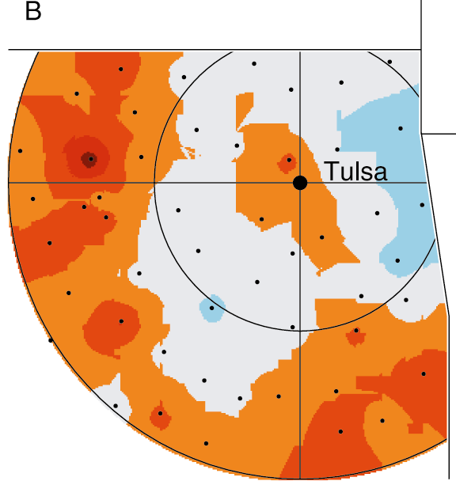
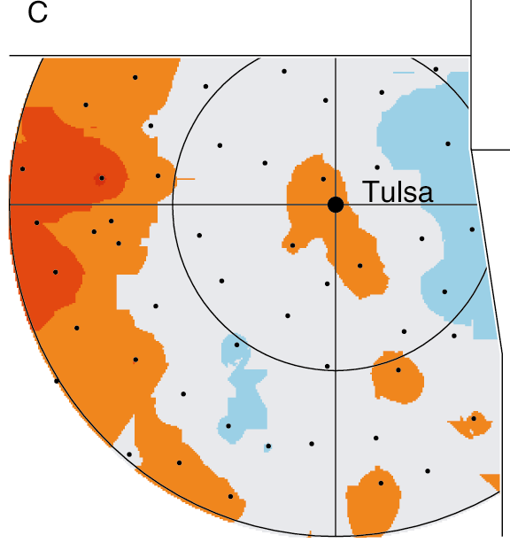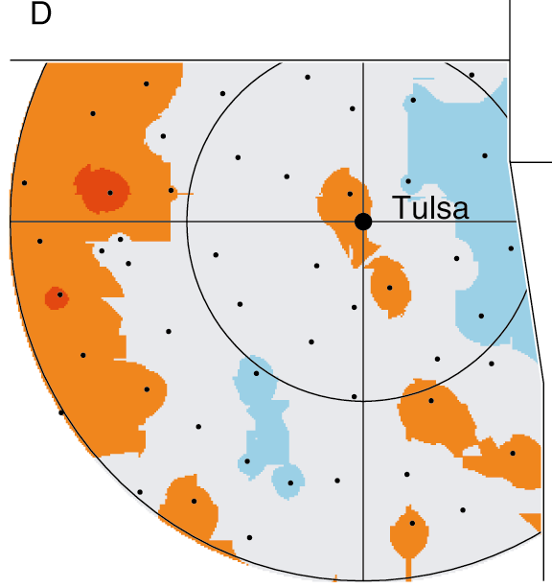
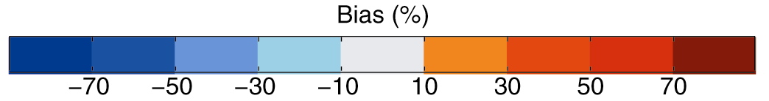

Figure 12. Bias between radar and gauge total rainfall accumulation, for radar data (A) before QC; (B) after QC; (C), after QC and MVPR correction; and (D) after QC and LVPR correction.

