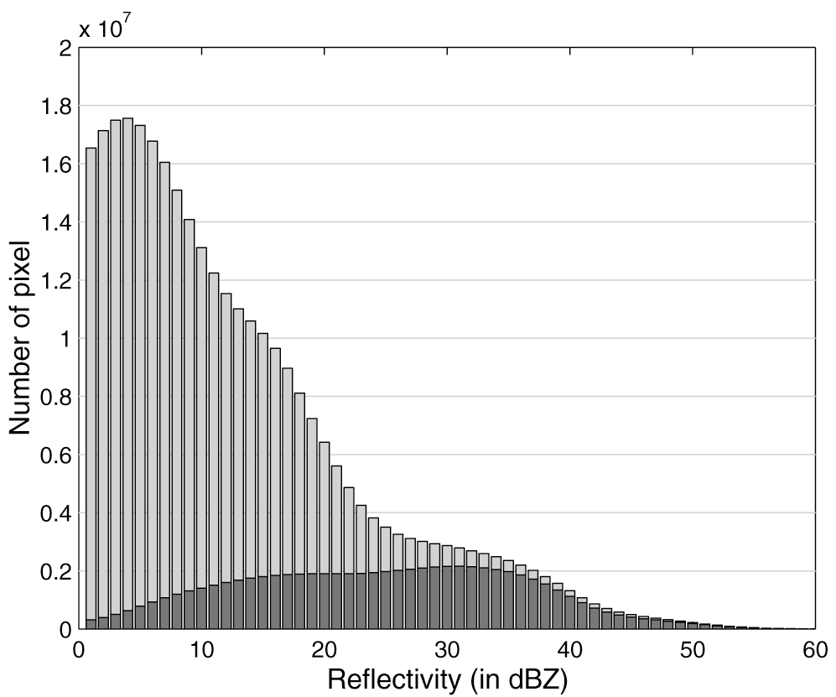

Fig. 1. Histogram of the radar reflectivity data used in the study. The dark shaded region corresponds to the data after QC.
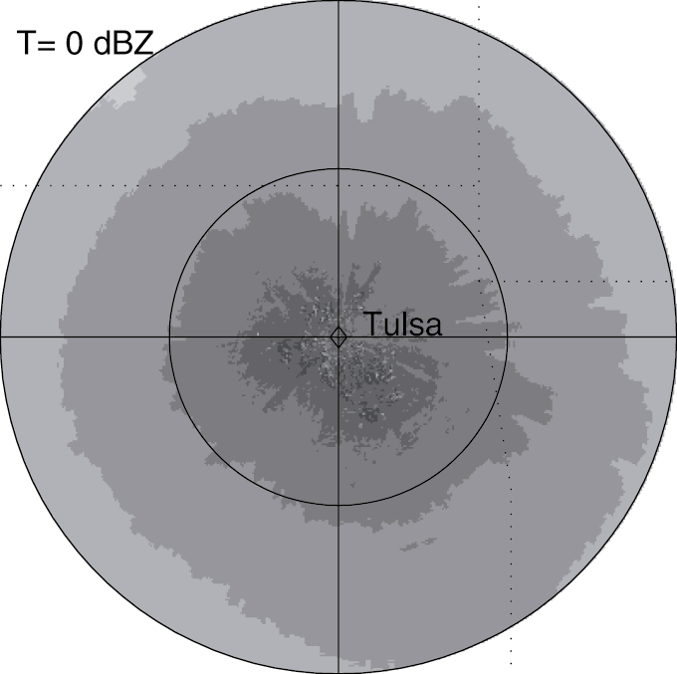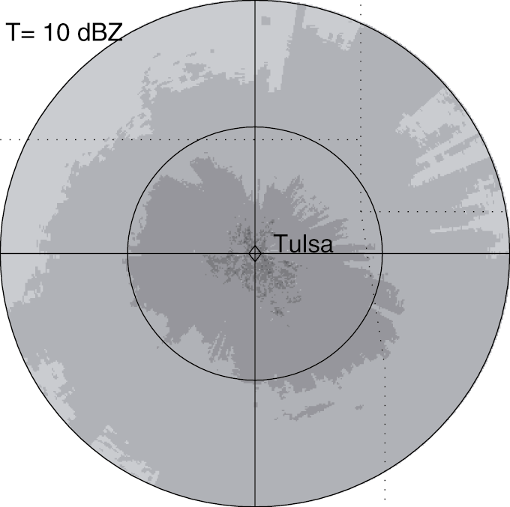
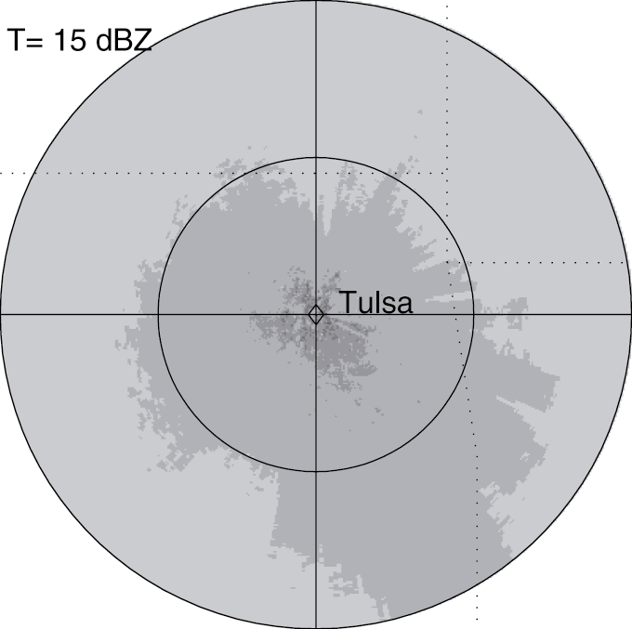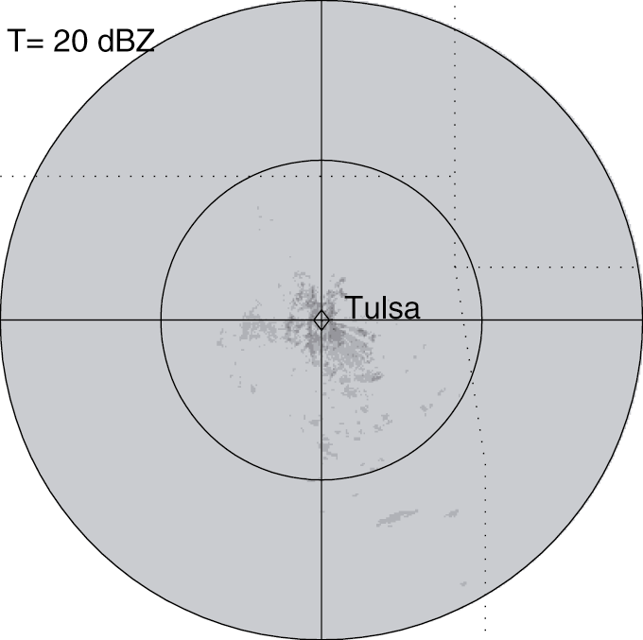
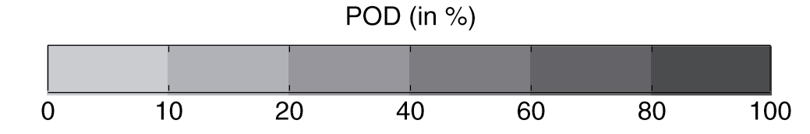

Fig. 2. Probability of detection (POD) before QC for different thresholds (from 0 dBZ to 20 dBZ) based on 10,000 volume scans collected by the Tulsa, Oklahoma WSR-88D between 1994 and 1995. The rings, centered on the radar, denote 100 and 200 km ranges.
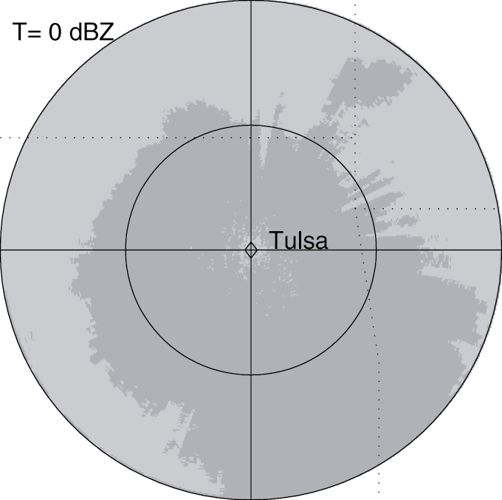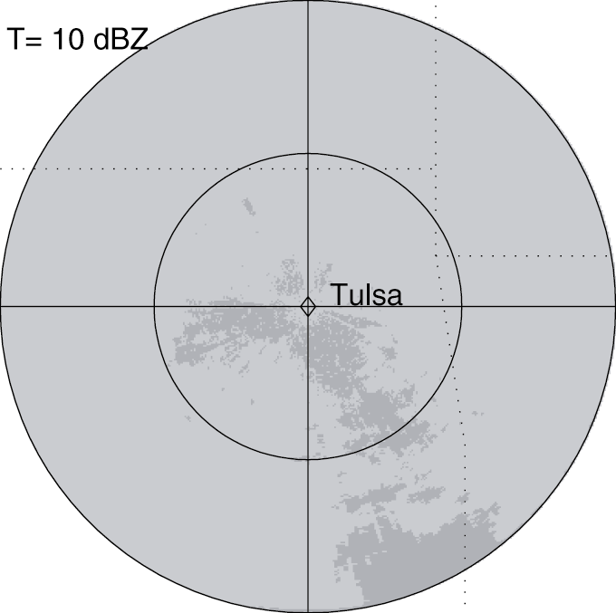
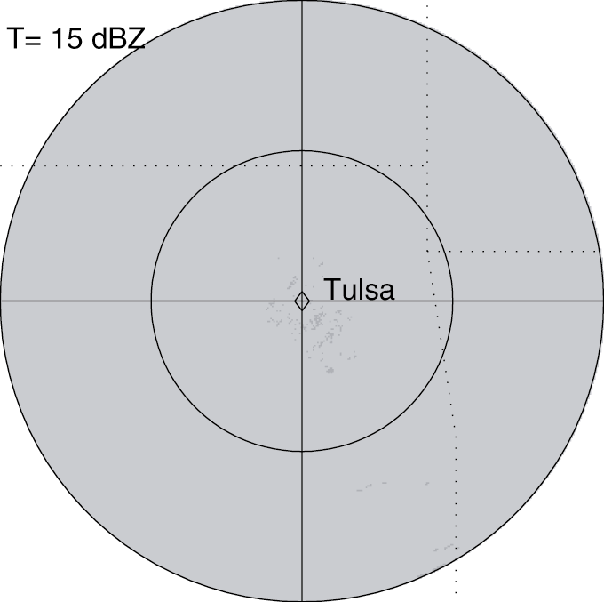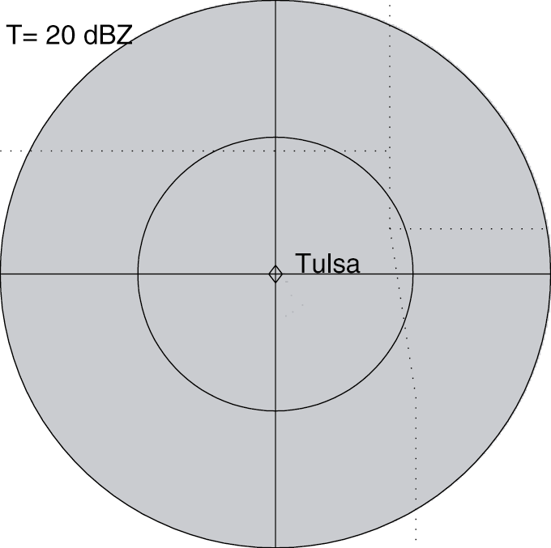

Fig. 3. Same as Figure 2, but after QC.
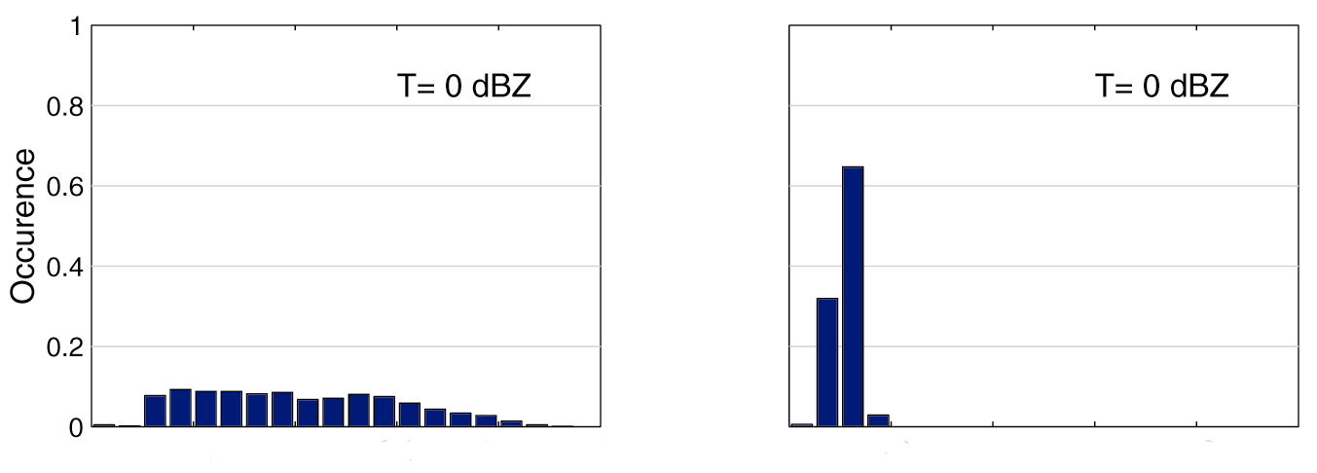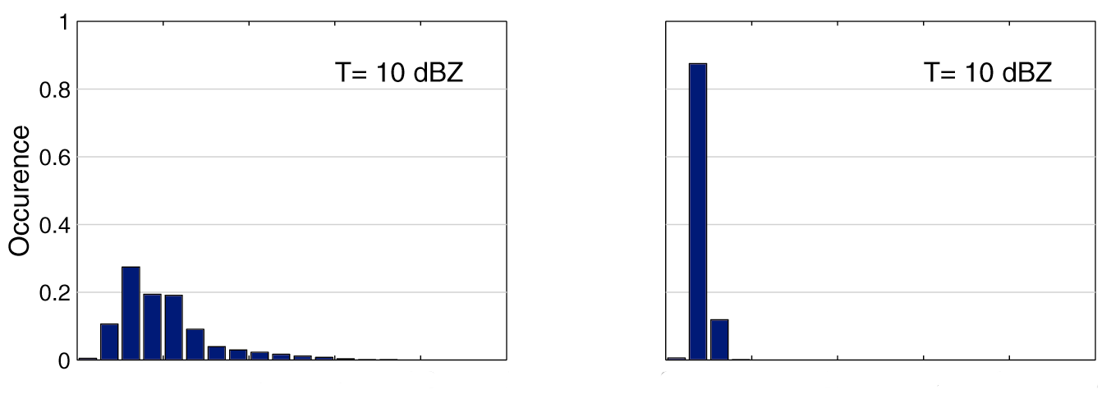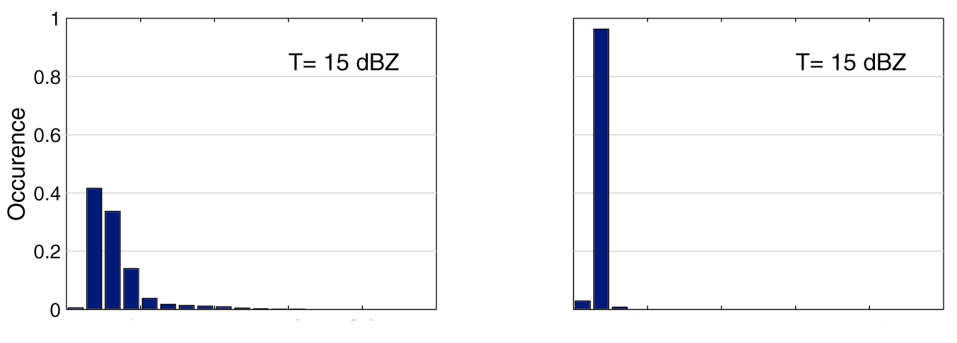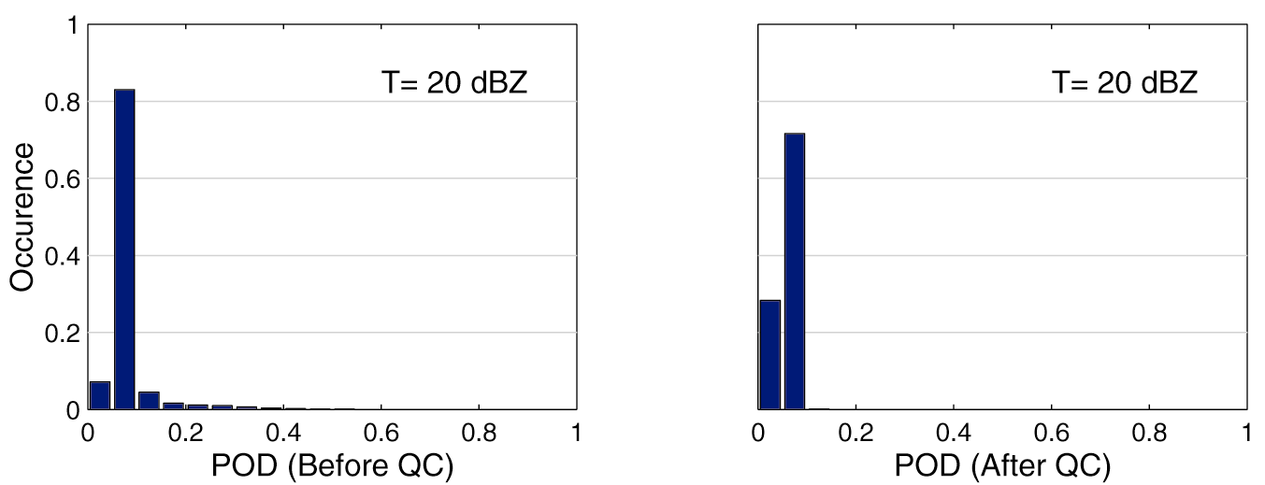
Fig. 4. Histogram of POD based on the 360×200 polar pixels of the radar domain.
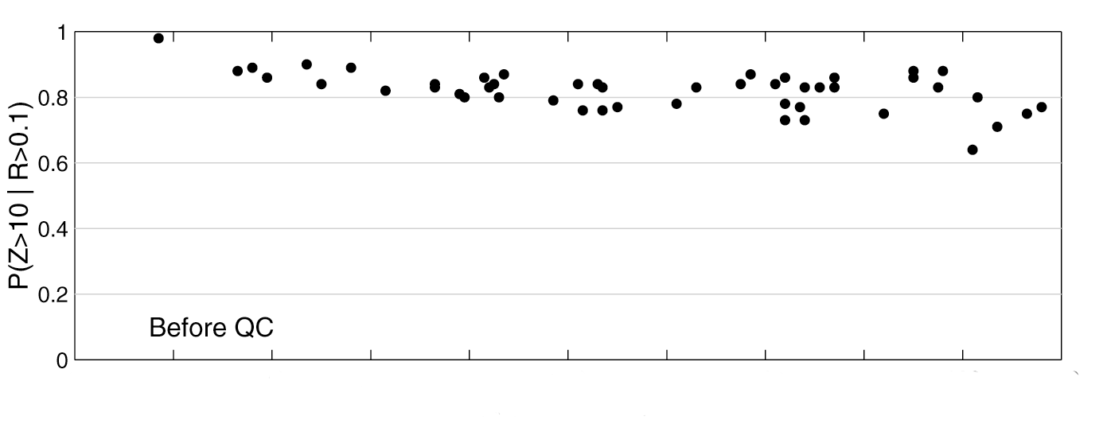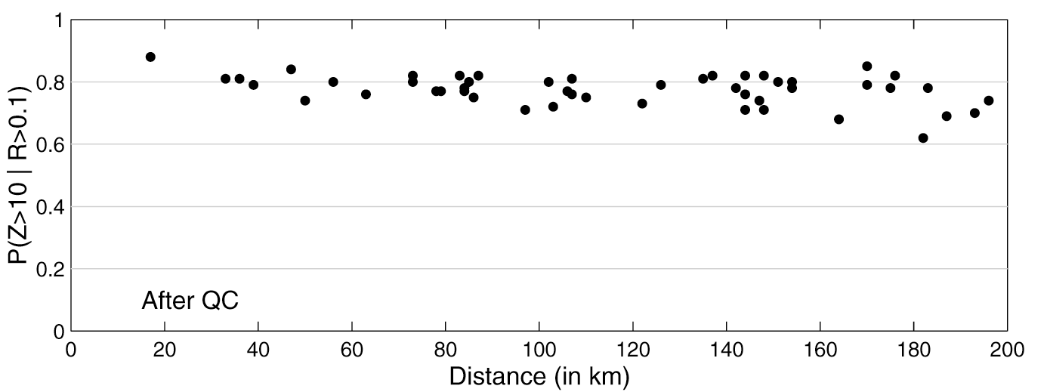

Fig. 5. Probability of detection conditional on the gauge measurements, $P(Z>\text{10} \text{dBZ} | R>0\text{.}1 \text{mm})$.
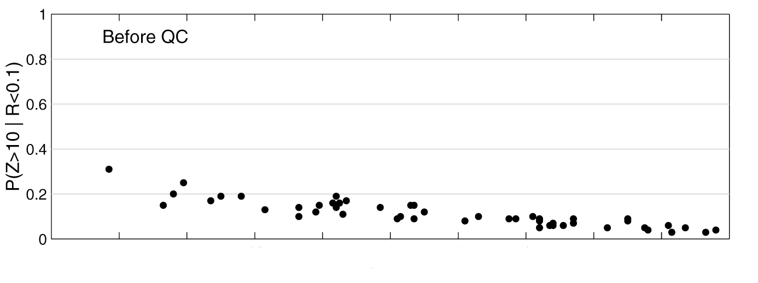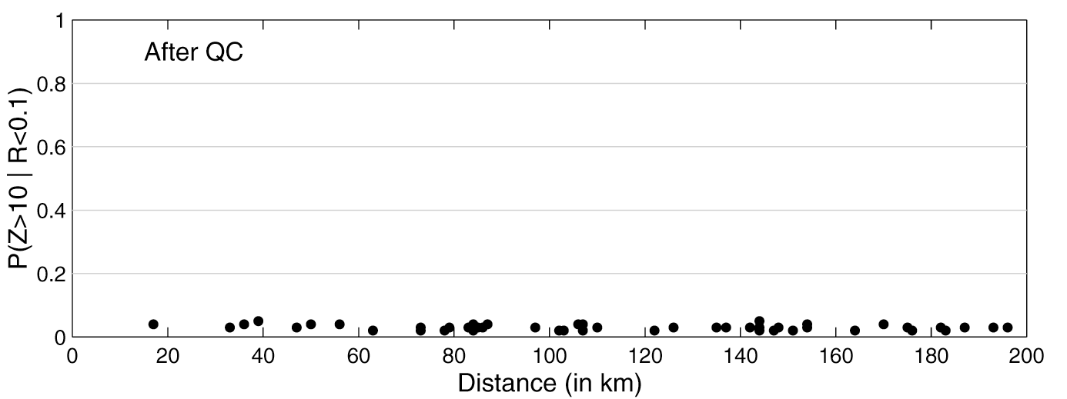

Fig. 6. Probability of false detection conditional on the gauge measurements, $P(Z>\text{10} \text{dBZ} | R<0\text{.}1 \text{mm})$.
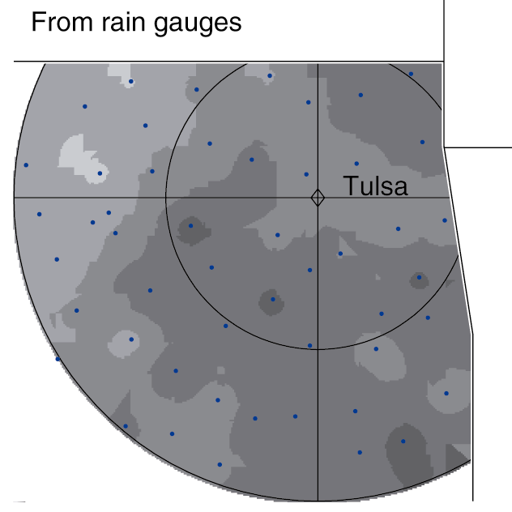
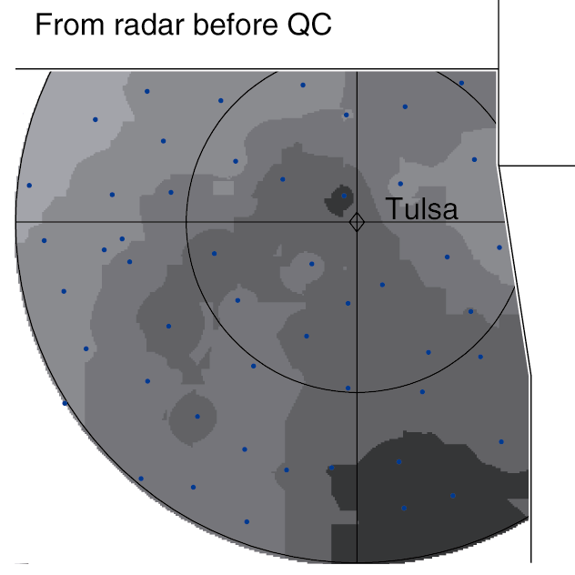
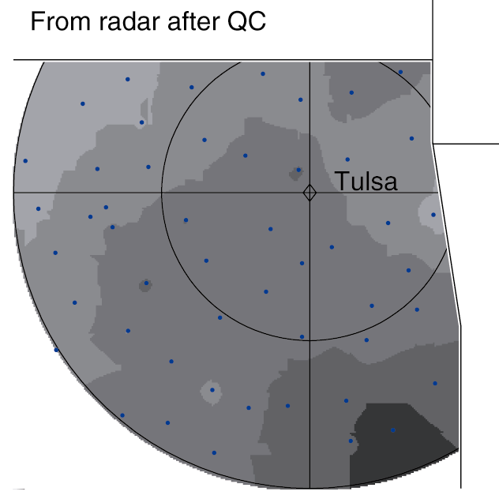
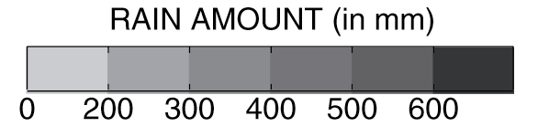
Fig. 7. Total rainfall accumulation interpolated from the Oklahoma Mesonet rain gauge data and from radar, both before QC and after QC. Dots denote the gauge locations; rings are every 100 km from radar.
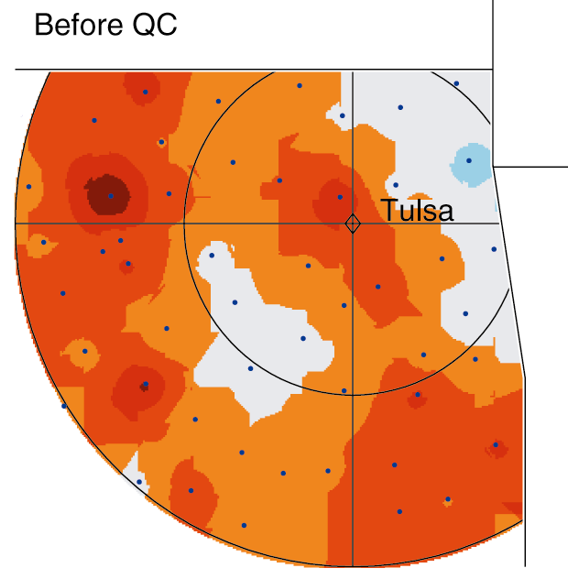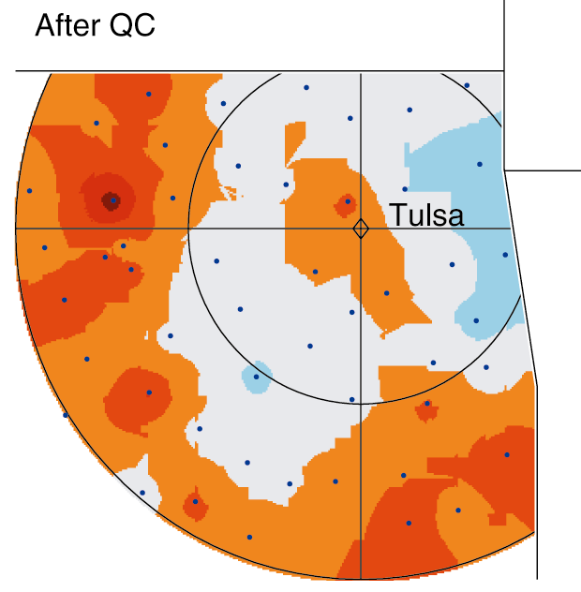
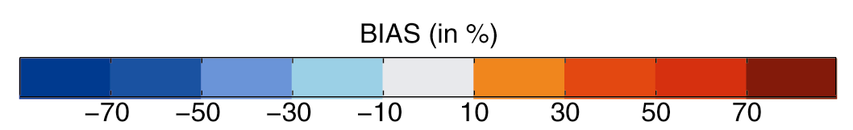

Fig. 8. Bias between radar and gauge total rainfall accumulation, considering radar data before and after QC. Dots denote the gauge locations; rings are every 100 km from the Tulsa WSR-88D radar.

