Tri-State Integrated Warning Team Tabletop Exercise
  - Situation Manual
October 16, 2018
This Situation Manual (SitMan) provides exercise participants with all the necessary tools for their roles in the exercise. Some exercise material is intended for the exclusive use of exercise planners, facilitators, and evaluators, but players may view other materials that are necessary to their performance. All exercise participants may view the SitMan.

Exercise Overview
Exercise Name | Tri-State Integrated Warning Team Tabletop Exercise
Exercise Dates | October 16, 2018
Scope | This exercise is a tabletop exercise planned for 2 hours during the Tri-State Integrated Warning Team Workshop in Ashland, KY.
Mission Area(s) | Protection and Response
Core Capabilities | Public Information and Warning, Operational Communications, Operational Coordination
Objectives | - Objective 1: Evaluate NWS ability to supply outlook and forecast information needed to support partner decisions.  - Objective 2: Exercise emergency management/NWS communications methods.  - Objective 3: Exercise emergency management response plans, including EOC activation and public notification.
Threat or Hazard | Severe weather and flash flooding.
Scenario | NWS meteorologists and partners will simulate the exchange of information that takes place leading up to a severe weather and flash flood event. Incidents will also occur leading up to the event that will test the ability of NWS and partners to communicate important decision support information and activate emergency response plans.
Sponsor | National Weather Service, Kings Daughters Medical Center
Participating Organizations | National Weather Service, Kentucky Emergency Management, Kentucky Department of Public Health, American Red Cross, Kentucky Transportation Cabinet, Ohio Emergency Management Agency, WOWK, WTAP…
Point of Contact | Tony Edwards  NOAA/NWS, 400 Parkway Road, Charleston, WV 25309  304-746-0173 x223

General Information

Exercise Objectives and Core Capabilities
The following exercise objectives in Table 1 describe the expected outcomes for the exercise. The objectives are linked to core capabilities, which are distinct critical elements necessary to achieve the specific mission area(s). The objectives and aligned core capabilities are guided by elected and appointed officials and selected by the Exercise Planning Team.
Exercise Objective | Core Capability
Evaluate NWS ability to supply outlook and forecast information needed to support partner decisions. | Public Information and Warning
Exercise emergency management/NWS communications methods. | Operational Communications
Exercise emergency management response plans, including EOC activation. | Operational Coordination

Table 1. Exercise Objectives and Associated Core Capabilities

Exercise Design Objectives Detail
Exercise design objectives focus on improving understanding of a response concept, identifying opportunities for improvement or problems, and achieving a change in attitude. This exercise will focus on the following design objectives selected by the Exercise Planning Team:
- Evaluate NWS ability to supply outlook and forecast information needed to support partner decisions. Discuss the adequacy of information presented throughout the outlook, watch, and warning time frame leading up to a severe weather/flood event. Evaluate whether information needed to trigger appropriate response is given in NWS products and services.
- Exercise emergency management/NWS communication methods. Evaluate various communication methods used by NWS to support emergency management decision making. Demonstrate the alerting tools available from the NWS to deliver weather information to core partners for decision support.
- Exercise emergency management response plans, including EOC activation. Identify important weather criteria and response thresholds used by NWS partners leading up to a severe weather/flood event. Discuss staffing, activation, and resource requests of the EOC according to county level plans and procedures. Evaluate the role that communication would play during the response.

Participant Roles and Responsibilities
The term participant encompasses many groups of people, not just those playing in the exercise. Groups of participants involved in the exercise, and their respective roles and responsibilities, are as follows:
Players. Players are personnel who have an active role in discussing or performing their regular roles and responsibilities during the exercise. Players discuss or initiate actions in response to the simulated emergency.
Observers. Observers do not directly participate in the exercise. However, they may support the development of player responses to the situation during the discussion by asking relevant questions or providing subject matter expertise.
Facilitators. Facilitators provide situation updates and moderate discussions. They also provide additional information or resolve questions as required. Key Exercise Planning Team members also may assist with facilitation as subject matter experts (SMEs) during the exercise.
Evaluators. Evaluators are assigned to observe and document certain objectives during the exercise. Their primary role is to document player discussions, including how and if those discussions conform to plans, polices, and procedures.

Exercise Structure
This tabletop exercise will be a multimedia, facilitated exercise. Players will participate in the following four modules:
Module 1: Severe Thunderstorm and Flood Potential Outlook – Five Days Out
Module 2: Severe Thunderstorm and Flood Potential Outlook – Three Days Out
Module 3: Severe Thunderstorm and Flood Potential Outlook – Two Day Out
Module 4: Impending Severe Thunderstorm and Flood Event Response Readiness

Each module begins with a multimedia update that summarizes key events occurring within that time period. After the updates, participants review the situation and engage in group discussions of appropriate response issues.
After these group discussions, participants will engage in a facilitated discussion in which a spokesperson will present a synopsis of the group’s actions, based on the scenario.

Exercise Guidelines
This tabletop exercise will be held in an open, low-stress, no-fault environment. Varying viewpoints, even disagreements, are expected.
Respond on the basis of your knowledge of current plans and capabilities (i.e., you may use only existing assets) and insights derived from your training.
Decisions are not precedent setting and may not reflect your organization’s final position on a given issue. This exercise is an opportunity to discuss and present multiple options and possible solutions.
Issue identification is not as valuable as suggestions and recommended actions that could improve response and preparedness efforts. Problem-solving efforts should be the focus.

Assumptions and Artificialities
In any exercise, assumptions and artificialities may be necessary to complete play in the time allotted. During this exercise, the following apply:
- The scenario is plausible and events occur as they are presented.
- There is no hidden agenda, and there are no trick questions.
- All players receive information at the same time.

Exercise Evaluation
Evaluation of the exercise is based on the exercise objectives and aligned capabilities, capability targets, and critical tasks, which are documented in Exercise Evaluation Guides (EEGs). Evaluators have EEGs for each of their assigned areas. Additionally, players will be asked to complete participant feedback forms. These documents, coupled with facilitator observations and notes, will be used to evaluate the exercise and compile the After-Action Report (AAR).

Module 1: Severe Thunderstorm and Flood Potential Outlook – Five Days Out

Tuesday October 16, 2018: 1000 hours
It will be a busy week as the county festival is scheduled to begin on Friday and continue through Sunday. Saturday is always the busiest day of the festival with several events, demolition derby, livestock judging and craft/food vendors. A 5K and half marathon race will occur Saturday morning between 10 am and Noon, followed by a parade between 130 pm and 230 pm. The biggest event of the weekend will be an open-air concert featuring The Band Perry scheduled to begin at 8 pm Saturday evening. You expect several thousand people to attend the concert.
You watched the morning news on TV this morning and heard that there could be severe weather this weekend. You decide to go over to your local NWS website to see what they have to say about the forecast.

Questions
Based on the information provided, participate in the discussion concerning the issues raised in Module 1. Please identify any additional requirements, critical issues, decisions, or questions that should be addressed at this time.
The following questions are provided as suggested general subjects that you may wish to address as the discussion progresses. These questions are not meant to constitute a definitive list of concerns to be addressed.
- Were you aware of the Hazardous Weather Outlook product before this exercise? If so, how often do you view this product and how do you normally view it?
- Were you aware of the Area Forecast Discussion product before this exercise? If so, how often do you view this product and how do you normally view it?
- Were you aware of the SPC Outlooks before this exercise? Do you understand the various categories used in the outlooks?
- Are the products used in Module 1 sufficient to deliver to you the information you would need about this event at this time frame? What additional products and services would be helpful to you and why?
- What actions would you take based on this briefing and why?

Module 2: Severe Thunderstorm and Flood Potential Outlook – Three Days Out

Thursday October 18, 2018: 0800 hours
You arrive in your office on Thursday morning. Upon opening your email, you see and read an email briefing from your local National Weather Service office.
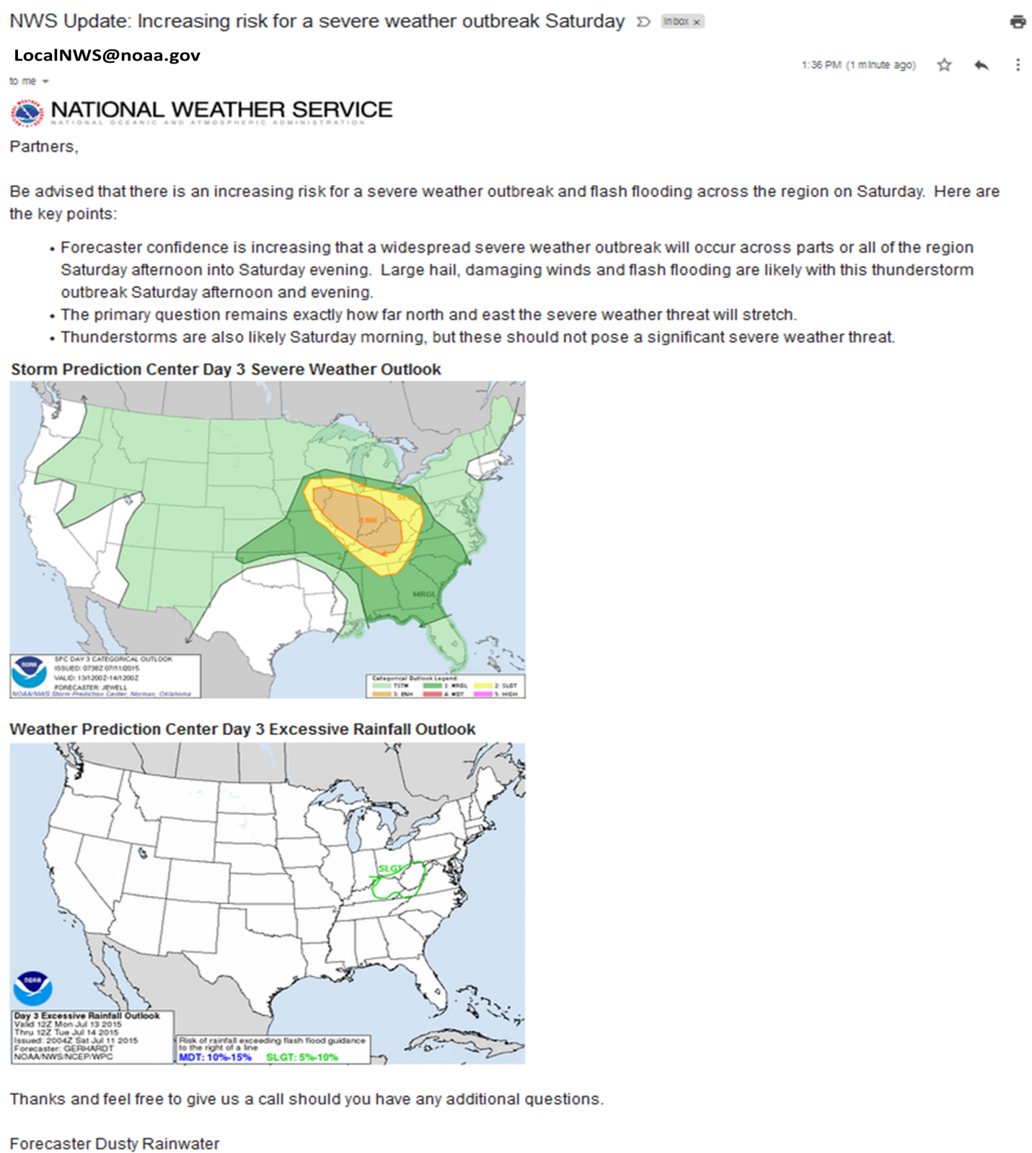

Thursday October 18, 2018: 1400 hours
You return to your office after lunch and see an email that your local National Weather Service has scheduled a Weather Conference Call/Webinar for 1400 hours.
At the start of the briefing, you recognize the meteorologist from their participation in a recent exercise you held in your county and know that they have been at the office for several years. You listen to the briefing and then look back over the briefing slides used in the presentation that was emailed out prior to the conference call.

Questions
Based on the information provided, participate in the discussion concerning the issues raised in Module 2. Please identify any additional requirements, critical issues, decisions, or questions that should be addressed at this time.
The following questions are provided as suggested general subjects that you may wish to address as the discussion progresses. These questions are not meant to constitute a definitive list of concerns to be addressed.
- Does the morning email you received adequately update you on the upcoming severe weather potential? Was there any information presented in the email that you did not understand?
- Would the morning email have prompted any actions on your part?
- During the afternoon conference call/webinar, you recognize the meteorologist and know from working with them in the past that they have been at the office for several years. Did this knowledge affect how you received the weather information presented? Did it change your confidence level in the information presented?
- During the afternoon conference call/webinar, the term derecho was used. Do you know what a derecho is and potential impacts it could bring?
- During the afternoon conference call/webinar, you are told that the Storm Prediction Center has issued an “enhanced risk” for severe weather for Saturday. What does the phrase “enhanced risk” of severe weather mean to you?
- During the afternoon conference call/webinar, you are told that the Weather Prediction Center has highlighted the region in a “slight risk” for flooding on Saturday. What does the phrase “slight risk” of flooding mean to you?
- What other entities in your county are you communicating with? Do you forward the weather briefing slides to anyone else in your county?
- At this point how often are you interacting with your local National Weather Service office and by what means are you interacting with them?
- What actions would be taken by Emergency Managers or related county officials in preparation for the upcoming severe weather event?
- Would individual local agency Emergency Operation Centers (EOCs) be activated at this time, and if so, what is the activation process, and how long would it take? How would the EOC be staffed at this point? How would these various entities communicate?

Module 3: Severe Thunderstorm and Flood Potential Outlook – Two Days Out

Friday October 19, 2018: 0630 hours
Shortly after waking up Friday morning, you pull up Facebook and see the following graphic from your Local National Weather Service Office:
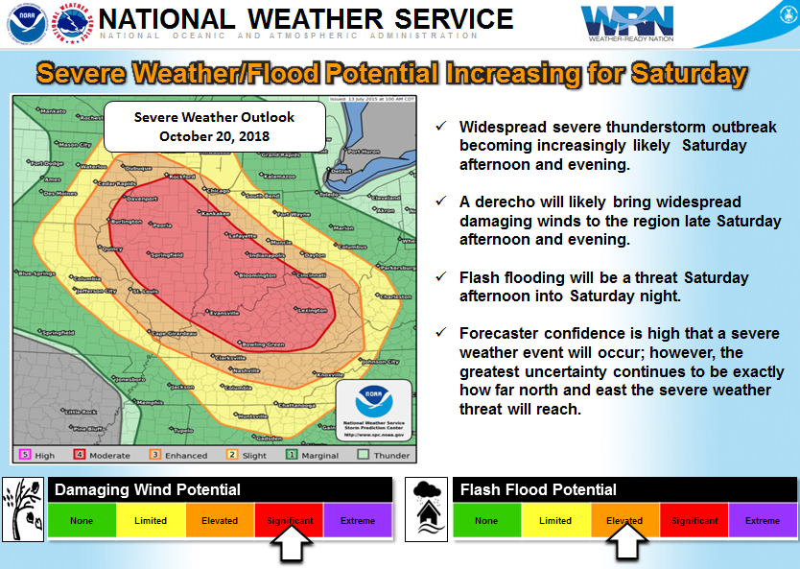

Friday October 19, 2018: 1130 hours
Your local National Weather Service office holds another Weather Conference Call/Webinar to discuss the upcoming severe weather event.
Shortly after the weather briefing, you find out from an announcement on Facebook that Luke Bryan is going to be making an appearance at Saturday evening’s concert along with The Band Perry. Social media is “blowing up” and the attendance at the evening concert is likely to set a record.

Questions
Based on the information provided, participate in the discussion concerning the issues raised in Module 3. Please identify any additional requirements, critical issues, decisions, or questions that should be addressed at this time.
The following questions are provided as suggested general subjects that you may wish to address as the discussion progresses. These questions are not meant to constitute a definitive list of concerns to be addressed.
- During the conference call/webinar, you are told that the Storm Prediction Center has issued a “Moderate Risk” for severe weather for Saturday. What does the phrase “moderate risk” of severe weather mean to you?
- What actions would you take specifically with regards to the festival and concert taking place, especially considering the weather information that has been briefed?
- What other entities in your county are you communicating with at this point?
- At this point how often are you interacting with your local National Weather Service office?
- Would you request special event support from the National Weather Service? If so, what kind of support would you request and how would you request it?
- What actions would be taken by Emergency Managers or related county staff in preparation for the upcoming severe weather event?
- Would the EOC be activated at this time, and if so, how would the EOC be staffed? How are key incident management personnel notified to report to the EOC?

Module 4: Impending Severe Thunderstorm and Flood Event Response Readiness
Saturday October 20, 2018: 1300 hours
It’s been a wet morning but the 5K and half marathons went off without a hitch. You are back at the office monitoring information on NWSchat.
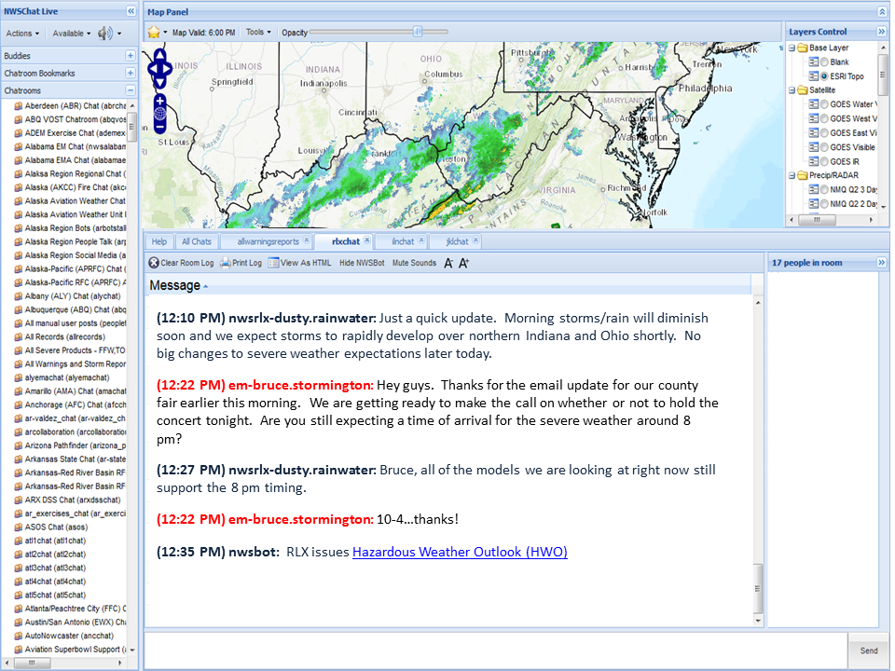
Suddenly, your phone alerts you to an incoming iNWS text alert:
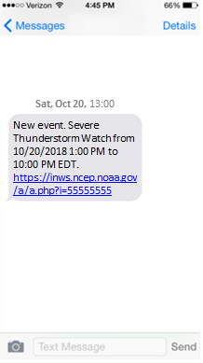
You click on the link and read the Severe Thunderstorm Watch message and notice the potential threats of damaging thunderstorm winds of up to 90 mph and isolated tornadoes are mentioned.
Saturday October 20, 2018: 1400 hours
While the parade is going on, you are able to attend a conference call/webinar from the National Weather Service.
Saturday October 20, 2018: 1415 hours
Shortly after the conference call ends, you are notified that a tanker truck carrying an unknown chemical is involved in an accident on the main highway about a quarter mile away from county festival grounds and parade route. Dispatch advises that the tanker truck has flipped rupturing the tank and a foul smelling chemical is spewing into the air.

Questions
Based on the information provided, participate in the discussion concerning the issues raised in Module 3. Please identify any additional requirements, critical issues, decisions, or questions that should be addressed at this time.
The following questions are provided as suggested general subjects that you may wish to address as the discussion progresses. These questions are not meant to constitute a definitive list of concerns to be addressed.
- What actions would you take to mitigate the hazmat threat and what agencies would you communicate with?
- How would you obtain weather information and would you ask for weather support from your local National Weather Service for the hazmat incident?
- What different communication methods would you use to communicate to the public about the hazmat threat?
- Later in the afternoon, after the hazmat situation has been mitigated, you would like an update on the weather situation. How would you get this update?
- Were you aware of the iNWS text alert service and did you have an account set up prior to this exercise?
- Were you aware of the NWSchat service and did you have an account set up prior to this exercise?
- What different communication methods would you use to communicate to the public about the threat? What information would you share?
- Who is staffed in your EOC at this point? Are you prepared for extended activation?
- What activities should county officials take to prepare for imminent severe weather?

Appendix A: Exercise Schedule
Note: Because this information is updated throughout the exercise planning process, appendices may be developed as stand-alone documents rather than part of the SitMan.
Time | Activity
October 16, 2018
12:30pm | Exercise Overview, Expectations and Objectives
12:40pm | Module 1: Briefing / Caucus Discussion
12:55pm | Module 1: Report-Out
1:10pm | Module 2: Briefing / Caucus Discussion
1:25pm | Module 2: Report-Out
1:40pm | Module 3: Briefing / Caucus Discussion
1:55pm | Module 3: Report-Out
2:10pm | Module 4: Briefing / Caucus Discussion
2:25pm | Module 4: Report-Out
2:40pm | EndEx / Hotwash

Appendix B: Exercise Players
Participating Organizations
Federal
National Weather Service – WFO Louisville KY, Jackson KY, Wilmington OH, Charleston WV
United States Coast Guard
State/Regional
Kentucky Division of Emergency Management
Kentucky Department for Public Health
Kentucky Transportation Cabinet
West Virginia Division of Highways
Ohio Emergency Management Agency
American Red Cross
Fresenius Kidney Care
Southern Ohio Amateur Radio Association
County
Boyd County KY EMA
Boyd County Public Schools
Ashland – Boyd County Health Department
Boyd County 911
Buchanan County VA Public Schools
Lawrence County KY EMA
Lawrence County OH EMA
Lawrence County OH EMS
Cabell County 911
Putnam County WV OEM-911
Kanawha County WV EMA
Jackson County OH EMA
Greenup County KY EMA
Lewis County KY EMA
Logan County WV Commission
Bath County KY Emergency Management
Greenup County ARES
Lawrence County OH ARES
Wood/Wirt County LEPC
City/Local
City of Grayson KY EMA
King’s Daughters Medical Center
Media
WTAP-TV
WSAZ-TV
WOWK-TV

Appendix C: Acronyms
Acronym | Term
AAR | After-Action Report
DHS | U.S. Department of Homeland Security
EEG | Exercise Evaluation Guide
EOC | Emergency Operations Center
HSEEP | Homeland Security Exercise and Evaluation Program
NOAA | National Oceanic and Atmospheric Administration
iNWS | InteractiveNWS Mobile Alerting – https://inws.ncep.noaa.gov
NWS | National Weather Service
NWSchat | NWS Chat Service – https://nwschat.weather.gov
SitMan | Situation Manual
SPC | Storm Prediction Center

Notes

