NOAA/NWS Lightning Toolkit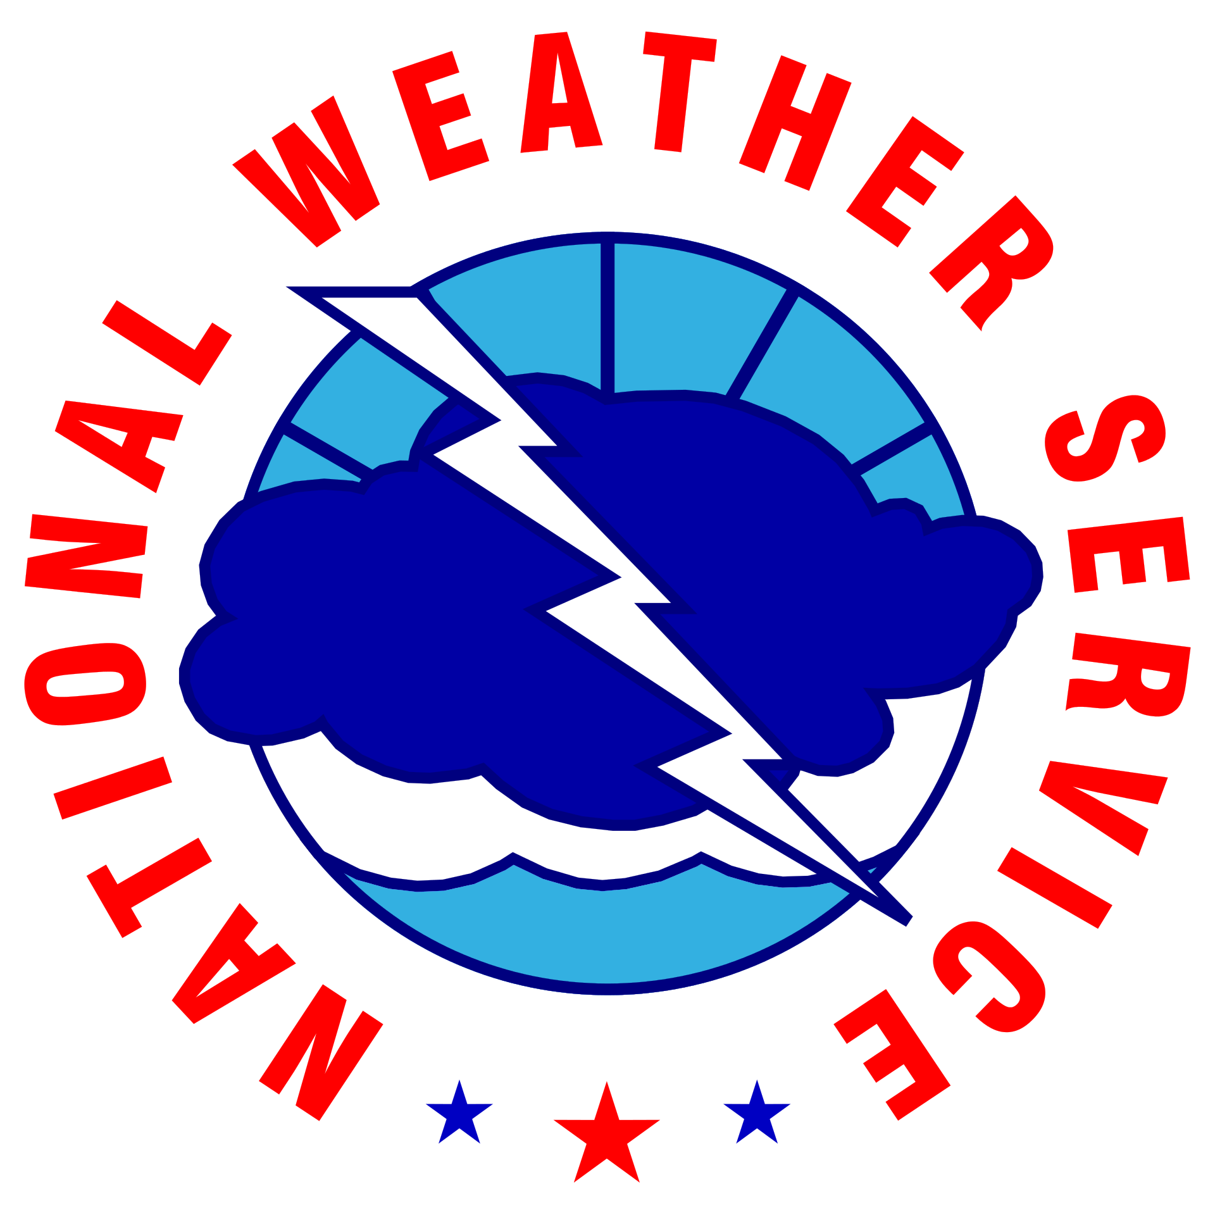

**BOATING & SAILING**

LIGHTNING SAFETY, ENTER ORG. NAME

horizontal line

# 

# Why This Matters

Every year, weather impacts cause serious injury and death to people on bodies of water in the U.S. The majority of these incidents occur in the summer, the peak season for outdoor and boating-related activities. The summer is also the peak season for lightning strikes. Mariners are especially at risk for a lightning strike since boats are usually the highest point on the water. Adverse weather cannot be prevented, but the vulnerability of mariners can be minimized through proper equipment and education. Planning, knowing forecasts and the local weather patterns, and recognizing hazardous weather are all important before spending a day on the water.

***The National Weather Service is committed to raising lightning safety awareness.***

## Thunderstorms

### A Mariner’s Greatest Risk

**While on the water, continually watch the skies for developing or approaching thunderstorms.** These form when quickly rising air condenses into a cloud. A thunderstorm life cycle has stages. There is a developing stage, the mature stage, and a dissipating stage. Given the amount of time needed to get safely to shore while boating, it is important to be able to recognize thunderstorms when they are in their developing stage.

A mariner can differentiate clouds which may grow into a storm from general fair-weather cumulus clouds by examining the updraft strength and depth. The intensity of an updraft can be identified by how crisp the edge of the cloud is. A cloud such as the one seen on the ***left*** likely won’t develop into a thunderstorm due to the shallow depth and the somewhat diffuse edges of the cloud. Alternatively, the picture ***below right*** has very crisp edges and a deep updraft and is likely already producing lightning and heavy rainfall. 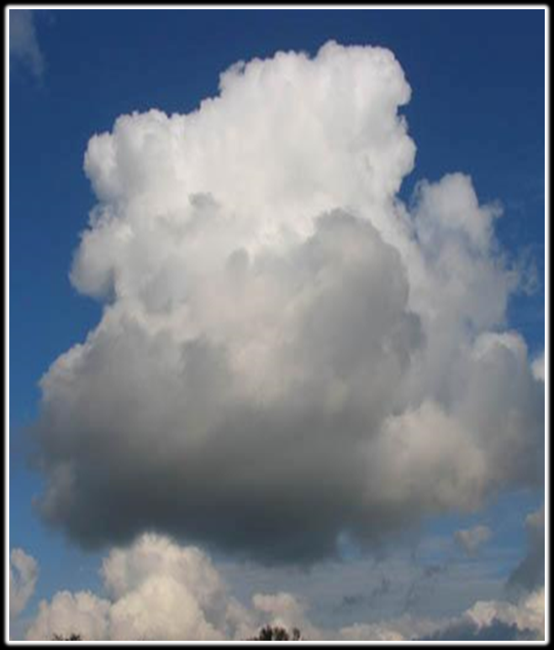

The crisp edges of the updraft of a thunderstorm may not always be visible from the ground due to other clouds restricting the view. In these cases it is important to look for darkening skies and listen for thunder. Use extra caution while boating on days when there is a chance for thunderstorms in the forecast. **Since there is no safe place to be on a boat during a thunderstorm, actions to get back to shore should be taken immediately at the first sign of a thunderstorm.** 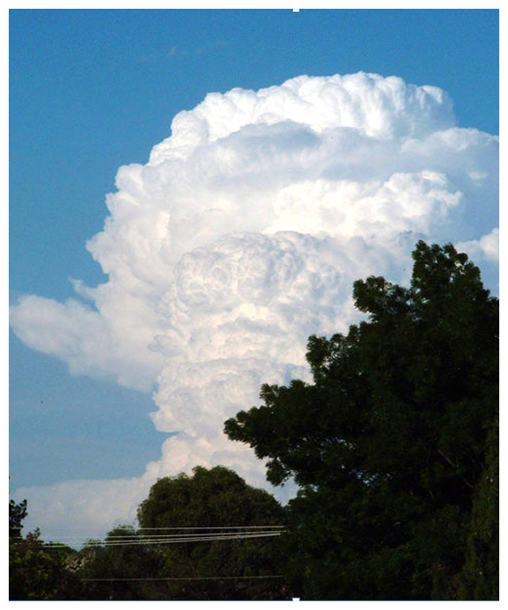

## 

## Be Prepared

### Get Informed Before You Go

Have more than one means to get forecasts and weather information. These include:

* NOAA Weather Radio
* National Weather Service website (www.weather.gov)
* Mobile Apps and Social Media
* Television and/or Radio (AM/FM/VHF)
* Lightning Detection System (Smartphone applications and SailFlow)
* Services from Commercial Weather Providers

Expect cellular service to be unreliable in remote areas or offshore.

***Know before you go. Don’t go out on the water when storms are predicted.***

### When Storms Threaten

As mentioned above, boaters should always monitor the forecast before going out on the water. There is **no** safe place on a boat: it is strongly recommended you do not venture out if thunderstorms are a possibility.

Already on the water? Use extra caution if you see signs of a developing thunderstorm, and have a plan to get to shore quickly. If you see growing thunderstorms nearby or hear thunder, head to port and get into a substantial building or closed top vehicle ASAP.

In addition to heading to shore, a few other actions can be taken onboard to reduce the risk of being struck by lightning.

* Lower antennas
* Pull in fishing lines or wakeboarders
* If there is an enclosed cabin, go inside
* Avoid touching anything metal
* Turn off electronics
* Stay low, keep arms and legs inside the boat

### Be Prepared (Cont.)

### Caught in a Storm

* Go to the center of your boat's cabin if it has one. If no cabin is available, crouch down in the center of the boat and stay as low as possible.
* Do not touch anything metal.
* Do not fish, water ski, or swim. Keep arms and legs in the boat and do not dangle them in the water. Divers should get out of the water and into a sturdy shelter or boat. If that is not possible, dive as deep as possible for the duration of the storm.
* Wear a life jacket at all times. A victim struck by lightning can be rendered unconscious and end up in the water.
* Do not touch electrical equipment, including the radio.
* Lower, remove, or tie down radio antennas and other protruding devices unless they are part of a lightning protection system.
* If your boat has a lightning protection system, avoid making contact with any device connected to that system. NEVER be in contact with two components connected to the system at once. Should you have a hand on both when lightning strikes, the lightning could travel through your body.
* After the last flash of lightning, or sound of thunder, wait 30 minutes before resuming normal activities.
* Every experienced boater should be trained in CPR. If someone is struck by lightning and their heart stops, prompt CPR can save their life.

## Get Your Craft Lightning Ready

Lightning tends to strike the tallest object in an area. Boats, especially sailboats, are the perfect target due to their relatively tall stature over a flat body of water. Sailboats are even more vulnerable than powerboats with statistics from Gowrie Group Insurance indicating it is 3 times more likely for a sailboat to be struck than a powerboat. While there is no such thing as a lightning-proof boat, these are ways to prepare your boat before you go out to make sure you are more prepared for adverse weather.

### Lightning Protection Systems

There is no such thing as a lightning-proof boat. Lightning-protected boats are meant to protect the people and equipment on board. Standard **TE-4** for lightning protection has been established by the American Boat and Yacht Council [[LINK](https://abycinc.org/page/StandardsSupp58)].

In a metal hull boat, the mast (as long as it is also made of conductive metal) can provide a cone of protection extending at a 45 degree angle from the top of the mast. It is important to avoid contact with the mast during a storm since this is the route the electricity will take on its way to the water. In addition, efforts should be made to avoid close proximity to the mast due to the possibility for side strikes.

### NOAA All-Hazards Weather Radio

A NOAA weather radio provides constant weather updates 24 hours per day. The radio will alarm if hazardous weather is imminent. All motor boats should have a NOAA weather radio, and even small, non-electric boats should have a battery-powered NOAA weather radio.

In addition to visual cloud identification mentioned above, a NOAA weather radio can help provide specifics on expected hazards, intensity, and timing. When hazardous conditions are imminent, specific marine products may be issued (listed on pages 8 & 9).

***If one of these marine products are issued, one should take immediate action to seek safe harbor.***

## Understanding Weather Forecasts & Products

### Types of Hazards

#### **Thunderstorms**

Thunderstorms can occur year-round, but are most common between April and September. Thunderstorms form when warm, moist air rises rapidly and creates a cumulonimbus cloud. Days that are favorable for thunderstorms are typically warm and humid. Most lightning strikes within 10 miles of a thunderstorm, however there are rare cases known as “bolts from the blue” when lightning can strike as far as 20 miles from a thunderstorm.

#### **High Winds**

Rapidly changing wind speed and direction can be caused by many factors. These include thunderstorms, outflow boundaries, frontal passages, and strong pressure gradients. In addition, wind speeds over water are typically stronger than over land due to fewer impediments such as trees and buildings.

* **Thunderstorm** winds can have rapidly changing speeds and direction. Wind speeds in excess of 60 mph are not uncommon. Winds can exceed 100mph in the most extreme events.
* **Outflow Boundaries** are typically formed by thunderstorms. These boundaries can travel 50 miles or further away from a thunderstorm with rapidly changing wind speeds and direction.
* **Frontal Passages** usually cause wind directions to change. In addition to the changing winds, thunderstorms are commonly associated with frontal passages during the summer months.
* **Strong pressure gradients** generally generate breezy to windy days. These pressure gradients are sometimes, but not always associated with low pressure systems.

## 

## Understanding Weather Forecasts & Products (Cont.)

#### **Types of Hazards (Cont.)**

#### **Waves/Swells**

Wind speed and direction have the greatest impact on wave heights. Waves will be largest where the wind has had the longest residence time (i.e. Northerly winds will cause the highest waves on the southern end of the body of water). In addition, sheltered areas away from the open water will typically have smaller waves.

On larger bodies of water, such as oceans, lakes, and bays, a swell can be caused by distant storms. Larger lakes can be very similar to being on the open waters of an ocean. On the Great Lakes, there have been several documented cases of a swell called a seiche that can cause water levels to rise several feet due to storms passing over the lake. In addition, a swell can be caused by strong low pressure centers. These would be caused by strong mid-latitude cyclones, or tropical systems such as hurricanes.

#### **Fog**

Fog is formed when air is cooled to its dew point and condenses. Marine fog can be caused when moist air moves over a cool body of water that cools the air to its dew point or can be caused when cold air moves over a warm body of water where the dewpoint is slightly higher than the surrounding land. Marine fog is known for being very dense and occurring over relatively shorter periods. Rapidly forming dense fog is especially common along the west coast of the United States due to warm/moist air meeting the relatively cool ocean waters.

## Understanding Weather Forecasts & Products (Cont.)

### NWS Marine Watch, Warning, & Advisory Products

The NWS issues marine watch, warning, and advisory hazard products for the oceans, Great Lakes, and other large bodies of water in the United States. These products can help to raise awareness towards any weather related marine hazards that may be present. For smaller inland bodies of water, standard land base NWS products should be used. 

**Special Marine Warning** - issued when a thunderstorm is producing wind gusts of 34 kts (39 mph) or greater, hail of ¾ inch or larger, or waterspouts. Special Marine Warnings can also be issued for non-thunderstorm weather events which may cause quickly increasing winds greater than 34 knots (39 mph).

**Marine Weather Statement** - issued for any potentially hazardous marine conditions that do not reach the threshold for a Special Marine Warning.

**Small Craft Advisory** – issued when winds reach a speed marginally less than gale force. For most locations the standard wind speeds used are 22 to 33 knots (25 to 38 mph). A small craft advisory may also be issued for wave heights exceeding a certain threshold, but this varies by location. Check with your local NWS office for your criteria.

**Small Craft Exercise Caution** - This advisory is issued when sustained winds of 15 to 20 knots (17 to 23 miles per hour) or seas of six feet are occurring or are expected to occur over the water.

**Dense Fog Advisory** – issued when fog is expected to reduce visibility to ¼ mi or less for 3 hours or longer duration.

**Gale Watch** – issued when there is a risk of winds or frequent gusts of 34 to 47 knots (40 to 54 mph) but occurrence, location, and/or timing of the event is still uncertain.

**Gale Warning** – issued when winds are in the range 34 knots to 47 knots (40 to 54 mph) or soon will be.

**Storm Watch** – issued when winds between 48 and 63 knots (55 and 72 mph) are expected, but occurrence, location, and/or timing is still uncertain.

**Storm Warning** – issued when winds between 48 and 63 knots (55 and 72 mph) are occurring or will soon begin.  ***Continued, next page***

## Understanding Weather Forecasts & Products (Cont.)

### NWS Marine Watch, Warning, & Advisory Products (Cont.)

**Heavy Freezing Spray Watch** – issued when there is an increased risk of a heavy freezing spray event to meet heavy freezing spray warning criteria, but its occurrence, location, and/or timing is still uncertain.

**Heavy Freezing Spray Warning** – issued to warn vessels that accumulation of freezing water droplets in excess of 2 cm (0.8 in) per hour is likely.

**Hurricane Force Wind Warning** – issued for sustained winds or frequent gusts of 64 knots (74 mph) or greater not associated with a tropical cyclone.

**Hurricane Force Wind Watch** – issued for an increased risk of a hurricane force wind event for sustained surface winds or frequent gusts of 64 knots (74 mph) or greater, but its occurrence, location, and/or timing is still uncertain.

**Low Water Advisory** – issued when significantly below average levels of water over the Great Lakes, coastal marine zones, and any tidal marine area, waterway, or river inlet within or adjacent to a marine zone that would potentially be impacted by low water conditions creating a hazard to navigation.

# Lightning Safety Plan (Page 1 of 3)

### General Information

|  |  |
| --- | --- |
| What is the name of the individual(s) assigned to monitor weather information for your boat/marina? | Click or tap here to enter text. |
| What is the contact information for the individuals(s) assigned to monitor weather information? | Click or tap here to enter text. |
| If you are at a marina or marine event, who is the supervisor to be notified if there is a threat of lightning and will review the lightning safety plan with the staff? | Click or tap here to enter text. |
| Which additional contacts need to be informed on the plan? | Click or tap here to enter text. |
| Has the facility identified areas of highest risk of lightning injuries/fatalities? Do you maintain records of lightning related injuries/fatalities? | Click or tap here to enter text. |

***Continued, next page***

## Lightning Safety Plan (Page 2 of 3)

### Situational Awareness

|  |  |
| --- | --- |
| Do you or does your event/entity have a lightning detection system or access to a commercial lightning detection network? | Click or tap here to enter text. |
| * If the answer is yes, which system do you use? | Click or tap here to enter text. |
| Does your venue have a subscription for weather alerting (mobile app, etc.)? | Click or tap here to enter text. |
| * If the answer is yes, who provides the alerting? | Click or tap here to enter text. |
| Identify how your organization receives weather information: | Mobile devices/apps  Internet  NOAA Weather Radio (NWR)  Television (local network or Cable TV)  Radio Station (AM/FM) - EAS Reception  Amateur Radio  Other: Click or tap here to enter text. |
| Do you have means of receiving weather information offshore? If so, how? | Satellite Data Service  NOAA Weather Radio (NWR) |

***Continued, next page***

## 

## Lightning Safety Plan (Page 3 of 3)

### Boat Safety

|  |  |
| --- | --- |
| Does your boat have a lightning protection system installed? | Click or tap here to enter text. |
| * If so, what, if any, regular maintenance is required for the system to perform optimally? | Click or tap here to enter text. |
| Do you have a fire extinguisher on board the boat? | Click or tap here to enter text. |
| * Is it checked regularly? | Click or tap here to enter text. |
| Do you have adequate and proper life safety equipment/jackets for all on board the vessel, in the event of an emergency? | Click or tap here to enter text. |

### Marina Safety (If Applicable)

|  |  |
| --- | --- |
| How often is the Lighting Safety Plan reviewed and drilled (annually, seasonally)? | Click or tap here to enter text. |
| Are your staff trained in CPR and other basic life saving techniques to assist in the event of a lightning strike victim? | Click or tap here to enter text. |
| Where are the locations (if any) of AED’s on the boat or at the marina/facility that could be used in the event of a lightning strike victim? | Click or tap here to enter text. |

## 

## Preparedness Graphic

### Feel Free to Share!

