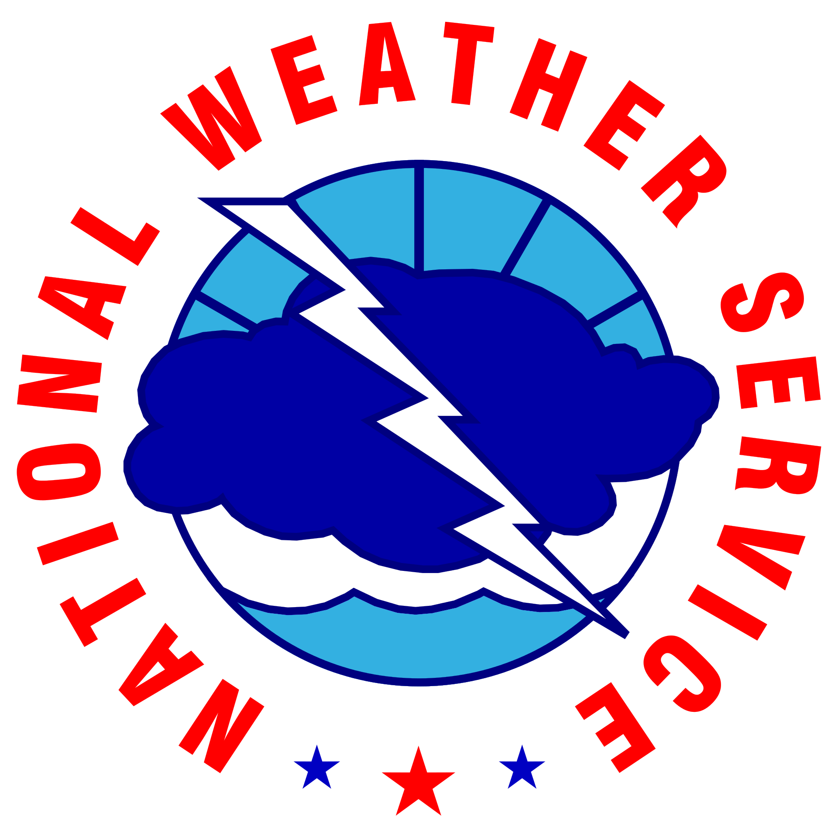
NOAA/NWS Lightning Toolkit

COMMUNITY
LIGHTNING SAFETY, ENTER ORG. NAME

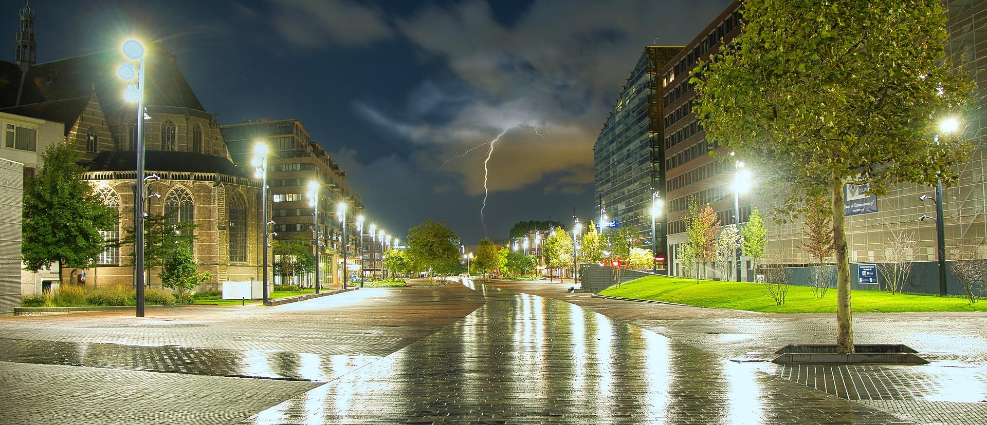

Why This Matters
When Thunder Roars, Go Indoors!
The National Weather Service (NWS) has implemented a voluntary recognition program for local counties and communities to create an awareness of the dangers of lightning at their outdoor recreational venues and provide the community with safety measures to protect themselves from the dangers of lightning. This campaign encourages the public to take action when they hear thunder, rather than waiting for lightning or rain. While this focuses on the community level, there are companion programs for large venues, golf courses, lifeguards, and beach patrols.
The NWS recognizes the efforts of counties and communities that follow these guidelines to protect those partaking in recreational outdoor activities from the dangers of lightning.
The National Weather Service is committed to raising lightning safety awareness.

Facility Name | Click or tap here to enter text.
Point Of Contact | Click or tap here to enter text.
Phone | Click or tap here to enter text.
Email | Click or tap here to enter text.
Address | Click or tap here to enter text.

Lightning Safety Plan Checklist
Elements of an effective lightning safety program should include a written plan that does accomplishes these tasks:
1) Identifies vulnerable venues where lightning poses a significant hazard to the public
2) Shows how each venue will demonstrate each of the following key elements:
Weather Situational Awareness | Obtain timely thunderstorm information; designate a weather watcher; and assign an official in charge who will stop events when required. | ☐
Public Notification Plan  “Heads Up” | Obtain timely thunderstorm information; designate a weather watcher; and assign an official in charge who will stop events when required. | ☐
Public Notification Plan “Imminent” | Communicate the imminent threat to staff and event attendees and explain that moving to a safe structure or evacuation actions will occur. | ☐
Protection Plan | Identify substantial lightning-safe structures and have specific evacuation instructions and maps. A lightning-safe structure is a fully-enclosed building that is grounded or a fully-enclosed metal vehicle. | ☐
Staff Education & Plan Review | Educate the staff so they know the lightning safety rules and are comfortable with all aspects of the written lightning safety plan. | ☐

A review of your plan by the National Weather Service is required to complete this lightning awareness program.

Lightning Safety: Outdoor Community Preparedness

When Thunder Roars, Go Indoors!

Lightning Safety Plan | Resource Guide
Thunder is an immediate warning of dangerous conditions outside. If thunder is heard, anyone outside is in danger of being struck by lightning. Other threats such as damaging winds, large hail, flash flooding, or even a tornado may also be possible. Immediate action needs to take place to safeguard the community. This plan specifies the actions that will be taken.

Weather Situational Awareness
Before each community event, a weather watcher will be designated to review the forecast and monitor weather conditions. The weather watcher will be a person able to devote the attention needed to adequately monitor conditions. This person will use at least enter a number weather information sources and keep abreast of changes to that forecast and current conditions. This person will know how to get thunderstorm forecasts from each source, especially if using the internet. If available, mobile technology (through web pages or mobile applications) should be used to supplement weather information (radar, warnings) during the event. The weather watcher’s main responsibility during the event is to keep their eyes and ears to the sky. If thunderstorms are in the forecast, then the weather watcher will notify the official in charge of the possible threat and will review the remainder of the safety plan with staff before the event.
- The designated weather watcher/official in charge is: Click to add name
  - Contact Information: Click to add phone number
- The official in charge of stopping the event: Click to add phone name
  - Contact Information: Click to add phone number

Weather Situational Awareness (Cont.)
The Community Weather Watcher will use the following methods to maintain situational awareness (Check the following that apply):
Lightning detection system: Click to add specifics | ☐
Commercial lightning detection network: Click to add provider name | ☐
Mobile device: Click to add specifics | ☐
Internet:  ● Subscription for alerts if available: Click to add provider/service  ● National Weather Service Watches, Warnings, and Hazardous Weather  Outlooks: www.weather.gov/ Click to finish office link. (Links to all NWS offices)  ● Thunderstorm Outlooks from the NWS Storm Prediction Center  (information 12 to 36 hours in advance): | ☐
NOAA Weather Radio station Click to add station name on 162.XYZ MHz | ☐
Television (local network or cable TV) and/or streaming services (where subscriptions, along with internet/wifi is available):  Click to add info | ☐
NOAA Weather Wire (subscription)  Click to add info | ☐
Radio Station (AM/FM) - EAS Reception  Click to add info | ☐
Amateur Radio  Click to add info | ☐
Other (please list in detail): Click to add info | ☐

Weather Situational Awareness (Cont.)

Additional Contacts

Name | Phone Number
Click or tap here to enter text. | Click or tap here to enter text.
Click or tap here to enter text. | Click or tap here to enter text.
Click or tap here to enter text. | Click or tap here to enter text.
Click or tap here to enter text. | Click or tap here to enter text.

Public Notification Plan
Event attendees will be provided with the following information:
- Before the event begins, attendees will be informed that a lightning threat exists and that protective action may be required that day.
- Prior to the event, instructions will be given on what protective measures will be taken if the lightning threat materializes.
- During the event, the attendees will be notified of any imminent threat and specific directions on taking protective action.
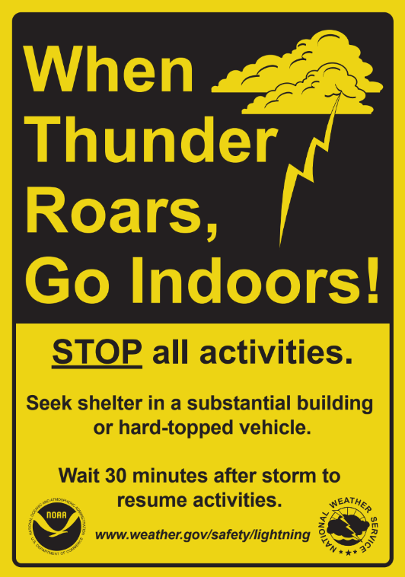
- After a delay, an “all clear” notice when it is safe to leave the lightning-safe structure and/or return to the event location.
Consider handing out lightning safety brochures or information sheets at the beginning of a season and/or at the day of an event. The National Weather Service can provide artwork for the “When Thunder Roars, Go Indoors” signs. This sign is an effective visual reminder of basic safety precautions to take in the event of a thunderstorm. Signs alone cannot satisfy the public notification recommendations; they can supplement your plan.

Public Notification Plan (Cont.)
When thunderstorms are forecast for the day of the event, the staff will use the following methods to communicate the possibility of threatening weather to the attendees in the community and the safety precautions that will take place if needed (check the following):

Public Address Announcements | ☐
Video Board Message Developed | ☐
Outdoor Warning Siren(s) | ☐
Venue TV Override | ☐
Telephone Tree to Event Staff | ☐
Local Alert Broadcast System | ☐
Local Pager System (dissemination) | ☐
Local Radio Broadcast (dissemination) | ☐
Text/Email message alerts | ☐
Social Media | ☐
Other (please list in detail):  Click to add info | ☐

Protection Plan

Protective action will be taken at the first sign of thunder or lightning.
The official in charge will suspend the event and initiate protective measures for the staff and attendees. There are two protective actions to take:
1) Move staff and attendees to substantial lightning-safe structures or
2) Terminate the event and evacuate the premises.
Evacuations should be considered if there are no lightning-safe structures available for everyone or if the official in charge determines that a restart of the event will likely not occur.

Outdoor activity can resume after 30 minutes of no lightning detected or thunder observed.

Safe Structures
There is no safe place outside when thunderstorms are in the area. If you hear thunder you are likely within striking distance of the storm. Just remember, “When Thunder Roars, Go Indoors!”
- A lightning-safe structure is either a substantial building (one with plumbing and wiring such as a home, school, church, office building, indoor concourse or recreation center) or an enclosed metal vehicle. Once inside, stay away from showers, sinks, bath tubs, and electric equipment such as stoves, radios, corded telephones and computers.
- Unsafe buildings include car ports, open garages, covered patios, picnic shelters, beach pavilions, and golf shelters, tents of any kind, baseball dugouts, sheds, and partially enclosed vending areas.
- A safe vehicle is any fully enclosed metal-topped vehicle such as a hard-topped car, minivan, bus, truck, etc. While inside a vehicle, do not open any windows and do not use electronic devices such as radio communications or touch metal framework during a thunderstorm.
- Unsafe vehicles include golf carts, convertibles, motorcycles, or any other open cab vehicle.

Protection Plan (Cont.)

Safe Structures (Cont.)
The following structures have been identified as a safe means to protect from lightning (complete list below):
Attendee’s vehicles | ☐
Nearby substantial building(s) with the Name and Location of the indicated building(s):  Click or tap here to enter text. | ☐
Other (please list in detail):  Click or tap here to enter text. | ☐

Evacuation Procedures (Complete Evacuation Of Premises)
List, in detail, evacuation procedures below:

Click or tap here to enter text.

Community Staff Education & Plan Review

Staff Education
All staff should understand this lightning safety plan before an event begins.
These procedures will be reviewed and drilled Click to type frequency (annually, seasonally, etc).
In addition, the following facts will supplement staff knowledge on lightning and lightning safety precautions:
- Severe Thunderstorm Warnings are not issued based on lightning. All thunderstorms produce thunder and lightning and are potentially deadly. A Severe Thunderstorm Watch or a Tornado Watch is issued when conditions are favorable for the development of severe storms (wind gusts in excess of 58 MPH, quarter size hail or larger, or tornadoes). A Severe Thunderstorm or Tornado Warning is issued when severe weather has been detected or may be imminent.
- Most victims survive a lightning strike; however, medical attention is needed immediately. Have someone call 911. Victims do not carry an electrical charge and can be touched. In many cases, the victim’s heart and/or breathing may stop and rescue breathing and/or CPR may be needed. Monitor the victim until medical help arrives; heart and/or respiratory problems could persist, or the victim could go into shock. If possible, move the victim to a safer place away from the threat of another lightning strike.
- Lightning can strike outside of the rain area or thunderstorm cloud. In extreme cases, “bolts from the blue” can strike 10-15 miles from the thunderstorm. Don’t wait for rain to get to a safe structure and don’t leave the safe structure just because the rain has let up.
- Many lightning casualties occur because people do not seek a safe structure soon enough. Not wanting to appear overly cautious, many people wait far too long before reacting to this potentially deadly weather threat.
- Don’t hesitate to stop the event and have patrons seek a lightning-safe structure if the sky appears threatening (especially if your weather watcher knows thunderstorms are a possibility). Thunderstorms can develop directly overhead and some storms may develop lightning just as they move into your area.
- Only about 10% of people who are struck by lightning are killed, leaving 90% with various degrees of disability, including life-long debilitating injuries.

The National Weather Service may be able to provide a free lightning safety talk to your group. Please contact your local National Weather Service Office for more information.

