NOAA/NWS Lightning Toolkit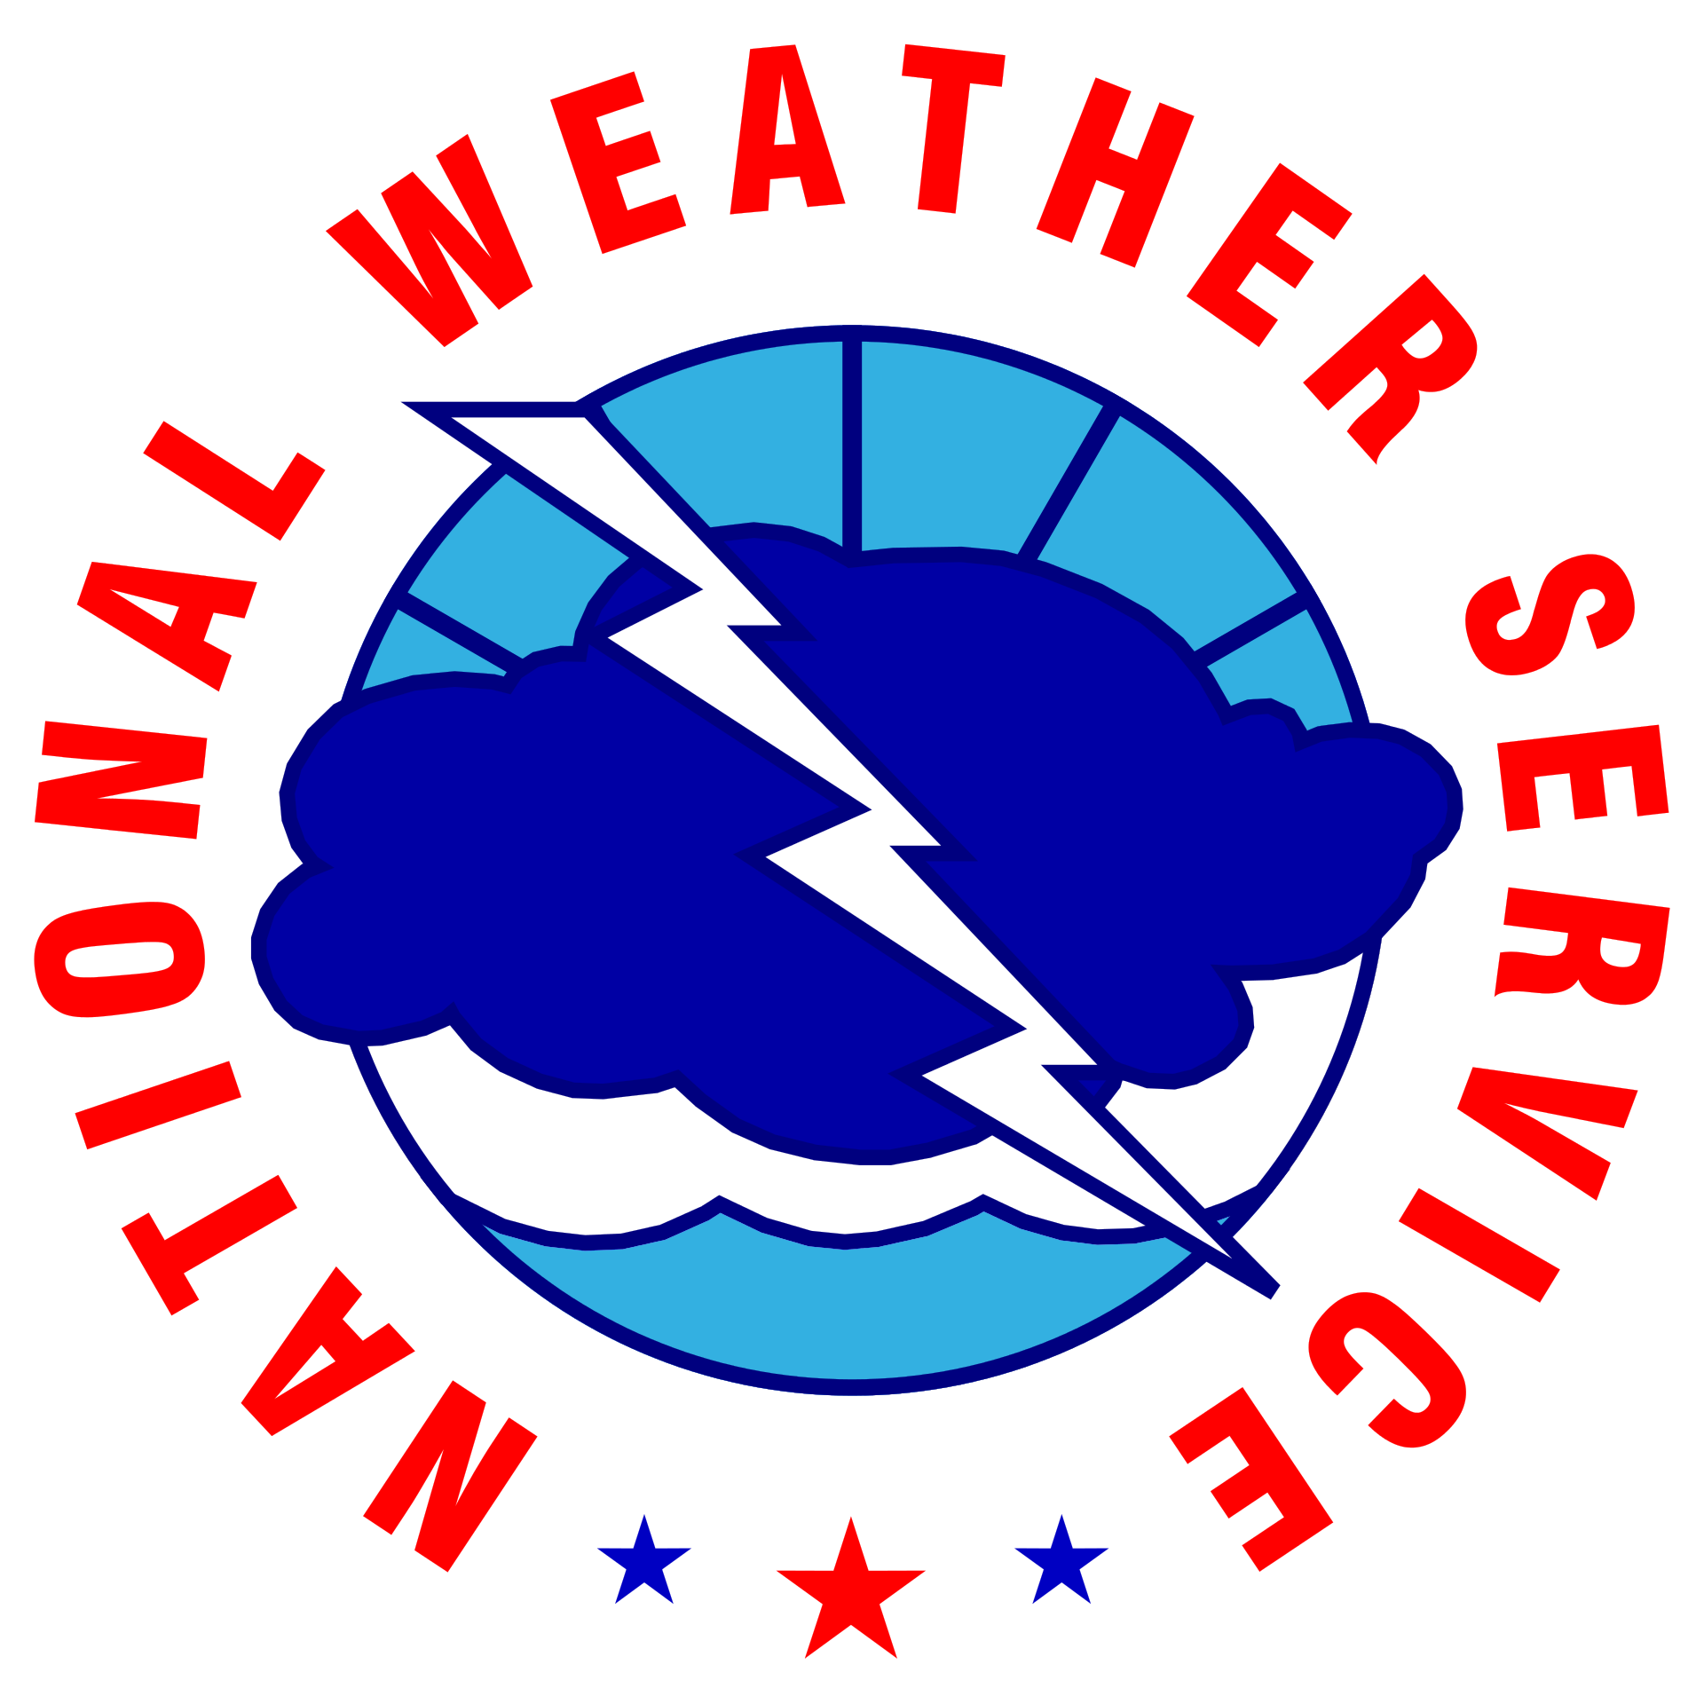

**WILDERNESS AREA**

LIGHTNING SAFETY, ENTER ORG. NAME

horizontal line

# 

# Why This Matters

***When Thunder Roars, Go Indoors!***

The National Weather Service (NWS) has implemented a voluntary recognition program for public land management agencies to make visitors aware of the dangers of lightning and provide them with safety measures to protect themselves. This campaign encourages visitors to plan activities when the risk of lightning is lower, monitor weather conditions and watch for storm development while outdoors, and take action when they hear thunder, rather than waiting for lightning or rain.

The NWS recognizes the efforts of public land management agencies that follow these guidelines to protect those participating in outdoor activities from the dangers of lightning.

***The National Weather Service is committed to raising lightning safety awareness.***

|  |  |
| --- | --- |
| Organization Name | Click or tap here to enter text. |
| Point Of Contact | Click or tap here to enter text. |
| Phone | Click or tap here to enter text. |
| Email | Click or tap here to enter text. |

|  |  |
| --- | --- |
| NWS Contact Name | Click or tap here to enter text. |
| Weather Forecast Office | Click or tap here to enter text. |
| Direct Phone Number | Click or tap here to enter text. |

# Overview

Thunder is an immediate indication of dangerous conditions outside. If thunder is heard, anyone outside is in danger of being struck by lightning. Other threats such as damaging winds, large hail, flash flooding, or even a tornado may also be possible. This plan specifies the actions that will be taken.

**Elements of an effective lightning safety program should include a written plan that 1) identifies areas where lightning poses a significant hazard to the public, and  
2) describes how officials will:**

|  |  |  |
| --- | --- | --- |
| **Public Education Plan** | Provide guidelines on how to stay safe from lightning hazards |  |
| **Weather Situational Awareness** | Obtain timely thunderstorm information |  |
| **Notification Plan** | Communicate the threat for lightning and hazardous weather to staff and visitors |  |
| **Protection Plan** | Identify substantial lightning-safe structures |  |
| **Education & Plan Review** | Educate the staff about lightning safety and ensure they are trained and familiar with all aspects of the written lightning safety plan |  |

**The Lightning Safety Plan Resource Guide on the following pages can be used as a template to create a new lightning safety plan or to strengthen an existing plan.**

**A review of your plan by the National Weather Service is required to complete this lightning awareness program.**

# Public Education Plan

Lightning safety information should be provided in publications and websites; when visitors enter the park; and at locations such as trailheads, picnic areas, marinas, and overlooks. The [Backcountry Lightning Safety](https://www.weather.gov/media/owlie/backcountry_lightning.pdf) brochure includes actions to reduce lightning risk when outdoors. The National Weather Service can provide artwork for the “When Thunder Roars, Go Indoors” signs and other graphics that offer safety precautions to take during thunderstorms.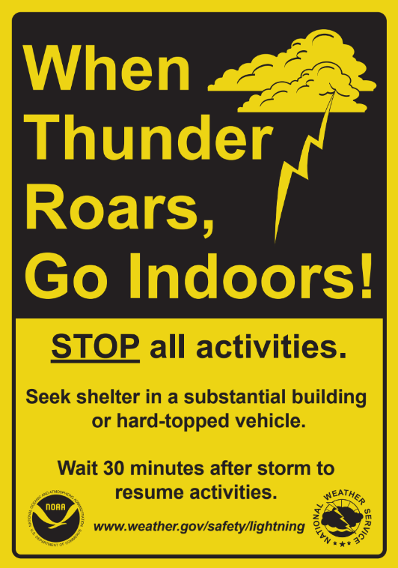

The employee in charge of monitoring the weather, (Click to add name of weather watcher) at Click to add location/facility, will review the forecast and monitor weather conditions every day using available weather information sources and communicate changes in the forecast to the staff.

When thunderstorms are forecast, the employee will notify Click to add park official name of the threat and review the lightning safety plan with staff. Please list any additional staff names or titles that will need to be notified of impending weather so the lightning safety plan can be implemented.

1. Click or tap here to enter text.
2. Click or tap here to enter text.
3. Click or tap here to enter text.
4. Click or tap here to enter text.
5. Click or tap here to enter text.

# 

# Public Education Plan (Cont.)

They will use the following methods to monitor weather conditions:

|  |  |
| --- | --- |
| Lightning detection system or commercial lightning detection network:  Click to add specifics |  |
| Mobile device app:  Click to add specifics |  |
| Interactive NWS (iNWS) notifications (text and/or email messages) |  |
| Internet:  ● Subscription for alerts if available: Click to add provider/service  ● National Weather Service Watches, Warnings, and Hazardous Weather  Outlooks: www.weather.gov/ Click to finish office link. ([Links to all NWS offices](https://www.weather.gov/srh/nwsoffices))  ● [Thunderstorm Outlooks](https://www.spc.noaa.gov/products/exper/enhtstm/) from the NWS Storm Prediction Center   (information 12 to 36 hours in advance): |  |
| NOAA Weather Radio station Click to add station name on 162.XYZ MHz |  |
| Social Media (Twitter): Twitter.com/NWSClick to finish office link |  |
| Television and/or AM/FM Radio (local network, cable TV, Radio Station):  Click to add info |  |
| Other (please list in detail):  Click to add info |  |

# 

# Education Plan

### Safety Guidelines

* **People should take shelter at the first sign of thunder or lightning. Outdoor activity can resume after 30 minutes of no lightning detected or thunder observed.**
* Time your outdoor activities with local weather patterns. Check the forecast before you start your activity and monitor sources of weather information and watch for developing storms while outdoors.
* Set turnaround times that will get you off higher terrain or the body of water before storms arrive, but turn back or get to shore earlier if you hear thunder or see lightning.
* If possible, find a safe structure either in an enclosed building or a metal-topped vehicle. Avoid open shelters like gazebos and open area picnic canopies. (see a full list of safe and unsafe structures below in the Protection Plan section.)
* Move to safer terrain as soon as you hear thunder: A dry ravine or other significant depression if you cannot get to a safe structure. Avoid peaks, ridges, plateaus, significantly higher ground, and taller trees that rise above others. Do not stand under a rock overhang or in a cave opening.
* If you cannot get to a safe structure or safer terrain when lightning is nearby, reduce your contact with the ground by putting your feet together, standing or sitting on a pack without metal, or crouching.
* If on a lake or other body of water, get to shore well before storms arrive.
* Select tent sites in safer terrain. If you hear thunder, do not lie flat; sit on a foam pad or pack or crouch.

# 

# Protection Plan

Staff and visitors will be notified when a lightning threat exists and what protective actions they need to take.

**When thunderstorms are forecast, the designated employee will use the following methods to notify staff and visitors of the lightning threat:**

|  |  |
| --- | --- |
| Notices at visitor centers, entrance stations, and marinas |  |
| Public Address Announcements |  |
| Telephone Tree / Local Pager System to Park Staff |  |
| Local Alert Broadcast System or Park Radio Station Broadcast |  |
| Text/Email message alerts |  |
| Social Media |  |
| Other (please list in detail): |  |

# 

# Protection Plan (Cont.)

#### Safe Structures

* There is no safe place outside when thunderstorms are in the area. If you hear thunder you are within striking distance of the storm. “When Thunder Roars, Go Indoors!”
* A lightning-safe structure is a substantial building with plumbing and wiring such as a home, school, church, office building, indoor concourse or recreation center. Once inside; do not use showers, sinks, bath tubs, and electric equipment such as televisions, stoves, radios, corded telephones and computers.
* Unsafe buildings include car ports, open garages, covered patios, picnic shelters, gazebos, beach pavilions, golf shelters, tents, baseball dugouts, sheds, and partially enclosed vending areas.
* A safe vehicle is a fully enclosed metal-topped vehicle such as a hard-topped passenger vehicle, bus, or truck. While inside a vehicle; do not open any windows, touch metal framework, or use electronic devices such as radios.
* Unsafe vehicles include golf carts, all-terrain vehicles (ATV), utility task vehicles (UTV), convertibles, motorcycles, or any other open cab vehicle.
* The following structures have been identified as safe locations to shelter from lightning within Click to add name of location/facility. Are these locations marked on a map or on the structures themselves: Click to add info.

#### Click or tap here to enter text.

#### Click or tap here to enter text.

#### Click or tap here to enter text.

#### Click or tap here to enter text.

|  |
| --- |
| *For more information on NWS support for special events, visit:* [*https://www.weather.gov/media/stormready/resources/specialevents.pdf*](https://www.weather.gov/media/stormready/resources/specialevents.pdf) |

# 

# Protection Plan (Cont.)

#### Life Saving Information

* If you observe a lightning victim or one is reported immediately call 911 and seek immediate medical attention for the victim(s). It is safe to approach and touch a victim after they have been struck, there will not be any lingering electric charge.
* Provide CPR to the victim and/or use an AED. Lightning often impacts the victims' cardiovascular and nervous systems. Burns, shock, and blunt force trauma are other possible injuries that would need to be treated.
* If possible, move the victim(s) to a place away from the threat of another lightning strike.
* Are there staff on site that are trained in CPR and other basic life saving techniques that can assist in the event of a lightning strike victim? List their titles and locations below:

Click or tap here to enter text.

* Where are the locations (if any) of Automated External Defibrillators (AEDs) that could be used in the event of a lightning strike victim?

#### Click or tap here to enter text.

# 

# Education *&* Plan Review

All staff should understand this Lightning Safety Plan before the season begins. It should also be shared with new staff and volunteers at the park throughout the year.

These procedures in the Lightning Safety Plan will be reviewed and drilled Click to add frequency (annually, seasonally, etc) Does your lightning safety plan include injury and fatality statistics for your park staff awareness? Yes or no?

Click to add info

**How does your park ensure guest are aware of lightning safety precautions they could take when at the park:**

|  |  |
| --- | --- |
| Staff Safety Training, including talks with the National Weather Service |  |
| Park Lightning Safety Day |  |
| Safety Information on maps/handouts/websites/trailheads |  |
| Announcements at Park Events and Headquarters |  |
| Other (please list in detail):  Click or tap here to enter text. |  |

# Education *&* Plan Review(Cont.)

|  |
| --- |
| *In addition, the following facts will supplement staff knowledge on lightning safety:*   * **Severe Thunderstorm Warnings are *not* issued based on lightning.** All thunderstorms produce thunder and lightning and are potentially deadly. A **Severe Thunderstorm Watch or a Tornado Watch** is issued when conditions are favorable for the development of thunderstorms with wind gusts of 58 MPH or higher, quarter size hail or larger, or tornadoes. A **Severe Thunderstorm or Tornado Warning** is issued when severe thunderstorms or a tornado has been detected or is imminent. * Lightning can strike outside the rain area or thunderstorm cloud. In extreme cases, lightning can strike 10-15 miles from the thunderstorm. Don’t wait for rain to get to a safe structure and don’t leave the safe structure just because the rain has ended. * Don’t hesitate to stop outdoor activities and have visitors get to a lightning-safe structure or their vehicles if the sky appears threatening, especially if thunderstorms are a possibility. Thunderstorms can develop directly overhead and some storms may develop lightning just as they move into your area. * Many lightning casualties occur because people do not get inside a shelter soon enough. Not wanting to appear overly cautious, many people wait too long before reacting to this potentially deadly weather threat. * Only about 10% of people who are struck by lightning are killed, leaving 90% with various degrees of disability, including life-long debilitating injuries. |