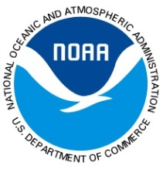 | Student Volunteer Application  NOAA National Weather Service Topeka, Kansas | 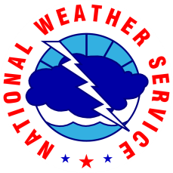

Name:

Email:

School:

Major/Minor:

Advisor:

Advisor Email:

Advisor Phone #:

Summer Address:

Summer Phone #:

Proposed Dates and Times:

Please include a copy of your latest transcript and resume with your application
Resume should include, but is not restricted to:
- College Awards and Honors
- Work/Volunteer Experiences
- Organizations/Memberships, Extracurricular Activities
- Research Experience
- Computer Skills (i.e., GIS, computer programming, Word, Excel, PowerPoint, Linux)

Please answer the following questions (short-answer responses):
What are your career goals?

Are there any aspects of weather that you’re most interested in pursuing and/or learning about more? (i.e., severe, winter, aviation, fire, hydrology, climate). Explain why.

Selected applicants will be notified via email.

